Enter The Project Location

Enter the Project Proposal

Temporary Traffic Management
Suitability Audit
Audit Ref: TMP/2018/001

TMP No XXX-XXXXX

Prepared for:
Enter Client Details
By:
Enter Organisation

Report Issue Date: 11/04/2024
Contents
1 PROJECT AND SITE DETAILS 3
1.1 Project / Site Description 3
1.2 The Audit Team 3
1.3 Scope of Audit 4
1.4 Audit Process 5
1.5 Risk Ratings 5
1.6 Background Data 6
1.6.1 Traffic and Speed Assessment 6
1.6.2 Appendices 6
2 AUDIT FINDINGS AND RECOMMENDATIONS 7
2.1 Finding – Provide a title for the identified finding 7
2.2 Finding – Provide a title for the identified finding 7
2.3 Finding – Provide a title for the identified finding 7
2.4 Finding – Provide a title for the identified finding 7
2.5 Finding – Provide a title for the identified finding 7
2.6 Finding – Provide a title for the identified finding 8
2.7 Finding – Provide a title for the identified finding 8
2.8 Finding – Provide a title for the identified finding 8
2.9 Finding – Provide a title for the identified finding 8
3 CONCLUDING STATEMENT 9

PROJECT AND SITE DETAILS

Project / Site Description

ITEM | DESCRIPTION
Approved TMP Number and file reference
Project Title
Project Location
Road Classification, Existing Speed Limit,
Traffic Volume
Road Authority
Local Government
Client (Audit Request)
Prime Contractor
Sub-Contractor
Scope of Works
Staging of Work
Project Date
Hours / Days of Work
Duration of Work
Other Constraints
Concurrent/adjacent
Works or Projects

The Audit Team
Accreditation No. | Name | Role | Organisation
000000 | [ENTER NAME] | Audit Team Leader | [ENTER ORGANISATION]
000000 | [ENTER NAME] | Audit Team Member | [ENTER ORGANISATION]

Scope of Audit
[AUDITOR ORGANISATION] was commissioned by [ENTER CLIENT] to undertake a Traffic Management Suitability Audit of [ENTER WORK TYPE, LOCATION AND DATE OF WORKS].

Suitability Auditing of a Traffic Management Plan is a formalised procedure which can be applied to all phases of a road project development. A Suitability Audit is a systematic and independent examination of the extent to which the proposed Traffic Management Plan addresses specified requirements and provides a measure of the projects capability in meeting those requirements. For the context of this Traffic Management Plan Suitability Audit the Auditor has remained independent of the designer and the project manager so that the TMP design is viewed with “fresh eyes”.

The purpose of the report is to identify any safety concerns or traffic management issues that have not been identified or resolved in the TMP prior to the TMP being implemented. The evaluation was made against the final revision of the [ENTER TMP NUMBER] and assessed against:
- Main Roads Traffic Management for Works on Roads Code of Practice,
- Austroads Guide to Temporary Traffic Management
- Australian Standard 1742.3,
- [ENTER SPECIFIC TM PROJECT KPI’S]
- [ENTER CONTRACT DOCUMENT] e.g. Scope of Works and Technical Content document, Specification 202, etc
- , and
- road environment factors identified out on site.

In reviewing the safety and traffic management aspects of a Traffic Management Plan, the reporting procedure is not intended as a re-design of the traffic management but to outline potential or pre-existing road safety or traffic operational issues and establish a basis upon which a design could produce an acceptable solution.

The review process also recognises the need to identify any work environment conditions or management practices that can potentially pose hazards to the workers and other personnel at the worksite.

Figure 1: Audit Location

Audit Process
A commencement meeting was held with [ENTER NAME AND ORGANISATION]. Road design plans, the TMP and TGS’s were provided to the audit team. Following which the on-site inspection was conducted at [ENTER ONSITE INSPECTION TIME].

The reporting procedure is to outline potential or existing safety and traffic management issues and establish a basis on which improvements could be made to achieve a safer, more efficient roadwork environment for all road users and workers.

The Corrective Action Report should be referred to the Contractor’s Representative for comment and returned to the Road Authority Representative. It is imperative that all intended actions and the reasons for this are given in writing and agreed to by the road authority representative (see attached Corrective Action Report).

Risk Ratings
Audit findings that are determined to be critical either due to crash risk or the impact to traffic (note: low and/or medium risks may also be noted).

Risk Rating | Description
Very High | Determined to be an unacceptable risk. Very high priority. HOLD POINT.
High | High priority. To be addressed ASAP.

Background Data

Traffic and Speed Assessment

Appendices
A. Photographs
D. Corrective Action Report

AUDIT FINDINGS AND RECOMMENDATIONS

Finding – Provide a title for the identified finding

Provide a summary of the finding including clarification of the location if necessary.

Include a justification explaining the problem and if applicable make reference to any standards or specifications that further support your finding

Recommendation:
Provide your recommendation ensuring that you do not use the terms ‘consider or ‘monitor.’

Finding – Provide a title for the identified finding

Provide a summary of the finding including clarification of the location if necessary.

Include a justification explaining the problem and if applicable make reference to any standards or specifications that further support your finding

Recommendation:
Provide your recommendation ensuring that you do not use the terms ‘consider or ‘monitor.’

Finding – Provide a title for the identified finding

Provide a summary of the finding including clarification of the location if necessary.

Include a justification explaining the problem and if applicable make reference to any standards or specifications that further support your finding

Recommendation:
Provide your recommendation ensuring that you do not use the terms ‘consider or ‘monitor.’

Finding – Provide a title for the identified finding

Provide a summary of the finding including clarification of the location if necessary.

Include a justification explaining the problem and if applicable make reference to any standards or specifications that further support your finding

Recommendation:
Provide your recommendation ensuring that you do not use the terms ‘consider or ‘monitor.’

Finding – Provide a title for the identified finding

Provide a summary of the finding including clarification of the location if necessary.

Include a justification explaining the problem and if applicable make reference to any standards or specifications that further support your finding

Recommendation:
Provide your recommendation ensuring that you do not use the terms ‘consider or ‘monitor.’

Finding – Provide a title for the identified finding

Provide a summary of the finding including clarification of the location if necessary.

Include a justification explaining the problem and if applicable make reference to any standards or specifications that further support your finding

Recommendation:
Provide your recommendation ensuring that you do not use the terms ‘consider or ‘monitor.’

Finding – Provide a title for the identified finding

Provide a summary of the finding including clarification of the location if necessary.

Include a justification explaining the problem and if applicable make reference to any standards or specifications that further support your finding

Recommendation:
Provide your recommendation ensuring that you do not use the terms ‘consider or ‘monitor.’

Finding – Provide a title for the identified finding

Provide a summary of the finding including clarification of the location if necessary.

Include a justification explaining the problem and if applicable make reference to any standards or specifications that further support your finding

Recommendation:
Provide your recommendation ensuring that you do not use the terms ‘consider or ‘monitor.’

Finding – Provide a title for the identified finding

Provide a summary of the finding including clarification of the location if necessary.

Include a justification explaining the problem and if applicable make reference to any standards or specifications that further support your finding

Recommendation:
Provide your recommendation ensuring that you do not use the terms ‘consider or ‘monitor.’

CONCLUDING STATEMENT

Provide concluding statement from the audit, ensure that an ‘exit’ meeting is conducted to raise the issues identified in the audit findings.

This audit has been carried out for the sole purpose of identifying any features of the design which could be altered or removed to improve its safety and efficiency. The traffic management plan and the documents listed in the Appendices have been examined and the site inspection has been conducted.

The Findings and Recommendations have been noted in the Corrective Action Report which is contained as an attachment to this report. The asset owner / contract manager / project manager and the designer are to assess these for implementation. It is imperative that the completed Corrective Action report along with the revised traffic management plan is returned to the asset owner / contract manager / project manager prior to the traffic management plan being approved for implementation.

XX, author of this audit will be pleased to discuss any aspects of the findings, recommendations or concluding statement contained within this report. S/he can be contacted on phone number XX or email XX.

…………………………………………………….
XX
(Team Leader) Date:

APPENDIX A

PHOTOGRAPHS
(Photos may be added to Finding section to help support findings)

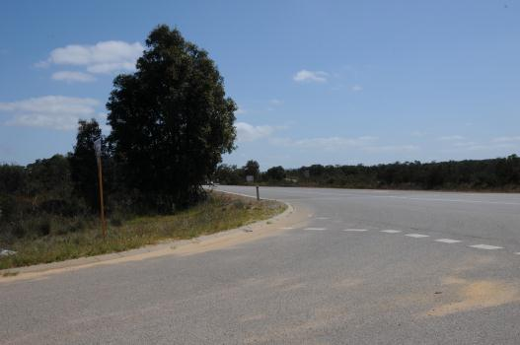
Photo 1

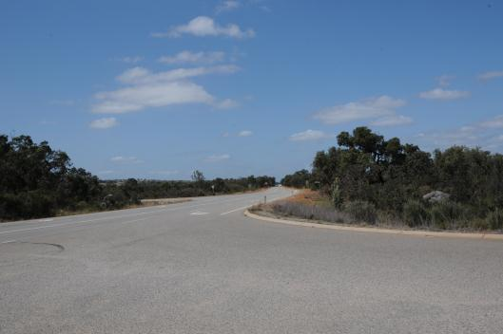
Photo 2

APPENDIX B

CORRECTIVE ACTION REPORT

NOTE:
THE FOLLOWING FINDINGS AND RECOMMENDATIONS ARE PRESENTED IN AN ABBREVIATED FORM IN THIS CAR;
THEY MUST BE READ IN CONJUNCTION WITH THE FULL REPORT AND SHALL NOT BE CONSIDERED IN ISOLATION.

2.1 Finding – Provide a title

Provide a summary of the finding.

Recommendation:

Provide your recommendation.

2.2 Finding – Provide a title

Provide a summary of the finding.

Recommendation:

Provide your recommendation.

2.3 Finding – Provide a title

Provide a summary of the finding.

Recommendation:

Provide your recommendation.

2.4 Finding – Provide a title

Provide a summary of the finding.

Recommendation:

Provide your recommendation.

2.5 Finding – Provide a title

Provide a summary of the finding.

Recommendation:

Provide your recommendation.

2.6 Finding – Provide a title

Provide a summary of the finding.

Recommendation:

Provide your recommendation.

2.7 Finding – Provide a title

Provide a summary of the finding.

Recommendation:

Provide your recommendation.

2.8 Finding – Provide a title

Provide a summary of the finding.

Recommendation:

Provide your recommendation.

2.9 Finding – Provide a title

Provide a summary of the finding.

Recommendation:

Provide your recommendation.

NOTE

- This corrective Action Report is to be read in conjunction with the full Suitability Audit Report and its findings and recommendations.

- The asset owners (MRWA and/or LGA) must be informed of these findings, recommendations and proposed actions.

- Items not under the responsibility of this project representative must be forwarded to the persons / agencies who are responsible.

These findings and recommendations have been considered, and the actions listed will be taken accordingly.

…………………………………………………………… …………..…………………………. …………….………………………. ……………….
Responsible project representative Company/Agency/Division Position Date

…………………………………………………………… …………..…………………………. …………….………………………. ……………….
Asset Owner representative MRWA / LGA / Other Position Date

Auditor: XX ph. XX

Date:

