Date 2017/04/01
Title Detail Survey – Smith Rd SLK 10 – 20

MRWA Ref – 2017STH9999

Survey Report

Company Name Surveyors Pty Ltd

Contact Details
John Jackson
jj@surveyorsptyltd.com
mob +61 444 444 444
office +61 8 9999 999

Table of Contents
1 PROJECT DESCRIPTION 2
2 PROJECT ZONE NAME 2
3 equipment used 3
4 survey methodology 3
5 survey control 3
5.1 horizontal network 3
5.2 vertical network 3
5.3 control network diagram 4
5.4 control SUMMARY TABLE 2
6 survey / model verification – quality assurance 2
7 data lodged / deliverables supplied 2
8 non-standard codes in genio 2
9 project issues 3
10 PRIVATE PROPERTY CONTACT RECORDS 3

PROJECT DESCRIPTION
May paste from MRWA survey request/brief/scope

project has been conducted and completed according to this Digital Ground Survey standard.

This project was completed in accordance with Main Roads survey standards.

Signed : Dated:
Surveyors Pty Ltd

MRWA Survey & Mapping
  - Name
  - Position
  - Email

MRWA Project Manager
  - Name
  - Position
  - Email

PROJECT ZONE NAME

PCG94

equipment used
- Gringle Total station
- Loika RTK GNSS
- Friegle mobile laser scanner system
- Copton digital level and invar staff

survey methodology
Summary of Survey methodology and workflows
- Existing control was confirmed
- New RRMs were established in accordance with 67-08-36 RRM standard using (survey methodology) total station traverse/static base lines. RRM summary diagrams are included at the end of the report.
- The following methodology was used to coordinate control.
- A free adjustment was performed on the MLS and issues were found with the following existing control.
- All points (new and existing) were levelled in the survey corridor with a digital level and comply to 12 root k
- Mobile laser scan was performed on the xx/xx/2014
- Minor control points were established and the MLS was pinned every Xm
- Check points were evenly distributed throught the project area between tie points.
- Verification points were collected …
- Natural surface points in outer edges of survey corridor collected with RTK GPS

survey control
In conjunction with the table farther below (section 4.4), this section is to include details of survey control used, adjacent to, and relevant to the survey as per requirements of the MRWA 67-08-43 DGS standard.

If new RRMs are established, completing this report/section appropriately can satisfy the requirements of the MRWA RRM standard 67-08-36

horizontal network
- Horizontal control was established by static GNSS/total station traverse.
  - Network diagram and adjustment report attached/included below in this document…

vertical network
- All existing control adjacent to site, and and new control points were 2-way levelled using Copton digital level and invar staff
- Levels on existing RRM and /or SSM X and Y were out of tolerance. Checks were made, conclusion that new Z value to be adjusted and applied from level run.

control network diagram
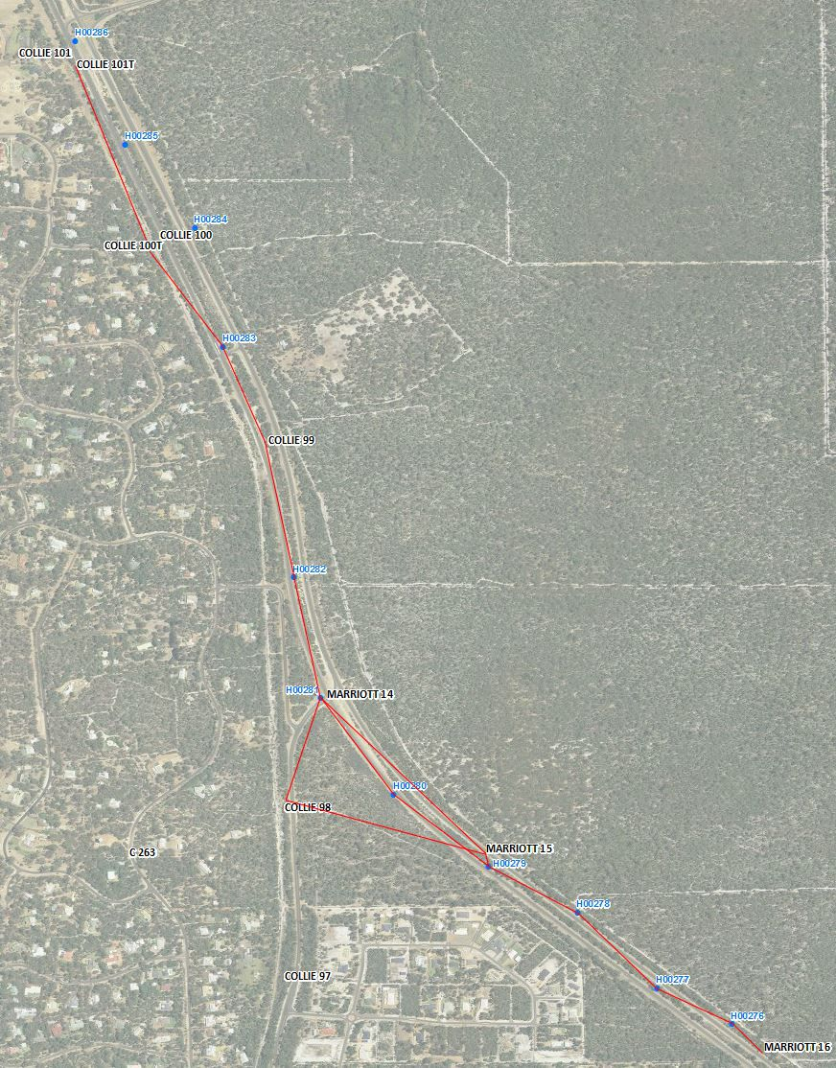

control SUMMARY TABLE

CONTROL TYPE | CONTROL NAME | EXISTING/NEW? | EASTING | NORTHING | HEIGHT | ZONE | CONSTRAINED? H/V | COMMENT
SSM | HR 999 | EXISTING | 12345.789 | 12345.789 | 321.456 | HUG94 | HV
RRM | RRM999 | NEW | 32145.344 | 126324.222 | 322.444 | HUG94 |  | Star iron in concrete with witness plate marker. With reference spikes in road.
BM
MCP
MLS Target

survey / model verification – quality assurance
- Triangulation generated in xxx software and evaluated for consistency/gross errors
- Statistical summary of field QA evaluation is…

data lodged / deliverables supplied
Deliverables of this project were emailed to:
- surveying@mainroads.wa.gov.au
  - 2017/04/01

The following files were supplied for this project
- Scan Report
  - H57_SLK_0_10_MLS_Report.docx
- Scan data
  - PCG94_Tile1.las
- Scan Tile index
  - H57_SLK_0_10_LAS_INDEX_PCG94.dxf
- Extracted Survey genio data
  - H57_SLK_0_10_PCG94.gen
- Verification data on the road surface
  - H57_SLK_0_10_VARIFICATION_ROAD_PCG94.gen
- Verification data on natural surface
  - H57_SLK_0_10_VARIFICATION_NATURAL_SURFACE_PCG94.gen
- Metadata
  - H57_SLK_0_10_MLS_Metadata.pdf
- Control network diagram & adjustment report
  - csv/excel spreadsheet file showing: pt #, E, N, RL, Zone, Datum for all points in the network and a brief header showing project information.

non-standard codes in genio
CODE | DESCRIPTION

project issues
Some? nil?
Roadworks/site conditions changing/changed?
Weather?
Denied property access?
Culvert condition – inaccessible invert?

Culvert at  E55555  N1236547  Inaccessible invert  Heavily silted. Invert interpreted from obvert and diameter width measured across culvert | 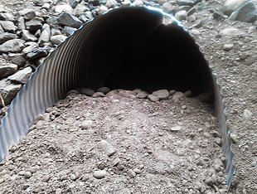

PRIVATE PROPERTY CONTACT RECORDS
Written description as required, or/and use table below,

LOT/PROPERTY | OWNER NAME | DATE OF CONTACT | DETAILS
LOT 77 43 Sniveller St | Mr John J Jackson | 2017/04/01 | Surveyor John Jackson telephoned owner, and access permitted, under condition of leaving all gates open/closed as found, and paddocks only traversed by foot. No pegs/survey marks to be left behind after project completion

