Traffic Model Report – Proposed Options Results
Title of Document
2nd line
SUBHEADING IF REQUIRED
Printed copies are uncontrolled unless marked otherwise. Refer to iRoads for current version.
Dxx#xxxxx
Month Year

Contents
1 Purpose 4
2 Introduction 4
2.1 Project Details 4
2.2 Project Location and Modelling Area 4
2.3 Predefined Modelling Scenarios for the Study 5
2.4 Localised Network Changes 5
3 Proposed options 5
3.1 Proposed Development 5
3.1.1 Site Plan 5
3.1.2 Zone Structure 6
3.1.3 Trip Generation 6
3.1.4 Development Traffic 6
3.1.5 Traffic Distribution 6
3.2 Future Analysis 6
3.3 Future Analysis 7
3.3.1 Road Network 7
3.3.2 Traffic Flows 7
3.3.3 Additional Developments 7
3.3.4 Public Transport 7
3.4 Total Future Traffic Flows 7
4 future scenario model results 7
4.1.1 Overview 7
4.1.2 Heat Map 8
4.1.3 Speed-Flow Diagram 8
4.1.4 Level of Service 8
4.1.5 Queue length 8
4.1.6 Average Delay 8
4.1.7 Travel Times 8
4.1.8 Mid-block Segment Volumes 8
4.1.9 Intersection Signal Timings 8
5 Mitigation Measures 8
5.1 Proposed Mitigation Measures 8
5.2 Mitigated Model output 8
6 conclusion 9
7 Documents/files provided 10
8 Appendices 10

Document Control
Owner | Consultant if prepared by them
Custodian
Approved
Document Number | Main Roads Ref
Issue Date | Consultant Date
Review Frequency

Amendments
Revision Number | Revision Date | Description of Key Changes | Section / Page No.

Purpose of the report:

To provide a report template for modelling of signal design and network impact, when a new/existing signalised intersection is being proposed/upgraded, and development that would have an impact on the State Road Network.

This template must be completed for all schemes planned for implementation on the State Road Network, and where schemes on other roads impact the performance of the State Road Network.

This document will provide a summary of project details, and model inputs and outputs for the proposed scheme.

Section 8 lists the data/files that need to be provided as a package with this report. The document number will be filled in by Main Roads Western Australia.

Main Roads Western Australia will provide the consultant with a document reference number for the traffic signals model report.

NOTE: all text in red is for information and should be deleted once report is completed and submitted to Main Roads Western Australia.

The Proposed Modelling Report Template should be used. The report should include:
- Any updates to the base model.
- Modelling assumptions
- Any variations from the parameters recommended in the Operational Modelling Guidelines.
- Details of the agreed options tested.
- Justification of the preferred option.
- The agreed proposed design.
- Approved base modelling report.

Purpose
Describe purpose of the modelling
E.g. blackspot scheme, timings improvement scheme

Introduction

Project Details
Project details should show all background information including purpose of modelling.

Project Location and Modelling Area
Project location should include area, suburb and main corridor of the affected area, and provide efficient local information that might be critical to the model, an example is shown below.

Project name | Perth Children’s Hospital Opening Model
Project affected area | 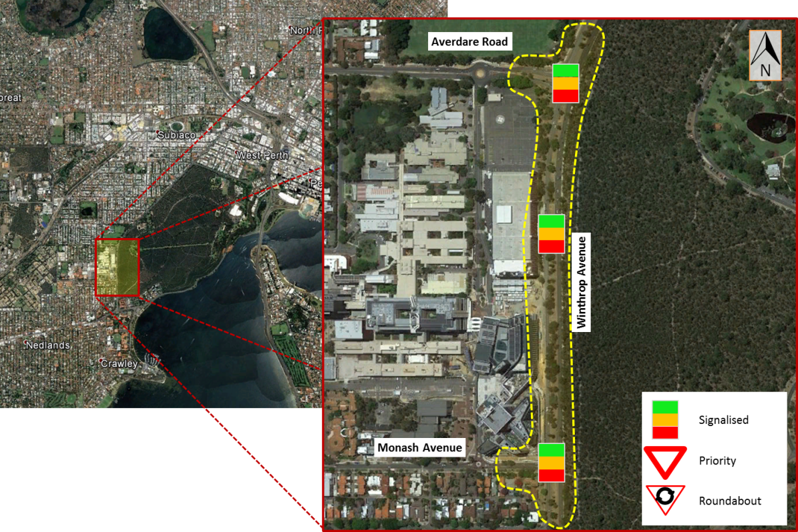  Map needs to show road names and North Point.  Show area of study in relation to Perth CBD.  List council (i.e. local council).
Area | Metro
Suburb | Nedlands
Main corridor | Winthrop Avenue
Secondary roads | Monash Avenue, QE II parking entrance, Aberdare Road
Local information | Medical school of the university of Western Australia has an entrance on Monash avenue, 500m from the development, and the main campus of the University of Western Australia is less than 1 Km north of development.

Include description of Microsimulation and Mesoscopic Areas

Predefined Modelling Scenarios for the Study
List and describe all modelling scenarios and peaks for the study.
The scenarios normally required to be modelled are:
- Existing year=A1
- Opening year=A1+B+C
- 5 years after opening=A2+B+C
- 10 years after opening=A3+B+C
  - A1=Existing without development (section 3.1.2);
  - A2=5 years’ traffic growth (section 3.3.2);
  - A3=10 years’ traffic growth (section 3.3.2);
  - B=Traffic generated by development (section 3.2.3); and
  - C=Traffic generated by additional development (section 3.3.3).

Localised Network Changes
Describe changes required in the wider network to accommodate traffic.

Proposed options

Proposed Development
This section needs to be filled out if the project includes a proposed development.

Site Plan
A Site drawing of the development is to be provided in this section with the proposed access and egress points demonstrated. The provision of an Auto CAD drawing with the road widths, lane lengths, and turning radii will assist the audit review of traffic models.

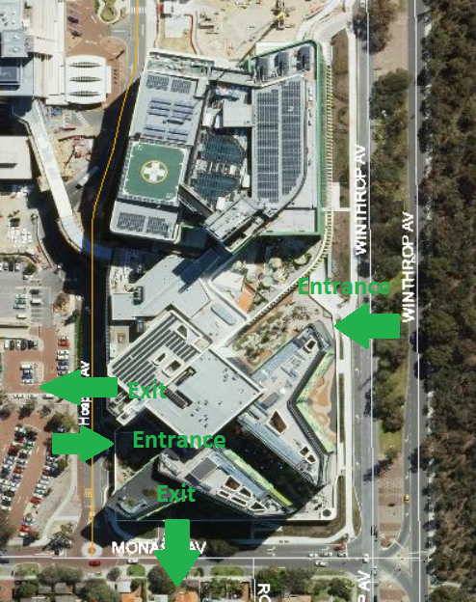

Zone Structure
Define zoning structure for the model. Information if static traversal procedure was undertaken.
Provide information of zone disaggregation from strategic model (ROM24). Number of zones created (external – internal)

Trip Generation
Trips generated by the development need to be summarised preferably in the format of an excel table and with reference to the source of the trip rate.

Development Traffic
Provide the anticipated number of traffic generated by the proposed development and the methodology used to calculate the development traffic.

Traffic Distribution
Origin to Destination trips generated by the development should be summarised preferably in the format of an OD diagram in excel.
Assumptions should be included here in relation to any changes in the OD matrix for background traffic.
Assumptions should be outlines here regarding the methodology used to derive the OD matrix (population area, census data, car plate recognition)
Assumptions of Demand matrices refinement.
Assumptions of Traffic demand profiles used in the base model.

Future Analysis
Provide information about Path assignments for Static route choice, Dynamic User Equilibrium (DUE).
Provide dynamic parameters used to run the scenarios.

Future Analysis
Include detail of the intended years of analysis in this section (include reasoning if not the normal +5yrs/+10yrs of analysis.)

Road Network
Provide drawings of the planned road network within the study area, if proposed. (This may differ for different future years)

Traffic Flows
Provide future traffic flows without development traffic flows.
Include assumptions regarding methodology of calculating the future traffic flows using traffic growth factor based on historical data. Raw data and traffic flow diagrams should be provided in Excel.

Include any assumption made while calculating the future traffic.
Future traffic can be calculated based on ROM data or by applying a growth factor on existing traffic flow (this needs to be discussed and agreed with Main Roads).

ROM data need to be calibrated in the first instance as described in Guidelines for Calibration of Traffic Volumes for ROM24; growth factor should be validated with historical data)
Raw data and traffic flow used should be provided in excel.

Additional Developments
Include this section if there is a need to take into account any traffic flow generated by additional developments. Information should be provided preferably in the format of traffic flow diagrams in Excel.

Public Transport
Provide details of PT line, stop, station and timetable for public transport planned in future year scenarios.

Total Future Traffic Flows
Provide traffic flow diagrams of the total traffic for each required scenario described in section 2.3.

future scenario model results
Once the existing model is calibrated and validated, a future model would be developed based on the validated existing model, with future traffic flows and existing/proposed road layout. The outputs of the future model would be shown in this section along with analysis of any major traffic impacts.

Outputs should include, Level of Service, Queue length, average delay and travel times.

For microsimulation models, travel time comparisons between existing and future scenarios are required. A list of cycle times for comparison between existing and future should be included with details of any cycle time optimisation and identification of the critical intersection if the model is a network.

Overview
Include general details of the results.

Heat Map
Comparing base and future scenario modelled vehicle speeds at predetermined routes over the peak periods for all options.

Speed-Flow Diagram
Comparing base and future scenario modelled speed flow diagram at predefined routes for all options.

Level of Service
Comparing base and future scenario modelled Level of Service at predefined intersections for all options.

Queue length
Comparing base and future scenario modelled queue lengths at predefined locations for all options.

Average Delay
Comparing base and future scenario modelled average delay at predefined locations for all options.

Travel Times
Comparing base and future scenario modelled travel times diagrams at predefined routes for all options.

Mid-block Segment Volumes
Comparing base and future scenario modelled screenline volumes diagrams at predefined locations for all options.

Intersection Signal Timings
Provide information at each intersection where signal timing were changed.

Mitigation Measures
Include this section if this is part of the scope of works.

Proposed Mitigation Measures
With major traffic impacts to the road network analysed in Sections of the report, mitigation measures can be presented in this section (if this is part of the scope), mitigation measures can include but are not limited to:
- Signal optimisation for future scenarios;
- Intersection upgrades;
- Line marking changes.

Mitigated Model output
Future models with mitigation measures applied to the network need to be assessed and the model outputs should be analysed. Model outputs should include: Level of Service, Queue length, average delay, Degree of Saturation, and travel times if the model is a microsimulation model.

conclusion
Summarise the purpose of the model and the outcome along with any recommendations.

Documents/files provided
Document Number | Document Name | Description
TRIM Ref provided by Main Roads | SCATS data | Raw SCATS data requested from MRWA including:  MF files  Phasing History Files SCATS Traffic Flows
TRIM Ref provided by Main Roads | Instruction sheet | List of sufficient information shall be used for the model
TRIM Ref provided by Main Roads | Latest Model | The lasted model showing information in the model summary
TRIM Ref provided by Main Roads | Model Summary | Sheets summarises information of the models listed:  1.Site Location  2.LMA & LMB drawing  3.Model Coding notes.  4.SCATS drawing, diagram, and time setting information.  5.Traffic flow summary  6.Pedestrain volume summary  7.Saturation flow  8.Scenarios  9.Future flow  10.Model output  11.Proposed mitigations  12.Mitigated model output  13. Meeting minutes with MRWA  14. Proposed layout agreement with MRWA (Email confirmation)
TRIM Ref provided by Main Roads | Model Report | A report of the model following this template
TRIM Ref provided by Main Roads | Model Audit Sheet | A model audit sheet provided by OMV, checked and signed by modeller building the model, and another senior modeller in the company before passing to OMV for review
TRIM Ref provided by Main Roads | Site Drawings | LMA and LMB drawings show signals and lines

Appendices
Include if required
Appendix | Title
Appendix 1
Appendix 2
Appendix 3
Appendix 4
Appendix 5

