Base Modelling Report
Title of Document
2nd line
SUBHEADING IF REQUIRED
Printed copies are uncontrolled unless marked otherwise. Refer to iRoads for current version.
Dxx#xxxxx
Month Year

Contents
1 Purpose 5
2 Introduction 5
2.1 Project Details 5
2.2 Project Location and Modelling Area 5
2.3 Predefined Modelling Scenarios for the Study 6
3 Data Collection 6
3.1 Existing Situation 6
3.1.1 Road Network 6
3.1.2 Traffic Flows 6
3.1.3 Signal Data (SCATS) 7
3.1.4 Travel Time 7
3.1.5 Queue Length 7
3.1.6 Saturation Flow 7
3.1.7 Public Transport 8
3.1.8 Site Plan 8
3.1.9 Zone Structure 8
3.1.10 Traffic Distribution 8
3.1.11 Road Network 9
4 Model calibration & Validation 9
4.1 Model Calibration 9
4.1.1 Software Version 9
4.1.2 Vehicle Behaviour 9
Vehicle behaviour parameters used values in the model 9
4.1.3 Configuration 9
4.1.4 Road types 9
4.1.5 Turn Penalty Functions 9
4.1.6 Volume Delay Functions 9
4.1.7 Traffic Management 9
4.1.8 Vehicle types 9
4.1.9 Link Counts 9
4.1.10 Turn Counts 9
4.1.11 Root Mean Square Error (RMSE) 10
4.1.12 Screenlines 10
4.1.13 Model Stability 10
4.2 Model Validation 10
4.2.1 Travel times 10
4.2.2 Speed-Flow Data 10
4.2.3 Weaving Validation 10
4.2.4 Queue Lengths 10
4.2.5 Heat Map 10
4.2.6 Speed-Flow Diagram 10
4.2.7 SCATS Signal Timings 10
5 conclusion 10
6 Documents/files provided 11
7 Appendices 11

Document Control
Owner | Consultant if prepared by them
Custodian
Approved
Document Number | Main Roads Ref
Issue Date | Consultant Date
Review Frequency

Amendments
Revision Number | Revision Date | Description of Key Changes | Section / Page No.

Purpose of the report:

To provide a report template for modelling of signal design and network impact, when a new/existing signalised intersection is being proposed/upgraded, and development that would have an impact on the State Road Network.

This template must be completed for all schemes planned for implementation on the State Road Network, and where schemes on other roads impact the performance of the State Road Network.

This document will provide a summary of project details, and model inputs and outputs for the proposed scheme.

Section 8 lists the data/files that need to be provided as a package with this report. The document number will be filled in by Main Roads Western Australia.

Main Roads Western Australia will provide the consultant with a document reference number for the traffic signals model report.

NOTE: all text in red is for information and should be deleted once report is completed and submitted to Main Roads Western Australia.

Purpose
Describe purpose of the modelling
E.g. blackspot scheme, timings improvement scheme

Introduction

Project Details
Project details should show all background information including purpose of modelling.

Project Location and Modelling Area
Project location should include area, suburb and main corridor of the affected area, and provide efficient local information that might be critical to the model, an example is shown below.

Project name | Perth Children’s Hospital Opening Model
Project affected area | 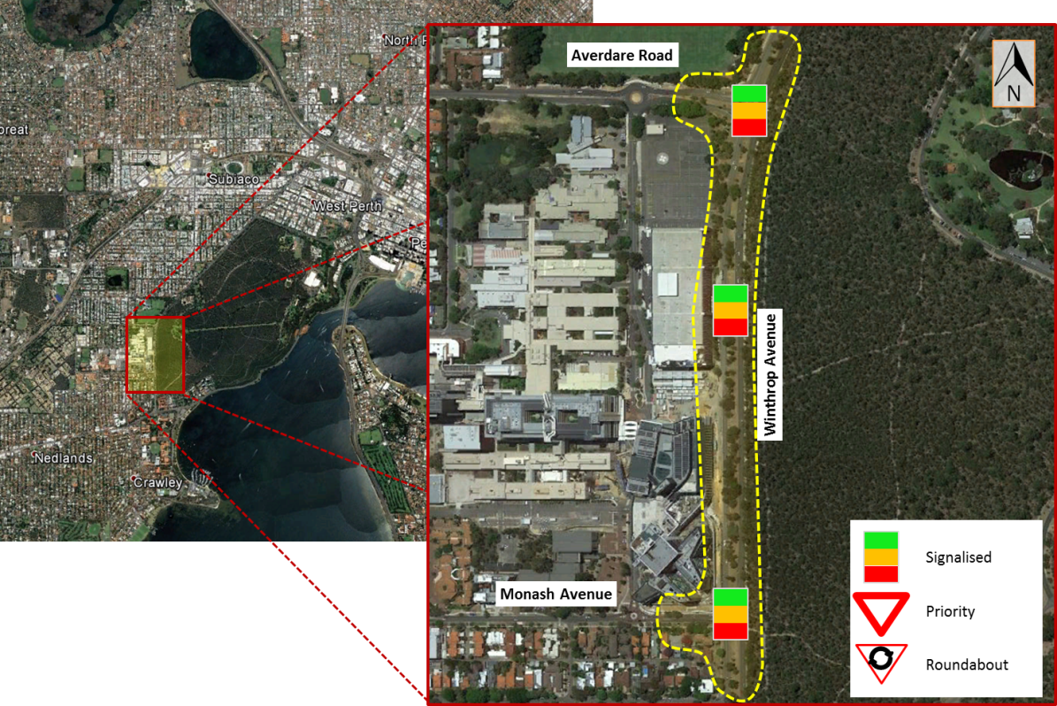  Map needs to show road names and North Point.  Show area of study in relation to Perth CBD.  List council (i.e. local council).
Area | Metro
Suburb | Nedlands
Main corridor | Winthrop Avenue
Secondary roads | Monash Avenue, QE II parking entrance, Aberdare Road
Local information | Medical school of the university of Western Australia has an entrance on Monash avenue, 500m from the development, and the main campus of the University of Western Australia is less than 1 Km north of development.

Include description of Microsimulation and Mesoscopic Areas

Details of modelling methodology, such as use of imported networks (ROM - STEM), Volume Delay Functions, Turning Penalty Functions, OD matrices, etc.

Predefined Modelling Scenarios for the Study
List and describe all modelling scenarios and peaks for the study.
The scenarios normally required to be modelled are:
- Existing year

Data Collection

Existing Situation
Show all information used for modelling existing conditions, describe onsite observations including Queues, traffic behaviour, weather, speed limit, road hierarchy and other factors.

Road Network
For the Study Area provide detailed drawings of the existing road network including lanes, line markings, measurements (road widths and short lane lengths, flare lengths) and signal heads for the network and the intersections of concern, preferably in Auto-CAD format, An example is shown for one intersection.

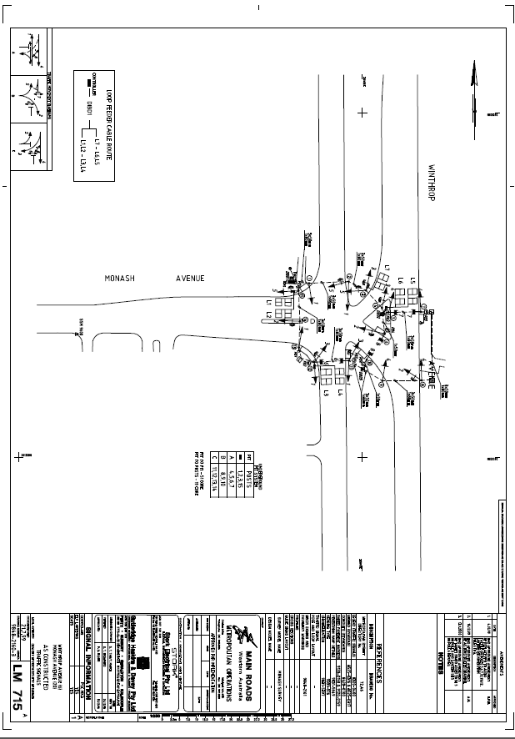

Traffic Flows
SCATS data and/or traffic survey data of the same date should be included in this section, and a traffic flow diagram with full turning movement surveys is required. Other traffic data such as Midblock tube counts, TomTom Data, Freeway vehicle detection system (VDS) should also be provided. A traffic flow spreadsheet is provided as an example.
Consultants should include heavy vehicles percentage and indicate special vehicle types in the study area.

Signal Data (SCATS)
The SCATS history file of the same day as the traffic surveys shall be analysed and summarized in this section. The SCATS historical data can be requested from Main Roads.

Travel Time
Travel time data should be collected if the modelling area comprises a network of intersections.

Queue Length
Queue lengths at the start of the green time for every movement/lane need to be observed on site. The collected queue data will be used to calibrate and validate the traffic model. This is primarily required when calibrating microsimulation models.

Saturation Flow
Saturation flows need to be measured onsite. Follow the Saturation Flows Information Sheet from MRWA.
Include in this report the calculations and surveyed information as an appendix.

Public Transport
Existing PT lines, stops, stations, and timetables are to be provided in a table list in this section if public transport is included in the modelling. Also provide PT route maps and timetables as reference.

Site Plan
A Site drawing of the existing site is to be provided in this section with the existing access and egress points demonstrated. The provision of an Auto CAD drawing with the road widths, lane lengths, and turning radii will assist the audit review of traffic models.

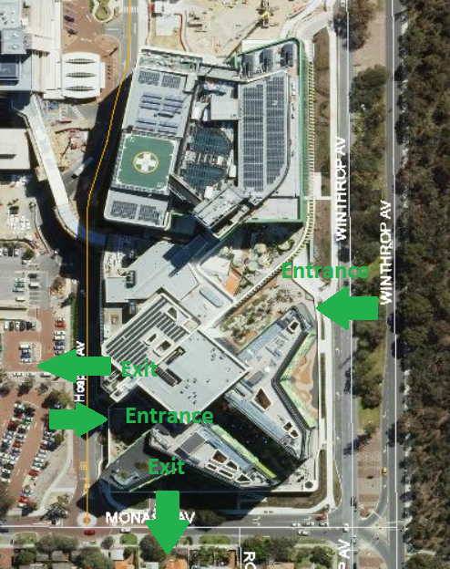

Zone Structure
Define zoning structure for the model. Information if static traversal procedure was undertaken.
Provide information of zone disaggregation from strategic model (ROM24). Number of zones created (external – internal)

Traffic Distribution
Existing Origin to Destination trips should be summarised preferably in the format of an OD diagram in excel.
Assumptions should be included here in relation to any changes in the OD matrix for background traffic.
Assumptions should be outlines here regarding the methodology used to derive the OD matrix (population area, census data, car plate recognition)
Assumptions of Demand matrices refinement.
Assumptions of Traffic demand profiles used in the base model.

Road Network
Provide drawings of the existing road network within the study area.

Model calibration & Validation

Model Calibration
The existing model needs to be built strictly following the existing layout and traffic flows. Once the model is completed, it can be calibrated based on available data (traffic counts, queue lengths, signal timing and travel times for a network), and other observations made on site. Calibration processes and results need to be summarised and presented in this section. Main Roads Western Australia would generally consider calibration is completed based on signal timings, queues and traffic flows.

Software Version
Version of the software were the model has been developed.

Vehicle Behaviour

Vehicle behaviour parameters used values in the model

Configuration
Simulation steps: Time step value used in the model
Mean reaction time: for each driver in seconds used in the model, and reasons if it was different to guidelines.
Global arrivals release style: release style used in the model.

Road types
List all road types used in the model with parameters.

Turn Penalty Functions
TPF applied and location during matrix adjustment and calibration process.

Volume Delay Functions
VDF applied and location in the model.

Traffic Management
Such as school zones, parking zones used in the model.

Vehicle types
Parameters used for each vehicle type on the model.

Link Counts
Comparing observed and modelled link counts for general traffic over the modelled peak hour periods.

Turn Counts
Comparing observed and modelled turning movements for general traffic over the modelled peak hour periods.

Root Mean Square Error (RMSE)
RMSE compares the difference between observed and modelled data. The RMSE will equate to a percentage and the percentage shall not be greater than 20% for intersection movements.

Screenlines
Comparing observed and modelled total link counts for general traffic across defined boundary lines over the modelled peak hour periods

Model Stability
Coefficient of variation (COV): to assess the variability between each run on the network statistics. The COV is a measure of the variation between model runs with 5 runs used for this test. Typically 5% is considered a good level of correlation

Model Validation
The model is commonly validated with data (traffic flows, travel times, Queues, and signal data) and other observations made on site to ensure the model is functioning well. Data used for validation is typically taken on a different day than data used to code and calibrate the model.

Travel times
Comparing observed and modelled journey travel times for general traffic over the modelled peak hour periods.

Speed-Flow Data
Comparing the observed and modelling speed data at predetermined locations.

Weaving Validation
Comparing the observed and modelling weaving volumes at predetermined locations.

Queue Lengths
Undertaking a visual check to confirm the modelled queue operation is consistent with those observed on site.

Heat Map
Comparing observed and modelled vehicle speeds at predetermined locations over the peak periods.

Speed-Flow Diagram
Comparing observed and modelled speed flow diagram at predefined locations.

SCATS Signal Timings
Comparing observed and modelled signal timings over the modelled peak hour periods.

conclusion
Summarise the purpose of the model and the outcome along with any recommendations.

Documents/files provided
Document Number | Document Name | Description
TRIM Ref provided by Main Roads | SCATS data | Raw SCATS data requested from MRWA including:  MF files  Phasing History Files SCATS Traffic Flows
TRIM Ref provided by Main Roads | Instruction sheet | List of sufficient information shall be used for the model
TRIM Ref provided by Main Roads | Latest Model | The lasted model showing information in the model summary
TRIM Ref provided by Main Roads | Model Summary | Sheets summarises information of the models listed:  1. Site Location  2. LMA & LMB drawing  3. Model Coding notes.  4. SCATS drawing, diagram, and time setting information.  5. Traffic flow summary  6. Pedestrain volume summary  7. Saturation flow  8. Model output  9. Meeting minutes with MRWA
TRIM Ref provided by Main Roads | Model Report | A report of the model following this template
TRIM Ref provided by Main Roads | Model Audit Sheet | A model audit sheet provided by OMV, checked and signed by modeller building the model, and another senior modeller in the company before passing to OMV for review
TRIM Ref provided by Main Roads | Site Drawings | LMA and LMB drawings show signals and lines

Appendices
Include if required
Appendix | Title
Appendix 1
Appendix 2
Appendix 3
Appendix 4
Appendix 5

