Document No. D14#86444 Issue Date 07/11/13

CORPORATE PROCEDURE

Environmental Guideline

VISUAL SCREENS WITHIN THE ROAD RESERVE

This document is owned and authorised by Executive Director Planning and Technical Services. Enquiries should be directed to the delegated custodian, Manager Environment.

Printed copies are uncontrolled unless marked otherwise

Contents
1. INTRODUCTION 1
2. PROVISION OF VISUAL SCREENS 1
3. HOW TO ASSESS VISUAL SCREENING REQUIREMENTS 4
4. DESIGN GUIDELINES 5

APPENDICES
Appendix A Definition of terms.
Appendix B Steps in the Project Assessment and Design Process.

REVISION STATUS RECORD

Revision No. | Revision Date | Description of Key Changes

1. INTRODUCTION

Purpose and Scope
This document provides guidance on visual screens within road reserves managed by Main Roads Western Australia (Main Roads).
The document, for use by staff and contractors, includes general guidance on screens and sets out the recommended approach to assess the need for, the placement and the design of visual screens. Specific requirements for visual screens are defined within the project planning and design process. Refer to appendix A for a definition of terms.
Guidance on the design of fencing and walls is available on the Main Roads website https://www.mainroads.wa.gov.au/BuildingRoads/StandardsTechnical/RoadandTrafficEngineering/RoadsideItems/Pages/Design_of_Fencing_Walls.aspx

PROVISION OF VISUAL SCREENS
Main Roads Western Australia (MRWA) is committed to maintain and improve the visual amenity within road reserves across the state network.
Visual intrusion is one environmental aspect that may be a high risk factor for some projects. In the process of establishing new roads and upgrading existing roads, there is often a need to assess and ameliorate visual impacts on the surrounding environs by the use of built visual screens. The need for screens is assessed, case by case, based on the project need and community expectations.
All new works (roads, bridges, footbridges, dual use paths etc.) must include an assessment of potential visual impacts and the need for visual screening (temporary or permanent) in addition to noise walls or new vegetation. The assessment is considered along with other potential impacts on adjoining landholders, i.e. from road noise, visual intrusion, access and security.
The provision of visual screens will not be considered necessary, for a proposed development site adjoining the road reserve, if no dwellings or other buildings are present at the time of the project implementation. No funded program exists to retrofit locations along the existing road network. In these cases the requirement, to assess and provide, for visual screening is determined by the Asset Manager.

Requirement for Visual Screens
Visual screens may be required, as a result of new works, where:
- the privacy of adjoining property/residences is impacted.
- the amenity of views from adjoining property/residences is reduced.
- there are potential visual distractions to road users (e.g. glare from vehicle headlights).
- screening of the view from the road is considered a requirement.

Visual Privacy
Visual privacy screens may be required where, as a result of road works, visual privacy has been reduced in the adjoining private land. Some examples include:
- unwanted views into private property (from buildings or outdoor living areas).
- unwanted views from the road reserve (roadways, bridges, shared paths or footbridges).
Screening may be appropriate where the adjoining land use is residential, for hospitals, churches, schools and commercial premises as well as motels, caravan parks and other temporary accommodation facilities.

Visual Amenity
In cases where there has been a loss or reduction in the visual amenity, as a result of new road works, (e.g. the amenity afforded by the existing view from a residence) a visual screen may be required to reduce the visual intrusion of the road within the field of view.

Visual Distractions
Visual screens may also be appropriate where a potential visual distraction occurs within the drivers’ field of view, for example:
- the alignment of an adjacent train line;
- night lighting shining directly into drivers’ line of sight;
- distracting activities or items within adjoining land; and
- redundant or future cleared carriageways giving the appearance of being in operation.
Visual screens may be installed to reduce the glare from headlights of on-coming vehicles in new road works where the distance between adjacent roads is less than 25 metres on curves and 15 metres on straight sections. (refer to Road and Traffic Engineering Guidelines https://www.mainroads.wa.gov.au/BuildingRoads/StandardsTechnical/RoadandTrafficEngineering).

Visual Improvements
Visual screens may also be appropriate where particular views from the road into adjoining land may be considered aesthetically unpleasant or intrusive (eg noxious land use adjoining a scenic road or scenic lookout).

Location of Visual Screens
The effective placement of visual screens in the road reserve depends on the project constraints and site conditions (the relative differences in surface levels and local topography).
Built screens are generally located on the property boundary. The existing boundary screen may not be of adequate height, material and/or structure and any alteration, removal and replacement may not be feasible or cost effective. A visual screen may therefore be located elsewhere within the reserve, provided maintenance access is retained and all safety requirements are satisfied.
In some instances a visual screen may form part of a bridge or footbridge. Where this is the case, the bridge design must take into account the bridge aesthetics, positioning of the screen, the additional design loads and must complement any existing screening.

Visual Screen Types and Material
Visual screens may be either permanent or temporary in the form of:
- built walls or fences;
- earth bunds;
- vegetation;
- combinations of the above; and
- temporary visual screens
- acoustic barriers or noise walls (may also provide for successful visual screening)
- vegetation (where space permits and sufficient lead-time is available for establishment)
Temporary visual screens have been successfully used to:
- reduce headlight glare until a vegetation screen is established.
- screen the visual distraction of roadwork activities from the driver’s field of view.
Photographic examples of visual screens are provided in the page below. Further examples of existing of visual screens along Perth metropolitan road reserves are provided in the Main Roads resource document on Visual Privacy Screens - Metropolitan Road Reserves (2000).

Photographic Examples of built Visual Screens

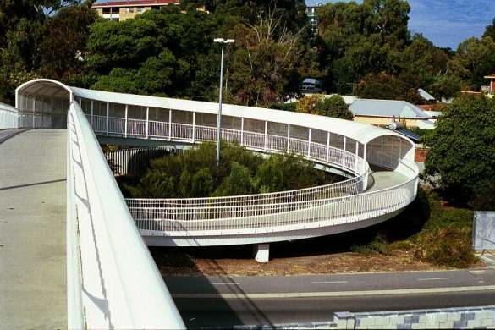
On footbridge-integrated with structure.

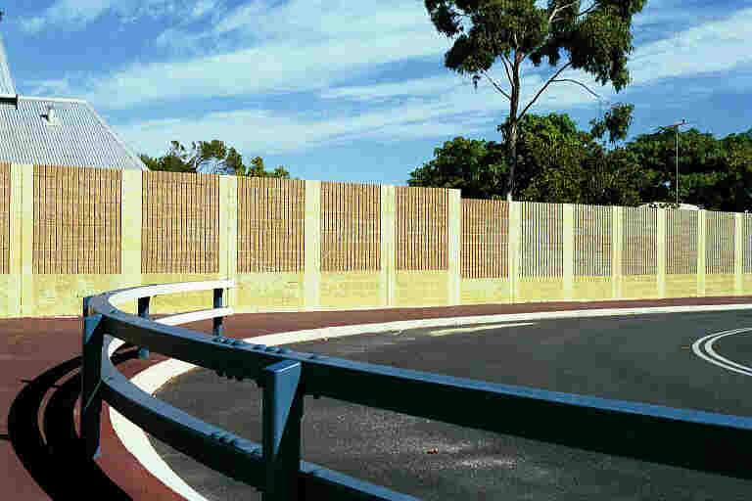
Along road verge-free standing.

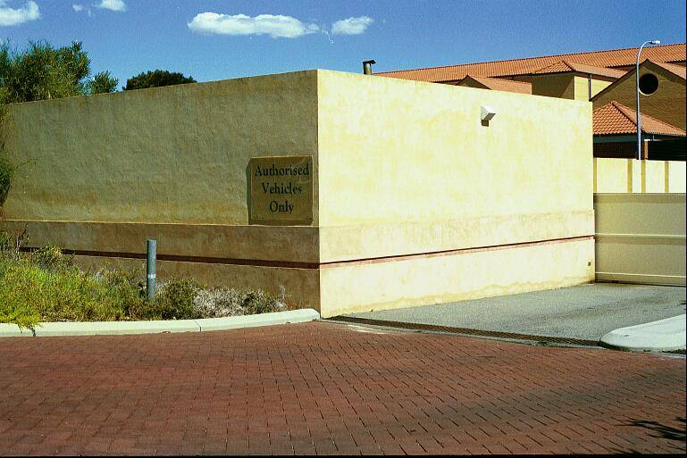

On building - integrated with structure.

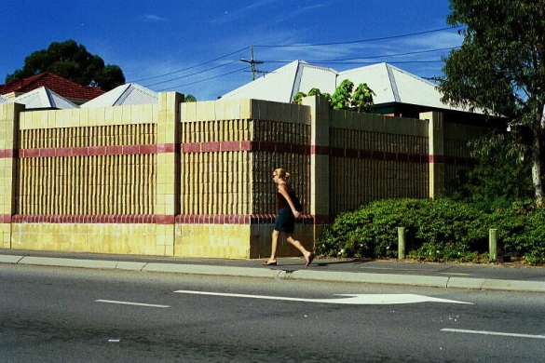
On boundary/property line – extension of fence/wall.

HOW TO ASSESS VISUAL SCREENING REQUIREMENTS
Each project environmental assessment process (EAAP) includes the reporting of potential visual impacts and also identifies likely locations where design measures may be required to mitigate the impacts. The need for visual screens is determined by undertaking a Visual Impact Assessment (VIA) for the road alignment at the design development stage (refer Main Roads consultant brief for Visual Impact Assessment Doc. No. 6707/020).
Details on the placement and design of screens are recorded in the form of a visual screening plan based on:
- Mapping visual intrusion zones within the project area.
- Identifying locations where visual intrusion or visual distractions may occur.
- Determining design details for any required built visual screens additional to noise walls.
The mapping of visual intrusion zones (at a suitable scale) can be prepared once the road and pathway designs (horizontal and vertical) are finalised along with information on site features and levels. Specific locations can then be identified where the position and elevation, relative to the proposed vertical and horizontal alignment of the roadway, paths or road structures, will result in a loss of privacy or amenity or visual distraction for road users.
For the assessment of privacy the visibility is typically measured from a viewing source (located on the road, path or bridge) to an object height of 2.0 m (located at the furthest residence wall facing the viewing source). All angles of vision must be considered. The height of the viewing source is typically measured as follows:
- Highway and ramps and roads with reasonable truck volumes 2.4 m.
- All other roads 2.0 m.
- Shared paths and footpaths (including on bridges) 2.0 m.
Assessment criteria typically includes the distance from the road, path or structure; the visible building wall height; any windows that are visible and; the extent of (side and rear) private living areas that are visible as a result of the new works. Screen walls are typically not required where the residence is located more than 100 m from the viewing source.
For each of the identified locations the height and level of screening required is determined along with design options on the most effective placement, height, extent, materials, colours and surface finishes. Noise walls provide visual screening, but there may be a need for additional screening. Design details are determined on a site-by-site basis as part of the design process for bridges and overpasses, noise walls and landscaping. Options include increasing the height of existing boundary fencing or proposed noise walls, new boundary fencing or new built screens within the road reserve, additional screens forming part of bridges and overpasses.
Preliminary options are documented in a form suitable for use in the consultation process with relevant stakeholders.
Following consultation, suitable visual screens for each of the identified locations are approved and documented as part of the final project design.
Recommended steps in the assessment and design process are provided as appendix A.

Consultation
The need for and form of consultation is determined, in part, by community expectations. When visual screens are determined to be necessary, their design must be acceptable to the local community and the local government authority in terms of appearance, location, height and security.
Where screen walls or fences are located on the boundary of a private property, the materials and the appearance of the screens must be acceptable and approved by the property owner.
Consultation involves decision making on suitable options to allow for a final design.

DESIGN GUIDELINES

Design Criteria
Visual screens must be designed to:
- meet all safety considerations including sightline and setbacks from the driving surfaces;
- provide an effective level of screening as determined in the project assessment;
- minimise maintenance requirements (durability, graffiti resistance and removal, surface finishes, clear access etc);
- complement the appearance of any adjacent noise walls, retaining walls, built features and adjacent vegetation areas;
- match the design life of other structural elements;
- provide a cost-effective solution for the site conditions;
- meet all structural engineering standards and codes (loading, frangibility); and
- minimise loads to existing structures if retro-fitted.

Height of Visual Screens
The actual height of screen walls and their location in the road reserve is determined by the visual screening plan, so as to provide an effective level of screening. In general, screen walls adjacent to residential property boundaries should be a minimum height of 1.8 metres.

Placement of Visual Screen Walls and Fencing
Screen walls and associated footings must be located completely within the road reserve, with effective placement dependent on the projects site conditions. General placements are summarised below, with photographic examples provided in Appendix A.

On Bridge | Along Road verge | On Boundary | On Building (s) (residence)
Integrated with structure | Free standing | Extension of fence/wall | Integrated with structure

Design Options
Design options for visual screens are to be determined according to the specific site conditions. The factors to consider in the design of visual screens are summarised in table 3. In general when determining visual screen design options it is recommended to aim for:
- high design quality with a long life, coarse surface and anti-graffiti coatings that have been found to be the most cost-effective long-term solution.
- locating screen wall footings completely outside the abutting property if situated on the road reserve boundary. Such footings must be designed and situated such that the face of the wall is as close as practicable and parallel to the boundary.
- a compatible screen design to complement the materials and form of any bridge or footbridge it adjoins. Where this is the case the screen design must take into account the bridge aesthetics, the positioning of the screen, the additional design loads and must complement any existing built screens. Compatibility with any existing structures may be a constraint.
- a logical termination point for the start and end of screen fences and walls.
- opportunities to improve the visual quality of all screens in the design process. This should allow for the aesthetic use of materials and surface finishes, eg patterns, colours and textures.

Design Considerations
Decision making on visual screen design should include the following considerations as appropriate for the particular location.

Design needs: | opaqueness/transparency, filtered, , materials, texture, colour(s), height, length, views in and views out.
Effectiveness: | immediate, views from road, bridge, for pedestrians and cyclists, the effective placement is dependant on the relative differences in topography between a source(eg road) and a viewer(eg property).
Compatibility: | with other site structure materials, in colours used and design detailing.
Visual Quality: | need to cater for high design quality, less vandalism and maintenance.
Maintenance: | allow for routine maintenance, immediate cleaning minimises vandalism.
Design Life: | match the design life of other structural elements – reduced costs.
Texture: | the more coarse the texture - the less vandalism and low maintenance.
Vandalism: | provide anti-graffiti coating to all materials.
Cost/Benefit considerations | the acceptable quality of any built screens, the construction costs, vandalism and maintenance costs, design life and replacement costs.

Table 1 General Consideration in the Design Process

Design Materials and finishes
A minimum 50 year design life is recommended for all screen materials, structural design and construction or to match the design life of adjoining structural elements if more than 50 year design life applies.

Solid opaque material(s) such as brick, concrete or stone are recommended. Timber, cement fibro sheeting, metal sheeting and reinforced glass materials may be considered subject to the site requirements.

All built screens must be treated with appropriate anti-graffiti proof coatings as per the manufacturer specifications (refer to Main Roads specifications for anti-graffiti proof coatings
https://www.mainroads.wa.gov.au/BuildingRoads/TenderPrep/Specifications/Pages/900series.aspx).

Subject to compliance with the design criteria, alternative design materials, patterns, heights and locations may be considered.

Where timber is an approved material then only plantation timber which has been pressure treated for protection against vermin and flammability shall be used in visual screens.

Where Reinforced glass and/or other composite manufactured materials is an approved material, then the materials shall satisfy Australian standards for safety to handlers, installers and recipients/users.

The use of paints is usually not recommended in order to minimise the on-going maintenance costs.

The use of painted surfaces may be considered for fibro sheeting or where artistic murals are being proposed on the front or back of the visual screen. For these situations, the mural and all visual portions of the screen are to be treated with appropriate anti-graffiti proof coatings.

Appendix A Definition of Terms

Visual Amenity
For road management purposes visual amenity refers to the scenic values and visual quality of the road reserve and the surrounding environment that makes an area pleasing in appearance and enjoyed by the community as the amenity.
Visual Impact
For road management purposes visual impacts refer to the visual changes that are a result of works undertaken as part of a road project. The impacts may be negative (detraction) or positive (improvement). An assessment can be made of the degree of change or influence such modifications have on a view, scenic values and visual quality or man-made feature.
Visual Intrusion
For road management purposes this refers to the changes, that are due to a road project, which may impact on the visual privacy or the field of view enjoyed by adjoining landholders or users. The relative intrusion impact can be assessed in terms of the distance from the viewer and extent of change within the field of view, the duration of view and frequency (number of viewers).
Visual Screens
For road management purposes this refers to fences, walls or barriers built to ameliorate visual impacts to and from the road reserve. Built screens may be permanent or temporary and free standing or as part of a bridge structure. New vegetation cover established within the road reserve can provide a screening function, over the medium to long term, but this may be lost as a result of clearing, storm or drought damage or senescence.
Visual Quality
For road management purposes visual quality refers to the aesthetics and appearance or visual design of the natural and built elements making up the road reserve, as experienced by the road user, adjoining landholders and the general community.

Appendix B
Recommended steps in the visual screen assessment and design process are shown below in table 2.

Assess Need for Visual Screens | Determine area(s) likely to be impacted  Use approved method of visual impact assessment as part of project environmental assessment and or design process.  Investigate site conditions/constraints relative height, distance and degree of privacy  (views from roadway for cars and trucks, from paths for pedestrians and cyclists, from footbridge overlooking back yards, single and/or group residences, first floor level, side, back, front yard)  Prepare visual intrusion mapping for project area and identify potential impact zones.
Determine Placement | Determine screen locations, extent and height  Define locations that will result in a loss of privacy or amenity or visual distraction for road users.  Define screen location, height and length in relation to residential areas (private/public) and from road/bridge viewing areas.  Ensure extent of screening provides for shifting fields of view.  The field of view for road users will change (relative distance and height) along the road alignment.  Determine noise barrier locations which may affect heights and material options for any additional visual screens.  Define and record required screen locations, extent and height (and noise barriers locations) on the visual intrusion mapping.
Determine Design Options | Identify design options for screen walls/fences.  Design the screen(s) to required height and length to match the level of privacy.  Determine required form and design life (temporary, permanent), free standing, part of existing or new wall/fence/structure.  Determine project cost range for visual screening (cost/benefit considerations).  Select design options (form, height, extent, materials, colours and surface finishes) to meet design parameters.  (Note moderate to high visual quality built screens tend to have less vandalism and lower maintenance costs).  Document design options in a form suitable for consultation process
Consult with Stakeholders | Consult on preferred design options with landholders at screen locations (placement, height, materials and finishes).  Identify and notify landholders as part of project consultation process.  Prepare documentation and presentation materials as required for consultation purposes.
Finalise Design Options | Revise and finalise selected design options following consultation (to match specific landholder’s needs/constraints).  Develop and complete design documentation for screen walls/fences and or extensions.  Prepare and distribute final information to landholders (as required) as part of project consultation process.
Complete design documentation for screens.
Develop and complete design documentation for screen walls/fences and or extensions.
Define requirements for visual screens on noise walls, boundary walls/fencing (and cross reference in design documentation).
Define requirements to accommodate screens in revegetation/landscaping (and cross reference in design documentation).
Prepare Visual Screening Plan report showing locations, special requirements and final design details.
Construct Visual Screen | Implement visual screen requirements as part of project works.
Maintain Visual Screen | Develop and implement maintenance program as required.
Table 2 Visual Screen Assessment and Design Process

