Document No. D12#157580 Issue Date 07/11/13

CORPORATE PROCEDURE

Environmental Guideline

VEGETATION PLACEMENT WITHIN THE ROAD RESERVE

This document is owned and authorised by Executive Director Planning and Technical Services. Enquiries should be directed to the delegated custodian, Manager Environment.

Printed copies are uncontrolled unless marked otherwise

CONTENTS

1. INTRODUCTION 1
1.1 Purpose 1
1.2 Scope 1
1.3 Application 1
1.4 Definitions 1
1.5 Associated References 1
2. vegetation MANAGEMENT within the road reserve 2
2.1 Existing vegetation within the road reserve 2
3. New vegetation placement within the road reserve 4

APPENDIX A

VEGETATION PLACEMENT GUIDES (All diagrams not to scale)

REVISION STATUS RECORD

Revision No. | Revision Date | Description of Key Changes
1 | Jan 2013 | Section 1 and 2 minor amendments
 |  | 1.5 - associated reference list updated
 |  | Section 3 diagrams minor amendments and all references updated.

INTRODUCTION

Purpose
This document provides guidance on the placement of new vegetation within road reserves managed by Main Roads Western Australia (Main Roads).

Scope
The guidance notes in this document set out the recommended setbacks and clearance requirements:
- from all driving surfaces;
- at intersections and crossings;
- from all directional signs;
- from overhead services and paths;
that apply for all revegetation (planting/seeding or transplanting) or landscaping associated with any new road works or remedial roadside works. Guidance on the control of the growth of existing vegetation is contained within other Main Roads documents.

Application
The guideline is intended for use by staff and agents involved in the placement of vegetation within road reserves for which Main Roads is responsible. All new revegetation and landscaping works within the road reserve must conform to this guideline. These requirements are summarised in the diagrams provided as Appendix A.

Definitions
Vegetation Placement
Refers to the lateral clearances and height constraints applied, within the road reserve, on the placement of any vegetation (by seeding, planting or transplanting) relative to the roadway edge, signs, paths, overhead services and other roadside furniture and facilities.
Vegetation Control
Refers to the mowing, slashing of grass and shrubs, the pruning of trees, the spraying of herbicides or the physical removal of existing vegetation within the road reserve. For general guidance refer to Main Roads guideline Vegetation Control (Document no. 67007/045).
Roadside Maintenance Zone (refer to Figure 1)
A zone (of variable width) is maintained on both sides of the roadway to retain clear sightlines and lateral clearances from the roadway and for functional off road drainage. Refer to each regional office of Main Roads for further details requirements within the region.
Clear Zone (refer to Figure 1)
A safety ‘clear zone’ or ‘recovery zone’ adjacent to both sides of the roadway is maintained clear of non-frangible objects, to help reduce the severity of accidents if vehicles run off the road. Restrictions apply for trees and fixed objects within this band of variable width. Refer to Main Roads Supplement to Austroads Guide to Road Design Part 6 and AUSTROADS. (2009). Guide to Road Design, Part 6, Roadside Design, Safety and Barriers.
Conflict Points, Safe Intersection Sight Distance, Sight Triangle
Refer to Glossary of terms in AUSTROADS. (2009). Guide to Road Design.
Crossing Sight Distance
Refer to Main Roads Supplement to Austroads Guide to Road Design Part 6 and AUSTROADS. (2009) Guide to Road Design, Part 4A Unsignalised and Signalised Intersections.

Associated References
The following references are cited in the guidelines.
AASHTO. (2006). Roadside Design Guide.- chapter 6, American Association of State Highway Transportation Officials.
AUSTROADS. (2009). Guide to Road Design,
Part 3, Geometric Design.
Part 4 Intersections and Crossings.
Part 4A Unsignalised and Signalise Intersections.
Part 4B Roundabouts.
Part 6 Roadside Design, Safety and Barriers.
Part 6A Pedestrian and Cyclist Paths.
AUSTROADS. (2009). Guide to Traffic Management, Part 10, Traffic Control and Communication Devices.
MRWA Supplement to Austroads Guide to Road Design Part 6 (online on Main Roads website).
Department of Consumer and Employment Protection. (2000). Guidelines for management of vegetation near power lines.
Main Roads environmental guideline Vegetation Control (Document no. 67007/045).

vegetation MANAGEMENT within the road reserve
Main Roads has the responsibility to manage vegetation within the road reserve for:
- Road safety;
- Protection of road formation and structures and adjacent properties;
- Biodiversity values within the road reserve;
- Roadside amenity values.
The width of the road reserves and roadsides varies across the state network. In rural areas an open channel (table drain) designed to receive road storm water runoff, is usually present adjoining the roadway. Beyond the table drain, the roadside (from a few meters to over 100 meters) extends to the edge of the road reserve and typically contains remnant native vegetation. In urban areas the roadway may be edged with a concrete kerb and road storm water runoff is collected into an underground drainage system. Medians may be present between roadways. The roadside may contain signs and other road furniture, footpaths and other facilities, as well as vegetation.
Functional management zones for vegetation within a typical road reserve are summarised in Figure 1.
Restrictions apply on the placement of vegetation permitted close to road infrastructure to assist in road safety, to help protect the integrity of the infrastructure assets and minimise the on-going need to control vegetation growth and to achieve a suitable level of amenity.
The roadway (the portion of road for use of vehicles) is kept clear of all vegetation.
All roadsides (includes the median where it exists) contain a maintenance zone (of variable width) to retain clear sightlines and lateral clearances from the roadway and for functional off road drainage. Vegetation within the maintenance zone is limited to a height < 200mm to limit the potential for screening of hidden objects that may reduce the capacity of drains and cause damage to the underside of vehicles leaving the roadway. Restrictions apply for all roadside surface treatments. For example road intersections or entry to roundabouts are paved (in part), maintained clear of vegetation, or planted with grass or low ground covers.
A ‘recovery zone’ or safety ‘clear zone’ adjacent to the road (on both sides of the roadway) is also maintained clear of non-frangible objects, to help reduce the severity of accidents if vehicles run off the road. Restrictions apply for trees and fixed objects within this band of variable width.

Existing vegetation within the road reserve
Restrictions apply on the growth of existing vegetation within the road reserve. Refer to Main Roads guideline Vegetation Control (Document no. 67007/045) for general details on vegetation control practices. Also refer to Main Roads regional offices for details of the vegetation control at a specific roadside location within a region.

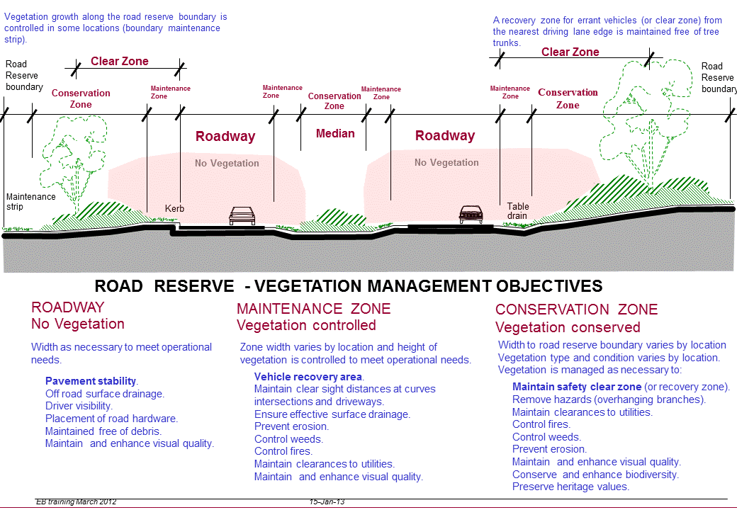
Figure 1 Typical cross section of a road reserve in agricultural regions

New vegetation placement within the road reserve
Lateral setbacks and vegetation height constraints are applied for the placement of any new vegetation (by seeding, planting or transplanting) within the road reserve, relative to the roadway edge, signs, paths, overhead services and other roadside furniture and facilities.

The width of the roadside maintenance zone and the clear zone is nominated by the specific road location within a region.

Vegetation placement requirements are dependent on a number of parameters including the road design speed, road alignment and the roadside batter slopes. An assessment of these parameters must be undertaken to determine the vegetation setbacks and clearances appropriate for a specific location.

Recommended setbacks for trees (or plants with a trunk diameter>100mm) are adapted from the AASHTO. (2006). Roadside Design Guide, chapter 6 and the Main Roads Supplement to AUSTROADS Guide to Road Design Part 6 (online on Main Roads website, http://www.mainroads.wa.gov.au/Standards and Technical/Roads and Traffic Engineering/ Roadside Items/ MRWA Supplement to Austroads Guide to Road Design Part 6).

All planting/seeding or transplanting of vegetation within the road reserve must conform to the diagrams (not drawn to scale) in Appendix A.

APPENDIX A

VEGETATION PLACEMENT GUIDES (All diagrams not to scale)

VPG1 Vegetation placement guide for verges and medians............................................ 6
VPG2 Vegetation placement guide for intersections and crossings.................................. 7
VPG3 Vegetation placement guide along curves in road………………………………… 8
VPG4 Vegetation placement guide for roundabouts…………………………………….. 9
VPG5 Vegetation placement guide for sight clearance to road signs…………………. 10
VPG6 Vegetation placement guide near roadway lighting ………………………………. 11
VPG6 Vegetation placement guide near Principal Shared Paths……………………….. 11
VPG7 Vegetation placement guide near overhead power transmission lines………… 12

