Document No. D13#550462 Issue Date 01/08/2014

CORPORATE DOCUMENT

Environmental Template

REVEGETATION PLAN

This document is owned and authorised by Manager Environment. Enquiries should be directed to the delegated custodian, Principal Environment Officer Policy.

REVISION STATUS RECORD

Revision No. | Revision Date | Description of Key Changes
0 | 04/10/2013 | Document creation.
1 | 01/08/2014 | Update to meet DER revegetation plan requirements and guidelines. Inclusion of Main Roads’ Central Review and Submission Process, update to document application, mapping and completion criteria. Inclusion of stakeholder consultation table and provision for stakeholder consultation within the Appendix. Revegetation Plan Checklist included as part of the appendices. Removal of references to project revegetation, regional revegetation plans and revegetation for non-statutory purposes. Minor formatting changes.

ABOUT THIS DOCUMENT

This template has been developed to provide assistance with preparing a Revegetation Plan (RP) for an area requiring revegetation under Main Roads WA (Main Roads) state-wide purpose clearing permits or project specific clearing permits. The two purpose clearing permits issued to Main Roads, CPS 818 and CPS 817, require regeneration and revegetation actions to be undertaken in accordance with permit conditions. This document includes details regarding the monitoring required as part of implementation of the RP. Forms which may be used to capture the revegetation activities undertaken are provided in Appendices A through to C. A detailed table outlining revegetation management actions and timeline for completion is provided in Appendix E.

This template may also be used to detail and implement planned revegetation activities included outside of CPS818 or CPS817 requirements. This template can likewise be used to produce a RP for project specific permits that require revegetation activities and for offsets involving revegetation activities.

The document will require editing to meet the individual requirements of each site. Advisory comments are included within this template and are shown as:
Red italics - guidance notes to be read and deleted.
Blue non-italicised - add relevant information, choose one of the selected options or provide information on the results once a task has been completed. Remove blue text or keep text and change font colour to black as relevant. If it was determined that the specific aspect is not relevant, this should be stated.
Black non-italicised - standard report information that should not be deleted.

The first four pages of this document should be deleted once the template has been completed. Update the revision number and author/reviewer details on page four and change the footer so that it is relevant to the current report. For advice in preparing the RP, please contact the Environment Branch.

Application

The RP template should be used by Main Roads employees for projects that require revegetation to be undertaken as part of compliance with the conditions of Main Roads’ State-wide purpose clearing permits CPS 818 and CPS 817 or a project specific clearing permit. Revegetation activities must be conducted in accordance with the final RP and monitoring undertaken to determine the success of the revegetation. A copy of the final RP must be sent to the Department of Environment Regulation (DER) for approval, through the Main Roads’ Central Review and Submission Process (CRSP) prior to clearing as part of the requirements of CPS 818. When native vegetation clearing is undertaken using CPS817 the RP should be submitted to the DER either prior to or during or immediately after native vegetation clearing. When clearing is undertaken using CPS817, the RP does not require approval by the DER prior to clearing. The Revegetation Plan Checklist provided in Appendix F should be completed by the author of the RP once the plan is finalised.

When the RP is required for compliance with CPS818 or CPS817, the completed Revegetation Plan Checklist and RP should be submitted to Main Roads’ Principal Environment Officer Operations (PEOO) as required as part of the CRSP. The RP and associated documents should be provided directly to Main Roads’ PEOO for central review via 818clearingpermit@mainroads.wa.gov.au. The PEOO will submit the RP to the DER for approval.

As part of compliance with the conditions of CPS818 and CPS817, an RP is not required when the area to be revegetated or rehabilitated is:
- 0.5 hectares or less,
- not located in an Environmentally Sensitive Area,
- is either not or not likely to be at variance with all of the ten clearing principles identified in Schedule 5 of the Environmental Protection Act (1986).

These areas will still require revegetation or rehabilitation as required for best practice environmental management.

Related Main Roads Documents
The Revegetation Plan must be developed having regard to the following Main Roads documents:
Revegetation Planning and Techniques Guideline,
Revegetation Topsoil Management Guideline,
Vegetation Placement Within the Road Reserve.

Related Environmental Guidelines

The Department of Environment Regulation guideline:
A guide to preparing revegetation plans for clearing permits.

REVEGETATION PLAN

<Insert Project Title>

<Insert Month Year>

Printed copies are uncontrolled unless marked otherwise

TRIM Document Number | D--#----
Project Manager | <insert name of PM>

Report Compilation and Review | Name and Position | Document Revision | Date
Author: | <insert name>  <insert position eg. Environment Officer> | Draft v1 | <Day/Month/Year format>
Reviewer: | <insert name>  <insert position eg. Senior Environment Officer> |  | <Day/Month/Year format>
Author: | <insert name>  <insert position eg. Environment Officer> | Rev 0 | <Day/Month/Year format>
Reviewer: | <insert name>  <insert position eg. Senior Environment Officer> | <insert additional rows as needed>

CONTENTS

Revegetation Summary 8
1. Road Project Description 9
1.1. Purpose 9
1.2. Proposed Road Project Activities 9
1.3. Revegetation Requirements 9
2. Road Project Location 9
3. existing Environment 11
3.1 Project area 11
3.2 Revegetation area 11
4. location of revegetation Area/<AREAS> 11
5. OBJECTIVE 13
6. Implementation Plan 13
6.1. Pre-clearing vegetation assessment 13
6.2. Site preparation 14
6.3. Species selection 14
6.4. Vegetation establishment 15
6.5. Weed Control 15
6.6. Dieback Management 16
7. completion criteria 16
Table X – Completion criteria including species diversity, plant density, composition, structure and weed cover. 17
8. monitoring 18
9. revegetation timeline 18
10. contingency measures 18
11. Stakeholder Consultation 19
Table X – Stakeholder Consultation 19
12. Reporting 19
13. Responsibilities 19
Table X – Responsibility for Revegetation Activities 19
14. References 20
appendix A Pre-Clearing Vegetation Assessment 21
appendix B Plant SPECIES LIST 22
Appendix C Target plant species list for revegetation 23
Appendix D Stakeholder Correspondence 24
Appendix E Management Action Timeline 25
Appendix F Revegetation Plan Checklist 28

Revegetation Summary

Revegetation location(s): <insert road name, section, suburb/town, SLK start and finish, local government authority>.

Revegetation area: <insert amount in XX hectares>.

Revegetation purpose:
For example:
- approval condition (CPS 818/11) to revegetate areas cleared for temporary works, or
- revegetation works are a part of an offset proposal for <insert project name>, or
- revegetation works are not required by statutory purposes and are a part of a regional revegetation plan or additional revegetation works associated with a project.
- Other….specify the purpose.

Revegetation objective:
For example:
To enhance the ecological value of the site by rehabilitating areas that are completely degraded (Keighery, 1994) or to offset and /or conserve vegetation values similar to that lost due to the <insert project name > clearing requirements.

Key outcomes of the revegetation plan:
- List the aims of the revegetation ie what are the main environmental values being targeted (fauna habitat, riparian vegetation, remnant vegetation etc).
- Revegetation works will consist of X ha of direct seeding and X ha of direct planting.
- Date revegetation works are expected to begin and target completion date.
- List any constraints to the revegetation (budget / timeframe / seed unavailability etc.).
- List if there other approvals required (land access etc.).
- List who will manage the revegetation site after completion criteria met.
- List any other key aspects that the reader would find useful in a summary.

Road Project Description

Purpose
Provide a brief summary of what is needed as part of implementation of the road project. What does the road project involve? Why is the road project necessary? Describe the expected outcome of the project. Use the summary of the road project from the PEIA/EIA report where appropriate.
For example:
‘The road project involves widening and sealing the shoulders of the Northam-Cranbrook Road to improve road user safety. The road upgrade project is also necessary to ensure the road complies with current Australian Standards’.

Proposed Road Project Activities
Describe the full extent of the proposed works; include all the components of the proposal such as access tracks, material pits, connecting roads, etc. How many hectares are being cleared? Insert relevant information from the PEIA/EIA report where appropriate.
Note: the amount of clearing to be undertaken in hectares is needed if revegetation or an offset is required as part of project clearing when CPS818 or CPS817 is used.

Revegetation Requirements
Describe why revegetation is required.
For example: ‘Revegetation is required as part of project activities and to fulfil the requirements of Section 13(a) of Main Roads Statewide Clearing Permit CPS818/11’.
Refer to the permit conditions the revegetation activities are meeting. For example:
- Condition 13 (a) of CPS818/11 for temporary works; or
- As an offset for Condition 13 of CPS818/11 utilising the Department of Environment Regulation’s offset calculator; or
- Revegetating within 28 days of clearing for an unplanned event under Condition 10 of CPS817/5, etc.
Outline what will occur following the end of the 5 year revegetation monitoring period on MRWA land or other lands. For example:
Revegetation of the project will commence in 20xx. Following a minimum of 5 years revegetation establishment and active monitoring, management of the revegetation site will be handed over to the <insert name of vesting authority eg Shire of Port Hedland or DER> for the purpose of <insert purpose eg conservation, regional open space> or management of the site is retained by Main Roads. This is dependent on completion criteria being met after 5 years.

Road Project Location
The road project clearing area is located on XX road, section or Lot No, suburb/town, SLK start and finish and local government authority.
MGA reference:
Latitude:
Longitude:

The road project area is shown in Figure 1:
Each Figure to be full page, be legible, of a suitable quality and include a legend and grid.
<insert Figure, then Figure title>

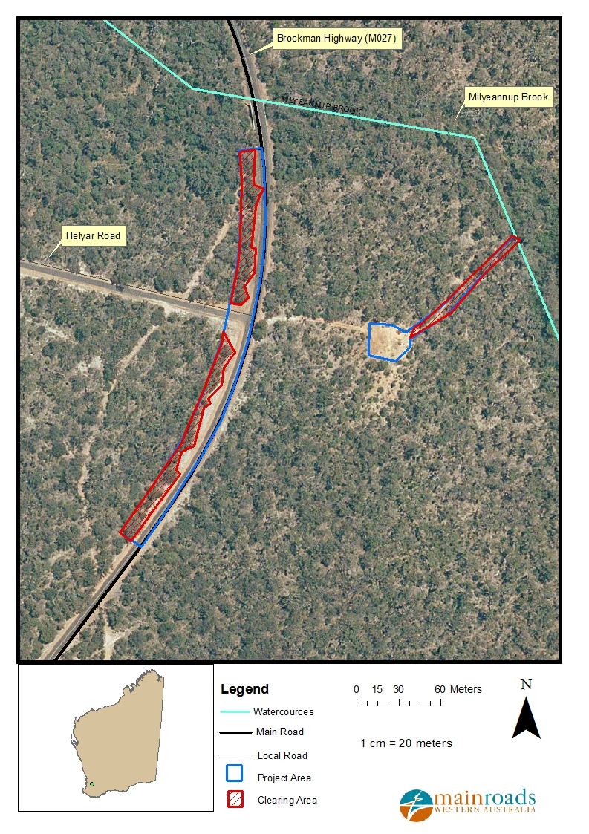

Figure 1 – Road Project Area – showing area/s of vegetation to be cleared. <amend as appropriate> <Note: The DER requires a map showing cleared areas and this may be different to the project area. For eg. The project area may include both sides of the road; however clearing will only be undertaken on the RH side of the road as the LH side of the road contains previously cleared areas. Or clearing may only be required in specified areas as parts of the project area contain permanently cleared areas. This information is important to identify on Figure 1 and will assist in the preparation of Figure 2 (Revegetation Areas). When using CPS818 or CPS817, temporarily cleared areas require revegetation whereas permanently cleared areas do not require revegetation>.

existing Environment

3.1 Project area
Provide a description of the vegetation that is being cleared (type, extent and condition using Keighery (1994). Use the best information available – survey data if possible. If not, then site visit and desktop assessment results from the PEIA/EIA and PCIA/CIA reports. Provide context by describing the vegetation existing around the revegetation area.

Provide a brief description of vegetation representation, e.g. Beard vegetation is < 30% and local area (10km radius) is highly cleared with less than 30% remaining vegetated.

Provide a brief description of soil type, topography and other relevant attributes.

3.2 Revegetation area
Provide a general description of the area to be revegetated; what is its site history and current land use? What is its adjoining land use? Are there physical site factors that need to be addressed (e.g. soil compaction, erosion, salinity, etc). What is the access to the site? Will there be limitations in terms of access to the revegetation area or land zoning? List any potentially limiting factors for the revegetation (eg. soil type, dieback, weeds, compaction, feral animals etc) Provide details of the land tenure / ownership / vesting / zoning of the revegetation land.
<Insert the vegetation condition of the revegetation area using Keighery (1994) if this area is to be used for the purpose of an offset>

location of revegetation Area/<AREAS>
Describe the location of the revegetation area(s) <revegetation area(s) are within xxkm radius of the project area and/or Lot No.xx or describe parcel of land if revegetation is required for the development of an Offset Proposal>. If the revegetation area is not located within or near the road project area, clearly describe where revegetation will take place.
Include which side of the road (N, S, E or W) and all SLK ranges.
Provide an estimated of the centre point of the revegetation area(s):
Latitude:
Longitude:

Note: An ESRI shapefile of the revegetation area is required as part of reporting conditions of CPS 818 and CPS 817. The ESRI shapefile of the revegetation / offset area will need to be submitted with this RP as part of the Main Roads CRSP process and then provided to the DER. Although the requirement for an ESRI shapefile is not specified in either CPS818 or CPS817, this is recommended to facilitate the assessment of the RP and revegetation area by the DER.

The revegetation area <areas> is<are> shown in Figure 2. <amend as appropriate>
Each Figure to be full page, be legible, of a suitable quality and include a legend and grid.
<insert Figure, then Figure title>

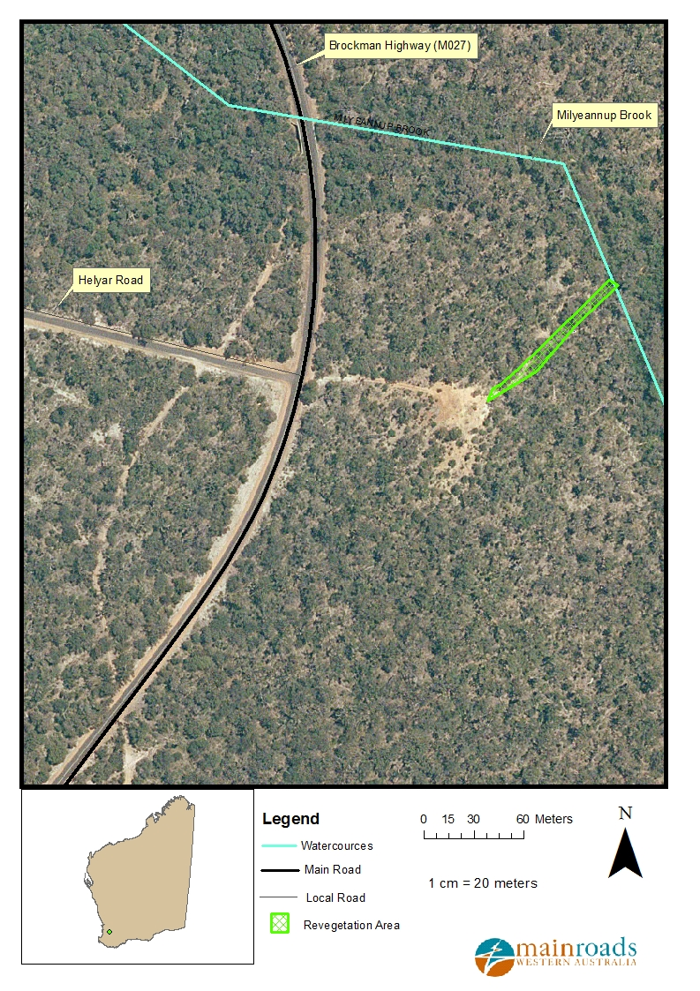

Figure 2 – Revegetation Area(s).

OBJECTIVE
State the objective of the revegetation. For example:

‘To re-establish vegetation values similar to those lost due to the construction of the New Perth-Bunbury Highway at Lot 200 and to establish an ecological corridor between the Harvey River Reserve and the Clifton MPA. Revegetation of Lot 200 will improve the condition of vegetation from degraded to a good condition’.

The Revegetation Plan is required for:
- Roadside stability and maintenance minimisation,
- Conservation and biodiversity,
- Rehabilitating temporarily cleared areas,
- Amenity (shade, shelter, etc),
- Safe and efficient road transport network,
- Roadside safety objectives,
- Resilient and self-sustaining vegetation
- Other (combination of the above).

Consider the desired outcome and how adjoining land use will impact on the revegetation, for example;
- to match the surrounding vegetation,
- to replace existing vegetation prior to clearing,
- to enhance the habitat targeted to a species (eg. XX number of Black Cockatoo habitat trees (Marri, Jarrah and Salmon gums required for Black Cockatoo habitat), XX grams of Peppermint Tree seed for Western Ringtail Possum habitat).

Revegetation projects will be completed using initiatives to provide safe roads and roadsides and enhance road infrastructure improvements. Vegetation will be appropriately placed within the road reserve in accordance with Main Roads Environmental Guideline, Vegetation Placement Within the Road Reserve (Document No. 6707/022).

If the Revegetation Plan is being used as part or all of an offset proposal then also state how the plan addresses the Clearing Principle(s) being impacted.

Implementation Plan
To meet the objective of <insert name of project revegetation activities/revegetation plan> the following rehabilitation approach will be implemented.

Pre-clearing vegetation assessment

Prior to native vegetation clearing commencing a preliminary survey (via quadrats, transects and / or photo point monitoring) must be undertaken on site to enable realistic and justifiable completion criteria to be determined. The survey should focus on determining the broad vegetation condition and vegetation structure, quick counts of species composition and estimate of the percentage of weed cover present. This data can then be used as a baseline and to determine and justify the nominated completion criteria in section 7.

<Insert details of what occurred as part of the pre-clearing vegetation assessment and present photos in Appendix A>

Explain how you undertook the preliminary survey, for example;
Prior to clearing commencing two 10m x 10m quadrats/hectare were set up and surveyed. The broad vegetation condition and vegetation structure was determined, a quick count of species composition and estimate of the percentage of weed cover present done on site. Photo points at each quadrat were also taken. Vegetation was considered to be in good condition (Keighery, 1994). This data has been used as the baseline to determine and justify the nominated completion criteria in section 7.
OR
Prior to clearing commencing one 100m transect/km with 2m x 2m quadrats evenly spaced 10m apart were set up and surveyed. The broad vegetation condition and vegetation structure was determined, including a quick count of species composition and estimate of the percentage of weed cover at the site. Photo points at each quadrat were also taken. Vegetation was considered to be in good condition (Keighery, 1994). This data has been used as the baseline to determine and justify the nominated completion criteria in section 7.
OR
On-site surveys were unable to be undertaken but representative site photos were taken to enable an estimation of broad vegetation condition and vegetation structure, counts of species composition and the percentage of weed cover present. This data has been used as the baseline to determine and justify the nominated completion criteria in section 7.

Site preparation

Provide relevant details such as removal or respreading of spoil, respread of topsoil and mulch. Is ripping / ploughing / mounding needed? – where, how, when, depth, width of rip lines etc? Detail all earthworks which need to be undertaken prior to the commencement of revegetation activities. Will earthworks be required to address rubbish or weed infestations prior to seeding/planting?
Does the site require contouring to manage surface water runoff? For eg; Material pit edges will be battered down and the slope of the site should drain naturally into the surrounding environment without any potential of ponding of surface water or erosion to occur.
Does the soil require amendment if so what type? Does the soil require improvement (eg fertiliser/nutrient enrichment or natural mulch application?).
What weed control will be employed as part of seedbed preparation? Is an initial herbicide treatment required to control weeds – where, how undertaken, with what herbicide and when?
Will the site be fenced to prevent stock access?

Species selection

Identify how you developed the species selection list, for example undertaking a site visit and preliminary survey, biological survey or NatureMap Mapping Database
Include consideration for sourcing seed from local provenance (within 50-100km) stock as first preference.

A list of plant species identified in the vicinity of the road project area (XX km radius of the clearing / revegetation area, etc) is provided in Appendix B. The species were selected to represent comparable vegetation to the <cleared vegetation with in the project area> OR <surrounding vegetation>. The list includes the major species identified <from Beard’s vegetation association, during the site visit> OR <using a XXkm radius on NatureMap>.

Using this information as a basis, research was undertaken to produce a suitable target seed species mix and/or variety of seedlings endemic to the area that could be provided by local nurseries.
OR
To address Clearing Principle(s) ‘x’ representative species of xx were included in the species selection.
OR
To replace vegetation cleared for temporary purposes, representative species of xx were included.

If the area that is being revegetated is different to the vegetation that is being cleared explain why you have chosen to revegetate a different vegetation type to what has been cleared. Provide further information about species selection if available (eg; selected wandoo and salmon gum tree species for Carnaby’s Cockatoo breeding habitat or Banksia species for Carnaby’s Cockatoo feeding habitat etc.).

Tubestock and seed will be obtained from <insert details of nursery/seed supplier>. The target plant species list determined for this revegetation plan is provided in Appendix C (or as a separate attachment if a large document).

Note: minor changes to the approved species list or number may occur at the last minute due to seedling death or unavailability of stock, substitutions to the species list may therefore occur. If substantial substitutions occur, the species list in the Plan will be amended with a summary of the reasons why species list had to be changed. The modified Revegetation Plan will be provided to DER as per condition 11(h) of CPS 818.

OR

For the northern and eastern regions with variable rainfall patterns (Kimberley, Pilbara, Goldfields-Esperance) species selection is not required at this stage as the revegetation method is the respread of topsoil and stockpiled vegetation only. Species selection will be undertaken as a contingency measure if the regeneration resulting from the respreading of topsoil and stockpiled vegetation does not meet the completion criteria.

Vegetation establishment

What activities will be conducted to achieve vegetation establishment? Will plants be irrigated to achieve vegetation establishment or will supplementary irrigation be needed in dry periods?
Include revegetation through natural regeneration – describe why and how this method will be used.
Example:
The revegetation area is in the <choose one northern or eastern region of WA> and has a variable rainfall pattern. Given this the vegetation establishment method is the respread of topsoil and stockpiled vegetation only. The topsoil and stockpiled vegetation will be respread evenly across the revegetation area etc.

For the relevant regions, include information on seedlings planted in month(s)/year at density of xx stems / hectare OR direct seeding in months(s)/year at a rate of xx kilograms of seed/hectare. (State whether a combination of planting and direct seeding will occur).
Describe any pre-treatment of seed that may be required, if relevant.

If initial vegetation establishment is not successful, contingency measures will be implemented and these are outlined in Section 10; Contingency Measures.

Weed Control

The following steps will be taken to minimise the risk of introduction and spread of weeds as per the site Hygiene Management Plan:
- All machinery, plant and equipment shall be free of soil and vegetative matter prior to entering and leaving the site.
- Imported soil or mulch shall not be weed-affected.

Note: if a Hygiene Management Plan is prepared, include this as part of the appendices.
Provide details of the weed control methods, locations and timing to be employed to manage weeds.
Initial weed control will be undertaken during site preparation. Additional weed control will only be completed if the follow up monitoring indicates that the weed control completion criteria are not being met. This follow-up weed control will predominantly be undertaken using Glyphosate / Simazine in approximately <insert month> when any germination has occurred. Application of other appropriate herbicides will occur, dependent on weed types present.

Should any declared plants or environmental weeds occur in the vicinity of the project area, monitoring and control activities specifically targeting these species will be undertaken.

A herbicide application record sheet will be completed and recorded for all herbicide treatment operations. Refer to TRIM Document D13#550469.

Dieback Management

The project area receives less than 400 mm average annual rainfall and as such, dieback is not considered to be an issue. Hygiene measures will be implemented to manage and prevent the potential introduction of pathogens including dieback into revegetation areas.

OR

The project falls within the rainfall zone in which dieback may occur. Hygiene measures will be included in the project Dieback Management Plan <or insert Environmental Management Plan> to reduce any possible spread if the disease is present which includes:
- All machinery, plant and equipment shall be free of soil and vegetative matter prior to entering the road reserve and when leaving the site,
- No entry will be permitted to vegetated areas outside of the road reserve boundary,
- The movement of soil shall be avoided in wet conditions,
- Road building materials or mulch provided from offsite areas and used in the revegetation area must be sourced from locations uninfested with dieback,
- The movement of machines and other vehicles will be restricted to the limits of the extent of the revegetation area.

If movement of soils is necessary in conditions other than dry conditions, a dieback management plan must be developed in consultation with the Department of Parks and Wildlife (DPaW). The dieback management plan will need to be implemented and adhered to. Provide a copy of the dieback management plan in the appendices of this template.

completion criteria
In many cases Main Roads is aiming to replace what was temporarily cleared. To facilitate this, where possible, completion criteria are to be based on the pre-clearing vegetation assessment. This enables the completion criteria to be justifiable.

Completion criteria include species diversity, density, composition, structure and weed cover are outlined in Table X. Performance against the completion criteria targets will determine if contingency measures are required. Completion criteria must be consistent with the SMART principles outline below;

Specific: what will be achieved is clearly defined.
Measurable: is there a way of measuring what will be achieved?
Achievable: is the objective realistic given the resources available?
Relevant: is the objective relevant to the vision for the revegetation?
Time-bound: is there a realistic and feasible time by which the objective is to be met?

Set the completion criteria by defined zones within the area if necessary. Create this table for each cell or zone in the revegetation area if there is likely to be significant variability across the site.

Justify targets used, for example no over storey vegetation (ie. no trees) in areas of the road reserve for the purpose of promoting road safety. The use of frangible vegetation is necessary in the road reserve. When revegetating grassland or heathland vegetation types, the structure may not feature an overstorey as it will be dominated by under or mid-storey.
Take into account if the revegetation is being done through topsoil and stockpiled vegetation spreading. State whether revegetation is being done through planting tube stock (number of plants) or by direct seeding (the weight of seed in g/ha).

Table X – Completion criteria including species diversity, plant density, composition, structure and weed cover.
Criteria | Target for 20xx (allow for min 5 years) | Justification of Target
Species diversity | <insert total no. of species, no. of species per hectare>  e.g. total of xx species, xx% of species list with a minimum composition of x native species per monitoring quadrat. | Insert justification for determining the completion criteria target for each of the criteria. e.g. The species diversity target for revegetation was chosen to correspond with the pre-clearing vegetation or surrounding vegetation.
Plant density | <insert no. of stems per hectare or % coverage of native plant species within X no. of years planting/seeding>
Plant composition | <insert details of species composition, evenness and abundance>.  eg. Vegetation representative of Banksia woodland.  e.g. native species consistent with mapped Beard vegetation association/type XX after XX years (Shepherd et al, 2001).
Structure | <insert 10-30% understorey, 40-80% midstorey, 10-30% overstorey>  e.g. 20% over storey, 70% mid-storey, 10% understorey
Weed cover | e.g. < 30% coverage.
<insert project specific criteria eg.  Cockatoo habitat trees> | e.g. Total of 20 Carnaby’s Cockatoo breeding trees, consisting of X no. of Eucalyptus calophylla and X no. of Eucalyptus rudis trees. | e.g. Project specific completion criteria were set to meet the pre-clearing vegetation assessment. The project activities required the removal of 20 Carnaby’s Cockatoo breeding trees.

Table above may be amended as required; however, all five completion criteria must be addressed as a minimum. Remove final row, if not required. Additionally targets can be set for individual years or as one off targets for completion for the entire period of the revegetation plan (eg: Fencing to be complete within 6 months of initial plating or 3 nesting hollows installed per hectare within 1 year of initial planting occurring or 50% weed cover first year 40% second and 30% third etc) not just the final year target.

monitoring
It is a DER requirement that a minimum of 5 years is required for monitoring and maintenance of revegetation activities.

Monitoring of the revegetation area will determine if completion criteria have been achieved and if contingency measures are required. The methodology for monitoring will involve onsite visual assessment/s to determine whether revegetation has been implemented as planned and that completion criteria have been met as outlined in Table X. The parameters that will be monitored to verify revegetation success include: species diversity, vegetation density, vegetation composition, vegetation structure, weed cover and any additional site specific criteria.

Provide details of monitoring methodology e.g. Include the number and timing of on-site visual assessment to be completed, the number of photo monitoring points and their location, number and location of quadrats/transects and a justification of the position of monitoring quadrats/transects. Include the timing of proposed monitoring. The layout of the representative plots must be appropriate to assess the shape of the revegetation area and the type of vegetation.

To assess if the project completion criteria have been met (Table X), vegetation assessments will be undertaken. This will be undertaken using <quadrat / transect and/or rapid assessment methods>. The quadrat/transect sites have been selected to ensure that at least one quadrat/transect occurs in each major vegetation type in the revegetation area. <Given that the revegetation area has a long linear nature the quadrat/transect locations were determined to be at the northern / eastern / southern / western / centre extents>. This ensures effective and representative sampling will be undertaken.

Monitoring of <insert number> quadrats will be used to assess the progress of revegetated area in meeting the completion criteria targets (Table X). The revegetation area will be monitored <insert number times per year> for a period of 5 years following the initial <seeding /planting/ regeneration>. Monitoring will be undertaken during <insert time of monitoring i.e. spring, summer etc.>. Photo point monitoring will also be completed during monitoring and will be taken from the <insert location, e.g. northwest> corner of each quadrat.

Where completion criteria are not met the appropriate contingency measures will be undertaken as outlined in Section 10; Contingency Measures.

Monitoring will be recorded in Main Roads “Revegetation Monitoring Form” (available from iRoads online documents section).
If the Revegetation Monitoring Form will not be used, delete this statement and provide relevant details on how monitoring will be recorded.

revegetation timeline
Details outlining the revegetation activities and a proposed timeline have been prepared for the <insert name of revegetation project>. Appendix E provides an outline of management actions and the timeline for implementation.

contingency measures
Where monitoring provides information that the completion criteria (identified in Section 7) are not being met then the following contingency measures will be undertaken, until the completion criteria are met: (for example)
- If the target Species Diversity and Plant Density criteria are not met then infill planting/seeding will occur during the next planting season (generally around June/July of each year) to ensure a density of xx stems/ha.
- If Plant composition criteria are not met then specific species will be infill planted / seeded during the next planting season.
- If Structure criteria are not met then infilling with desired species will be conducted during the next planting season.
- If weed cover is not met then herbicide will be applied to affected areas in June/July <insert year> and November/December <insert year>.
- If the target Species Diversity and Plant Density or Plant Composition criteria are not met then a species selection list will be developed and the areas will be planted/seeded during the next planting season.

Stakeholder Consultation
Details of stakeholders who were consulted during the preparation of this RP are provided in Table X. <Correspondence relevant to the preparation of this RP is included in Appendix D.>

Table X – Stakeholder Consultation
Name of Stakeholder | Organisation | Comments | Consultation Date
 |  |  | (day/mth/yr)

<Provide details of further stakeholder consultation that is required prior to implementation of the RP, if relevant>.

Reporting
A revegetation activities and site assessment report outlining the revegetation activities and results of the monitoring for the revegetation sites will be prepared annually. <Revegetation activities undertaken as part of CPS818/CPS187 are required to be submitted to DER by 30 June each year for revegetation activities undertaken during the period 1 January to 31 December the preceding year.>

Responsibilities
<Provide details of the role of Main Roads’ employees and contact details of the person responsible for implementation of the revegetation plan, monitoring and reporting of actions in the table below>.

Table X – Responsibility for Revegetation Activities
Role | Actions Responsible For | Contact Name and Details
Regional Environment Officer | Revegetation implementation, record keeping and internal reporting | e.g. EO Name and Phone Number or Email Address
Roadside Vegetation Maintenance Officer | Monitoring revegetation works and undertaking contingency measures
Manager Environment | Reporting externally (completed through annual reporting of CPS818)
Project Manager | Transfer of land ownership, machinery operation.
Insert Others as required | Define action responsible for

References
Department of Environment and Conservation. (2013). NatureMap: Mapping Western Australia's Biodiversity. Department of Environment and Conservation. Accessed <insert date> from: http://naturemap.dec.wa.gov.au/

Department of Environment Regulation. (2013). A guide to preparing revegetation plans for clearing permits under Part V of the Environmental Protection Act 1986. Department of Environment Regulation, Perth, WA. Retrieved from: http://www.der.wa.gov.au/images/documents/your-environment/native-vegetation/Guidelines/A_guide_to_preparing_revegetation_plans_for_clearing_permits.pdf.

Government of Western Australia. (2013). 2013 Statewide Vegetation Statistics Incorporating the CAR Reserve Analysis (Full Report), Current as of June 2013. Department of Parks and Wildlife, Perth, WA.

Keighery, B. J. (1994). Bushland Plant Survey: A Guide to Plant Community Survey for the Community. Wildflower Society of WA (Inc). Nedlands, WA.

Main Roads WA. (2003). Environmental Guideline, Vegetation Placement Within the Road Reserve. Document No. 6707/022. Main Roads WA, Perth, WA.

Main Roads WA. (2004). Environmental Guideline, Revegetation Planning and Techniques. Document No. 6707/031. Main Roads WA, Perth, WA.

Main Roads WA. (2013). Environmental Guideline, Revegetation Topsoil Management. Document No. 6707/053. Main Roads WA, Perth, WA.

Shepherd, D. P., Beeston, G.R., and Hopkins, A. J. M. (2001). Native Vegetation in Western Australia, Technical Report 249. Department of Agriculture, South Perth, WA.

appendix A Pre-Clearing Vegetation Assessment
<Note: Main Roads should supply site photos if possible (eg. Photos of pre-clearing vegetation condition will assist in the assessment of completion criteria for revegetation activities. Remove Appendix A, if not required.>

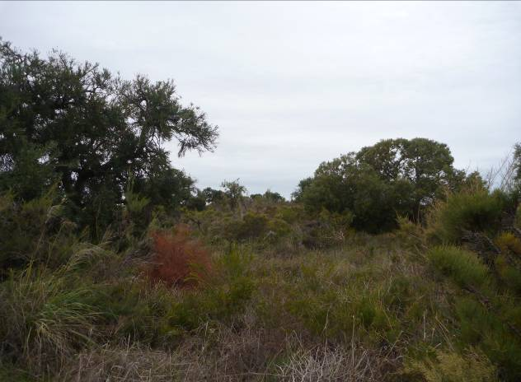 | 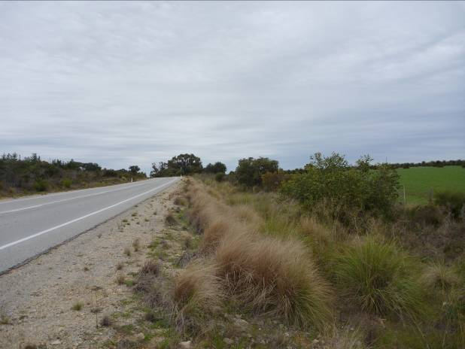
Photo 1. Looking north in Passing Lane 1. Area in predominately excellent (Keighery, 1994) condition. Area represents Banksia woodland consisting of Banksia attenuata, Banksia sessilis (parrot bush), Eucalyptus todtiana (blackbutt), Macrozamia riedlei, Acacia pulchella (prickly moses), and Petrophile and Xanthorrhoea species. Limited weed presence. | Photo 2. Looking south in Passing Lane 2. Area in completely degraded (Keighery, 1994) condition. Scattered Eucalyptus todtiana (blackbutt) trees. Understorey includes Petrophile species. Heavy weed presence.

appendix B Plant SPECIES LIST
DEC NATUREMAP PLANT SPECIES LIST
Search: xxkm radius of coordinates xxE xxS for Kingdom Plantae

Appendix C Target plant species list for revegetation

Quantity is by tubestock numbers or seed weight
Species Name | Quantity (Specify no.’s or g) | Type (overstorey, midstorey or understorey) | Species Name | Quantity (no.’s or g) | Type (overstorey, mid or under) | Source
Acacia acuminata | 41 | Mid | Eucalyptus orthostemon | 164 | Overstorey | ABC nursery
Acacia erinacea | 205 | Mid | Eucalyptus salicola | 164 | Overstorey | XYZ seed supply
Etc.
 |  |  | TOTAL no. seedlings | 5000

Appendix D Stakeholder Correspondence

Insert copies of correspondence with relevant stakeholders undertaken as part of the preparation of this RP. Include letters from stakeholders or concise email correspondence. If no correspondence was undertaken, remove this appendix and update the TOC on page 8. Be sure to adjust the letters corresponding to each Appendix accordingly.

Appendix E Management Action Timeline

Management actions outlined in Table XX will be undertaken, where appropriate and required, for the revegetation site.

Adjust table contents and remove sections if not applicable.

Table XX: Management actions for <revegetation plan name>
Topic | Action | Responsibility | Timing
Pre-clearing vegetation | Conduct a preliminary survey (via quadrats, transects and / or photo point monitoring) to determine vegetation baseline data to assist with completion criteria development. | Environment Officer | Month / year
 | Develop species selection list | Environment Officer | Month / year
 | Arrange seed purchase | Environment Officer | Month / year
 | Arrange seed collection | Environment Officer | Month / year
 | Is seed to be collected from site prior to clearing? If so, provide detail on technique, species and intended use in revegetation.  Seed to be collection during <what> months before clearing occurs.  XX species will be targeted as propagation in nurseries is difficult etc. | Environment Officer | Month / year
 | Will there be any transplanting or translocation of flora? | Environment Officer | Month / year
Site Preparation | Ripping, mounding, scalping of site.  <insert relevant> site earthworks. | Environment Officer | Month / year
Cleared vegetation | Cleared vegetation shall be managed in accordance with <the project’s Vegetation Management Plan> and <Specification 301>. | Project Manager | Ongoing
 | Vegetation to be cleared must be stockpiled and mulched / chipped and respread over the revegetation area to assist with natural regeneration. |  | Month / year
 | Vegetation stockpiled and removed or opened to public for firewood |  | Month / year
Topsoil | Use relevant passages from the Topsoil Management Guideline and Specification 302. If a Topsoil Management Plan was prepared by a consultant, include key actions from the plan here and reference the report.  Implement Topsoil Management Plan |  | Ongoing
 | Provide detail and reasoning on topsoil (refer to Topsoil Management Guideline for further guidance)  Topsoil will be left in-situ (for offset or infill revegetation), stripped and stockpiled and disposed offsite (weed infested). |  | Month / year
 | If topsoil is being stripped, provide the maximum depth. If topsoil is being stockpiled provide a location map and description of how the topsoil will be managed  Topsoil is to be piled on already cleared area, piled no more than 1.5m high, windrowed, stockpiled as per Specification 302, etc.). |  | Month / year
Vegetation Establishment | Seedling planting and/or direct seeding to occur. | Environment Officer | Month / year
Dieback management plan | Refer to dieback management plan if relevant, include key actions from the plan here and reference the report.  Implement Dieback Management Plan |  | Ongoing
Weed control | Weed control carried out prior to vegetation establishment / planting. | Environment Officer | Month / year
 | Weed control triggered by contingency measures carried out. | Environment Officer | Month / year
Monitoring | Undertake monitoring actions. Enter relevant monitoring actions as required. | Environment Officer | Month / year
Contingency measures | Undertake contingency measures, where triggered. | Environment Officer | As required
Machinery and earth moving equipment | Oil changes will not be carried out within the revegetation site. | Project Manager | Ongoing
 | All machinery to be fitted with fire extinguishers. | Project Manager | Before works begin
 | Any soil contaminated by oil or fuel will be removed from site and disposed of at an approved location. | Project Manager | Ongoing
 | Fuel will not be stored on site | Project Manager | Ongoing
Fire management | Identify fire control management measures if applicable? Location of firebreaks.  Firebreaks will be located on the eastern boundary of the revegetation area. | Project Manager | Month / year
Rubbish removal | Remove rubbish from revegetation site, the site will be kept free of rubbish and litter. | Project Manager | Month / year
Access | What areas will be fenced and how will this occur?  Fencing to exclude public access, construct gate to control access at only site entry etc | Project Manager | Month / year
Fauna habitat | Provide details on any activities undertaken that will improve the site as fauna habitat (where it does not compromise road user safety).  Note: Confirm whether a regional MRWA policy exists regarding keeping boulders or large logs in the road reserve and adjust information accordingly.  To increase fauna habitat any large boulders and wood debris brought to the surface during ripping will be left in situ for utilisation as fauna habitat’. | Environment Officer | Month / year
 | XX nesting tubes (Cockatubes) will be installed at XX locations (provide a GPS reference location) | Environment Officer | Month / year
Pest and other fauna control | Is a pest control program needed? Control of feral animals through baiting etc | Environment Officer | Month / year
 | Install tree guards around seedlings (where required). | Environment Officer | Month / year
Transfer land ownership and /or management | Does the land require transfer to another agency?  Consultation with DPAW regarding timing and management of transfer of title to Conservation Estates etc. | Project Manager | Month / year
 | Acceptance by DPAW. | Project Manager | Month / year
Record keeping | Relevant required records maintained:  Dates of revegetation activities  Location of revegetation activities (including an ESRI shapefile)  Description of revegetation activities undertaken | Environment Officer | Month / year

Appendix F Revegetation Plan Checklist
Name of Checklist Assessor:

Section 1 – Permit and clearing details
CPS No. |  |  |  | Permit Holder/Applicant: |  | Main Roads WA
Project Name:
Main Roads’ WA Region: |  |  |  |  |  | Proposed clearing amount (ha’s):
Clearing purpose:

Section 2 – Revegetation site details and objectives
Purpose of revegetation (revegetation of temporarily cleared areas or offset site): |  | Proposed revegetation amount (ha’s):
Property details of revegetation area:
Vegetation assocation/complex/type of revegetation area (include description):
Offset reveg only – vegetation condition (Keighery 1994) of revegetation area:
Temp clearing revegegation only – vegetation condition (Keighery 1994) of temporary clearing area pre-clearing:

Section 3 – Stakeholder Consultation / Advice
Stakeholder | When to seek advice | Advice required (Y/N)? | Date request sent  (Day/mth/yr) | Date response received  (Day/mth/yr) | Issues identified (Y/N)?*
DPaW Region | Revegetation within DPaW managed land
DPaW Species & Communities | Revegetation associated with significant flora, fauna, wetlands or ecological communities
Bush Forever | Revegetation within a Bush Forever site
<insert stakeholder> | <insert relevant aspect>
*If issues are identified please discuss in the relevant area of Section 4 of the checklist.

Section 4 – Review of Revegetation Plan
Note: The ‘black filled’ boxes do not require a Y/N response, but do require a response in the comment box. The comment section should be completed by referring to the Section of the RP where the information is located.
Nature of the site:
Factor | Y/N/? | Comments (Provide a clear and concise justification as to why the factor was not checked or is not relevant to the RP, if this is the case)
Has an adequate map / shapefile of the revegetation area been provided?
Have details of tenure/ ownership/ vesting/ zoning of the land been provided? Please describe.
Is land access / zoning etc. likely to be an issue? If so, please describe.
What is the historical land use of the site?
List any potentially limiting factors for the revegetation (e.g. soil type, dieback, weeds, salinity, waterlogging, compaction, erosion, feral animals, dumping, illegal access, landform, site dimensions etc.).

Site preparation:
Factor | Y/N/? | Comments
What site preparation is proposed? Please provide brief description (e.g. ripping, scalping, weed control, baiting, stockpiling topsoil & cleared veg etc.) |  | For eg. Refer Section 6.2.
Is the site preparation proposed likely to be inadequate (e.g. is it unlikely to overcome any significant limiting factors identified above)? If so, please describe.
Is fencing of the revegetation site required (e.g. to prevent stock access)?
If fencing is required is it included as a requirement of the revegetation plan?
Is hygiene management adequately addressed in the revegetation plan and is it specific (where relevant) to the proposed works?

Vegetation establishment:
Factor | Y/N/? | Comments
What is the vegetation establishment method proposed (e.g. natural regeneration, planting, seeding etc.)?
Is this method inappropriate (e.g. is there unlikely to be sufficient seed stored in the topsoil for natural regeneration, is the weed load likely to be too high for natural regeneration/ seeding etc.)?
Is the source of seed identified?
Is the source appropriate?
How many species are included on the revegetation species list?
Will all of these be seeded / planted? If not, what is the minimum number of species that will be seeded / planted?
Is the species list (and/or the list of species that will definitely be seeded/ planted) appropriate (e.g. how was it determined, does it include dominant species from the mapped vegetation type, does it include an appropriate mix of overstorey, midstorey and understorey species, does it include species adapted to the landform of the site etc.)?
What are the minimum seeding/planting rates proposed (e.g. minimum number of stems/kg per hectare, minimum number of species per hectare, minimum composition per hectare)?
Are these appropriate?
Are any additional establishment methods required (e.g. watering transplanted rare flora etc.)?
If so, are the methods described in the revegetation plan appropriate? Please include a brief description of the methods proposed.

Completion criteria:
Factor | Y/N/? | Comments
What are the completion criteria proposed (do not include staged targets here only the final criteria)?
Note: Depending on the purpose of the revegetation plan, the following completion criteria should be included as a minimum:
- Species diversity (e.g. total no. species, no. species per hectare etc.)
- Density (e.g. no. stems per hectare)
- Structure (e.g. 10-30% understorey, 40-80% midstorey, 10-30% overstorey)
- Species composition/ evenness/ abundance (e.g. vegetation representative of banksia woodland)
- Weed cover
Do the completion criteria relate to the entire period of the revegetation plan or are staged targets included?
Are the completion criteria appropriate (both final targets and staged targets if included)? If not, include reasons here. If unknown, include here what further information would be required to assess the appropriateness of the completion criteria (e.g. information regarding the species diversity, density etc. of the area pre-clearing or of similar remnant vegetation nearby). Describe what information would be required.

Monitoring:
Factor | Y/N/? | Comments
What monitoring methods are proposed (e.g. photo monitoring, quadrats, transects etc.)?
Is this appropriate for the site (e.g. will it cover enough of the site etc.)?
What will be recorded (e.g. species density, diversity, structure, weed cover etc.)?
Is this appropriate (e.g. will it record the necessary information to allow assessment against the completion criteria)?
What is the proposed frequency of the monitoring?
Is this appropriate?
What is the proposed term of the monitoring?
Is this appropriate (i.e. 5 years minimum)?

Contingency actions/maintenance/remedial actions:
Factor | Y/N/? | Comments
What contingency/ maintenance requirements are identified in the revegetation plan (e.g. weed control, infill planting, pest control etc.)?
Are they triggered by monitoring against the completion criteria? If not, what are they triggered by?
What period do they relate to?
Is this appropriate (i.e. 5 years minimum)?
Are they appropriate (e.g. will they address the relevant completion criteria)?

Other:
Factor | Y/N/? | Comments
Is the timing / schedule of the revegetation plan actions appropriate (e.g. timing of site prep, seeding/ planting, weed control, monitoring, contingency actions etc.)?
Is the proposed revegetation funded?
Please describe any other factors that may affect the success of the revegetation as proposed.
Does the revegetation plan need to address any permit specific requirements? If so please describe/provide comment.

Section 5 – Summary
Factor | Y/N/? | Comments
Has the revegetation plan been previously assessed by the DER and have their comments been addressed? (i.e. is it a revised version)?

