The Bunbury Outer Ring Road (BORR) will reduce local congestion and increase efficiency for freight vehicles and regional traffic while improving long-term access to the Bunbury Port. The project will support social and economic growth and development, enhance amenity on local roads by reducing freight and regional traffic on them, and create a safer road system for our community in greater Bunbury and the wider South West region.

Southern section EPA update
Road foundation works at Raymond Road site.
The $852 million Bunbury Outer Ring Road project is jointly funded by the Australian Government ($681.6 million) and the State Government ($170.4 million).
The southern section proposal is still under consideration by the Environmental Protection Authority (EPA). It is expected that a decision will be handed down in the final quarter of 2021.
However, on 1 September, the EPA consented to changes to the project proposal under s43A. Main Roads submitted these changes to the EPA to address community concerns and further reduce the impact of the road on the community and environment.
A detailed list of proposed design changes is available on the EPA website here. The EPA also published the Responses to Submissions document prepared by Main Roads.
A series of reference documents are available under the ‘Environmental Review’ header on the EPA website which offers additional detailed information about the project.
Construction update
As we move out of the wetter months, we are still seeing some rainy days on-site, but progress on the project continues according to the program.
Most recently, we have seen the BORR alignment start to take shape at Raymond Road. The diversion road which will be used when we begin constructing the Raymond Road interchange is coming along well and will be completed within the next few weeks as conditions improve.
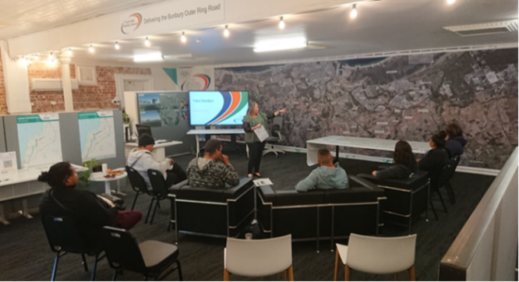
In the central section at Willinge Drive, it has been especially wet, but the team is continuing to make good progress with road foundations in the area.
Finally, in the Paris/Clifton Road area, we have completed some initial clearing in the Forrest Highway median, and south of Clifton Road. We will continue establishing a site laydown area south of Clifton Road in the coming weeks.
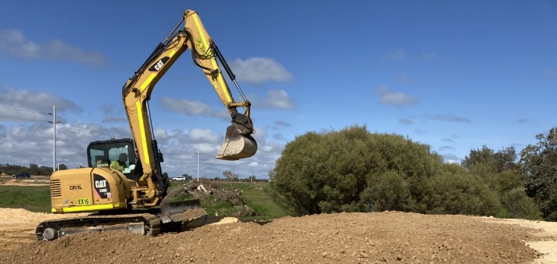
Digger at the central section project site

Yaka Dandjoo Program
The Yaka Dandjoo program has been designed to provide unemployed participants with support, knowledge and skill development to assist in their transition to become ‘construction industry’ work-ready.
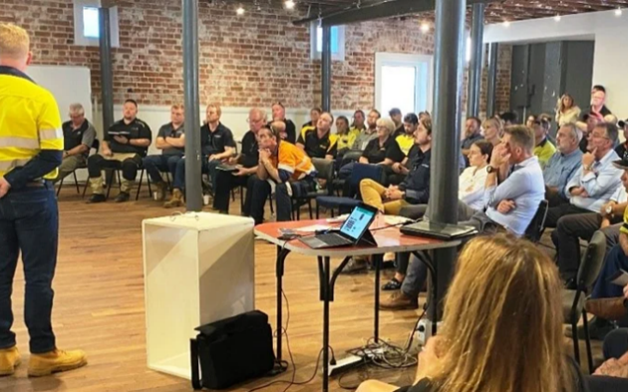
The six-phase program includes an accredited course (Infrastructure Ready Skill Set or the Heavy Haulage Program) providing life skills and on the job mentoring to help participants build a sustainable career, including industry-specific traineeships and apprenticeships.
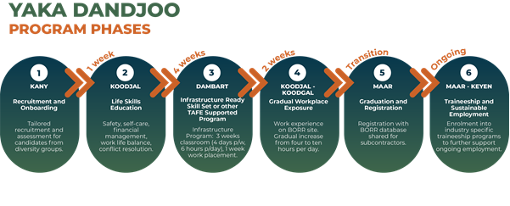
With a specific focus on ensuring opportunities are presented for Aboriginal people, the program supports unemployed jobseekers to develop meaningful and sustainable careers on infrastructure projects in WA.
The Bunbury Outer Ring Road project is committed to employing at least 60 full-time Aboriginal employees and achieving a goal of 10 per cent of our workforce being currently unemployed, including providing opportunities for prison release participants.
The Yaka Dandjoo program started in September, with 45 jobseekers participating in activities designed to identify their individual employment requirements. We look forward to welcoming more participants as the project progresses.
Yaka Dandjoo meeting at the SWGA Hub

Business Briefings
The next Business Briefing and Aboriginal Industry Briefing is happening on Tuesday, 26 October at the Maker + Co. building (75 Victoria Street, Bunbury). The local Business Briefing session will take place between 11:30am – 1:00pm, and the Aboriginal Industry Briefing will take place between 2:00pm – 3:30pm.
We welcome you to attend either session on the day. At each session, we will be providing an update on upcoming work packages and ways for your business to get involved in the project. To register, click here. Business Briefing session
Meet the team
Kandice Hart – HR Administrator
Kandice is our HR Administrator and joined the project in October 2020. Kandice’s role on the project includes helping with recruitment, training, and employment on the project. Kandice has been a key contributor to the Yaka Dandjoo program.
“The thing I am enjoying the most about the project is helping build the Yaka Dandjoo Program and watching it come to life,” she said. “We have a lot of keen and excited candidates coming through the program, and we can’t wait to hear the success stories and outcomes for the students.”
Jackie Graham – Training Manager
Jackie is the Training Manager on the project and a member of the People and Culture team. Jackie is a trained social worker and a Bunbury local.
“What I’m enjoying most is the opportunity to work on a project that is committed to achieving authentic outcomes for my community,” she said. “I have spent the past 15 years advocating employment opportunities for disadvantaged and marginalised individuals and the employment sustainability and Aboriginal Participation objectives formed a big part of my decision to join the project.”
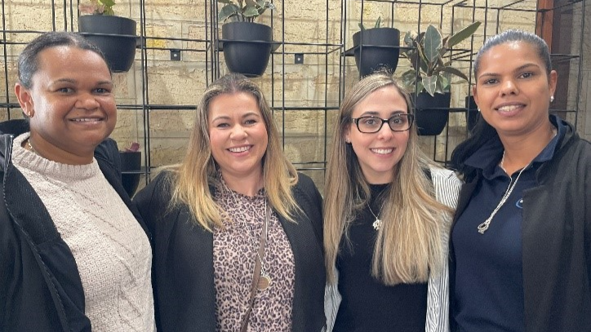
Left to right: Joanne Hill - Aboriginal Participation Manager, Jackie Graham - Training Manager, Maja Prvulovic - People and Culture, Kandice Hart - HR Administrator.
Local spend
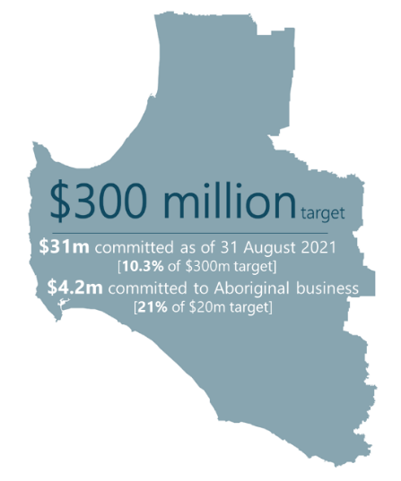
With another month of the project behind us, we are pleased to announce we have committed $4.2m to Aboriginal Businesses and have spent $1.85m so far. We are now engaging 10 Aboriginal Businesses on the project. We have also committed $31m to 130 South West businesses, with a total of $21.8m spent.

What’s happening next?
The timeline below shows what we have planned for the coming months.
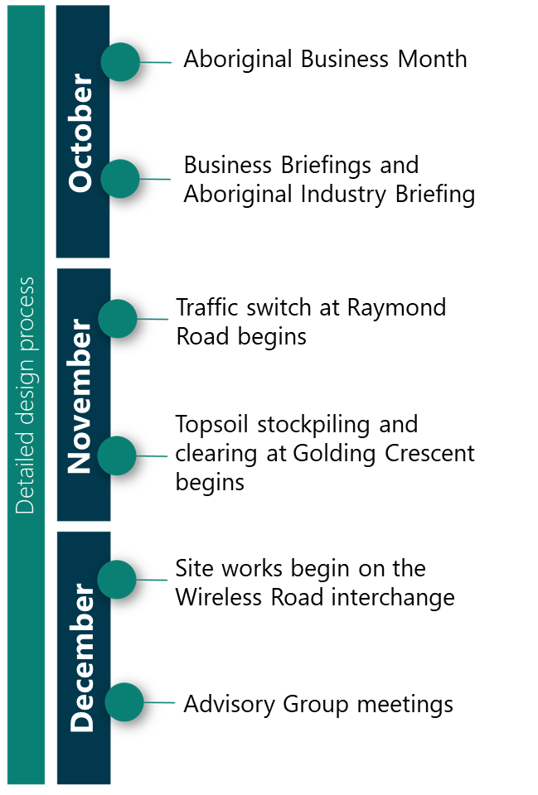

Further information
Website: www.mainroads.wa.gov.au/BORR
Phone: 138 138
Email: enquiries@mainroads.wa.gov.au.
Join our Facebook Group

