The Bunbury Outer Ring Road (BORR) will reduce local congestion and increase efficiency for freight vehicles and regional traffic while improving long-term access to the Bunbury Port. The project will support social and economic growth and development, enhance amenity on local roads by reducing freight and regional traffic on them, and create a safer road system for our community in greater Bunbury and the wider South West region.

Road foundation works at Raymond Road site.
The $852 million Bunbury Outer Ring Road project is jointly funded by the Australian Government ($681.6 million) and the State Government ($170.4 million).
Since BORR construction began in January, we have made good progress with preliminary works out on-site including clearing, topsoil stockpiling and ground improvement. Behind the scenes, our team has been very busy finalising the design as well as implementing many social initiatives that will lead to meaningful outcomes for the local community. Everyone in our South West Gateway Alliance (SWGA) team is playing a role in making this happen.
Urban Design and Landscaping update
Thank you to everyone who completed the Urban Design and Landscaping community survey. We were delighted to receive 113 responses. In the coming weeks, we will share a summary of survey responses and feedback we received on our Urban Design concepts.
We now have a broad range of feedback and ideas which we will use, along with the insights and input from the Aboriginal Community Engagement, to refine the Urban Design and Landscaping themes on BORR.
NAIDOC Week
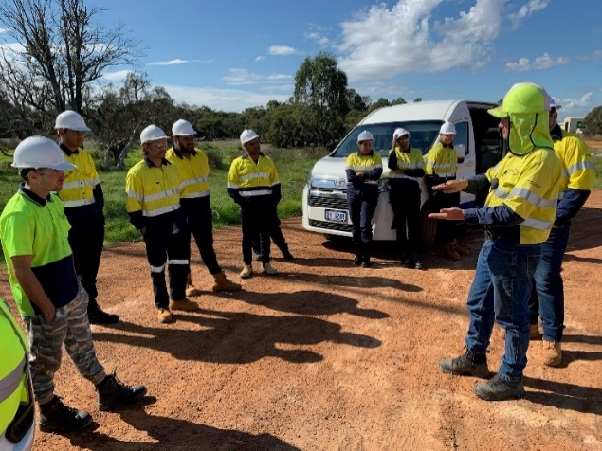
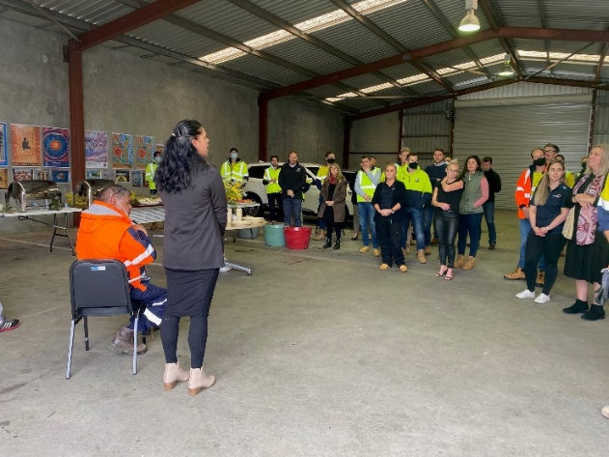
To celebrate NAIDOC Week in Bunbury this year, SWGA attended the flag-raising ceremony at Graham Bricknell Shell. The event was hosted by City of Bunbury Mayor, Gary Brennan, and local Noongar community members. We also hosted our own events, including discussions with local Aboriginal Elders about what NAIDOC Week means to them. This gave our team the opportunity to learn more about healing country and to reflect on our commitment to recognising the importance of Aboriginal Culture. The Alliance is continuing to work closely with the local Aboriginal Community to provide employment opportunities, support business growth, assist with heritage management and cultural recognition on BORR.
NAIDOC week celebrations

Traffic update
Driving conditions are now regularly changing and it is important to stay informed about detours, lane closures of other impacts when travelling in the area. We send out regular updates to our subscriber base, as well as sharing them on Facebook. For the most recent updates to your journey, you can visit the Main Roads Travel Map.
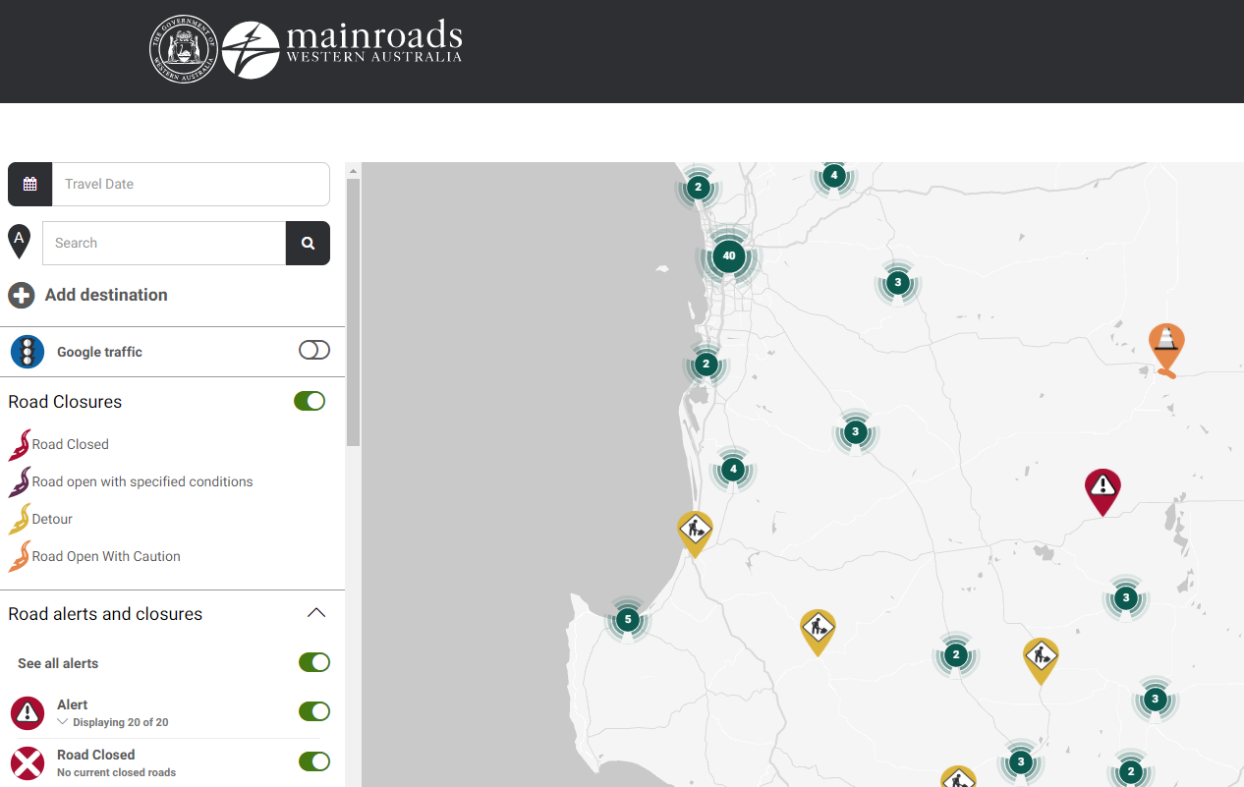
Main Roads Travel Map
Sharing knowledge on BORR
We want to share our experience and knowledge with schools and higher education providers. If you are a teacher or an educator interested in setting up a site visit, or would like to invite some of our team members to deliver a presentation, you can contact us on 1800 979 770 or by email enquiries@swgateway.com.au.

Infrastructure Ready Program class on-site
Construction update
We’re getting ready to build the Raymond Road interchange. You may have seen us building, a temporary access track for traffic on Raymond Road. We’ll let you know when the diversion will be coming into operation.
At the Paris/Clifton interchange site, we are starting topsoil stockpiling and ground improvement.
At the Willinge Drive project site, we are closing some lanes on the existing Bunbury Outer Ring Road, and Willinge Drive. This will allow us to upgrade the pavement in the median strip and make it easier for future traffic switches during roadworks.

Meet the BORR team
Scott Radici – Local Content Advisor
Scott joined the BORR project in early July and has hit the ground running assisting local businesses with identifying opportunities to work on the project. Scott’s role includes helping businesses with registering interest to work on the project and preparing for upcoming tenders.
“I’m looking forward to meeting and working with more South West businesses interested in participating on the project,” he said. You can find Scott at the SWGA Community Hub or give him a call on 1800 979 770.

Local spend tracker
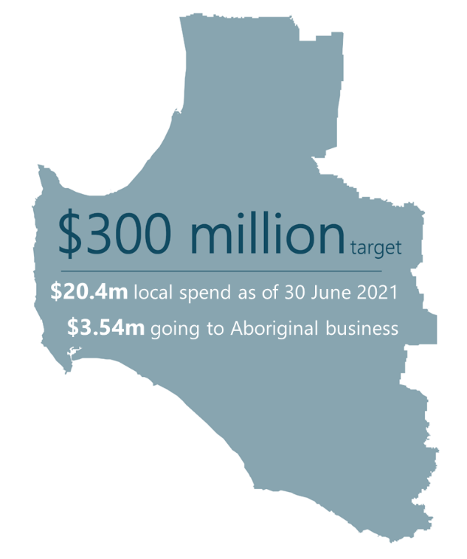
Our commitment to providing opportunities for local contractors is integral to the success of the BORR project. At 30 June, we had spent $12.5m with local business and committed to more than $20m. We have spent the first million of a committed $3.5m with Aboriginal Businesses. More than 86 local businesses and 10 Aboriginal businesses on the project have provided goods and services.

Join the BORR Facebook Group
If you would like to keep up with the latest news on the BORR project, join our community Facebook group. We have now reached more than 1,500 members and will be keeping you all updated with regular posts about the project.
Search Bunbury Outer Ring Road Project
Community Group on Facebook or visit www.facebook.com/groups/borrproject and
join as a member.

What’s happening next?
The timeline below shows what we have planned for the coming months.
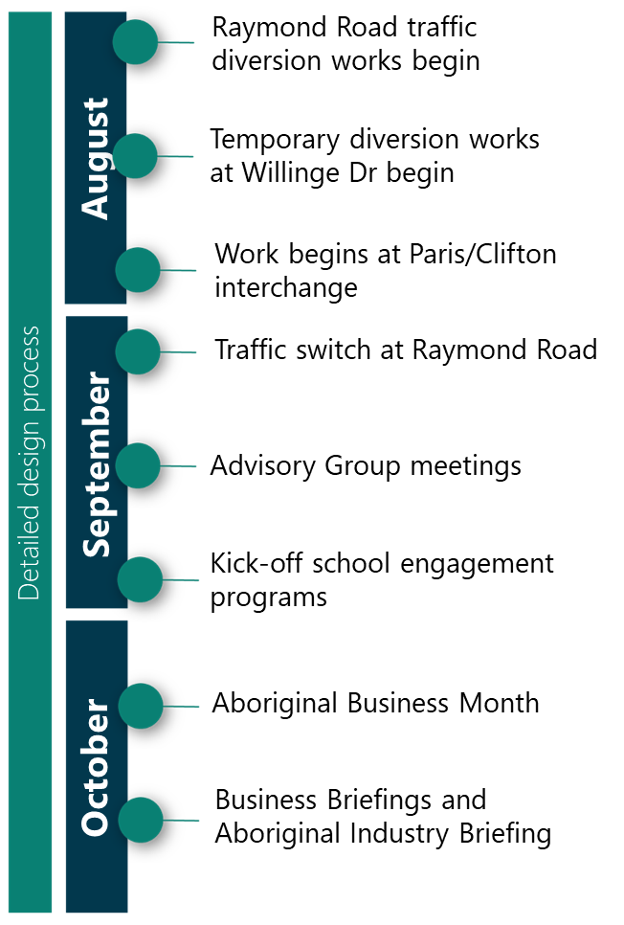

Further information
Website: www.mainroads.wa.gov.au/BORR
Phone: 138 138
Email: enquiries@mainroads.wa.gov.au.
Join our Facebook Group

