Updated concept designs for Phase Two of the project
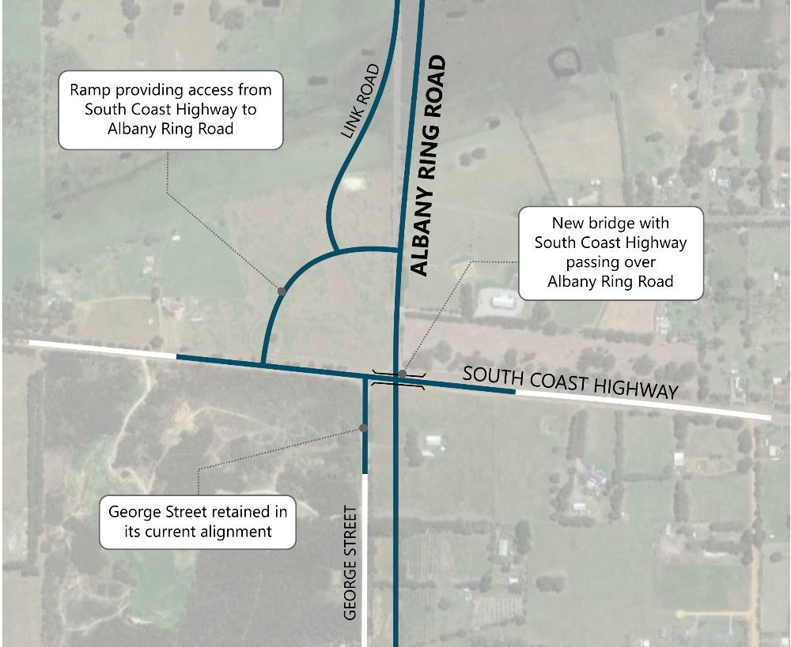

Phase Two of the Albany Ring Road project, between Lancaster Road and Princess Royal Drive, has reached a major milestone, with the release of updated concept designs for the new interchanges on the Ring Road at South Coast Highway and Hanrahan Road / Frenchman Bay Road respectively.

Each design has evolved to reduce the project’s environmental and heritage footprint, while maintaining the free-flowing route and maximising local connectivity. Construction of Phase Two is expected to begin by the end of the year subject to receipt of regulatory approvals.

Phase 2 designs explained
Albany Ring Road and South Coast Highway Interchange
South Coast Highway will pass over Albany Ring Road with connectivity in all directions retained through a ramp. This ramp will also provide direct access to and from Link Road.
This design, which was shared with the project’s Environmental Reference Group, has evolved to avoid some environmentally sensitive possum habitat to the south west of the interchange.
The reduced footprint will also allow the interchange to be constructed more efficiently, reducing long term impacts to road users.
George Street access to South Coast Highway retained following community feedback
The revised design of Albany Ring Road and South Coast Highway interchange allows George Street between Lower Denmark Road and South Coast Highway to be retained in its entirety. This includes full access between George Street and South Coast Highway. This positive design change reflects the extensive feedback received from residents living on George Street, Lowanna Drive and Frederick Street.
The retention of the George Street connection also means that a new connection to the Albany Ring Road from Clarko Road, included in earlier designs, is no longer required.

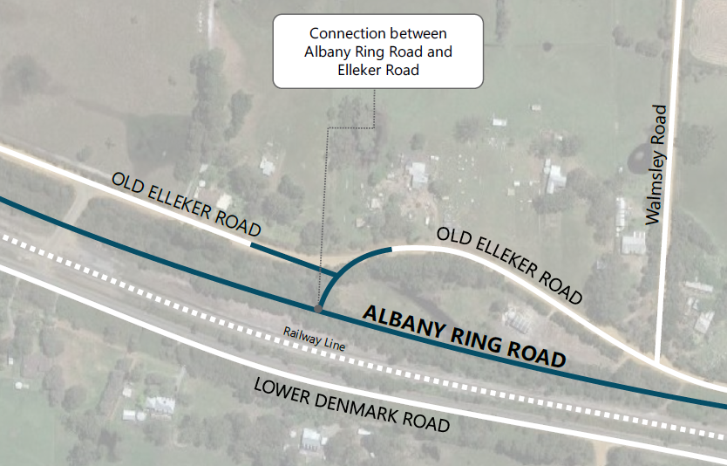
Old Elleker Road connection update
The latest design includes a connection between the Albany Ring Road and Old Elleker Road. This direct connection opens up the area to future land-use and development opportunities.
Old Elleker Road will no longer be connected through to Roundhay Road as originally proposed, and will remain in its existing alignment, avoiding the requirement for land acquisition from adjoining lots.
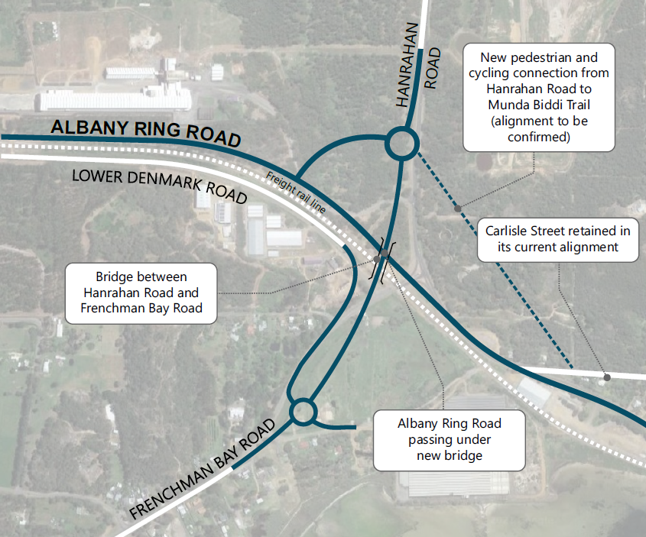
Albany Ring Road and Frenchman Bay Road / Hanrahan Road Interchange
The overall footprint of the interchange has been reduced to limit impact on the environment and community amenity.
A single bridge structure linking Hanrahan Road to Frenchman Bay Road, will pass over the Albany Ring Road and the freight rail line. New roundabouts will be constructed to the north and south of the interchange to provide access to and from the Ring Road and Lower Denmark Road.
The proposed realignment of Carlisle Street, which was necessary to accommodate earlier designs, is no longer required.

Design changes allow wartime heritage story to be celebrated
We have been working closely with our contractor Decmil, to ensure the design of the Albany Ring Road and Frenchman Bay Road / Hanrahan Road Interchange, has negligible impact on the Albany Seaboard Bulk Fuel Oil Depot, located to the north of the Ring Road alignment. The depot was constructed in 1943 to satisfy Government demands for the ‘pooling’ of fuel supplies as a means of avoiding wartime petrol rationing.
Following liaison with the Heritage Council, Department of Planning, Lands & Heritage, Albany Returned and Services League (RSL) and local
political representatives, the alignment of the interchange has been moved further south, allowing retention of the Depot’s large storage tanks.
In February 2021, the site was formally entered into the State Register of Heritage Places and is protected from future development.
Over the coming months, our project team will progress discussions with the City of Albany and other local stakeholders around leaving a lasting legacy in this area, by activating the
space around the tanks for the community’s enjoyment. This could include walkways and new cycling connections.

Further information
Project information is available at www. mainroads.wa.gov.au/projects, or by emailing enquiries@mainroads.wa.gov.au or phoning 138 138. You can also register for project updates by heading to our project webpage and subscribing for email updates.

