Temporary traffic changes at Hanrahan Road / Frenchman Bay Road from 25 January 2023
To enable the construction of the new interchange at the intersection of Hanrahan Road and Frenchman Bay Road, the following temporary traffic changes will occur:
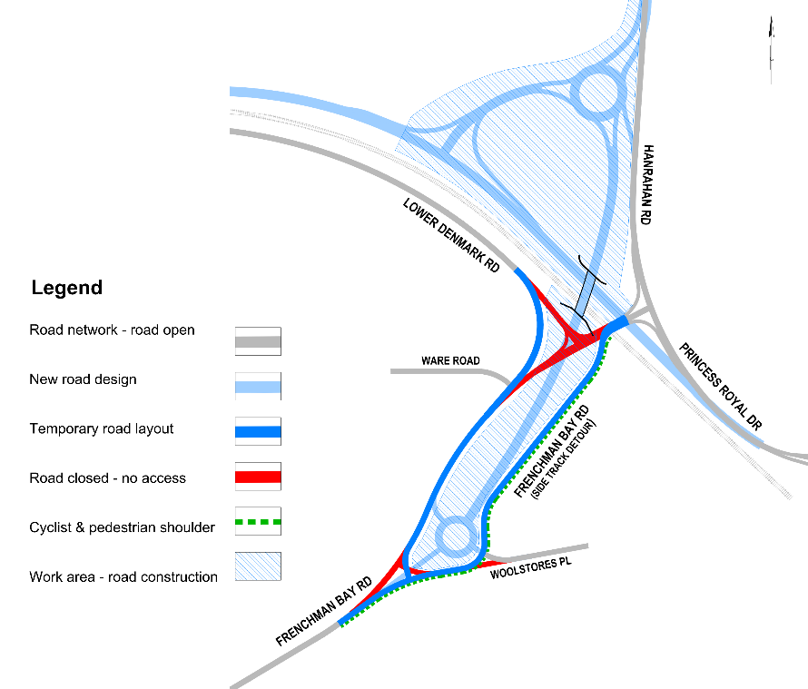
Temporary road layout at Hanrahan Road / Frenchman Bay Road
- From Wednesday 25 January until the new interchange is operational in 2024
- Access between Lower Denmark Road and Princess Royal Drive / Hanrahan Road for all road users will be via a loop along Frenchman Bay Road and Woolstores Place
- A sealed shoulder will be provided for cyclists and pedestrians
- Speed reduced to 40km/h through the works
The traffic management requirements are necessary to safely undertake the works. We apologise in advance for any inconvenience these works may cause.
Dates and duration of works are subject to weather conditions.
Road conditions may be unfamiliar. Please proceed with caution, adhere to the speed limit and signage throughout the area and allow additional journey time where possible.
Further information
Project information is available at www.mainroads.wa.gov.au/albany-ring-road, or by emailing enquiries@mainroads.wa.gov.au or phoning 138 138. You can also register for project updates by heading to our project webpage and subscribing for email updates.

