Albany Ring Road
PROJECT update
March 2022

Final section of the Albany Ring Road project formally underway
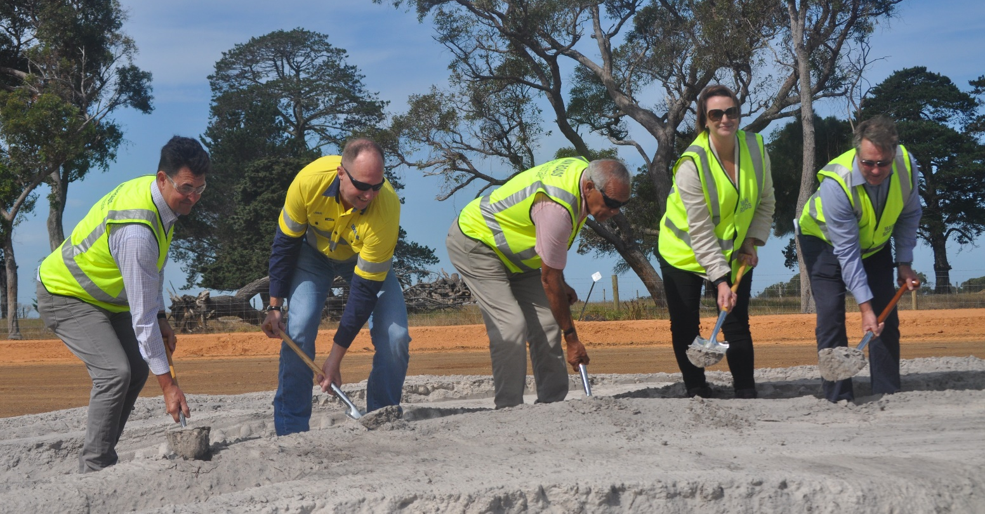
Member for Albany Rebecca Stephens, Federal Member for O’Connor Rick Wilson and local Aboriginal Elder Lester Coyne join representatives from Main Roads and Decmil to formally break ground on the final section of the Albany Ring Road.
The final section of the $175 million Albany Ring Road project, between South Coast Highway and Princess Royal Drive, is formally underway. Upon completion in 2024, the 6km connection will establish an 11km free flowing route between Albany Highway and Princess Royal Drive, improving freight efficiency and reducing congestion on existing roads.
Over the past month, the project team have worked towards preparing the site for earthworks, bridge works and the construction of the main alignment. Activity has included installation of new fencing, seed collection, topsoil removal, utilities relocations and services protection works. Initial vegetation clearing has also taken place at the CSBP-owned site off Hanrahan Road.

A temporary closure of Link Road between Lancaster Road and South Coast Highway was implemented in late February. This will allow the new access ramps associated with the

Albany Ring Road and South Coast Highway interchange to be constructed safely and efficiently.

The Albany Ring Road is the largest road infrastructure project to be undertaken in the Great Southern Region. The Australian Government has committed $140 million toward the $175 million Albany Ring Road upgrade, with the Western Australian Government providing $35 million.

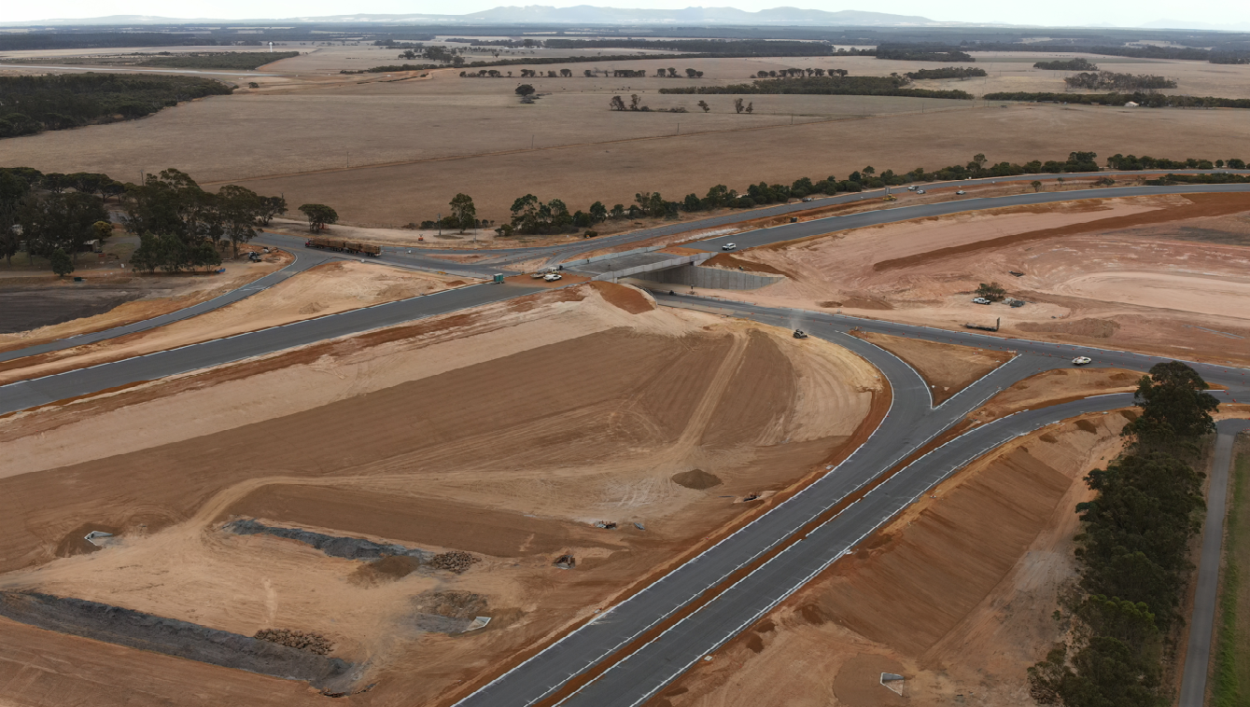
The new interchange at Albany Highway and Menang Drive (looking north-east).

Menang Drive and Albany Highway Interchange
Construction of the first grade separated interchange in the Great Southern Region – at Menang Drive and Albany Highway - is making good progress, with the bridge deck now in place.

The interchange is expected to open to traffic in April 2022. Vehicles heading north from the Menang Drive intersection will cross over the new bridge and utilise a new loop ramp to access Albany Highway. Information for road users will be shared with the community in the coming weeks.

We are also working closely with the City of Albany and Traditional Owners to develop an artwork theme for the bridge walls. It is expected the chosen theme will also be adopted and used on the other two bridge sites along the alignment. Painting is expected to begin in the winter months

Revegetation of this section of the project is also scheduled to begin over the winter months. This will consist of approximately 15ha of feature planting, basin mixes and Road Reserve planting.

Albany Ring Road and South Coast Highway Interchange
Early works activities in recent months have changed the landscape between Lancaster Road and South Coast Highway, with topsoil removed and construction fencing now in place.

Construction of the access ramps for the new interchange will gather speed over the autumn period, with a temporary
closure of Link Road currently in place. We thank local residents and road users for their ongoing patience and support during this period.

The new access ramps are planned for completion prior to the onset of winter. Once the ramps are operational, construction of the bridge structure will begin.

Albany Ring Road, Hanrahan Road and Frenchman Bay Road Interchange
Early works are also underway in the area off Hanrahan Road, to the north of the existing freight rail level crossing. This has included some vegetation clearing, initially at the site owned by CSBP. This clearing has been necessary to facilitate construction of a new access into the facility from Hanrahan Road.

This will be followed by additional clearing in the area of the proposed interchange, commencing from mid-March onwards. All clearing works will be preceded by fauna monitoring, capture and release, and will be undertaken in accordance with the project’s environmental approvals and Environmental Management Plan.

Reducing clearing impact through design enhancements
In mid-2021, several enhancements were made to the design of the section of the Albany Ring Road between South Coast Highway and Princess Royal Drive. These improvements have reduced the overall clearing footprint by almost 50%.
Nevertheless, in recognition of the residual impacts of clearing, a substantial offset has been proposed, which will result in a net benefit to the environment through the revegetation of 3.56ha of the site and provision of funds for 65ha of conservation land to be acquired and managed by the Department of Biodiversity Conservation and Attractions.

What to expect as a local resident

Construction during the drier months
Changes to the local landscape will become more visible with new fencing, vegetation removal, topsoil stripping and increased construction activity. Whilst construction can be a challenge in dry, windy conditions, particularly when undertaking earthworks, our contractor Decmil has in place a Noise, Dust and Vibration Management Plan that aims to lessen the impacts of construction activities on the local neighbourhood.

These plans include the requirement to work within specific hours, have a water truck on site and monitoring of noise from time to time in sensitive areas.

Services
Throughout the project area there will be extensive service relocations and / or placing existing services underground, however lengthy disruptions should not be necessary. In the unlikely event that telecommunications, water or power services will need to be interrupted, the appropriate service provider will provide notice.

Current hours of operation are:
Monday – Saturday 6am – 7pm
Sunday 7am – 7pm
Public Holidays 9am – 5pm as required (advance notice will be issued prior to working any public holidays)

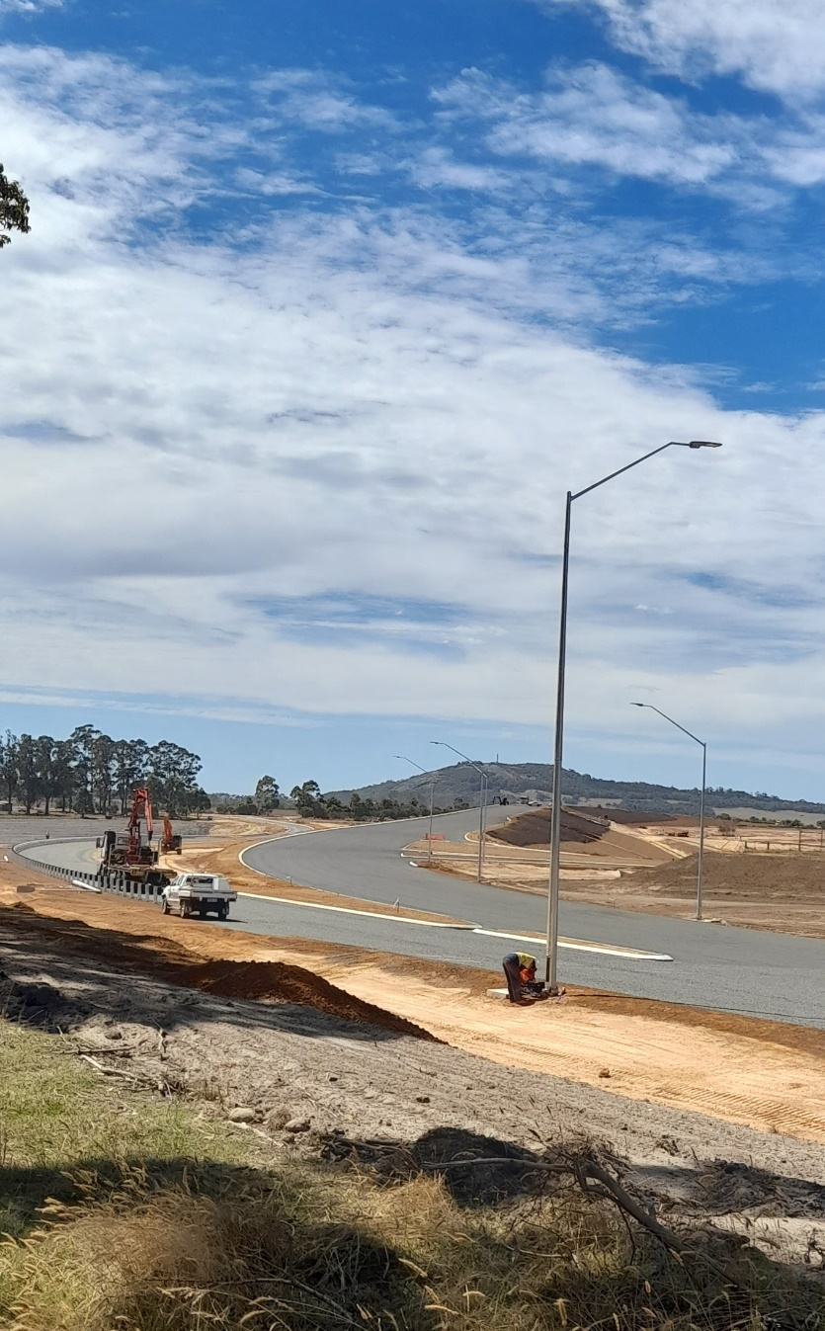
Lighting and barrier installation on the newly-constructed section of Ring Road between Albany Highway and Lancaster Road

Supporting local businesses
The Albany Ring Road is the biggest infrastructure project ever undertaken in the Great Southern Region, and a game changer for the local area.
As well as the safety and congestion improvements, the project is delivering major economic benefits to the local community. At the end of January, $14.1 million had been spent on local businesses; and of this figure, $2.6 million had been expended on Aboriginal suppliers.
In addition, 24 per cent of the construction workforce identify as Aboriginal, significantly exceeding the project’s target.
With the larger, more complex part of the project only just getting underway, we expect to see these numbers increase significantly over the next two years.

Ring Road trainee picks up coveted award
One of these local success stories is 22 year old Barry Roberts, who has just been named the Skill Hire Trainee of the Year. Barry is currently completing his Certificate II in Civil Construction and is one of six trainees working for Decmil across the Albany Ring Road project.
Skill Hire Trainee of the Year and Albany Ring Road construction team member Barry Roberts (centre)

More information?
If local residents have any questions or wish to discuss any aspect of the Albany Ring Road project, they can contact our team via 138 138 or email enquiries@mainroads.wa.gov.au

