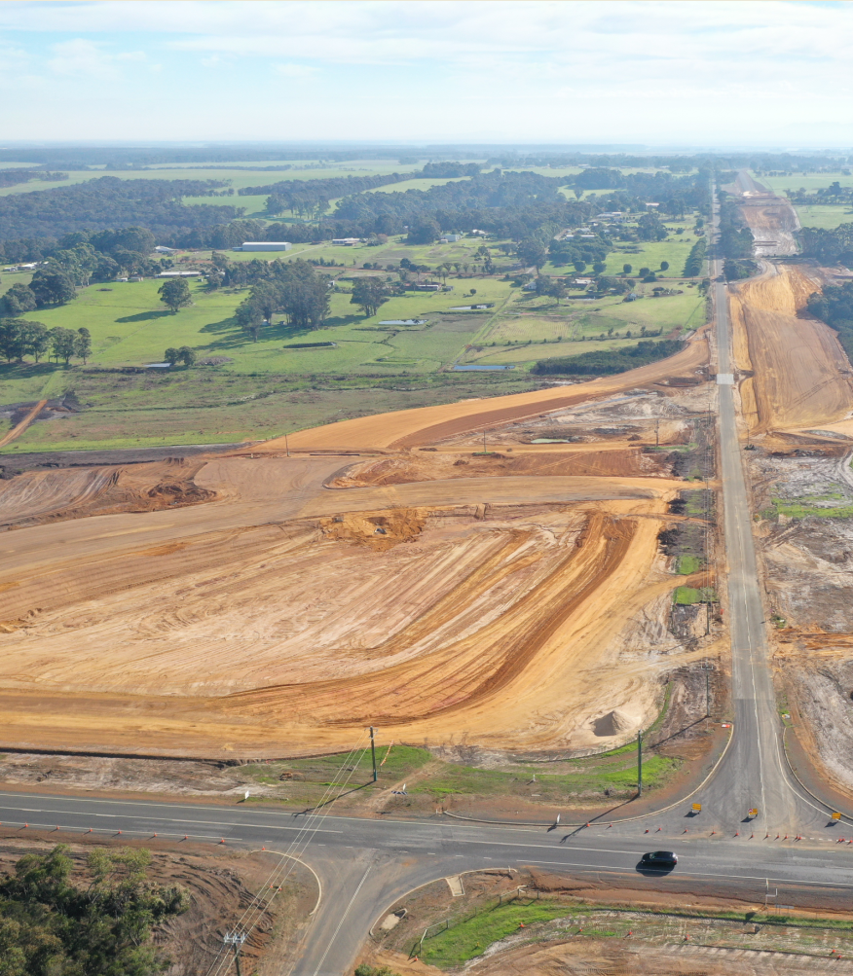
Following the opening of the first phase of the Albany Ring Road project in April, the focus has shifted to constructing new interchanges at South Coast Highway and Hanrahan Road / Frenchman Bay Road.
Earth works to construct the South Coast Highway – Albany Ring Road Interchange
The first grade-separated interchange in the Great Southern Region, at Menang Drive and Albany Highway, is already delivering benefits for local road users through a safer, more efficient road network. With the interchange now complete, mulching and landscaping of large open areas is now in progress and will include native tube stocks and seeds.
The area between Lancaster Road and Princess Royal Drive has changed dramatically, with clearing and earthworks taking place to accommodate the second phase of the project. This involves major earth works and drainage to accommodate the new South Coast Highway Interchange as well as significant cut and fill works from Lancaster Road to Old Elleker Road. South of Frederick Street, the ground levels will increase in height by up to 8.2 metres, using over 500,000 tonnes of material transported from other areas of the project.
Works have also commenced in off-road locations near the intersections of Lower Denmark Road, Frenchman Bay Road and Hanrahan Road. This includes vegetation clearing and earthworks to create the first stage of a major detour that will separate road users from construction activities. This will allow construction of the new Hanrahan Road / Frenchman Bay Road bridge and interchange with the Albany Ring Road to take place offline, allowing the works to be completed faster, safer and minimising inconvenience for road users.
With the wet winter period now upon us, the works have shifted to new areas. This includes service relocations (electricity, water and telecommunications). Service providers will advise their customers in advance of any expected service interruptions. Access changes to some local roads will also be progressively implemented in coming months. A Changes to Local Roads Fact Sheet can be download from the project website.

Advanced notice of planned major detours
To-date, construction of the Albany Ring Road has not significantly impacted road users as most construction activity has taken place away from the live traffic environment. However, construction of the major interchanges at South Coast Highway and at Hanrahan Road / Frenchman Bay Road will require several significant detours over an extended period.
These detours will be implemented over a period of up to two years and will change as the works progress. Extensive communications and maps are being prepared to assist residents, tourists, cyclists and industry to navigate their way through the works. To stay up to date with the detours, please subscribe to the project’s email list by visiting the project webpage.

Detour at Hanrahan Road – Frenchman Bay Road (December 2022 to 2024)
A detour will be implemented at Hanrahan Road / Frenchman Bay Road to build the bridge over the railway and the Albany Ring Road to separate road users from the construction activities. Access between Lower Denmark Road and Princess Royal Drive / Hanrahan Road for cyclists and road users will be via a loop along Frenchman Bay Road and Woolstores Place.
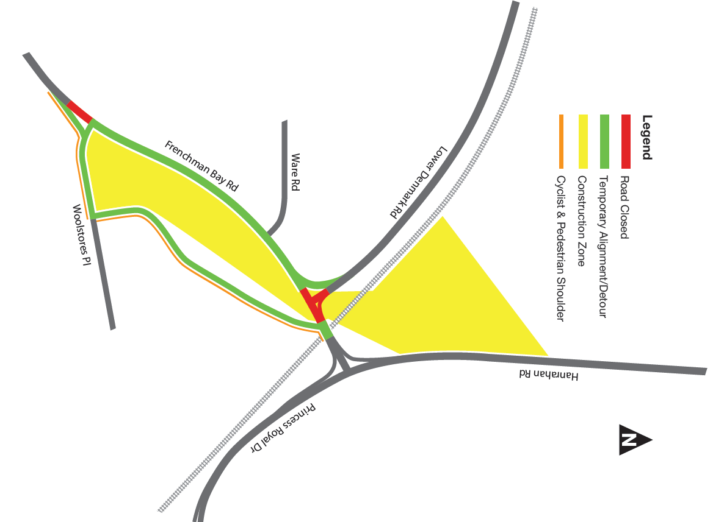
The detour will be signed and a sealed two-metre shoulder will be provided for cyclists and pedestrians. The speed limit through the detour will be reduced and road users should allow extra travel time during peak travel periods.

Detour at South Coast Highway and Link Road (October 2022 to 2024)
A long-term closure of South Coast Highway, between George Street and Timewell Road is required in order to build the South Coast Highway / Albany Ring Road Interchange and separate road users from the construction activities. This closure is expected to commence in October 2022.
Extensive information regarding detour routes will be communicated in the Spring. This will be complemented by a thorough signage strategy, both in Albany and in locations further to the west.

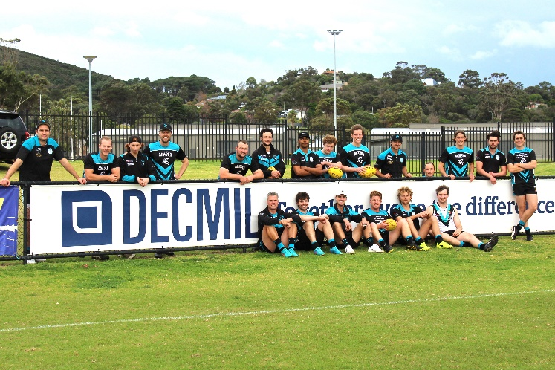
Delivering for the Great Southern Region
Decmil Sponsorship of the Albany Sharks
The largest road infrastructure project in the Great Southern Region is delivering local jobs and growing local businesses. To date, 44 per cent of the contract value has been awarded to businesses located within 100km of the Albany CBD. Approximately 10 per cent of the hours worked on the project have been undertaken by the project’s Aboriginal workforce and 40 per cent of project professional staff live within the Great Southern region.
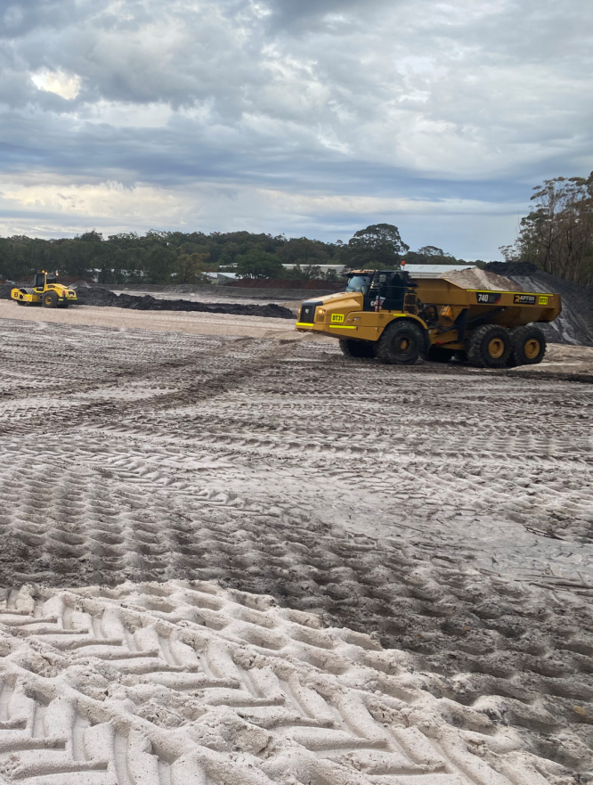
Mobile plant supplied by a local business being used on the project.
The project’s head contractor, Decmil, is also supporting local community groups, with a $10,000 donation to the Albany RSL, and sponsorships of the Albany Sharks Football Team.
Decmil, has also been encouraging local students to study STEM subjects at school and partnering with UWA students to use the project as a case study to develop their Ecological Monitoring Program.
Local businesses that wish to supply the project can register their interest via Decmil’s business portal at https://supplychain.decmil.com

Community Engagement
Winter has delivered us a short window to prepare the next stage of community engagement activities. In coming months, a variety of local activities will be taking place including pop-up and meetings with community groups and industry. These activities will be designed to prepare the community and stakeholders for the major works that will commence in September.
We are also continuing our regular engagement program, which include liaising with adjacent residents to better understand how the project can limit its impact on their daily activities.
In acknowledging the strong cycling community in Albany, we are looking forward to the opportunity of providing in-person briefings to local cycling clubs and working with members to ensure cyclists can safely navigate their way through the works.

Further information
The best way to stay up to date with the project is to subscribe to email notifications via our project webpage at:
www.mainroads.wa.gov.au/albany-ring-road
You can also phone: 138 138 or email: enquiries@mainroads.wa.gov.au

