Albany Ring Road
Water management
fact sheet
February 2022
The Albany Ring Road project is committed to minimising water run-off and maintaining existing drainage conditions wherever possible.

The Albany Ring Road alignment runs through a number of low-lying areas and complex series of water tributaries that remain wet for many months of the year and traditionally flood in severe weather events.
The requirement to provide adequate drainage to prevent water pooling on the new road surface, while preventing additional water run-off to private properties, presents a series of challenges which are addressed through a detailed Drainage Management Plan.
As a guiding principle, the project has sought to retain existing conditions as far as is practicably possible and not adversely impact current existing flow.

Water retention basins
To achieve this, a series of ‘capture and release’ water retention basins are being installed in areas along the alignment where runoff water and excessive rainfall may accumulate. Water can then be channelled away from the road and slowly released into natural water courses in a controlled manner.
The basins will reduce the velocity of water discharge from the project, capture sedimentation from the road, as well as pollution from road spills within the project.
These types of basins do not typically hold water all year round. Examples can be seen around the new interchange at Albany Highway and Menang Drive (see photo below).
Similar basins are planned along the remaining section of the alignment, between Lancaster Road and Princess Royal Drive. A schematic, explaining how the basins work is found overleaf.
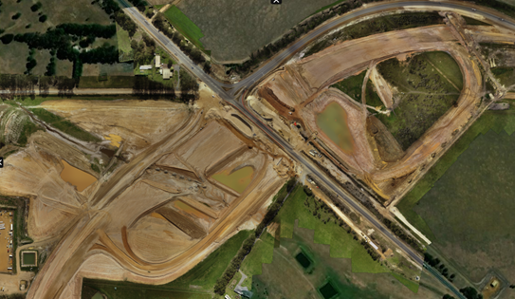
Above: aerial view of ‘capture and release’ drainage basins located either side of Albany Highway as part of Phase 1 drainage works.

What will be the impact on properties adjacent to the alignment during construction?
Installation of the drainage basins will take place in the early stages of construction wherever possible to reduce the impacts of water run off onto private property. In instances where early installation cannot be achieved, the project team will work closely with affected landowners to put temporary controls in place.

Unusual wet weather events
The project experienced an early break of season in 2021, along with a rare high intensity rainfall event, which apart from damaging local roads and the railway line, impacted the construction site and the installation of retention basins. This resulted in increased flows and quantities over the winter period.
In Phase 2 of the Project between Lancaster Road and Princess Royal Drive, the Project Team will construct the basins before the onset of winter wherever possible to mitigate future impacts.
Additional water management measures that will be considered during high rainfall events include core logs, silt traps, filter clothes, weirs and temporary basins.
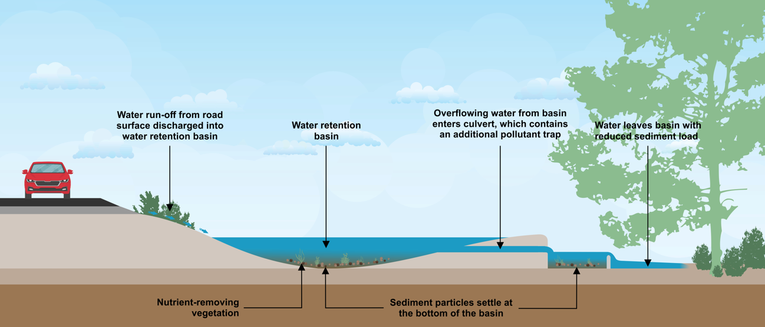
Above: Functionality of a water retention basin (not to scale)

Managing impacts on waterways
The attenuation of runoff water within specially designed basins will limit any increase in the flow of water in existing waterways during a rain event. The basins, in conjunction with specially designed outlets will mitigate any road pollution spill events.
In addition, the basins will be planted with suitable species that will remove nutrients from the water. This will ensure that any water coming from the Albany Ring Road will have minimal impact on the existing waterways and environment.

How can local residents raise concerns?
If local residents have any further questions or concerns about the management of water in relation to their own properties, or any other aspect of the Albany Ring Road project, they can contact our team via 138 138 or email enquiries@mainroads.wa.gov.au

