Albany Ring Road
Fact sheet: Vegetation Management
fact sheet
April 2022
The Albany Ring Road project is committed to minimising clearing and applying best practice in vegetation management wherever possible

As a guiding principle, the Albany Ring Road Project is committed to minimising vegetation clearing and other impacts as far as is practicably possible.
While some clearing has taken place to accommodate Phase 1 of the project between Albany Highway and Lancaster Road, this part of the Ring Road has had a negligible impact on native vegetation. Revegetation plans for this area consist of approximately 15ha of feature planting, basin mixes and Road Reserve planting. This will commence during the forthcoming winter season (mid-2022).
Phase 2 of Albany Ring Road alignment traverses several dense patches of planted and native vegetation of varying quality between Lancaster Road and Princess Royal Drive. For this reason, the project has been subject to an extensive environmental assessment and approvals process to ensure that wherever possible, best practice environmental management strategies are implemented.

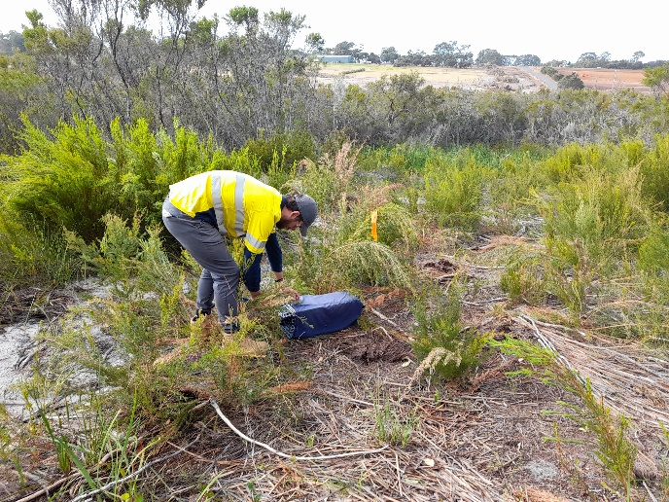
Native vegetation impacts: Lancaster Road to Princess Royal Drive
Phase 2 of the project has environmental approvals to clear 15.67ha of native vegetation, within an overall project footprint of approximately 76 ha.
Through recent design enhancements, the overall clearing footprint for this section of the project, particularly at the interchange sites at South Coast Highway and Frenchman Bay Road, has been reduced by almost 50 per cent. In addition, 10 of the 15.67ha of vegetation to be cleared is categorised by pre-construction Flora & Vegetation Surveys as being in “degraded or worse” condition (based on the Keighley Vegetation Condition Scale).
Despite measures to reduce the clearing footprint as far as possible, some clearing is unavoidable in order to deliver this significant project. In recognition of the residual impacts of clearing, a substantial offset has been proposed, which will result in a net benefit to the environment through the revegetation of 3.56ha of the site and provision of funds for 65ha of conservation land to be acquired for the planting of native species that will also provide fauna habitat.

This offset site will be managed by the Department of Biodiversity Conservation and Attractions.

Vegetation management strategies
The project is committed to minimising the amount of disturbance and only clearing what is necessary.
As part of a sustainable approach to vegetation clearing, the following activities and / or strategies have been implemented:

Seed has been collected from along the alignment so that local provenance species can be re-established;
- Trees that have been removed are mulched for use in landscaping the site; and
- Timber has been donated to Albany Woodturners which will be used to create fine art, craft and furniture.

What happens to fauna?
Prior to clearing activities, daylight spotting and night spot lighting is conducted in areas of known western ringtail possum, bandicoot and other fauna habitats; to trap, record and if required; relocate any individuals present.

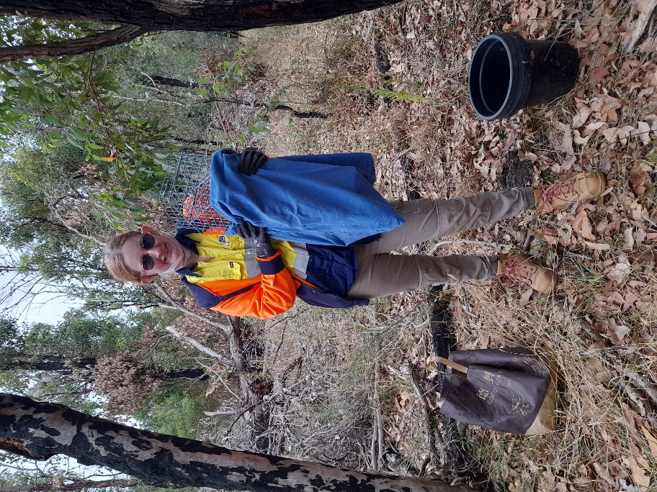
The Albany Ring Road design also includes the installation of at least two rope bridges and two fauna underpasses that will support the ongoing efforts of the City of Albany to create a fauna corridor throughout the area for ringtail possums. Additional sites are being investigated.
The locations of these proposed crossing points are being determined in consultation with the Great Southern Region Environmental Reference Group (ERG). Further information will be shared with the community once these locations are confirmed.
Right: Pre-clearing trap setting.

Landscaping
In addition to native flora offsets, the project will rehabilitate and revegetate the new landscape with local native species through the implementation of an Urban Landscape Design Plan.
The Plan is being developed in consultation with key stakeholders, including the ERG who continue to provide valuable input into endemic native species selection; as well as the fauna crossing locations.

Want to know more?
For more information on vegetation clearing, or any other aspect of the Albany Ring Road project, contact our Team via 138 138 or email enquiries@mainroads.wa.gov.au

