Albany Ring Road
Fact Sheet: Bridge Artwork
fact sheet
June 2022
The Albany Ring Road project contains three bridges, which provide a unique opportunity to showcase cultural significance of Albany and its surrounds to the Menang Noongar community.
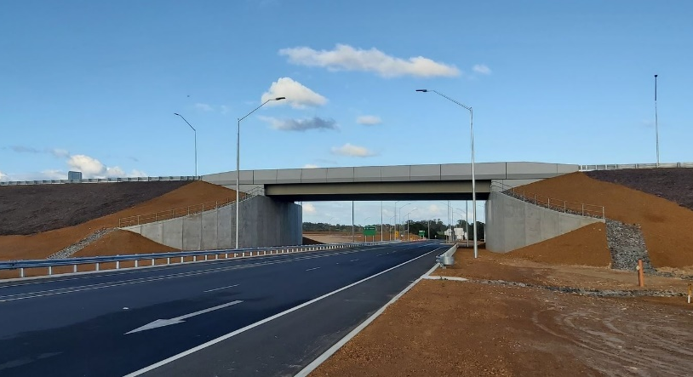
It is envisaged the project could comprise either individual artworks, or a theme extending across the three bridges.

Methodology – Public Art Advisory Group
A Public Art Advisory Group (PAAG) has been formed to liaise with the project’s artwork consultant to approve shortlisted artists, explore key themes and endorse design concepts.
The group will be chaired by the City of Albany, in acknowledgement that the artwork will be a community asset with the potential to build upon other City of Albany initiatives relating to recognition of local Indigenous culture.
It will also comprise two local Traditional Owner Elders from the Albany Heritage Reference Group and representation from Main Roads and Albany Ring Road Contractor Decmil.
Concept development and liaison with local artists will be led by leading creative consultancy FORM. FORM is an independent, not-for-profit arts and cultural organisation operating across Western Australia. FORM has facilitated numerous high profile art installation projects across Western Australia including the Field of Light: Avenue of Honour in Albany and the Public Silo Trail across various Regional WA towns.

Artist consultation and selection process
As an initial step, FORM will engage extensively with the Menang Noongar community to develop an understanding of key themes, stories and messages of cultural significance, as well as the significance of certain sites in the vicinity of the area. This consultation will be based on extensive research, building on FORM’s previous work in Albany. Equal opportunity will be provided for Traditional Owner representatives to get involved.
This initial consultation will be followed by the development of artist briefs and the release of an Expression of Interest. The Menang Noongar community will also have opportunity to review and confirm the shortlist of artists prior to its submission to the project’s PAAG for a final decision.

Installation
It is envisaged that the artwork will be installed on the first of the Albany Ring Road bridges, at Albany Highway (above-right), within the next 12 months.

Artwork will be installed at the bridges at South Coast Highway and Hanrahan Road / Frenchman Bay Road once the second phase of the project is completed in 2024.

Indicative timeline
June 2022 – Introductory PAAG meeting
July – September 2022 – FORM to undertake consultation for bridge artwork and provide a shortlist of preferred artists
September 2022 – PAAG select shortlisted artist(s) and concepts
September – October 2022 – Engagement of artists and development of design
November 2022 – PAAG to finalise design selection
November – December 2022 – Artwork finalised
Early 2023 – Artwork installation on Albany Highway bridge – the first of three bridges on the Albany Ring Road alignment

Find out more
For more information on the artwork strategy, or any other aspect of the Albany Ring Road project, contact our Team via 138 138 or email enquiries@mainroads.wa.gov.au
Any local artists wishing to register their interest in the project can contact FORM directly via email at mail@form.net.au

