Albany Highway bridge foundations taking shape

With the onset of the wet winter weather, the Albany Ring Road project team is focusing its efforts at the site of the new interchange at Albany Highway and Albany Ring Road.
Construction of the footings to support the new bridge over Albany Highway are progressing well, with reinforcing steel installed in preparation for a concrete pour. We anticipate that both footings for the bridge will be completed by the end of the month.
Completion of the footings will allow more visible bridge construction activity to take place. This includes installation of Mechanically Stabilised Earth (MSE) walls on each side of Albany Highway.
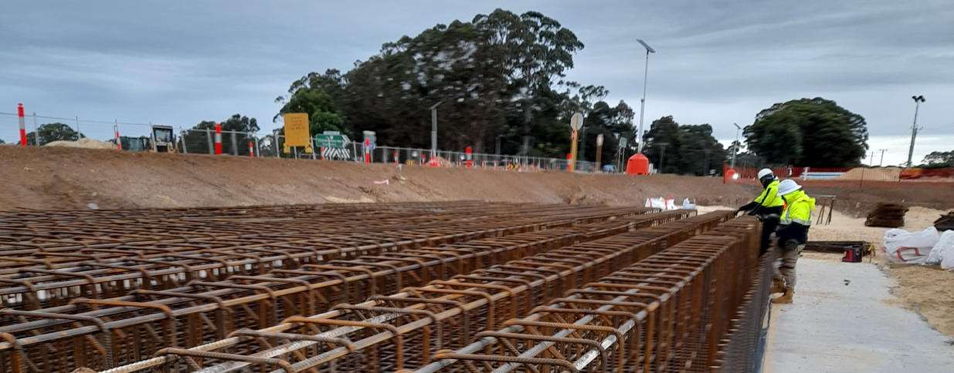
In the meantime, away from the site, our team has been overseeing the manufacture of the four main beams that will form the span of the bridge. Each reinforced beam measures around 33 metres long.
Reinforcing steel being installed ready for pouring the concrete bridge footings

Due to the specialised nature of the beams, they have been manufactured in Perth and following a period of curing will be transported down to the Albany Ring Road site in the coming months.

Main alignment update
Road users may have noticed that major construction work on the Albany Ring Road alignment between Albany Highway and Lancaster Road has paused in recent weeks. This is due to high levels of winter rain making meaningful road construction activity challenging and unproductive. This was anticipated prior to project commencement and was factored into the overall construction schedule.
A significant amount of earthworks on the main alignment have been completed, ready for the new road to be constructed in the Spring.

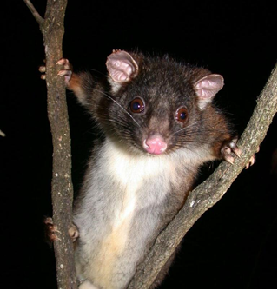
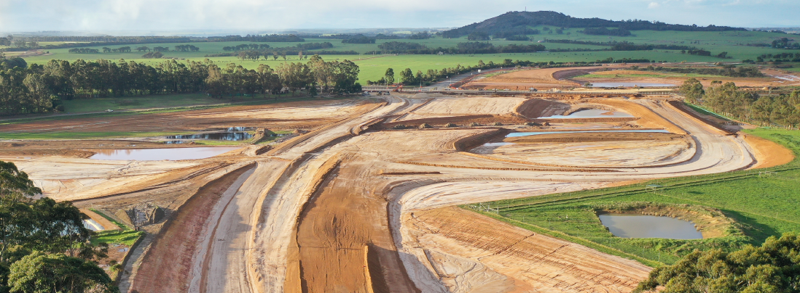
Majority of earthworks on the main alignment have been completed

Local conservation group working to inform better outcomes for endangered species
The Albany Ring Road team is working with the Torbay Catchment Group (TCG) who are volunteering their time to gather valuable independent information that will help the project plan and limit the impact of the Albany Ring Road construction on the critically endangered Western Ringtail Possum.
The TCG is undertaking Western Ringtail Possum counts and GPS logging along the Albany Ring Road footprint, as a continuation of their previous research into the movement of the possums in the area.
Recently a night-time (spotlight) survey was undertaken and 10 Western Ringtail Possums were spotted: two individuals and four pairs.
Western Ringtail Possum (source: Department of Biodiversity, Conservation & Attractions)
The data will be used in consideration of the best location for the planned fauna crossing to serve the local population movement.

Update on kangaroo population
The number of kangaroos living in and around the Albany Ring Road site has stabilised at around 60-80, down from between 250-300 at the start of the project.
In recent months, the kangaroos have migrated to alternative locations off Link Road, and continue to move between properties in response to environmental conditions.
While there have been isolated observations of displaced kangaroos on and around Link Road, the impact of the kangaroo migration from the Albany Ring Road site on the overall kangaroo population within the district appears to have been small.
There have also been no incidents or conflicts between the kangaroos and construction machinery.
Given the prevalence of kangaroos in the area west of Albany Highway, we remind road users to remain vigilant when passing through the area, particularly at night.

Further information
Project information is available at www. mainroads.wa.gov.au/projects, or by emailing enquiries@mainroads.wa.gov.au or phoning 138 138. You can also register for project updates by heading to our project webpage and subscribing for email updates.

