Beam lifts, deck pour, earthworks and roadworks
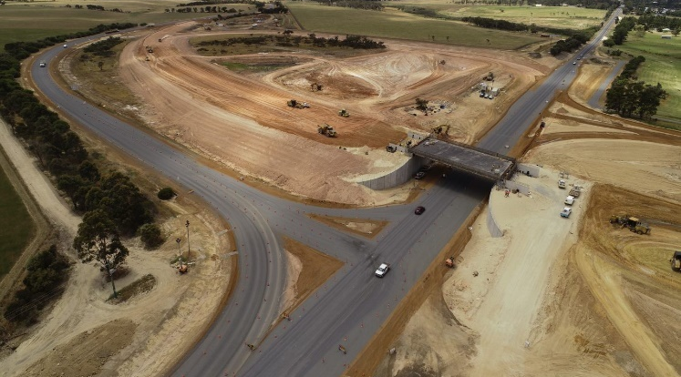
Above: South-east view of Albany Highway, the new bridge and Menang Drive intersection

The early summer months have been a busy time for the Albany Ring Road team, with the new bridge over Albany Highway taking shape and earthworks between Albany Highway and Lancaster Road in full swing.
Behind the scenes, we continue to refine designs for the second phase of the project, with construction to begin south of Lancaster Road early in the new year.
Key construction activities undertaken since September include:

- Backfilling of the east and west abutments to the bridge over Albany Highway.
- Installation of bridge beams.
- Concrete pour to form the bridge deck.
- Completion of permanent drainage works along Albany Highway, around the bridge works and ramps.
- Progressing ramp construction and earthworks to tie ramps into Albany Highway and Menang Drive.
- Reconstruction of Menang Drive and Albany Highway intersection.
- Sealing of Menang Drive.
- Reprofiling and sealing Albany Highway.
- Maintaining earthworks on the main alignment.

Menang Drive and Albany Highway interchange starts to shape the landscape
Road users, freight operators, local residents and visitors to the region would have noticed the new Menang Drive and Albany Highway interchange rapidly taking shape. This includes the new bridge over Albany Highway, which will allow traffic on the Albany Ring Road to flow freely through this location without having to stop.
In October, the project reached an important milestone with the installation of the bridge beams. The four 150 tonne, 33.3 metre reinforced concrete beams were lifted into place to form the span of the bridge over a period of two days. The installation was logistically complex, with consideration given to the transportation of the beams and crane from Perth, and detour arrangements for residents, visitors and heavy vehicles. Despite these challenges, the installation was completed safely and ahead of schedule.
With the beams securely in place, concrete pours to form the bridge deck took place in early December.
Bridge landscaping and artwork
The bridge is a major change to the landscape on the approach to Albany. A carefully considered painting and landscaping program is incorporated within the project, with the theme to extend to the other major interchanges along the Albany Ring Road alignment at South Coast Highway and Hanrahan Road / Frenchmans Bay Road respectively. In early 2022 we will work closely with local stakeholders and the broader community to confirm the artwork theme.
Above: Lifting beam 3 into position

Phase 2 preconstruction activities
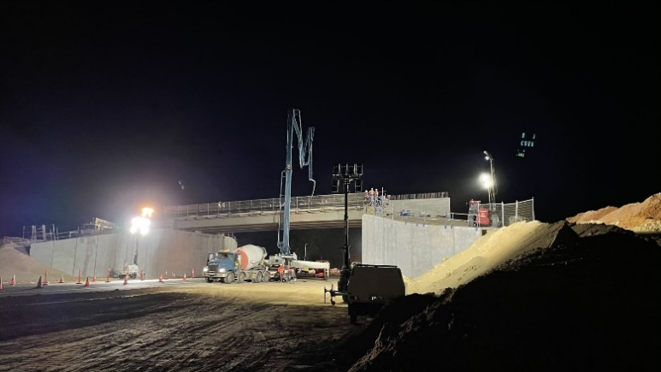
Early works activities are underway in preparation for construction of the second phase of the Albany Ring Road project, between Lancaster Road and Princess Royal Drive. This includes investigations (potholing) to identify the location of water and power services, as well as environmental and geotechnical surveys
Numerous underground and above ground services will be relocated early in the Phase 2 program to allow construction to proceed. Western Power will be relocating some service lines and power poles on Link Road, South Coast Highway and George Street as part of these early works.
Above: Early morning start for deck pour

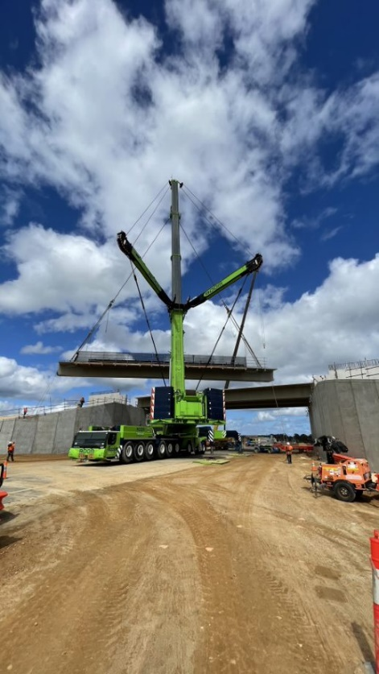

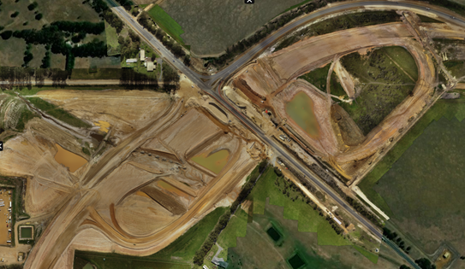
Environment approvals update
Environmental approvals have been received for the section of the Ring Road between Lancaster Road and South Coast Highway, with the remaining approvals anticipated early in 2022.
Fauna monitoring is currently being undertaken to help determine locations for fauna crossing points along the alignment.
Above: Aerial view of ‘capture and release’ drainage basins located either side of Albany Highway as part of Phase 1 drainage works

What to expect over summer
Summer is construction season. This is particularly the case in the Great Southern Region where work schedules are often constrained by wet weather.
To take advantage of the drier weather, from January to June 2022, the Project Team will significantly increase onsite activities to progress works as much as possible.
However, when combined with the onset of dry, windy conditions of summer, the intensified work schedule will generate dust as machinery moves through the site.
To minimise dust impacts to residents and road users, the team will run several water carts through the worksite as much as practicable to minimise dust impacts to residents and road users.
In addition, we are currently collating baseline data to enable comparative air quality and vibration monitoring to be undertaken as the project progresses.

Lookahead

Phase 1 (Menang Drive to Lancaster Road)
January – April 2022
- Earthworks will continue on the ramps and tie-ins to Albany Highway. Drainage and earthworks on the main alignment are also ongoing.
- This will be followed by construction of the road surface.
- The Menang Drive and Albany Highway interchange is on track for completion by early April 2022.

Phase 2 (Lancaster to Princess Royal) Update
January - April 2022.
- Road users will see additional pre-construction activities between Lancaster Road to South Coast Highway. This will include service relocations, vegetation clearing and installing revised cadastral boundary fencing.
- Earthworks on the western side of the South Coast Highway / Link Road intersection will also continue.
- During this period, we will also continue to develop detailed design and progress discussions and engagement with local stakeholders and the community.

Further information
Emailing enquiries@mainroads.wa.gov.au or call 138 138.

