Albany Highway bridge starts to shape the landscape

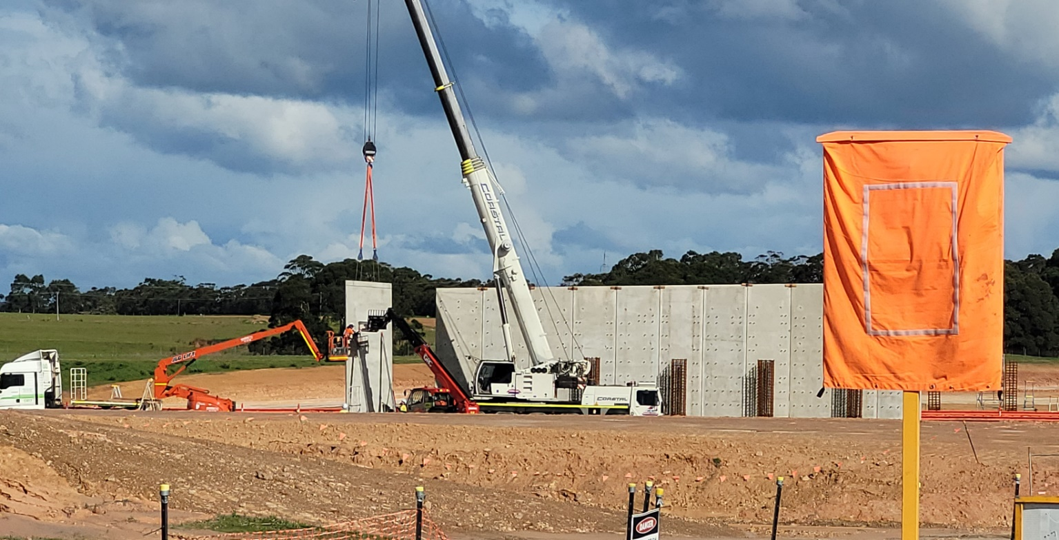
Construction of the eastern MSE wall along Albany Highway (view from Menang Drive
In recent weeks, road users on Albany Highway may have noticed the changing landscape as the new Albany Ring Road bridge starts to take shape.
Two Mechanically Stabilised Earth (MSE) walls have erected on either side of Albany Highway. A total of 57 concrete panels will support the span of the bridge, with each MSE wall to be backfilled over the next two months.
The steel support cages for central supporting piers are also in place.
These significant construction activities have been undertaken with minimal disruption to traffic on Albany Highway and Menang Drive.
Other key activity in July included the relocation of water and effluent services that run alongside Albany Highway. These activities are almost complete. Water Corporation will advise its customers directly of any impending disruption to services.
Earthworks on the main alignment are being maintained in preparation to recommence construction of the new road in Spring. Recent weather and current ground conditions remain unsuitable for road construction until after winter.
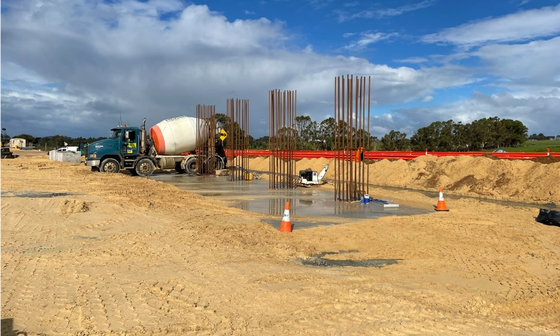

Beam installation
Reinforced concrete beams will be installed on the MSE walls to form the span of the bridge across Albany Highway. The beams will be transported from Perth to the Albany Ring Road site within the next couple of months and are expected to be installed in October 2021.
The beams, each measuring 33 metres long and weighing 150 tonnes, will be lifted and secured in postion by a large crane. Undertaking this safely will require a temporary closure of Albany Highway. We are conscious that this closure may cause some inconvenience and disruption to journeys, and specific timings and detour routes will be shared with the communities as soon as they are confirmed.

Central steel support piers taking shape

Further information
Project information is available at www. mainroads.wa.gov.au/projects, or by emailing enquiries@mainroads.wa.gov.au or phoning 138 138. You can also register for project updates by heading to our project webpage and subscribing for email updates.

