The freeway extension is taking shape with the first layers of asphalt laid and all bridges now under construction.
Earthworks are in their final stages across nearly 6km of new freeway, with attention shifting to drainage and pavements.
Road users may notice progress of the new northbound lanes, between Hester Avenue and Lukin Drive, with the first layers of asphalt laid in March.
Construction of the freeway interchanges are also underway, with the installation of the bridge piers and concrete walls in their advanced stages.
Forty bridge beams, ranging in size from 80 -110 tonnes are being cast offsite and will be transported for installation once the piers and walls are complete.
Mitchell Freeway is being extended from Hester Avenue to Romeo Road to bust congestion and improve connectivity in Perth’s rapidly growing north-west corridor. The $232 million project, along with the $25.2 million Wanneroo Road Duplication from Dunstan Road to Romeo Road, are jointly funded by the Australian Government and the Western Australian Government.
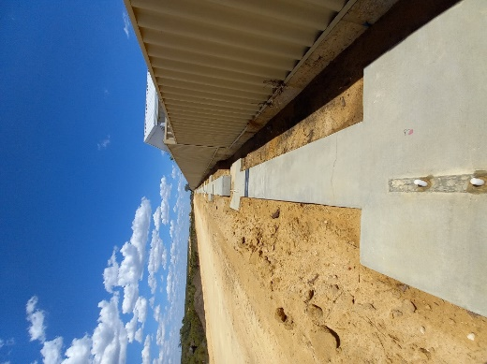
There have been some night works and early morning starts required for the construction of the bridges. We thank local residents for their patience as we undertake these works.

Providing noise mitigation for the local community
Construction of around 5.6kms of noise walls has started in some sections to limit noise from traffic on the extended freeway. Engagement with residents along the project boundary is underway.
Noise wall footings ready for the arrival of blocks
Constraints around supply of blocks and workforce availability has brought some challenges, however the project is actively working with suppliers and contractors to ensure noise wall construction continues to progress.

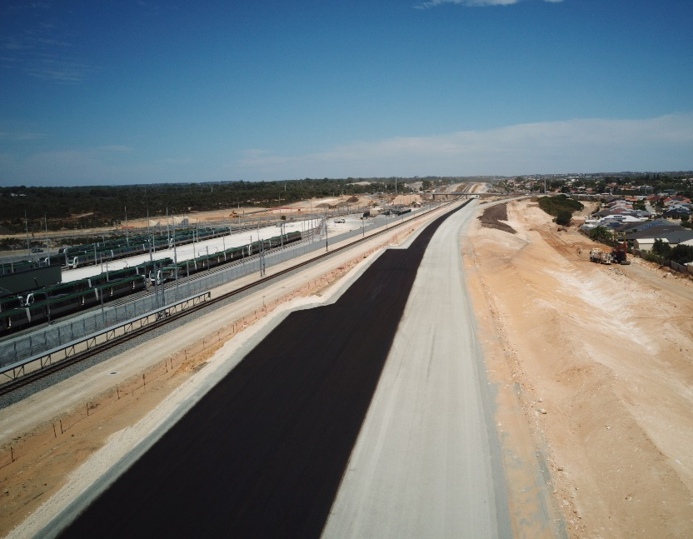
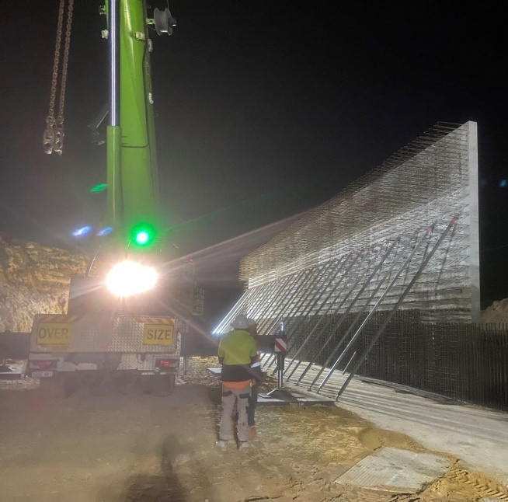
Upgrading Wanneroo Road and Romeo Road
Pre-cast panel installation for the freeway bridges has been undertaken over multiple night shifts.
Works to duplicate Wanneroo Road between Trian Road and Romeo Road are underway to improve safety on a section that has a particularly crash history and enable the road to manage with future traffic demands from the freeway. Design is in progress for the Wanneroo Road duplication south of Romeo Road to Dunstan Road.
Works to create a new east–west link between Wanneroo Road and Marmion Avenue, via Romeo Road, are also underway. This will improve connectivity to local schools, businesses and train stations, while taking pressure off parallel roads.
There are significant water and power upgrades associated with these works too, including the installation of 0.9m to 1.4m diameter wide water mains the length of Romeo Road.
While the work is being undertaken, Romeo Road is closed to all traffic. On Wanneroo Road, the speed limit through this section is 60km/h to ensure workers can operate safely in proximity to vehicles.

Continuing our commitment to Aboriginal engagement
Pavement construction of the freeway looking south from Lukin Drive to Hester Avenue.
Building on the success of the partnership with Quinns Rocks Primary School to build a yarning circle, the project continues to meet its Aboriginal engagement and participation targets.
This includes a minimum of 10% of total hours worked on the project allocated to Aboriginal employees and contractors and a minimum of 2% of the contract value being spent with majority owned Aboriginal businesses.
The project is working in partnership with Nudge to provide employment and training opportunities to Aboriginal people. Contact the project at enquiries@mainroads.wa.gov.au to find out more.

Review of our dust management controls
In response to recent community feedback, the project has completed a comprehensive review of its dust management controls.
Perth has experienced its hottest summer on record and the combination of hot days and strong winds have created higher levels of dust from the works.
Following the review, the following actions have been implemented:
- A 33% increase in the number of water trucks used to spray water on exposed earth to reduce wind erosion.
- A significant reduction in the number of vehicle movements in areas prone to nuisance dust.
- Increase in monitoring and controls of truck speed when operating in proximity to residents.

- Application of dust suppression crusting agents to stockpiles and areas that will not be accessed for long periods of time to stabilise surfaces.
- Enhanced monitoring of dust generating activities during hot temperatures and high winds, with rapid deployment of additional controls.
In addition to the above controls, the use of water trucks have been extended to include Sundays when the conditions warrant.
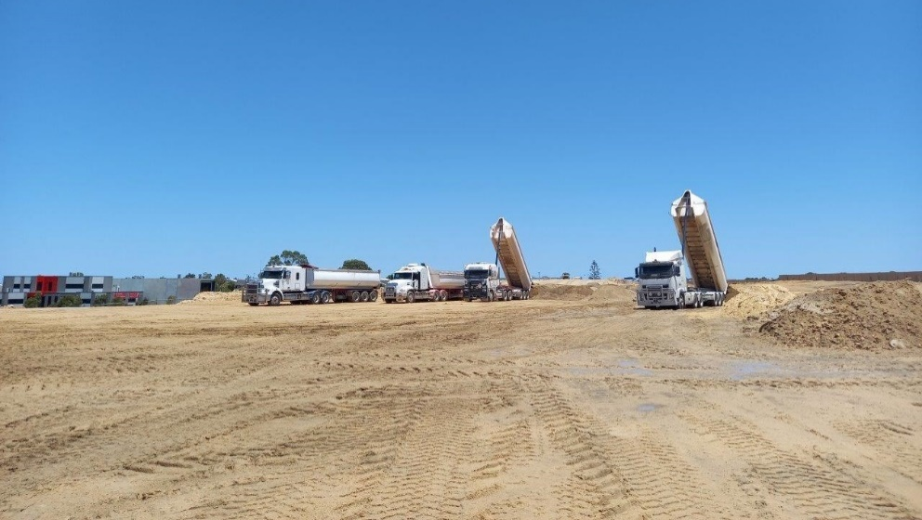
The project understands that nuisance dust is problematic for residents living in proximity to the works and is committed to reducing the impacts.
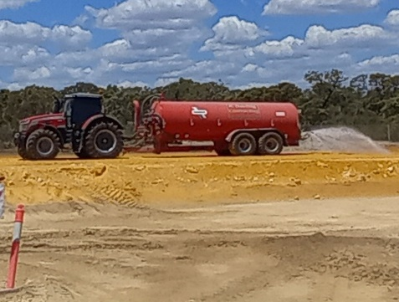
Water cart spraying water to supress dust.
Transferring surplus fill from Metronet.

Working with Metronet to achieve sustainable outcomes
Progress towards achieving the project’s sustainability targets was given a boost late last year when the project agreed to accept sand from METRONET’s Yanchep Rail Extension project.
Approximately 170,000 cubic metres of surplus fill is being transferred to the project to fill a shortfall in quality infill material.
This agreement significantly reduces the carbon emissions associated with transporting clean sand from across the Perth Metropolitan area.

Further information
If you would like further information, have any questions or concerns, you can contact us at 138 138 or email: enquiries@mainroads.wa.gov. au
You can also subscribe to receive updates directly to your inbox by registering your email on the project’s webpage: www.mainroads.wa.gov.au/mitchell-fwy-extension
While visiting our website, let us know how effective our communications are by clicking on 'feedback survey'.

