Local workforce engaged for design and construction contract
The extension of Mitchell Freeway is now underway to bust congestion and improve connectivity in Perth’s rapidly growing north-west corridor. The $215 million project is jointly funded by the Australian and Western Australian Governments, each contributing $107.5 million.

The Mitchell Extension Joint Venture (MEJV), on behalf of Main Roads, has been appointed to design and construct the Mitchell Freeway Extension project.
The joint venture comprising of two Australian owned construction companies, BMD Constructions and Georgiou Group, has engaged a local workforce of experienced and qualified professionals, and will draw on the expertise of local partners to deliver this important project.
The project office will be in Alkimos, and site compounds will be at the eastern ends of Lukin Drive and Butler Boulevard to allow easy access to and from the works.

About the project
The project will extend Mitchell Freeway 5.6 km north, from Hester Avenue to Romeo Road, with two lanes in each direction. Freeway access points will be constructed at Hester Avenue, Lukin Drive and Romeo Road.
Enhancements to the Local Road Network include widening Lukin Drive to Connolly Drive, and duplicating Wanneroo Road from south of Romeo Road to Trian Road. Romeo Road will also be constructed as a dual carriageway from Marmion Avenue to Wanneroo Road, with signal modifications at the Marmion Avenue intersection, an intersection upgrade at Wanneroo Road, and a new intersection at Benenden Avenue.
A Principal Shared Path (PSP) will be built on the western side of the freeway and will include a pedestrian underpass at Lukin Drive. A new shared path will also be constructed on Romeo Road to link the cycle network to Marmion Avenue.
The works complement the METRONET Yanchep Rail Extension as part of a whole of network transport strategy to manage the future growth of Perth’s northern suburbs.

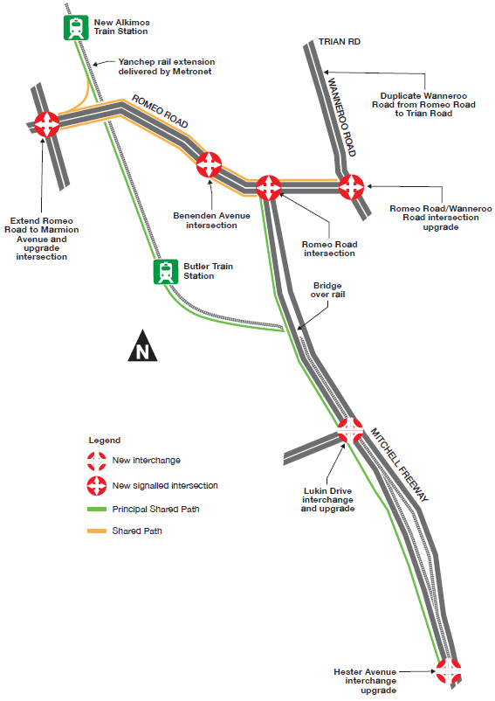
Progress so far
Detailed design is well underway, with the construction scheduled to commence by mid-2021.
Investigative works have commenced to locate utilities, complete geotechnical investigations and undertake surveying.

Protecting native animals
Installation of a fauna fence will begin in May, in line with the commencement of clearing activity. It will be installed along the entire western side of Neerabup National Park to prevent large fauna movements into the project site.
Fauna capturing by professional fauna handlers will also start in May, prior to vegetation clearing. Animals will be relocated to the National Park, with input from the Department of Biodiversity, Conservation and Attractions.
The species identified as potentially requiring relocation includes the Southern Brown Bandicoot, Western Brush Wallaby, Black-striped Snake and Jewelled Ctenotus (skink).

Truck movements
One of the challenges of delivering this exciting project is the relocation of 300,000 cubic metres of earth from the southern project area to the northern area.
The train line cuts the worksite in half, which requires trucks to enter and exit the worksite at dedicated entrances at the eastern end of Lukin Drive and Butler Boulevard.
We carefully assessed the available haulage routes and determined that using a combination of Connolly Drive and Marmion Avenue will minimise the project’s impact on local businesses, schools and residents.

Noise walls
Noise walls will be constructed from reconstituted limestone blocks between Hester Avenue and Romeo Road.
The exact location and heights will be advised in future updates. Residents who will have a wall installed on their rear boundary will receive individual notification.

Further information
You can contact us at 138 138 or enquiries@mainroads.wa.gov.au
You can also subscribe to email updates on the project’s webpage: www.mainroads.wa.gov.au/Mitchell-fwy-extension

