As part of the Mitchell Freeway Extension project, noise walls will be installed between Hester Avenue and Romeo Road to reduce traffic noise for local residents.

Design and location
Noise walls are designed to keep the noise generated by traffic below the limits set by State Planning Policy 5.4. The project has undertaken noise modelling to determine the location and heights for noise walls when the predicted future noise levels are likely to exceed the allowable levels set in the Policy.
Once installed, the noise walls may also provide added aesthetic, screening and security benefits. These are not the primary purpose of the walls, except where overlooking from adjacent bridges and roads may be a problem.
In designing a noise wall, the materials used must be thick enough to act as a noise barrier and high enough to limit noise travelling over the wall. Where gaps are required between walls, the walls will overlap to prevent noise from travelling around corners and through the gap.
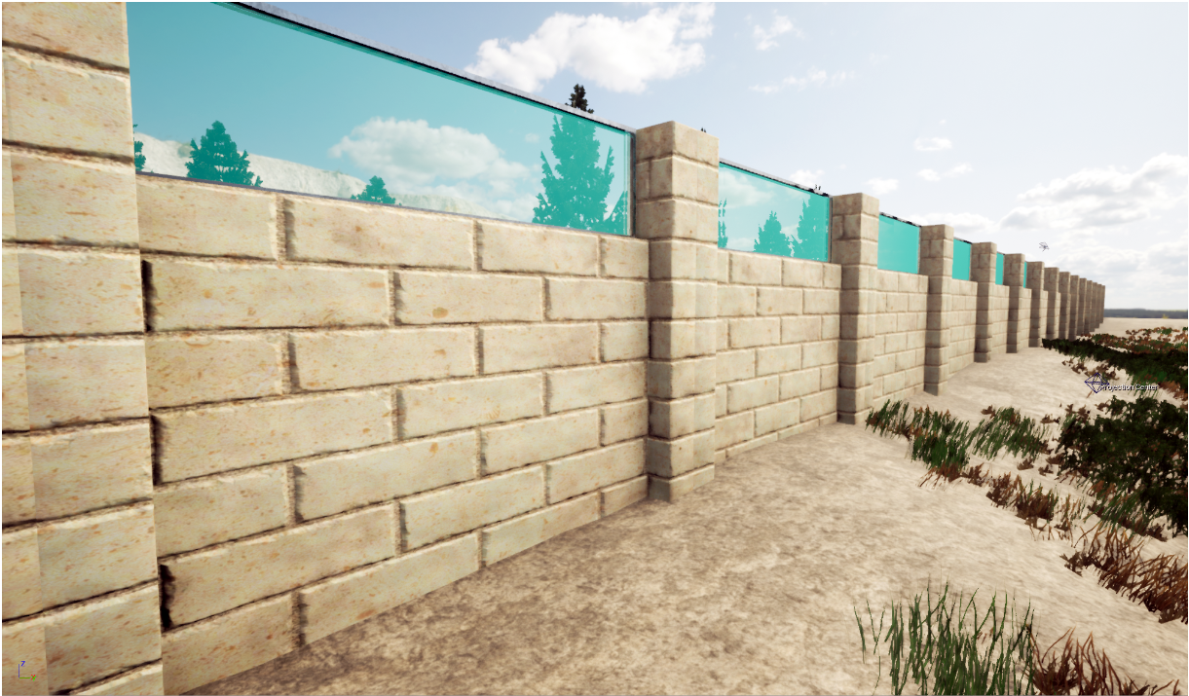
Artist impression of acrylic panels
Noise walls will have a minimum height of 2.4m measured from the ground level of a property boundary on the residential side, or the top of a retaining wall. Noise walls that exceed 3m in height will have tinted acrylic panels installed from 2.7m high to allow light to come through into backyards and reduce shadowing effects. The maximum height on noise walls will be 5m. Heights are determined through a complex noise modelling process undertaken by experts in acoustics.
Noise walls will be installed along the western side of the freeway from Hester Avenue to Romeo Road. They will be within the road reserve as close as possible to residential boundaries.

Construction
Noise walls will be constructed using cream Eco-Blocks; a key sustainability initiative for the project. These blocks are made from crushed limestone and recycled crushed concrete to deliver a high-quality product with similar appearance to reconstituted limestone blocks.
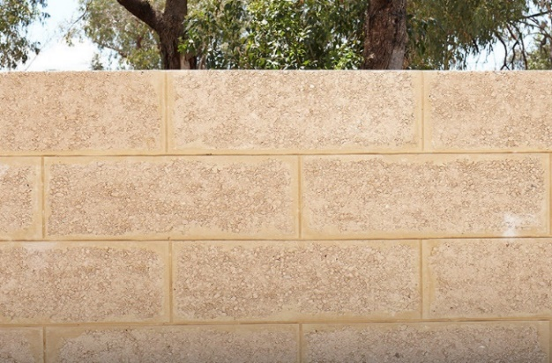
Cream Eco-Blocks
We will communicate with homeowners/tenants individually on the specifics of the construction process including access and timing. It is likely access to the rear of properties will be necessary to construct the walls and the option for us to remove the existing fence will be available for residents. For more information, visit our project webpage at https://project.mainroads.wa.gov.au/home, call 138 138 or email enquiries@mainroads.wa.gov.au.

