The Mitchell Freeway is being extended from Hester Avenue to Romeo Road. A comprehensive sustainability framework has been developed to manage the project’s impacts on the local environment.

Vegetation clearing
In early May 2021, the removal of vegetation in the road reserve, between Hester Avenue and Romeo Road, and Romeo Road and Marmion Avenue, will begin.
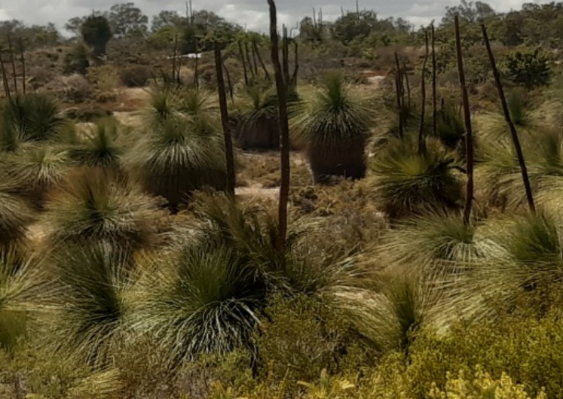
The clearing is necessary to extend the freeway, and construct the Principal Shared Path, local roads and noise walls.
Grass Trees in the road reserve
Vegetation has been assessed and strict clearing permits and approvals have been issued by the relevant authorities.
Emus passing through the road reserve
While the removal of vegetation and the accompanying earth works may have the potential to increase the visibility of the new freeway, the absence of the vegetation will not increase noise transmission to neighbouring residents. Noise walls will be installed on residential boundaries.

Replanting and revegetation
Arrangements are now in place for a selection of native plants that respond well to relocation (such as grass trees) to be replanted at local schools. Larger pieces of timber will also be made available to local schools for use in playgrounds.
The remaining vegetation will be mulched and used as part of the revegetation process. The revegetation of the road reserve will include native vegetation species, and endemic tube stock and seeds. This will occur once construction works are complete and will be timed to coincide with optimum wetter months for planting.
Protecting Native Animals
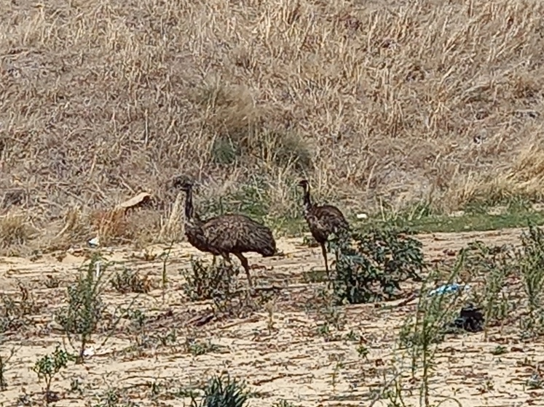
A fauna fence will be installed along the entire western side of Neerabup National Park to prevent large fauna movements into the project site.

Fauna trapping will be undertaken by ecologists to relocate fauna of significance to adjacent National Park areas. Fauna trapping is scheduled to commence in late April 2021, prior to vegetation clearing in May 2021.
The species identified by the project as potentially requiring relocation include the Southern Brown Bandicoot, Black-striped Snake, Jewelled Southwest Ctenotus (skink) and Western Brush Wallaby.
A new fauna and pedestrian underpass will be installed at Romeo Road on the Yaberoo Budjara trail to allow fauna connectivity between north and south of Romeo Road.
Tree hollows are being identified and relocated to the Kaarakin Black Cockatoo Centre (a specialist wildlife centre located in Perth Hills), where they will be reused as fauna habitat.
Salvaged timber will also be available for some schools.

Sustainability
The project is using the Infrastructure Sustainability Council of Australia 2.0 Rating Scheme, which evaluates the sustainability performance of the quadruple bottom line (Governance, Economic, Environmental and Social) of infrastructure development.
In addition to assessing opportunities to deliver more sustainable infrastructure, the project is actively exploring the following sustainability initiatives.
Use of Eco Blocks – Approximately 5km of noise and screening walls will be constructed using environmentally conscious Eco Blocks. These blocks are made from crushed limestone and crushed recycled concrete to deliver a high quality product with similar appearance to reconstituted limestone blocks.
Electrical Vehicle Trial – Two PEVs (Plug-in Electrical Vehicles) have been purchased by the project as a part of a Main Roads trial to assess the suitability of PEVs on major infrastructure projects.

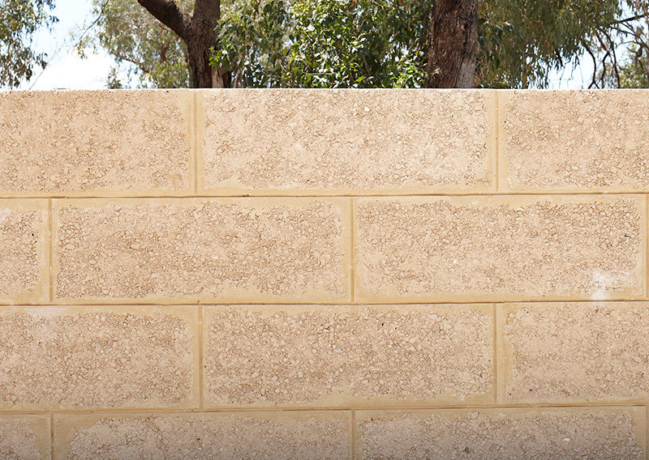
Cream Eco Blocks
Adaptability to climate change – The project is considering the impact of climate change over the 100-year life of the assets and considering initiatives to create resilience in response to changing climatic conditions.
Future proofing – The future needs of other agencies, including water and power have been considered in the project’s design. Their inclusion will reduce the need for costly retrofitting that often requires demolition and reconstruction of infrastructure assets.
The project is also actively exploring additional initiatives to utilise crushed recycled concrete (CRC) and the installation of energy efficient LED street lighting on the freeway and shared paths.

Further information
If you would like further information, have any questions or concerns, you can contact us at 138 138 or email: enquiries@mainroads.wa.gov.au
You can also subscribe to receive updates directly to your inbox by registering your email on the project’s webpage: https://www.mainroads.wa.gov.au/Mitchell-fwy-extension

