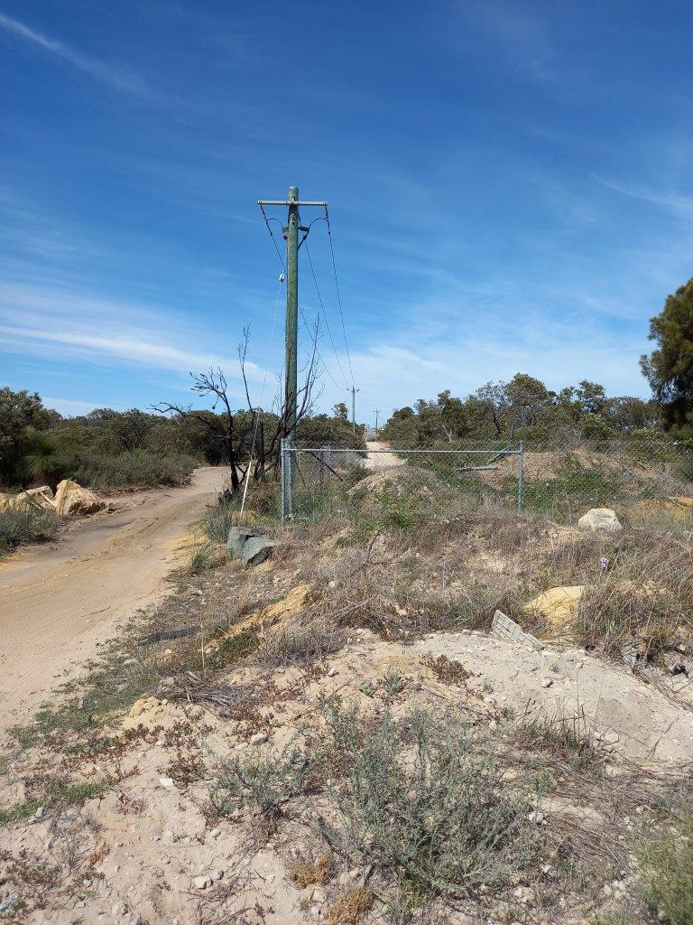
Site establishment
Over the next few weeks, project activities will start to ramp-up around the work site including the establishment of site compounds and fencing the road reserve.
Fencing the road reserve is necessary to prevent unauthorised access during the works and to ensure a safe distance is maintained between the community and construction machinery.
Fauna fencing will be installed on the eastern side of the road reserve to prevent larger animals from straying into the work site.

Illegal dumping of rubbish
The project is aware of illegal rubbish dumping within the road reserve area. We remind community members that fines of up to $5,000 for individuals and $10,000 for corporations apply to illegal rubbish dumping.
With our increased presence onsite and monitoring (including CCTV), we will be actively monitoring suspicious vehicles movements in the area and reporting rubbish dumping to the authorities. In cases of littering from vehicles, the registered owner of a vehicle can be deemed to have committed the offence and may have to pay the fine unless they can identify the offender.

Closures and changes to tracks
Once the road reserve is fenced, public access to existing informal tracks will be removed. This includes tracks in the following locations:
- East-west tracks between Romeo Road to Marmion Avenue
- North-south tracks between Hester Avenue and Romeo Road

In addition to the closure of informal tracks, the project is negotiating with the Department of Biodiversity, Conversation and Attractions to realign a small section of the Yaberoo Budjara Walk Trail in the Neerabup National Park. Access through the National Park will be maintained at all times.

Further information
To stay up to date with the project, you can subscribe to email notifications via our project webpage at https://www.mainroads.wa.gov.au/Mitchell-fwy-extension
24/7 project information line that can be contacted on 138 138 or email enquiries@mainroads.wa.gov.au

