Project works depot establishment
During April and May, initial works will begin for the Mitchell Freeway Extension project, including setting up temporary works depots.

Depots will be established at the eastern ends of Butler Boulevard and Lukin Drive in preparation for the start of construction works.
These depots will be created in April and May 2021 and will remain in place until the project’s completion in 2023.
The depots will typically operate from 6am to 7pm, and occasionally during scheduled night works.
They will include car parking for light vehicles, construction equipment, trucks, demountable accommodation for offices, meeting rooms and toilets, and may be used to store construction materials at various stages of the project in amongst other things.
Each depot will be fenced and security will include CCTV, lighting and motion detectors with regular security checks.
To limit interaction with local traffic, access to the depots will be via Butler Boulevard and Lukin Drive.
Works, vehicle and machinery movements may be noticeable in the areas, however we will make every effort to minimise impacts where possible.
We also have a significant proportion of the project workforce in an existing office space in Alkimos.
The approximate location of each depot is presented on the reverse.

Further information
The project is in its early stages and we are in the process of creating additional communications to keep the community informed.
To stay up to date with the project, you can subscribe to email notifications via our project webpage at https://www.mainroads.wa.gov.au/Mitchell-fwy-extension
There is a 24/7 project information line that can be contacted on 138 138 or email enquiries@mainroads.wa.gov.au

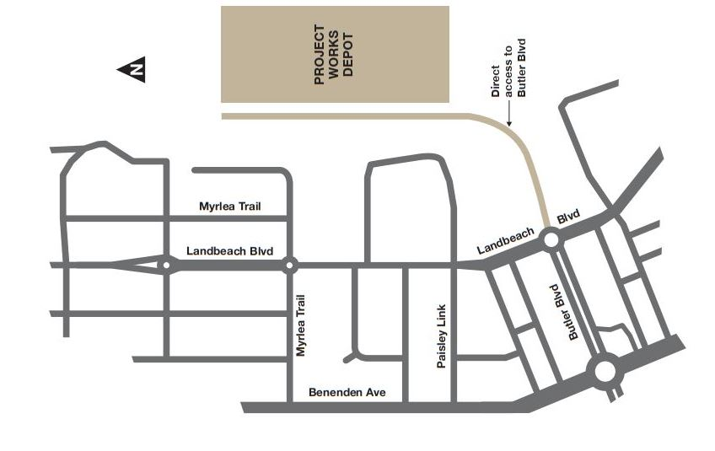
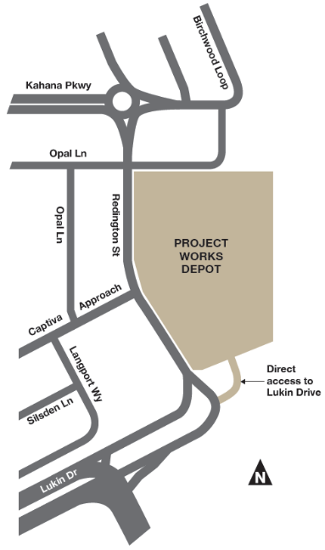
Areas are indicative only and not to scale

Butler Boulevard Depot

Lukin Drive Depot

