The Mitchell Freeway Extension project is progressing well, with construction underway across the entire alignment.
Construction activities commenced in May 2021 and have included the establishment of site depots, clearing, fencing and earthworks.
3.2 million tonnes of earth is being moved across 6kms of the worksite and approximately 800,000 tonnes of earth is being transported using trucks, via Lukin Drive and Butler Boulevard.
These truck movements will continue until late 2022.
A new interchange at Butler Boulevard
Mitchell Freeway is being extended from Hester Avenue to Romeo Road to bust congestion and improve connectivity in Perth’s rapidly growing north-west corridor. The $232 million project is jointly funded by the Australian and Western Australian Governments, each contributing $116 million.

In May 2021, the Federal and State Governments announced funding for a new freeway interchange at Butler Boulevard to be included in the project’s scope.
The Butler Boulevard interchange will increase the number of freeway accesses to four between Hester Avenue and Romeo Road. It will also create a more even distribution of traffic on local roads and improve connectivity for residents and businesses in Butler and Jindalee.
A pedestrian underpass will be constructed for uninterrupted journeys on the freeway Principal Shared Path and connect to the Neerabup National Park.
The interchange is currently in the design phase, with construction to be integrated into the existing program.
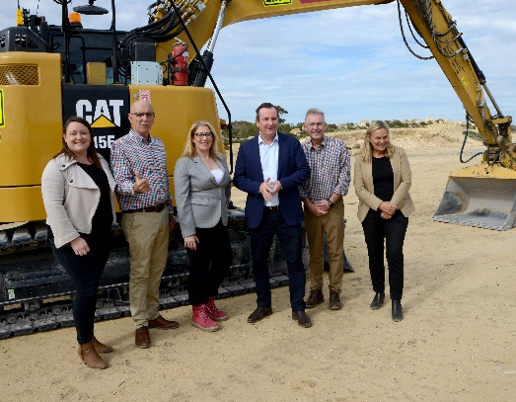
Local members Emily Hamilton (Joondalup), John Quigley (Butler), Transport Minister Rita Saffioti, Premier Mark McGowan, Mark Folkard (Burns Beach) and Sabine Winton (Wanneroo) at the project’s ground-breaking ceremony.

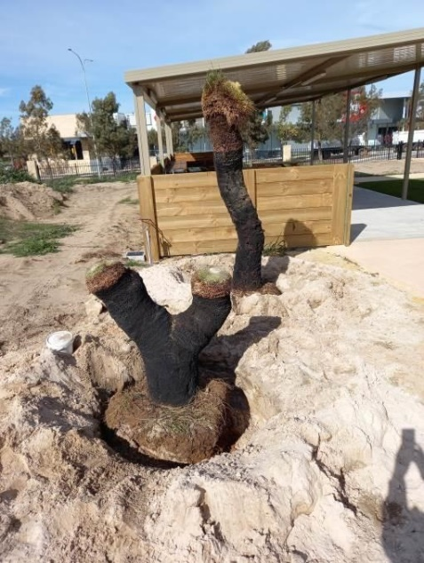
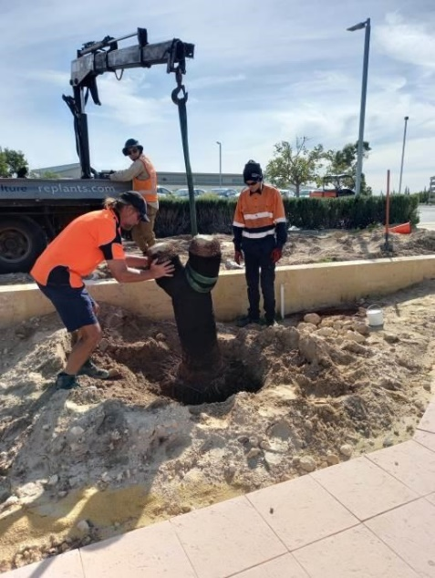
Sustainability focus
Grass tree relocation and fauna relocation prior to clearing works commencing.
As part of clearing activities, the project has attempted to relocate as many native plants as possible.
St James Anglican School, Quinns Rocks Primary School, Northshore Christian Grammar School and Atlantis Beach Baptist College have all accepted grass trees from the project.
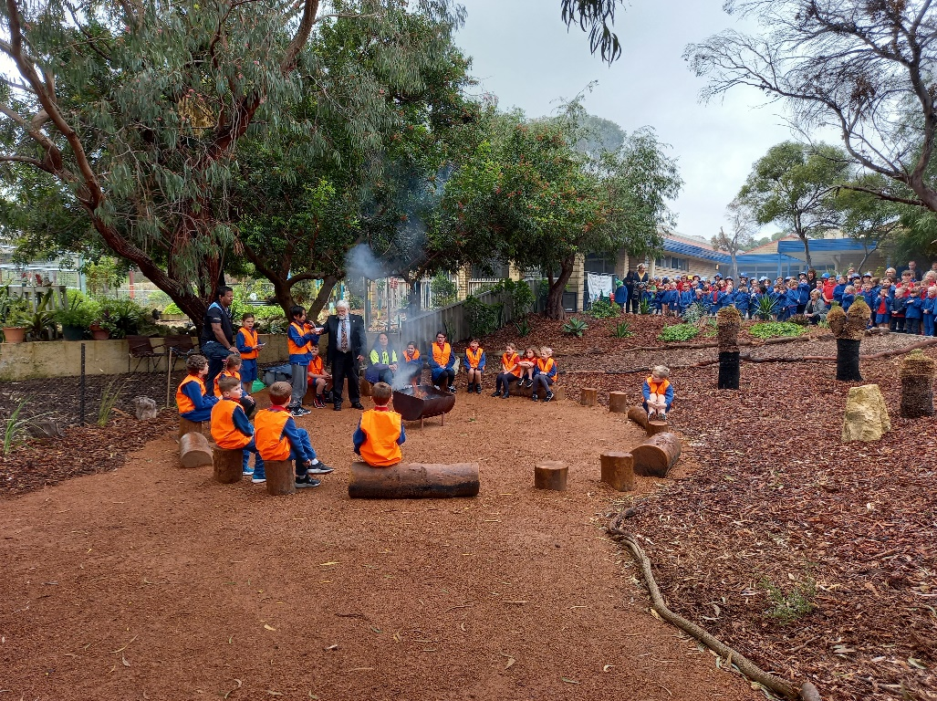
The trapping and relocation of animals prior to the removal of vegetation has been a great success, with no fauna fatalities reported due to works.
The relocations included 58 Southern Brown Bandicoots, 10 Western Grey Kangaroos, and 2 Emus.
In addition to trapping, spotters walked in front and behind machinery to usher animals into the Neerabup National Park.
Fencing and barriers have also been installed to prevent animals from returning to the work area.

Aboriginal engagement
Grass trees and materials that required clearing for the project have been reused to create a Yarning Circle at Quinns Rocks Primary School.
A Yarning Circle created using relocated grass trees and cleared materials.
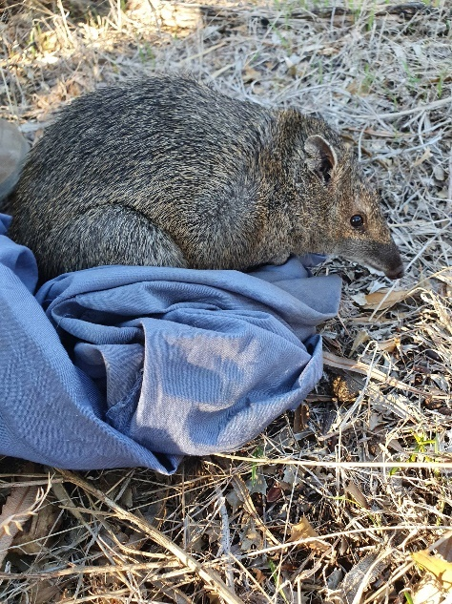
The Yarning Circle draws on 40,000 years of local Whadjuk Noongar history to inspire respectful and honest conversations.
It will be used by the school for oral language activities and provides them with an open environment to share cultural knowledge, communicate and problem solve as teams. It teaches the importance of listening and respecting the ideas and opinions of others.

Gravel, mulch, logs, rocks, cycads and 12 mature grass trees from the project site were used to create the circle.
The school gardener added a pathway to look like a stream flowing into the circle, that would ‘carry’ children to the Yarning Circle.

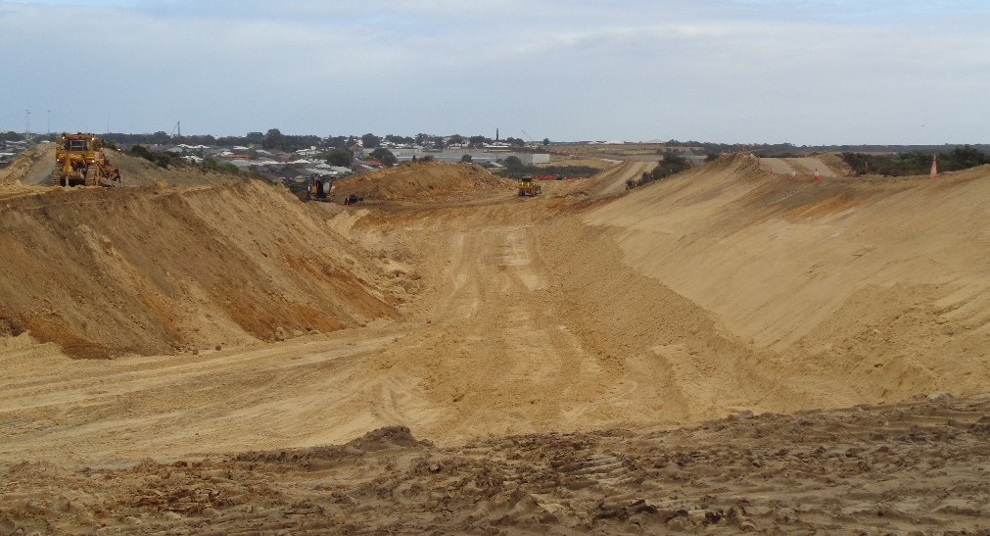
New connections for the local community
In addition to benefits the freeway extension will bring residents, the project is also improving connections in the local community in the following ways:
- The extension and dualling of Romeo Road from Wanneroo Road to Marmion Avenue to improve access to Alkimos and Eglinton.
- The widening of Lukin Drive to Connolly Drive, to pre-emptively improve congestion and safety along Lukin Drive; a new link to the Mitchell Freeway. These were optional works now being undertaken by the project.
Construction has been underway since May 2021
- 13.7km of new cycling and pedestrian paths including 5.7kms of new Principal Shared Path (PSP).
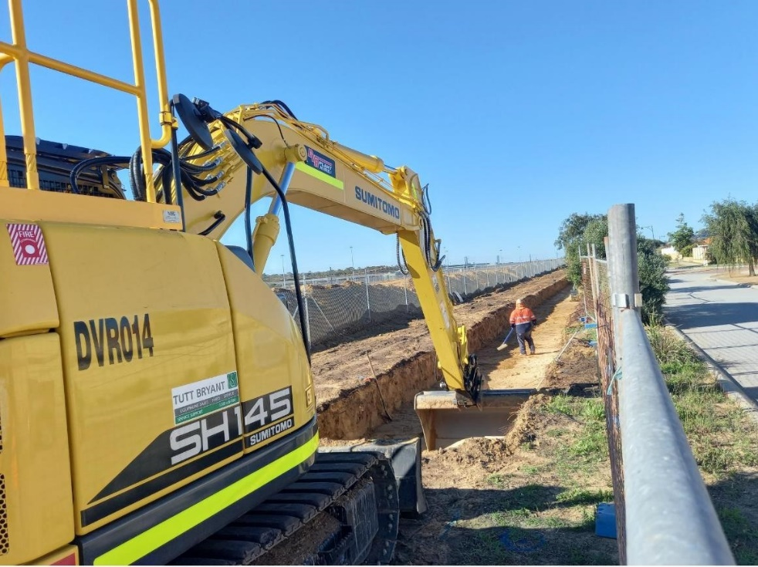
- New cycling and pedestrian connections into the Neerabup National Park from Lukin Drive and Butler Boulevard.
Noise wall construction in Ridgewood

Noise mitigation measures
Noise walls will be constructed at selected locations between Hester Avenue and Romeo Road.
The design of the noise walls and the construction scheduling is entering their final stages.
The construction of small sections of noise walls in Ridgewood has already started.
Residents that will have noise walls constructed on their boundaries are receiving regular updates on the progress of noise walls near their properties.

Further information
If you would like further information, have any questions or concerns, you can contact us at 138 138 or email: enquiries@mainroads.wa.gov.au
You can also subscribe to receive updates directly to your inbox by registering your email on the project’s webpage: www.mainroads.wa.gov.au/mitchell-fwy-extension
Let us know how effective our communications are by visiting our project website and clicking on ‘feedback survey’

