# Pavement works

Pavement works will start in November on the new freeway lanes being constructed as part of the Mitchell Freeway Extension project.

The pavement is the top section of the roadworks that eventually receives the bitumen treatment. This layer requires the most work and is the most important layer. The construction process involves building the pavement in layers and takes several months. Each new layer requires compacting to ensure the new surface can withstand the stress that will be applied when the lanes are open to traffic (refer to the image on the reverse).

Compaction activities will continue over the next twelve months along the 5.6km length of the project. During this period, you may hear unusual noises and sense vibrations in your home. This is likely to be intermittent, with short periods of intense activity followed by lengthy periods of limited activity.

These noises and sensations are being generated by compaction equipment that are designed to limit the impact on residents and the potential for damage to neighbouring structures, including homes.

# Managing construction impacts

Sensor equipment is strategically located across the project site to monitor and record vibration levels. The results are used to actively manage vibrations and to ensure the levels remain below the threshold for damage to structures.

During construction, residents near the works may feel intermittent vibrations from construction activities. This might include door and window screens shaking and a rattling sound. Tightly packed glassware or ceramics with poorly fitted lids may also produce a rattling sound.

Humans are sensitive to vibrations and can detect very low vibration levels. When this sensitivity to vibrations is partnered with rattling sounds the experience may be unsettling but is unlikely to cause damage.

A Vibration Management Plan is in place and is used to regulate and manage vibration generated by the construction activities. The plan includes:

* Ongoing monitoring of vibration levels near residential and business structures.
* Adherence to the relevant Australian standards for acceptable vibration levels for humans and structures.

# Further information

To stay up to date with the project, subscribe to email notifications via our project webpage at <https://www.mainroads.wa.gov.au/mitchell-fwy-extension>

While visiting our website, you can also let us know how effective our communications are by clicking on 'feedback survey'.

We also have a 24/7 information line that can be contacted on 138 138 or email [enquiries@mainroads.wa.gov.au](mailto:enquiries@mainroads.wa.gov.au)

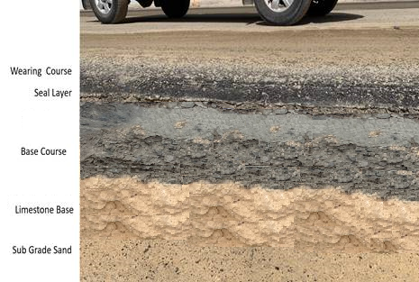

Representation of the layers required to construct the Mitchell Freeway extension. Each layer requires compaction.