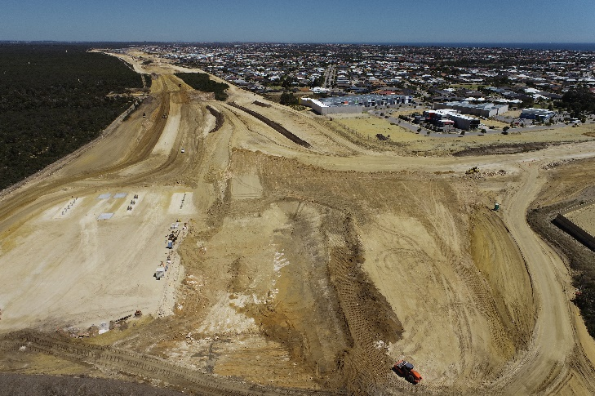
Construction has been underway on the Mitchell Freeway Extension since May and has progressed well throughout the year, with bulk earthworks continuing across the site and pavement works recently commencing between Hester Avenue and Lukin Drive.
Construction activity on Wanneroo Road
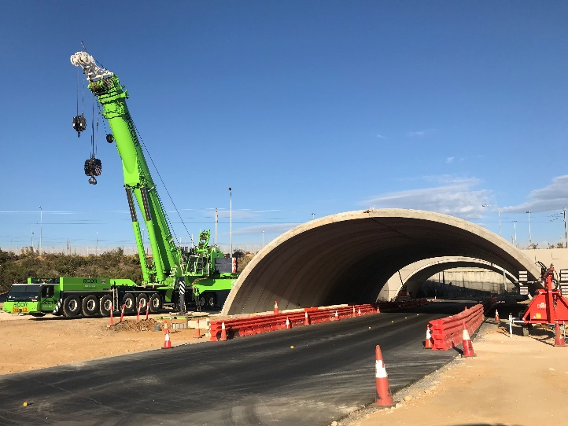
The removal of vegetation along Wanneroo Road on the western side is complete, with a small section to be removed on the eastern side in early 2022, when works recommence. Installation of traffic barriers on the western side of Wanneroo Road will also occur early in 2022 to enable drainage and pavements to be installed, along with surveying to locate services between Romeo Road and Dunstan Road.
Figure 1 - Drone footage of the project (Butler Boulevard).

Traffic Management over the holiday period
Over the holiday period, traffic management and reduced speeds will remain in place as follows:
- Lukin Drive between Connolly Drive and Redington Drive: Speed reduced to 40km/h and traffic management
- Wanneroo Road between Romeo Road and Trian Road: Speed reduced and traffic management
There will be reduced activities on site, however security and site inspections will continue.
Figure 2 – Arch structure installation for the new Nowergup Public Transport Authority Depot bridge
Retaining the reduced speed limit is particularly important for people who infrequently use these roads and will be unfamiliar with the changed conditions.

Further information
To stay up to date with the project, subscribe to email notifications via our project webpage at https://www.mainroads.wa.gov.au/mitchell-fwy-extension
While visiting our website, you can also let us know how effective our communications are by clicking on 'feedback survey'.
We also have a 24/7 information line that can be contacted on 138 138 or email enquiries@mainroads.wa.gov.au

