Construction has been underway on the Mitchell Freeway Extension to Romeo Road since May 2021 to bust congestion and improve connectivity in Perth’s rapidly growing north-west corridor.
Earthworks are continuing with over 670,000m3 of material placed on site so far, with fill being transferred between Lukin Drive and Butler Boulevard, and along the southbound alignment. Drainage works have commenced on the northbound carriageway, along with the excavation of footings for a PTA rail arch and Lukin Drive interchange. Noise wall construction has continued including footings and the laying of limestone Ecoblocks in multiple locations.
See below some recent drone footage captured of the progress so far, moving north from Hester Avenue.
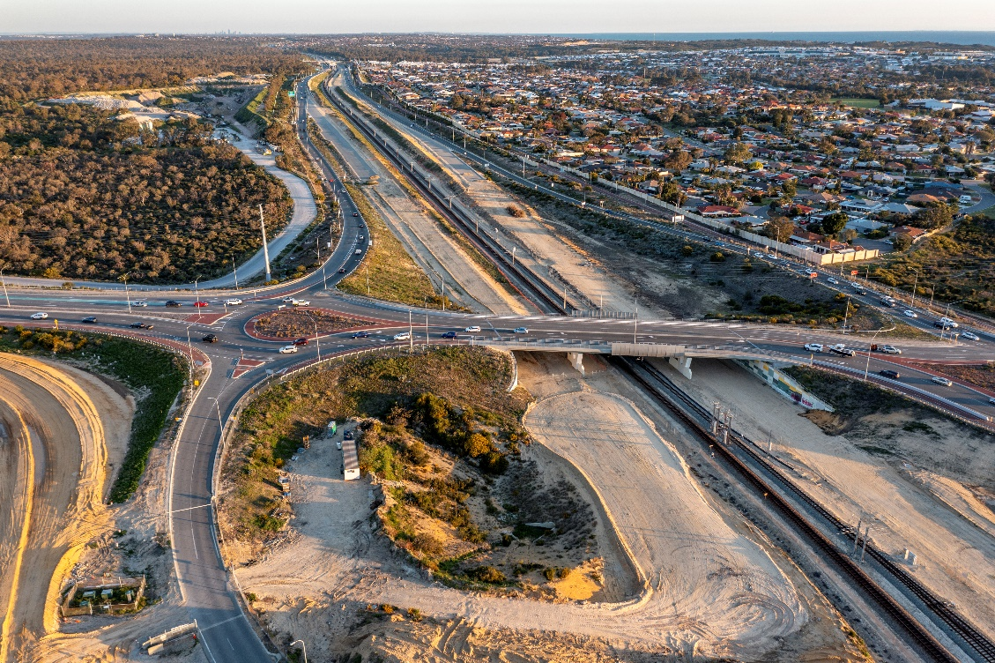
Figure 1 – Looking south over Hester Ave, some preliminary works have commenced for connection to the Freeway.
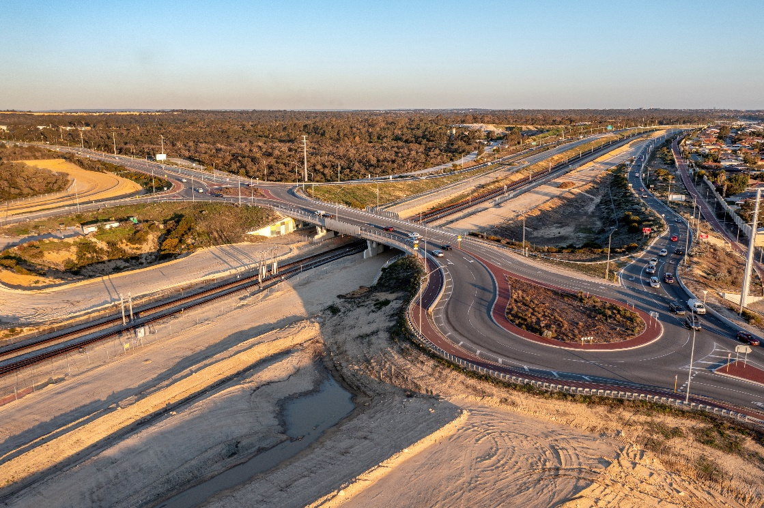
Figure 2 – Looking Southeast over Hester Ave with some earthworks and drainage works in the foreground.
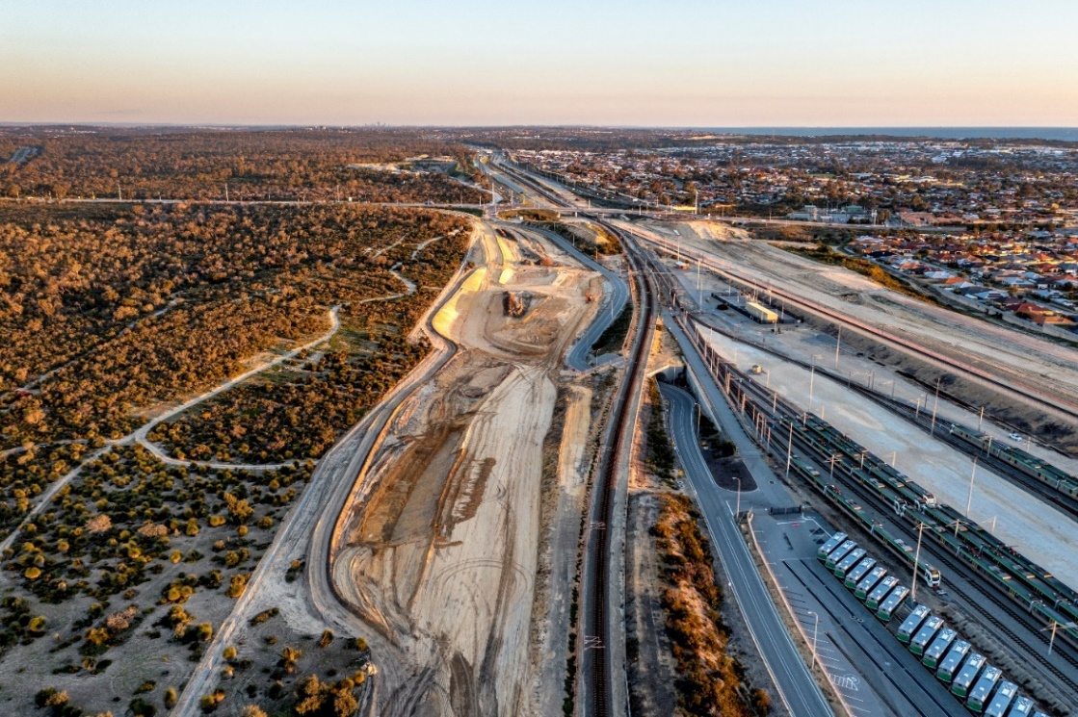
Figure 3 – Looking South from Rail Depot to Hester Ave showing earthworks in progress for realignment of Depot access road.
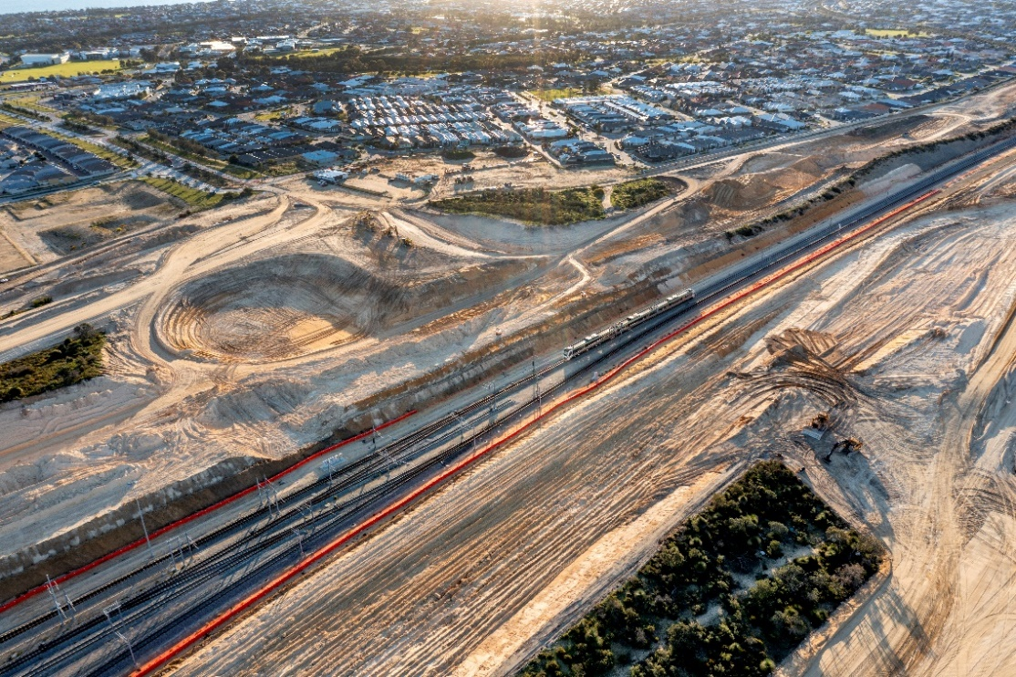
Figure 4 – Looking North West at the northern extent of the Rail depot showing current earthworks for both Southbound and Northbound carriageways of the Freeway where they start to diverge to go around the Depot.

If you would like further information, have any questions or concerns, you can contact us at 138 138 or email: enquiries@mainroads.wa.gov.au
You can also subscribe to receive updates directly to your inbox by registering your email on the project’s webpage: www.mainroads.wa.gov.au/mitchell-fwy-extension
Let us know how effective our communications are by visiting our project website and clicking on ‘feedback survey’

