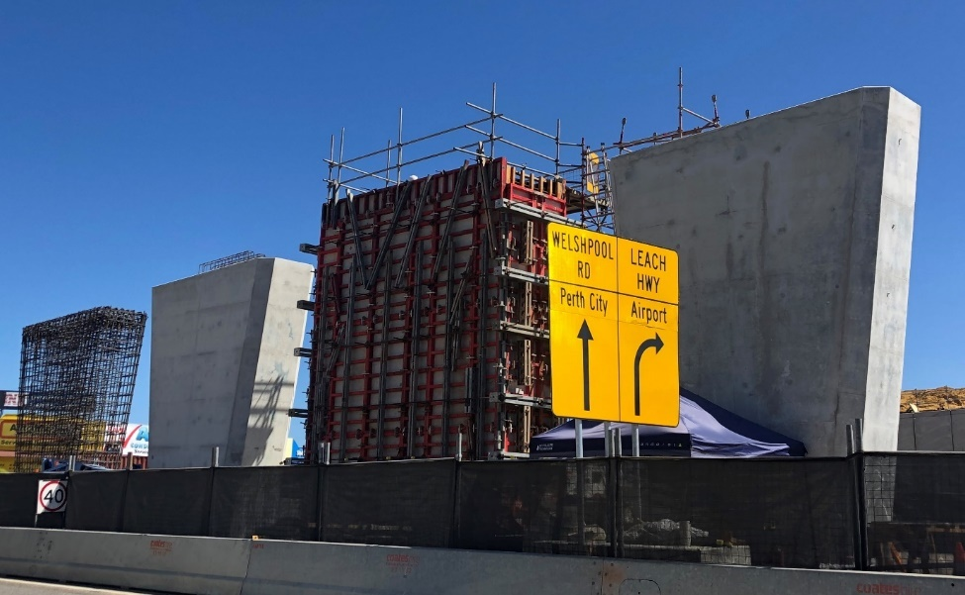
What’s happening
Beam installation for both bridges on the project are on track to be completed during March and April. Once the beams are in place, work will continue under the bridges and on the decks.
Construction activities on Leach Highway either side of the bridges, and on access ramps, are ongoing.
Piers for the new Leach Highway bridge over Welshpool Road are going up inside the temporary roundabout at the intersection. Footings were poured in December last year. This year, piers have been built during January, February and March.
Under construction: Piers for the new Leach Highway bridge over Welshpool Road.
Construction of the four 7.5 metre piers will require 240 cubic metres of concrete and 24 tonnes of steel reinforcement.

Traffic changes
Leach Highway southbound off-ramp to Albany Highway
- Closed until mid-April 2022
- Allow for the new off-ramp to be built
- Detours in place.
Welshpool Road between John Street and Ewing Street North
- Closed from 7pm Friday 1 April to 5am Monday 4 April
- Facilitate building crane pads, assembling cranes, lifting and installation of bridge beams for the new Leach Highway bridge across Welshpool Road.
- Local traffic will be allowed in by traffic controllers where possible.
- Signage will advise that businesses on Welshpool Road between Radium and Ewing Street are open for business.
Sections of Leach Highway
- Reduced to one lane in each direction for short periods over coming months
- Traffic management in place.

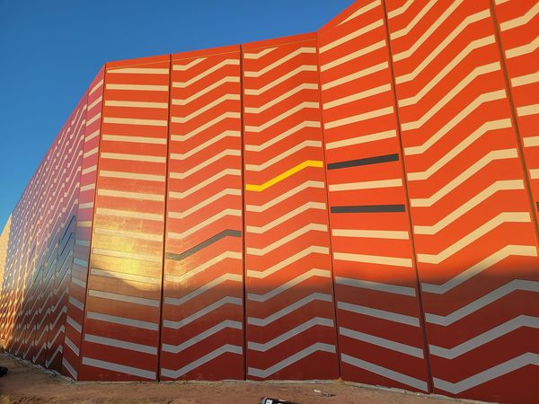
Colour scheme shines out
Noise wall construction has been completed along Leach Highway behind the Bentley Hospital. The wall has been painted in yellow and grey tones to tie in with the colour scheme for bridge areas.
In February, painting of abutment walls began for the new Leach Highway bridge over Welshpool Road.
Colours for the concrete panels include earth, rust and grey, to echo the surrounding industrial zone. The colours also tie in with those of other noise walls and bridges along Leach Highway.

Bringing the old and new together
Abutment walls: Colours and shapes echo industrial buildings and sawtooth walls nearby.
For engineer Graeme Dundas, working on the Leach Highway upgrade through Welshpool has been rewarding for a number of reasons.
Back in 1974, one of Graeme’s first jobs as a Graduate Engineer in Main Roads’ bridge design branch was with the team designing the existing Leach Highway bridge over the Armadale railway line. Step forward to today and now a Technical Director at design house, BG&E, he is part of the Leach Welshpool Alliance team working on the duplicate bridge and the refurbishment and upgrade of the original.
In the 1970s, design tools included slide rules and punch cards for a mainframe computer but despite now having the latest technology, the design process on this new duplicate bridge produced many challenges and constraints. Graeme said there were two main drivers – height limits due to the power lines for the trains below the deck and the overhead Western Power lines above. Also, beams had to be pre-cast within weight limits to enable lifting into place. Standards and requirements have increased since the initial bridge was designed, with the new bridge able to support twice the loads of the existing bridge.
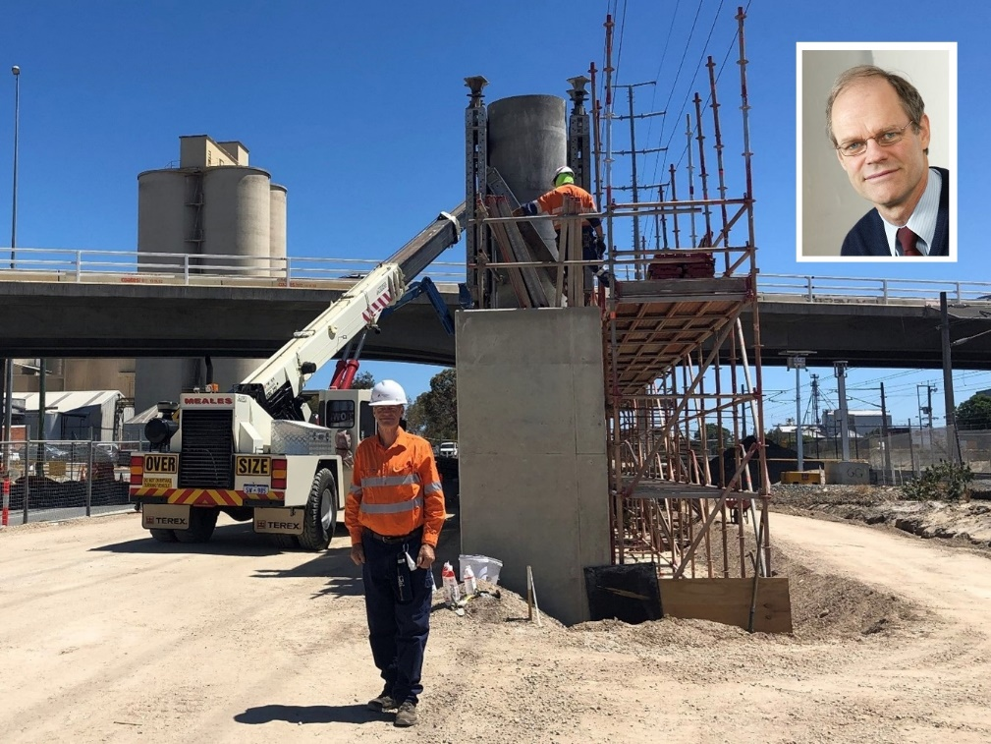
Alliance Director Will Telfer said the team appreciated the knowledge Graeme brought to the project.
“Graeme provides a wealth of experience which he’s been passing on to the younger engineers within our team, and it’s great to see the transferal of his knowledge and the personal development he’s provided.
“The two bridges side-by-side will be a showcase for the progression of the industry in terms of design standards, strength of materials and construction methods.”

More information
If you have any questions or concerns, please email enquiries@mainroads.wa.gov.au or call 138 138. For more information, see www.mainroads.wa.gov.au/Leach-hwy-welshpool-rd
Tale of two bridges: Engineer Graeme Dundas in front of the duplicate bridge under construction, with the existing bridge in the background.

