Local Road Design Update – Stirling Crescent, Talbot Road and Adelaide Street
Completion of the new interchanges on Great Eastern Highway Bypass at Roe Highway and Abernethy Road requires the removal of the signalised intersection of Stirling Crescent and the Great Eastern Highway Bypass (the Bypass). Removal of the Stirling Crescent intersection will result in free-flowing traffic along the Bypass between Roe Highway and Kalamunda Road and will eliminate queuing of traffic at signals during peak travel times.

To close the intersection of Stirling Crescent and the Bypass, a cul-de-sac will be built on both sides of the Bypass preventing access between the two roads.

Stirling Crescent will close (at the intersection of the Bypass) once the new interchange and local road upgrades are in place.
Changes to Stirling Crescent, Talbot Road and Adelaide Street
To facilitate continued access to the Bypass from Stirling Crescent (on the south side of the Bypass), Greater Connect Alliance is extending Adelaide Street to Abernethy Road. A roundabout will be built at the intersection of Adelaide Street and Abernethy Road where vehicles will be able to travel northbound to the Bypass.
In addition, the City of Swan will be undertaking the following local upgrade works:
- Construction of new roundabouts at the intersection of Stirling Crescent and Talbot Road; and the intersection of Stirling Crescent and Adelaide Street.
  - The roundabout at the intersection of Stirling Crescent and Talbot Road will be a peanut-shaped roundabout. The intent of the peanut roundabout is to maintain the existing alignments of both roads. This roundabout facilitates movements in all directions.
  - The roundabout at Adelaide Street will be a large circular roundabout facilitating all vehicle movements.
- The section of Stirling Crescent between Talbot Road and Adelaide Street will be upgraded.
- A cul de sac will be constructed at the western end of Talbot Road.
The map over the page shows access to the Great Eastern Highway Bypass following the closure of the Stirling Crescent/Great Eastern Highway Bypass intersection.
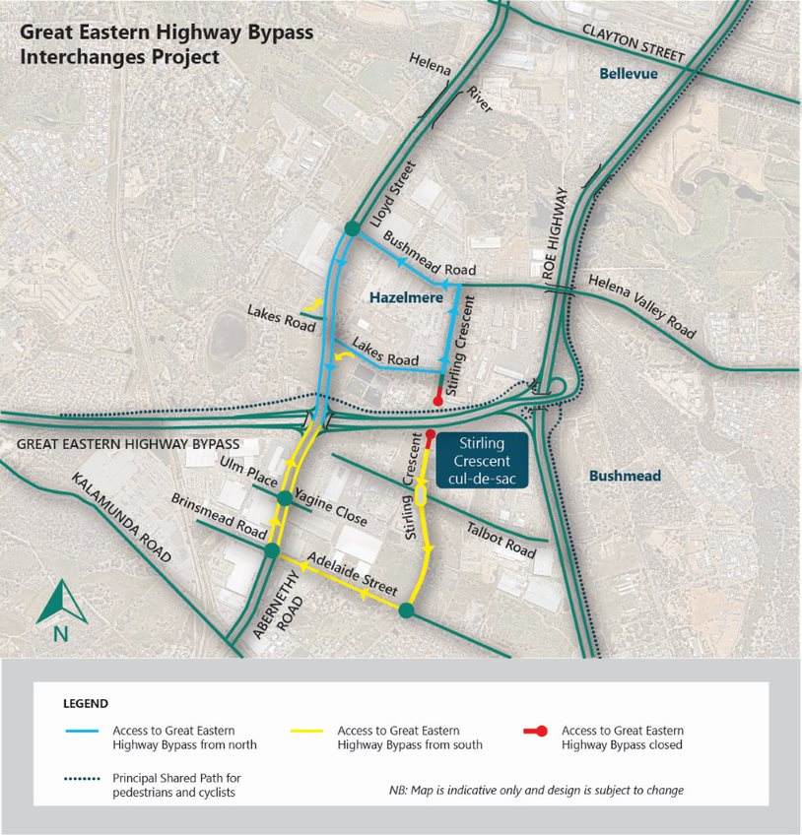
Considerations
Although direct access between Stirling Crescent and Great Eastern Highway Bypass will be closed, the wider road network will continue to provide full access for the local community and businesses accessing the area. Safety for all road users is of paramount consideration. Allowing access to the Bypass from Stirling Crescent when the two new interchanges at Roe Highway and Abernethy Road are in place would create unnecessary congestion.
The perceived extra travel distance associated with accessing the Bypass via Adelaide Street and Abernethy Road is expected to be balanced by time savings provided by the free-flowing traffic conditions on Great Eastern Highway Bypass following completion of the new interchanges at Abernethy Road and Roe Highway. Traffic monitoring will take place after construction to check that the road network continues to perform satisfactorily.

Further information
We appreciate your feedback and will work hard to make sure we keep you informed of progress and any upcoming works that may impact you. If you have any questions or concerns, please phone 138 138 or email enquiries@mainroads.wa.gov.au. More information on the Great Eastern Highway Bypass Interchanges project is available at https://www.mainroads.wa.gov.au/geh-bypass-interchanges

