Breaking ground
On 16 November, a ground-breaking ceremony took place to mark formal commencement of construction works on the project. Senior representatives from Main Roads and Greater Connect Alliance were joined by Federal Minister for Indigenous Australians Ken Wyatt, WA Transport Minister Rita Saffioti, Member for Forrestfield Stephen Price, and the Mayors of the Cities of Swan and Kalamunda, to turn the first sod.
The political dignitaries heralded the $386.5 million project, funded by the Australian ($247.25million), State ($128.22 million) and Local Governments as a game changer for road users in Perth’s east, providing hundreds of local jobs as well as contracting opportunities for Aboriginal businesses and employees.
The first official project works commenced the following week at the intersection of the Great Eastern Highway Bypass and Abernethy Road. The works include constructing a temporary intersection, including relocation of traffic lanes in the central median of the Bypass between the Midland Freight Rail Bridge and Stirling Crescent. The temporary intersection and traffic lanes, which will open to road users in April 2022, will allow continued traffic flow while the new Great Eastern Highway Bypass and Abernethy Road interchange is constructed.
Completion of the new interchange will allow free flowing traffic along the Bypass between Roe Highway and Kalamunda Road. It will also enhance access to the Bushmead Industrial Area and provide a direct connection to Midland via the new Lloyd Street Bridge over the Helena River.

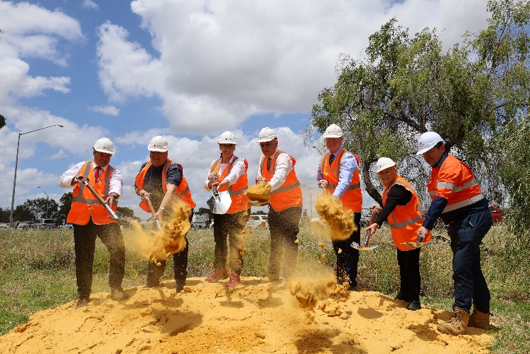

Community feedback
In September, Greater Connect Alliance invited community feedback on the project. Information displays were held at two local shopping centres and a four-week consultation period enabled the community to provide feedback via a community survey and social pinpoint map hosted on an online project portal.

We received extensive and detailed feedback about various aspects of the project, reflecting diverse views within the community. Key feedback themes included:

- Protecting the environment and look and feel of the local area was a high priority with strong support for ensuring the design complements and protects the surrounding environment.
- Support for a design that protects and enhances Aboriginal heritage values including integration of the history of the area into the project design.
- Requests for a bridge design over the Helena River at Lloyd Street that minimises the clearing footprint, ensures continuity of waterflow, protects the floodplain and improves access to the river for pedestrians and cyclists.
- Support for new Principal Shared Paths including suggestions for additional connections.
- Strong support for use of recycled materials and materials that are easy to maintain.

Greater Connect Alliance has carefully considered the feedback. To date, significant design changes resulting from feedback include:

- Changes to the design of the Lloyd Street Bridge batter slopes on the bridge approaches. Proposed changes include adding sections of gabion retaining walls within the southern embankment to reduce the embankment footprint and consequently reduce the clearing of remnant native trees.
- Investigation into the addition of a shared path along Adelaide Street between Stirling Crescent and Abernethy Road to provide better connectivity for High Wycombe residents.
- Review of flora species to be incorporated in project landscaping.
- Commitment to development and implementation of a heritage interpretation and Aboriginal Art Plan for the project.
- Use of recycled materials for construction such as Recycled Asphalt Pavement and recycled concrete.

More than 700 community members visited the information displays and over 1600 people visited the online portal.
92 community members participated in a Quick Poll with responses indicating that more than 80% of participants support the project.

The community consultation report is available on the project website https://www.mainroads.wa.gov.au/geh-bypass-interchanges

Planting the seed
Landscaping is generally the last piece of the puzzle for infrastructure projects. However, the Greater Connect Alliance team is already on the front foot planting the seed to conserve threatened native vegetation species for the future.
The project has engaged Gambara, a local indigenous company that provides environmental, landscaping, rehabilitation, and revegetation works in the infrastructure and resources industry.
Gambara will be collecting seed pods off existing vegetation within the project footprint during the upcoming summer months. The seeds will be stored in a specialised facility during construction, ready for replanting as part of the project's landscaping works.
"Seed is a precious commodity and essential for landscape revegetation works. It is crucial in Banksia Woodlands, due to a diminishing amount of vegetation of this type left on the Swan Coastal Plain," said Matt Oswald, Director of Gambara.
Various seed species will be collected during the process. The Banksia Menzies (or Bulgalla in Noongar) and Banksia Attenuata (Biara in Noongar) are vital for local wildlife. They are an important food source for insects and birds, including the Carnaby and Red-Tailed Black Cockatoo.
Traditionally, Noongar people would use banksia nectar to make a sweet honey drink, and the cones used as a torch to carry fire from camp to camp. In addition, Noongar people ate the root of the Kangaroo Paw (or Kurulbrang in Noongar) as it contained high levels of stored starch. The collection of seed and other revegetation works undertaken by Gambara has a strong synergy for Noongar staff in caring and cultural connection to country.
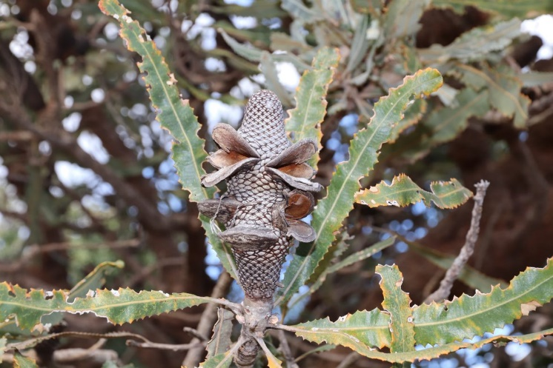
Fast fact: in Noongar culture if you find a feather of a Carnaby it’s considered a good sign!

