Local Road Design Update – Lloyd Street and Lakes Road Intersection
As part of the early planning for the Great Eastern Highway Bypass Interchanges project, concept plans were developed to assist with cost estimation, community and stakeholder engagement, land requirements and approvals. Greater Connect Alliance is now progressing the design and exploring innovations in construction to reduce impacts to road users, the community, and the environment.
Sections of Lloyd Street between Great Eastern Highway and Great Eastern Highway Bypass have already been constructed including:
Extension of Lloyd Street to the Bypass is expected to have significant benefits in travel time, travel costs and net emissions including saving up to 12 minutes for commuters currently detouring around the Helena River.
It is also expected to reduce traffic volumes through Guildford by 15 – 20 percent.
- Between Great Eastern Highway and the roundabout adjacent to Bunnings, north of the Helena River
- Between Stirling Crescent and Lakes Road, south of the Helena River
The gaps along the Lloyd Street alignment will be constructed as part of the Great Eastern Highway Bypass Interchanges project on behalf of the City of Swan including:
- The section between the current end point adjacent to Bunnings and Stirling Crescent, including a bridge over the Helena River
- The section between Lakes Road and Great Eastern Highway Bypass (the Bypass) where it will connect via a new grade separated interchange (the Great Eastern Highway Bypass and Abernethy Road interchange).
When the gaps along the Lloyd Street alignment are constructed, Lloyd Street will be free-flowing between Clayton Street and the new Great Eastern Highway Bypass and Abernethy Road interchange, providing significant benefits in travel time, cost and net emissions.

Design of Lloyd Street and Lakes Road intersection
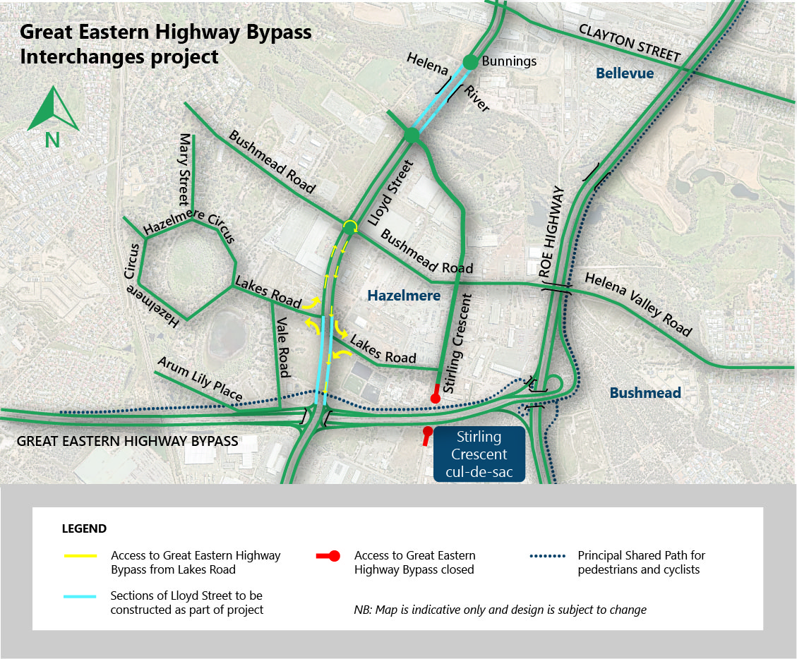
To ensure connectivity between the new sections of Lloyd Street and the surrounding area, a new unsignalised Staggered-T intersection will be constructed at the intersection of Lloyd Street and Lakes Road. The Staggered-T intersection between Lakes Road and Lloyd Street will allow left-in, left-out access only as shown by the yellow arrows in the map below.
Getting around
Access to the Great Eastern Highway Bypass will be as follows:
- Businesses located on the eastern side of Lloyd Street will be able to access the Bypass via Lakes Road and Lloyd Street and/or Stirling Crescent, Bushmead Road and Lloyd Street.
- Businesses and residents located on the western side of Lloyd Street will be able to access the Bypass by turning left into Lloyd Street from Lakes Road, travelling to the roundabout at Bushmead Road and continuing around the roundabout on to Lloyd Street southbound back to the Bypass. The additional journey time associated with traversing the roundabout is approximately one minute.
To access Lakes Road from the Great Eastern Highway Bypass, road users can:
- Exit the Bypass via the new interchange at Abernethy Road and Lloyd Street, and head north along Lloyd Street (towards Hazelmere)
- A left-turn into the section of Lakes Road west of Lloyd Street will be located approximately 400 metres from the interchange.
- To enter the section of Lakes Road to the east of Lloyd Street, road users should use roundabout at Bushmead Road to turn around, head back towards the Bypass and turn left into to Lakes Road.

Considerations
Although left-in, left-out access between Lloyd Street and Lakes Road is proposed, the wider road network will continue to provide full access for local community and businesses accessing the area. Safety for all road users is of paramount consideration. Introducing unprotected right hand turning movements across traffic in this location would create a heightened risk, particularly given the significant volume of heavy vehicle movements in this area and the close proximity of this intersection to the new interchange.
The extra travel distance associated with left-in, left-out access between Lakes Road and Lloyd Street is expected to be balanced by time savings provided by the free-flowing traffic conditions on Great Eastern Highway Bypass following completion of the new interchanges at Abernethy Road and Roe Highway. Traffic monitoring will take place after construction to check that the road network continues to perform satisfactorily.
Based on predicted traffic volumes to 2036, there is no immediate requirement for traffic lights at this intersection and traffic lights would have a significant impact on north/south traffic movements on Lloyd Street and introduce unnecessary congestion.

Further information
We appreciate your feedback and will work hard to make sure we keep you informed of progress and any upcoming works that may impact you. If you have any questions or concerns, please phone 138 138 or email enquiries@mainroads.wa.gov.au. More information on the Great Eastern Highway Bypass Interchanges project is available at https://www.mainroads.wa.gov.au/geh-bypass-interchanges

The Great Eastern Highway Bypass Interchanges project will enhance connectivity, relieve congestion, and improve safety in Perth’s Eastern Metropolitan Region, bringing immediate benefits for over 60,000 road users per day.

