Urban Design and Landscaping

The Great Eastern Highway Bypass Interchanges project is being carefully designed to complement and enhance the built, natural and community environment. Consideration will be given to the unique environmental and heritage values of Midland and Hazelmere, and surrounding areas.

An Urban Design and Landscape Framework has been developed to ensure the project achieves the best possible urban and landscape design outcomes for the community and road users. Urban design will include visual design and finishes of new structures and retaining walls, public and community art, interpretive signage opportunities, wayfinding elements, shared path connections, and landscaping. The Framework considers:

- Land-use - the project area is characterised by mixed land uses including industrial/commercial, residential, semi-rural, bushland, and recreation.
- Environment and heritage – the project area comprises the Helena River which has significant heritage and cultural value, along with several areas of significant remnant vegetation, threatened ecological communities, and Bush Forever sites. Topography, soil composition, and vegetation are also considered.
- Landscape character – Industrial streetscapes, roadside vegetation, and elevated views of the Darling Scarp will influence the urban design.
- Community and sustainability – Long term social needs of the local community are considered including a focus on environmental enhancement and creating better community integration and connectivity.

Urban design colour scheme
The proposed colour scheme for the project incorporates local floral forms, patterns and colours visually connecting and referencing the Nuytsia floribunda (Western Australian Christmas Tree) flower found in the surrounding Bush Forever sites. It is proposed that the side of any noise and screen walls facing the traffic will be themed with bold colours transitioning between yellow, orange, and green. A dark green is proposed to be used where walls are visible from the adjoining residential areas to limit visual impact. Anti-graffiti paint will be used to reduce the potential for vandalism. The urban design colour scheme will be subject to consultation with relevant stakeholders and feedback from the local community.

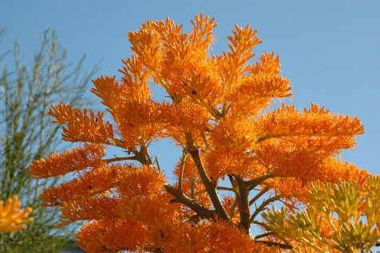
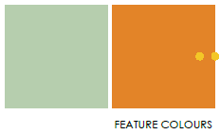
The proposed colour scheme for the project incorporates local floral forms, patterns and colours visually connecting and referencing the Nuytsia floribunda (Western Australian Christmas Tree) flower found in the surrounding Bush Forever sites

Landscaping
Landscaping is a defining component of the project. The soft landscaping elements will feature surrounding native species that will give the project a sense of place, consistent with the existing landscapes that surround the new infrastructure. Hard landscaping such as stone pitching will be used between kerbs, paths and the roadside where there is insufficient room for landscape planting. Instead of the commonly used limestone pitching, it is proposed that laterite from the Darling Scarp will be used. The colour and texture of laterite will better suit and integrate with the local environment.
The nearby Great Eastern Highway/Roe Highway Interchange showcases how urban design can incorporate feature lighting, landscaping and artwork into bridge and road design. It also demonstrates how using colours that complement the local environment can provide an iconic statement that celebrates the beauty of the Perth Hills and surrounding area and celebrates Western Australia as the wildflower state.
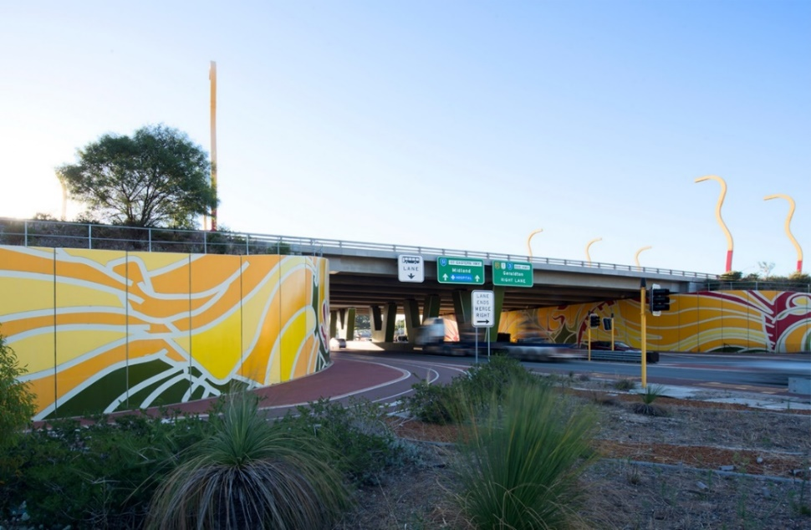

Wayfinding and lighting
Wayfinding elements are important for the project and will include treatments to strengthen visual connections and support wayfinding along and between roads during the day and at night. The new interchanges will be illuminated, providing a visual connection and aiding in wayfinding. Directional and interpretive signage is also proposed along the Principal Shared Path (PSP) as a way of connecting path users and the community to the environmental and heritage aspects of the area. Wayfinding signage will be present at all intersections in the PSP and shared path connections

Public and community art
To create a cohesive urban design outcome for the project and enhance community amenity in the area, public and community art and interpretation within the works will be considered. There are opportunities for retaining walls and underpasses to incorporate public artwork on the walls and ceilings. The project team hopes to work with local emerging Aboriginal artists to develop and deliver artwork for the project.

