Cultural Heritage
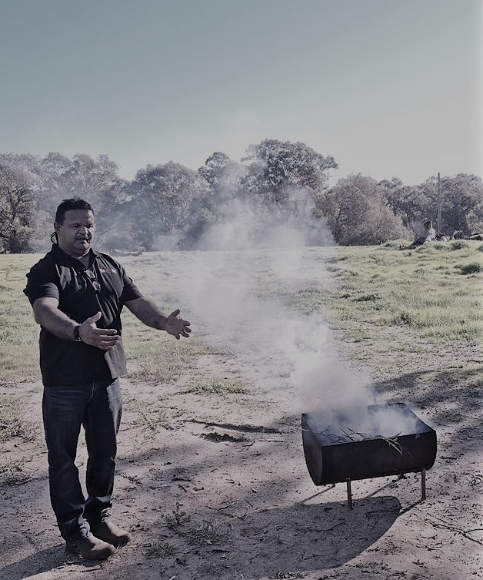
Our commitment
The Great Eastern Highway Bypass Interchanges Project (the project) will be constructed and operated on the traditional lands of the Whadjuk Noongar people.

When projects are planned to take place in areas where known Aboriginal heritage exists, there is a risk that project activity may damage, disturb, or interfere with the known Aboriginal sites, cultural values, objects or remains. In project areas where heritage is unknown or may be subsurface, there is also a risk of damage to Aboriginal heritage uncovered or discovered during project works.

Main Roads and the Greater Connect Alliance is committed to achieving excellence in cultural heritage management and we strongly recognise and respect the inherent connection that Aboriginal people have with their land, including their historic and ongoing responsibility and care for their country.
Whadjuk Man Steven Jacobs welcomed staff from Main Roads and the Greater Connect Alliance to country prior to commencement of project site investigation works. A Smoking Ceremony was held so the project team can work safely on Whadjuk Noongar Boodja land.

How is the project managing Aboriginal cultural heritage?
The project will survey and explore areas previously untouched by cultural heritage investigation, which puts us in a unique position to uncover potential discoveries that will add to the wider community’s knowledge of, and respect for Aboriginal people’s use of the land and Australia’s shared cultural heritage.

Cultural heritage assessments have been undertaken to ensure that potential impacts on heritage are considered early in the planning stage of the project. These assessments consider the impacts associated with each potential design option at each site as well as identify opportunities to reduce any potential heritage impacts through design refinement and how the project will be constructed.
The project has prepared an Aboriginal Heritage Management plan in consultation with representatives from the Whadjuk Native Title Claim group. We are working closely with this group to develop survey methodologies, conduct on-site inspections and assessments, and discuss any recommendations to manage and preserve cultural heritage.

We are also working with this group to ensure we engage with the appropriate technical advisors where required or requested. This includes Aboriginal heritage monitors, archaeologists, anthropologists, and environmental specialists who are all skilled in the identification, preservation, and further management of Aboriginal cultural heritage.

Aboriginal heritage monitoring and preservation
Aboriginal heritage is dynamic. It includes tangible and intangible expressions of culture that link generations of Aboriginal people over time. Aboriginal people express their cultural heritage through ‘the person’, their relationships with country, people, beliefs, knowledge, law, language, symbols, ways of living, sea, land and objects all of which arise from their spirituality.

Consultation with Noongar representatives on any areas of construction with known cultural heritage will be ongoing throughout development, design, and construction to ensure areas that are significant are protected during all project activities.

Throughout clearing or other works causing ground disturbance, Aboriginal heritage monitors will be present on site to monitor the works within any areas of interest.

Aboriginal cultural heritage findings will be recorded and preserved for future generations through appropriate mitigation and management. Heritage findings will be entered into relevant government databases to ensure there is no future harm to cultural heritage sites and knowledge is recorded for future generations. However, not all information is suitable to share more broadly due to cultural protocols.

Celebrating cultural heritage through art
As project development progresses, Main Roads and the Greater Connect Alliance will explore opportunities to work with local Aboriginal artists to develop and deliver artwork on the walls and ceilings of the underpasses and retaining walls constructed as part of the project.

Incorporating Aboriginal art in the project design creates an opportunity for local Aboriginal artists to tell and share stories of the local Noongar people and ensure their stories are celebrated and shared for generations to come.

