Moves is our online portal which allows registered users to manage the administrative tasks associated with operating a RAV within WA.

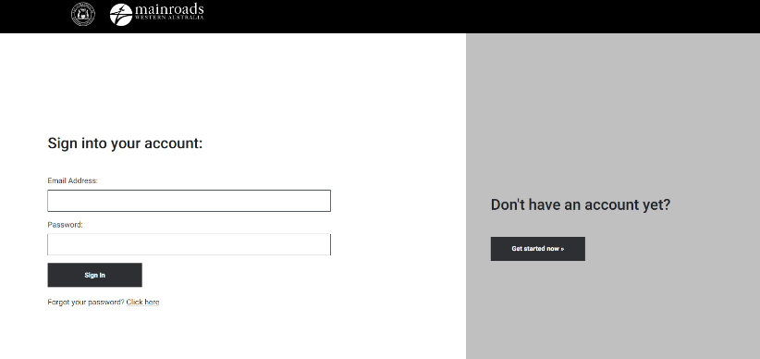

The first step in accessing MOVES is to create an account with Main Roads. To do this, follow the instructions on the ‘myaccount.mainroads.wa.gov.au’ page. You can access this page via
https://myaccount.mainroads.wa.gov.au

Once you have created your portal account, Please send an email to: MOVES@mainroads.wa.gov.au and request to link your account to MOVES. You will need to include: your Operator name & number; your physical address; and the email address you used to create your ‘my.account’
When we have actioned your request, we will send you a confirmation email and with the details to access your MOVES account.
If you have any questions or need our help to complete your MOVES account set-up, our Heavy Vehicle Helpdesk is ready to assist you. Contact them via ph) 138 486 or hvs@mainroads.wa.gov.au

