Dieback and Weed Management Plan
Brand Highway Widening 120-136 and 139-152 SLK
January 2021

Report Compilation & Review | Name and Position | Document Revision | Date
Author: | Emma Simpson  Environment Officer | Draft v1 | 21/12/2020
Reviewer | Gaynor Owen  Senior Environment Officer | Draft v1 | 22/12/2020
Author: | Emma Simpson  Environment Officer | Rev 0 | 23/12/2020
Reviewer | Nathan Ashburner  DBCA Officer | Rev 0 | 20/1/2021
Author: | Emma Simpson  Environment Officer | Rev 1 | 27/1/2021

Contents
1 PROJECT SUMMARY 4
2 INTRODUCTION 4
3 Project Description 4
3.1 Project Location 4
4 Existing STATUS 7
4.1 Dieback 7
4.1.1 Status 7
4.1.2 Locations 7
4.2 Weeds 13
4.2.1 Introduced Weeds 13
4.2.2 Locations of Weed Species 13
5 Objectives 15
5.1 Dieback 15
5.2 Weeds 15
6 Stakeholder consultation 15
7 Management and monitoring Actions 15
7.1 Dieback 15
7.2 Weeds 16
8 Reporting 18
9 Communication 18
10 Accountability 18
11 References 19
Appendix A: Dieback Management Plan 20
Appendix B: Dieback Clean on Entry Maps 33
Appendix C: Dieback Classification Table 38
Appendix D: Dieback Contingency Actions 39
Appendix E: Dieback Report 41

PROJECT SUMMARY
Project Title: Brand Highway Widening 120-136 and 139-152 SLK.

Project Location: This project occurs on Brand Highway 120-136 and 139-152 SLK within the Shire of Dandaragan.

Dieback Management Objectives:
- Prevent the spread of dieback along Brand Highway.

Weed Management Objectives:
- Prevent the introduction of weeds
- Control (and if possible reduce) existing weed populations.

INTRODUCTION
Main Roads Mid-West Gascoyne Region proposes to widen sections of Brand Highway between 120-136 and 139-152 SLK. This will increase the safety of the road by improving the functionality of the road. This dieback and weed management plan (DWMP) has been created to prescribe management actions for this project in accordance with Condition 7 of CPS 7533/2.

Project Description
This project will involve the widening of the road between 120-136 and 139-152 SLK within the Shire of Dandaragan. The widening involves upgrading the seal/pavement configuration to a 9 metre (m) on 11m. This includes two 3.5m lanes, two 1m sealed shoulders and two 1m unsealed shoulders.

Project Location
The project is located on Brand Highway:

Widening 120-136 SLK within the Shire of Dandaragan (Figure 1)
Start: Latitude: -30.6627
Longitude: 115.4665
End: Latitude: -30.5194
Longitude: 115.4634

Widening 139-152 SLK within the Shire of Dandaragan (Figure 2)
Start: Latitude: -30.4979
Longitude: 115.4793
End: Latitude: -30.384
Longitude: 115.4962

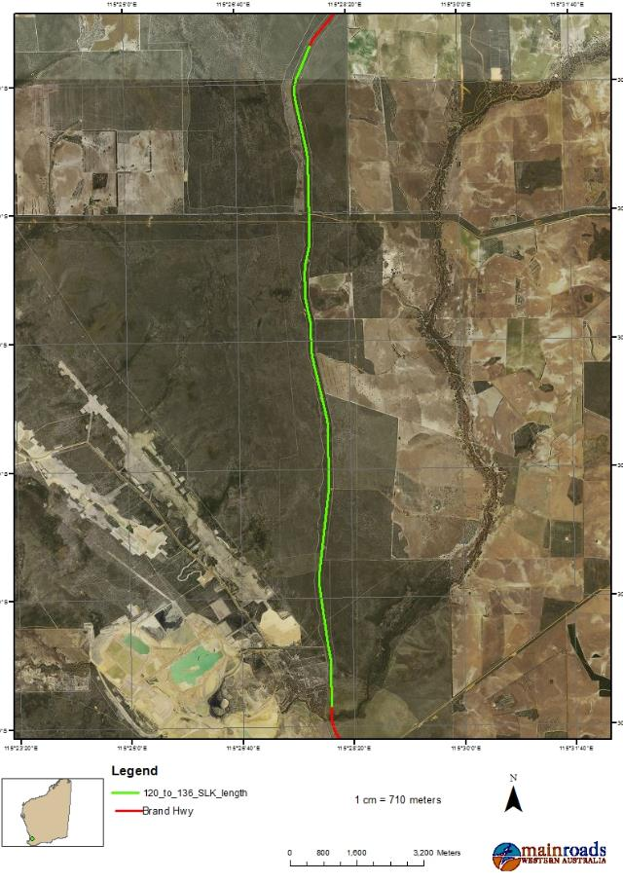
Figure 1: Project Location Widening 120-136 SLK

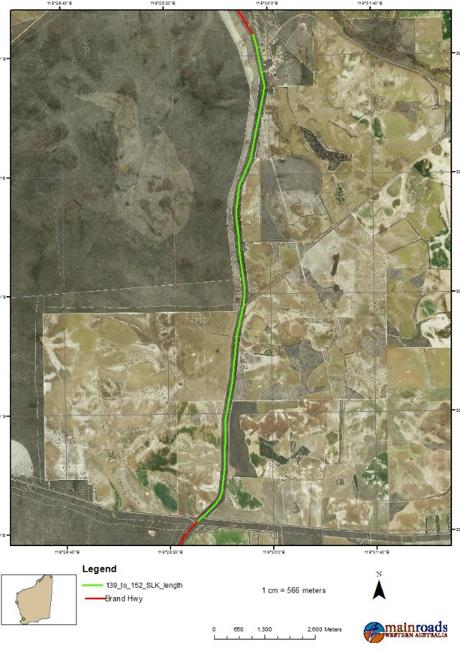
Figure 2: Project Location Widening 139-152 SLK

Existing STATUS

Dieback
Phytophthora dieback (dieback) is the name used to describe the plant disease caused by a soil-borne pathogen (technically classified as a water mould not a fungus), most commonly identified as Phytophthora cinnamomi.

Dieback kills a wide range of plant species in Western Australia (WA) by attacking plant root systems and causing them to rot, thereby stopping the uptake of water and nutrients. The pathogen is spread via root to root contact, through infested soil and plant material and via surface and sub-surface water flows.

The pathogen is most rapidly spread through human activity and animals. The unintentional movement of pathogen-infested soil by vehicles, equipment and footwear from infested into uninfested areas is the most common means of dispersal of the organism. Moist soil conditions are conducive to the spread of the pathogen and the movement of the pathogen in the landscape is much faster downslope. Risks of new infestations are higher when moist soil, mud or gravel is transported from infested to uninfested areas.

The risk of soil transportation of dieback is considerably reduced in dieback susceptible areas when the movement of vehicles and machinery between infested and uninfested areas is undertaken in dry conditions. However, when activities require soil movement in wet conditions, best practice environmental management strategies should be developed and implemented to minimise soil movement and the increased risk of dieback spread or intensification. In these circumstances, specified management strategies and a project specific Dieback Management Plan (DMP) are needed to manage the potential spread of dieback and the threat to biodiversity posed by the pathogen.

Status
A dieback assessment was undertaken by Glevan Consulting in November 2020 (Appendix E). Dieback is known to exist in the project area, with the majority of the project being protectable. The dieback survey identified that the majority of the project area is uninfested with nine small areas of infestation. These included Phytophthora cinnamomi and other Phytophthora species infestations.

Locations
Figure 3-7 below shows the dieback mapping of the project areas as determined during the Glevan survey.

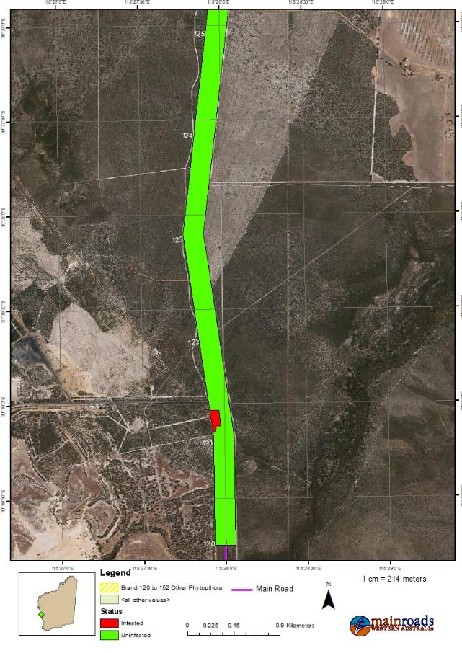
Figure 3: Current dieback status-Widening 120-125 SLK
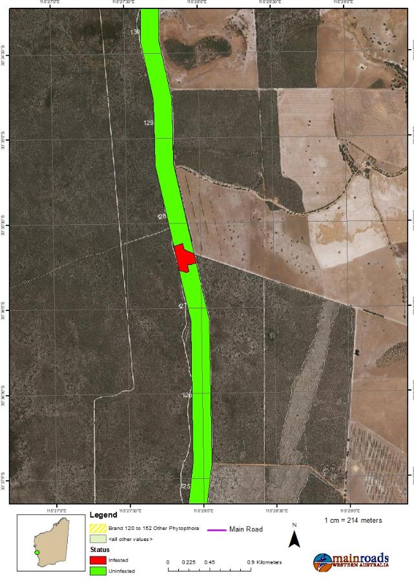
Figure 4: Current dieback status- Widening 125-130 SLK
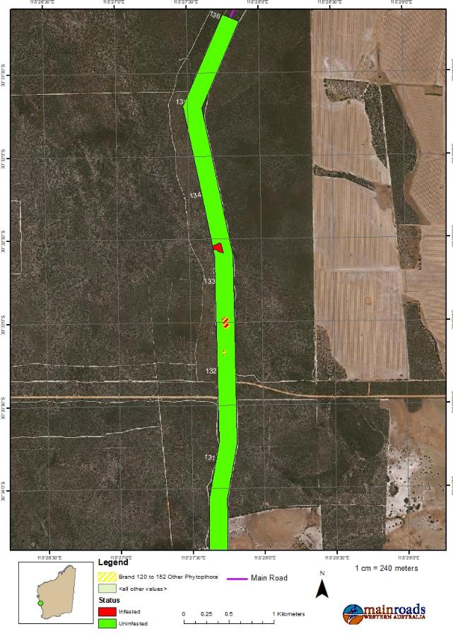
Figure 5: Current dieback status-Widening 130-136 SLK
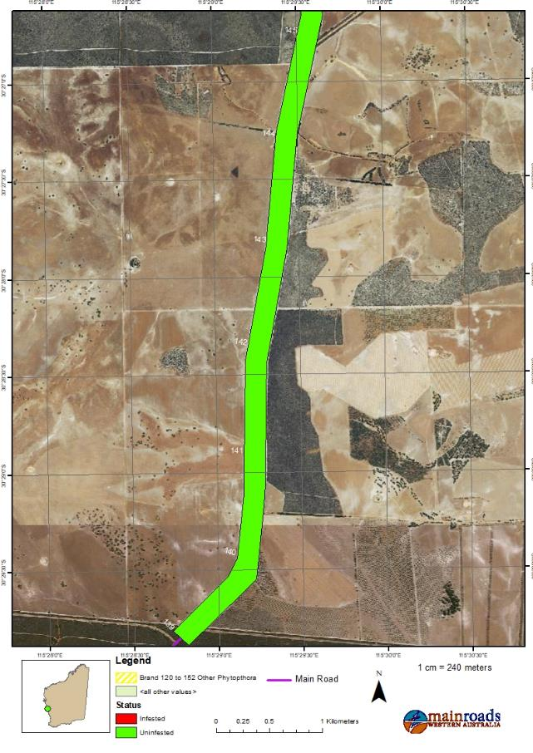
Figure 6: Current dieback status-Widening 139-145 SLK
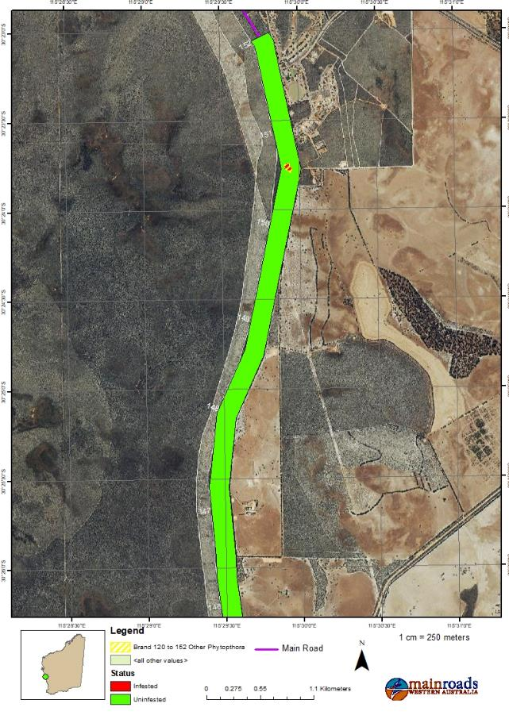
Figure 7: Current dieback status- Widening 145-152 SLK

Weeds
Weeds are not native to an area and are generally opportunistic plant species. Once weeds are introduced to an area they effectively compete for resources. The presence of weeds in an area can result in numerous environmental impacts including resource competition, the prevention of seedling recruitment of native plant species, changes to soil nutrients and fire regimes and alteration of geomorphological and hydrological cycles.

Introduced Weeds
Two weed species categorised as Declared Pests under the Biosecurity and Agriculture Management Act 2007 were recorded within the Project Area during the GHD 2016 survey (refer to Table 1). Moraea flaccida (Cape Tulip) and Echium plantagineum (Paterson’s Curse). There was only one individual located at each location.

Cape Tulip is a perennial herb growing up to 70cm high and the flowers are orange to salmon pink with yellow centres. This species is widespread throughout the south-west of WA.

Paterson’s Curse is an erect weed, growing up to 1.5m tall high, commonly 30-60cm and the flowers are purple. This species is widespread throughout the south-west of WA and the eastern Goldfields.

Table 1: Declared weed species in the project area
Species Name | Common Name | Latitude | Longitude
Moraea flaccida | Cape Tulip | -30.5943 | 115.4649
Echium plantagineum | Paterson’s Curse | -30.5839 | 115.4628

Locations of Weed Species
Figure 8 below shows the location of Cape Tulip and Paterson’s Curse within the project area.

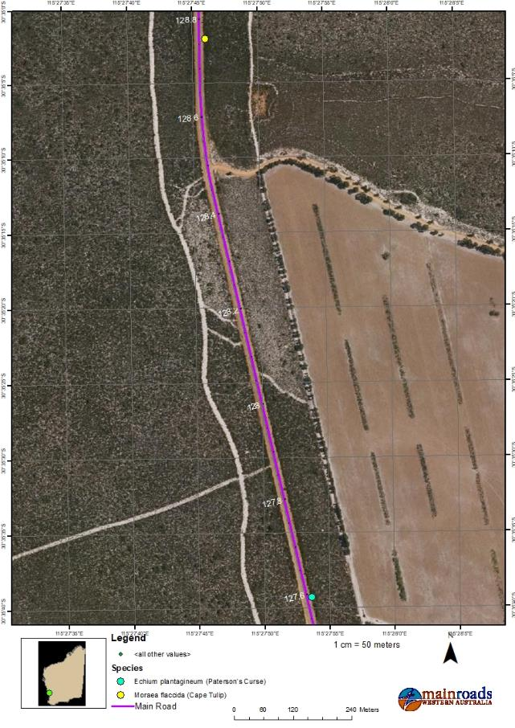
Figure 8. Declared weed locations in the project area

Objectives

Dieback
The objective of the DWMP is to prescribe management actions to avoid, mitigate and manage the potential introduction of dieback within the project area. As dieback is usually spread during the movement of soil and vegetative material, management actions will focus on these aspects.

Weeds
Management objectives with respect to mitigating potential environmental impacts have been developed, consistent with statutory requirements and commitments, to effectively manage weeds as follows:
- Prevent the introduction of weeds
- Control (and if possible reduce) existing weed populations.

For each objective, management actions have been developed to ensure the impacts from construction operations are managed, and that appropriate monitoring is undertaken to support the successful implementation of the management actions.

Stakeholder consultation
The DWMP and associated management actions have been prepared in line with the DBCA’s Phytophthora Dieback Management Manual. This plan will be reviewed by Department of Biodiversity, Conservation and Attractions (DBCA) as it occurs adjacent to DBCA land. The plan will also be approved by the Department of Water and Environmental Regulation (DWER).

Management and monitoring Actions

Dieback
The Dieback Management Plan is attached as Appendix A.

Weeds
The contractor shall implement the weed management actions outlined in Table 2 below.

Table 2: Weed management actions
Management Action | Monitoring/Maintenance Program | Responsible Person | Completion Timeframe
Preconstruction
Preconstruction survey shall be undertaken to determine extent of weeds in the project area | Pre-construction | Consultant | Completed
At the pre-start meeting (or equivalent) – provide clear maps indicating the location of weeds (limited to the project area) | Pre-construction / Construction | Environmental Management Representative | Prior to clearing commencing
Have on site a copy of the Weed Management Plan | Pre-construction / Construction | Environmental Management Representative | Prior to clearing commencing
Where known locations of weeds will be impacted by construction activities, undertake weed control through removal and burial at approved location | Pre-construction / Construction | Environmental Management Representative | Prior to clearing commencing
Construction
Ensure all plant and equipment are clean, inspected and certified weed free prior to entering the project area | Construction | Environmental Management Representative | Completion of construction
Where possible clean equipment/machinery after operating in existing drainage | Construction | Environmental Management Representative | Completion of construction
Infested material can be used in areas which are infested with P.c., but it cannot be used in areas infested with other pathogens. | Construction | Environmental Management Representative | Completion of construction
Restrict movement of machines and other vehicles to the limits of the project area | Construction | Environmental Management Representative | Completion of construction
Any other weeds or plants germinating from stockpiled topsoil are to be controlled with herbicide | Construction | Environmental Management Representative | Completion of construction
Any stockpiles with Paterson’s Curse or Cape Tulip germinating are to be disposed of as weedy topsoil | Construction | Environmental Management Representative | Completion of construction

Management Action | Monitoring/Maintenance Program | Responsible Person | Completion Timeframe
Monitoring
Weed monitoring to be undertaken post construction | Post-construction | Site Supervisor | Expiry of defects period
Where weed infestation is evident, herbicide application shall be undertaken to ensure no establishment of declared weed species | Construction / Post-construction | Site Supervisor | Expiry of defects period
Contractor shall monitor site where weeds are buried (in approved location) to ensure no establishment of declared weed species | Construction / Post-construction | Site Supervisor | Expiry of defects period

Reporting
The Contract Project Manager will maintain the following records, which will be reported annually to DWER as required under the conditions of CPS 7533/2.
- Copy of this DWMP, DBCA and DWER approval letters
- Copy of the dieback survey report; and
- actions taken in implementing this DWMP.

Communication
Main Roads employees, contractors and agents who are involved in the project activities and who have the potential to introduce and spread dieback or weeds into uninfested areas, should read and comprehend this DWMP. The dieback and weed management maps will be available on site in the site office and supervisor vehicles. The dieback management sectors will also be demarcated on site with orange flagging tape and the CoE points will be identified. The weeds will be demarcated in pink flagging tape. Information regarding dieback and weed management will be communicated to all project employees as follows:

Table 3 Communication Program

Method | Frequency | Participants | Reference | Record
Induction | Prior to commencement of work | All personnel and sub-contractors | DWMP, Main Roads’ Environmental Policy Statement and CEMP | Induction meeting
Training | Prior to commencement of work | All personnel and sub-contractors | DWMP and toolbox | Records of training
Pre-start Meetings | Daily | Project Personnel | DWMP, Contractor Environment & Safety Plan | Minutes of meeting
Superintendent meeting | Fortnightly | Main Roads’ Project Manager and Contract Project Manager | DWMP | Minutes of meeting

Accountability
The Project Manager and Contractor are responsible for ensuring the dieback and weed management actions, monitoring program and timeframes for completion are undertaken.

References

Glevan (2020) Brand Highway120-152 SLK. Unpublished report to Main Roads Western Australia.

GHD (2016) Brand Highway Passing Lanes Biological Assessment. Unpublished report to Main Roads Western Australia.

Department of Agriculture and Food (2019) Western Australian Organism List (WAOL).
https://www.agric.wa.gov.au/bam/western-australian-organism-list-waol Accessed 25 November 2020.

Appendix A: Dieback Management Plan
Phytophthora Dieback Management Plan
PART A: COVER PAGE
This form is to be used for assessing the dieback risks associated with planned disturbance activities on lands managed by the Department of Biodiversity, Conservation and Attractions, for documenting the risk reduction tactics and monitoring implementation of the plan.
The form has three parts, and at least two parts will need to be completed for each disturbance activity. Please indicate in the table below which parts have been completed for this disturbance activity.
Part | Purpose | Requirement | Tick those completed
Part A | Cover Page  (instructions, details about the activity) | Must be completed (if activity requires more than basic dieback management as per section 1.4 of manual)
Part B | Risk Assessment | To be conducted for all planned disturbance activities  in the vulnerable zone on lands managed by the department, except:  Where risk is already known to be ‘High’ a proponent may choose to go directly to Part C.
Part C | Management Actions | Where the risk has been assessed as ‘High’ or ‘Moderate’ a management map is to be included.  Part C is not required where the risk has been assessed to be ‘Low’. In this case, the proponent can proceed using basic dieback management.

Dieback Management Plan No.
District allocated - to be recorded on all parts of plan submitted
Details of the disturbance activity
Region/District of activity: | Moora District | Date of activity:  (give date range if a prolonged activity) | Clearing programmed February to May 2021.
Location of site of activity:  (Forest Block, Reserve or coordinates) | Refer to Section 3.1 above
Vegetation type/complex: | Widening 120-136 SLK  This application area’s vegetation is in excellent to completely degraded (EPA and DPaW, 2015) condition with the majority in completely degraded condition. The application area is comprised of five vegetation types:  Tall Adenanthos and Allocasuarina Shrubland  Tall shrubland of Adenanthos cygnorum, Allocasuarina humilis and Leptospermum erubescens over mixed, low shrubland of Jacksonia floribunda, Hibbertia hypericoides and Daviesia podophylla over herbland of Dampiera linearis, Dampiera linearis and Conostylis teretifolia.  Low Calothamnus heath  Closed shrubland of Calothamnus species over herbland of Drosera spp., Hypochaeris sp. and Stylidium sp.  Highly modified  Includes areas that have been predominantly cleared but which still contain either scattered natives or introduced species. These include bulldozed firebreaks that contain seed and which may support occasional native species.  Low, mixed heath  Sparse shrubland of Allocasuarina humilis, Leptospermum erubescens and Conospermum stoechadis over sedgeland of Ecdeiocolea monostachya over low shrubland of Calothamnus sanguineus, Hibbertia hypericoides and Daviesia nudiflora over mixed sedgeland and grassland of Neurachne alopecuroidea, Desmocladus spp. and Mesomelaena pseudostygia, Schoenus spp. and  sparse herbland of Trachymene pilosa, Drosera spp. and Poranthera microphylla.  Mixed Tall shrubland  Sparse woodland of Banksia attenuata over tall shrubland of Adenanthos cygnorum, Allocasuarina humilis, Jacksonia nutans over mixed, low shrubland of Jacksonia floribunda, Hibbertia hypericoides and Eremaea asterocarpa over sedgeland of Alexgeorgea nitens, Lyginia barbata and Mesomelaena pseudostygia.  Widening 139-152 SLK  This application area’s vegetation is in excellent to completely degraded (EPA and DPaW, 2015) condition with the majority in completely degraded condition. The application area is comprised of four vegetation types:  Cleared/ Degraded  Includes existing clearing road reserve, gravel pits, tracks and firebreaks. Often comprises Scattered Shrubs over Scattered Bunch introduced grass and Scattered Herbs.  Mixed Heath on White Sand (with Laterite)  Open Heathland of Leucopogon oldfieldii, Conostephium sanguineus, Hibbertia  hypericoides, H. subvaginata, Leucopogon oldfieldii, Stirlingia incrassata over Low Open Shrubland Banksia shuttleworthiana, Hakea conchifolia, Jacksonia floribunda over Sedgeland of Dasypogon bromeliifolius, Mesomelaena pseudostygia, Xanthorrhoea preissii, Desmocladus subterranea over Scattered Herbs of Drosera citrina, D. bulbosa subsp. bulbosa, Stylidium miniatum, on white sand with laterite.  Low Open Banksia Woodland  Low Open Woodland of Eucalyptus todtiana, Banksia menziesii, B. attenuata, over  Shrubland of Hakea obliqua over Low Open Shrubland of Banksia shuttleworthiana, Jacksonia floribunda, Conostylis setigera subsp. setigera, Stirlingia latifolia, Calothamnus sanguineus, Hakea prostrata over Open Sedgeland of Schoenus rigens, Dasypogon bromeliifolius, Desmocladus subterranea, Lyginia barbata, Mesomelaena pseudostygia over Very Open Herbs of Phyllangium divergens, Burchardia congesta, Drosera citrina, Stylidium miniatum.  Heath on Gravel  Scattered Shrubs of Petrophile macrostachya, Allocasuarina humilis over Low Open Heath of Leucopogon oldfieldii, Gastrolobium polystachyum, Eremaea pauciflora, Astroloma glaucescens over Sedgeland of Mesomelaena tetragona over Scattered Herbs of Stylidium cygnorum, Drosera porrecta.
Description of the activity:  (timber harvesting, road upgrade etc.) | Refer to Section 3 above
Proponent of the activity:  (DBCA, FPC, MRWA, Water Corp. etc.) | Main Roads Western Australia
Departmental objective for dieback management: | To minimise the potential for the introduction or spread of dieback associated with planned disturbance activities.
PART B: RISK ASSESSMENT

Dieback Management Plan No.
District allocated - to be recorded on all parts of plan submitted

Step 1: Forecast the MOISTURE conditions during the activity
Higher moisture during the activity will increase the likelihood that soil will stick to vehicles, equipment and/or footwear. Tick the box adjacent to the moisture conditions that are forecast for the period of the activity. If the activity will continue for an extended period, planning should consider the highest possible risk (wettest) conditions that may occur. If during a disturbance activity soil moisture becomes higher than anticipated, the DMP should be reviewed to confirm that all management actions remain appropriate (assuming the risk rating of the activity increased with the additional moisture).
Dry soil | where dust forms when exposed soil is disturbed
Moist soil | where soil is damp but does not stick to tyres, equipment and/or footwear
Wet soil | where soil and moisture combine so that soil sticks to tyres, equipment and/or footwear

Step 2: Determine the LIKELIHOOD of introducing or spreading dieback
Circle the description in each column that best describes the activity. An activity may fit between descriptions, in which case write a description into the appropriate blank cell.
The overall likelihood rating is determined by the factor with the highest rating.
Disturbance type  (e.g. action) | Introduction of raw material | Access | Complexity of activity | Extent of activity | Duration of activity | Drainage | Unmanaged access | Likelihood  rating
Heavy earth moving, tracked vehicles | Infested or unknown raw material | Access crosses water (irrespective of frequency) |  |  | Activity area disturbed & map expired so impossible to revalidate boundaries |  | Increased public access in area of high public use | Almost certain
Soil disturbance over a distance |  | Activity requires frequent access to site | Highly complex | Vehicle traverses several mini-catchments | Activity extends over several wet seasons | Surface water increased |  | Likely
Soil disturbance at single points | Crushed rock with no organic fraction |  | Complex |  | Activity occurs during a single wet season |  | Increased public access, but access restricted and/or site remote | Possible
Rubber tyred vehicle, bicycle | ‘High confidence’ uninfested raw material | Activity requires infrequent access to site |  | Single mini-catchment | Entry in short timeframe under dry conditions | Minimal increase in surface water |  | Unlikely
Human, animal traffic |  |  | Not complex | Point or human traffic | Single entry in short timeframe under dry conditions |  | Activity does not alter frequency of access to site | Very unlikely

Step 3: Determine the CONSEQUENCE of introducing or spreading dieback
Determine the potential CONSEQUENCE that introducing or spreading dieback may cause by going through the table below systematically and circling the description in each column that best estimates the consequence.
The overall consequence rating is determined by the factor with the highest rating.
Area put at risk | Predicted impact | Biodiversity and sensitive areas at risk | Consequence  rating
Potential to infest all protectable areas in activity landscape unit* | Predicted high or very high impact: (majority of species at the activity area are susceptible and/or introducing dieback will result in extinction of species or populations)  or  Wet areas which contain any Banksia species or jarrah | >1 threatened/priority plant or animal species, critical habitat, TEC and/or Ramsar wetlands that is susceptible to dieback  and/or  - Old-growth jarrah forest  - Project Dieback PPA (uninfested high value hotspot) | Severe
Potential to infest more than 5% of any protectable area or 4 ha’s (whichever is greater – assessor may set a lower minimum protectable area where appropriate) | Predicted high impact:  (many susceptible species and/or introducing the pathogen will result in loss of populations or localised extinction of species)  or  Where predicted impact cannot be determined, jarrah forest on upland areas | At least one threatened/priority plant or animal species, critical habitat, TEC and/or Ramsar wetlands that is susceptible to dieback  and/or  - Project Dieback PPA (uninfested high value landscapes)  - Sensitive neighbouring property | Significant
 | Predicted moderate impact:  (moderate numbers of susceptible species and/or introducing the pathogen will result in a reduction in species/populations) |  | Intermediate
 | Predicted low impact  (low numbers of susceptible species) | Fauna Habitat Zones | Minor
No protectable areas estimated within any related landscape unit | No susceptible species and/or the activity area is in the ‘excluded’ category. Introducing dieback will have no impact discernible outside natural variation | No threatened/priority plant or animal species; critical habitat; TEC; Ramsar wetlands that are susceptible to dieback and/or; PPAs | Insignificant
*Landscape unit is an area bounded by features such as creeks, ridges, saddles, open roads and/or freehold land
Step 4: Determine the overall dieback RISK rating
- Refer to the table below that corresponds to the soil MOISTURE conditions (Step 1)

- Circle where the LIKELIHOOD rating (Step 2) intersects the CONSEQUENCE rating (Step 3)
This is the overall dieback RISK rating for the activity.

DRY SOIL
 | CONSEQUENCE
LIKELIHOOD | Insignificant | Minor | Intermediate | Significant | Severe
Almost certain | Low | Moderate | High | High | High
Likely | Low | Moderate | Moderate | High | High
Possible | Low | Low | Moderate | Moderate | High
Unlikely | Low | Low | Low | Moderate | High
Very unlikely | Low | Low | Low | Moderate | High
MOIST SOIL
 | CONSEQUENCE
LIKELIHOOD | Insignificant | Minor | Intermediate | Significant | Severe
Almost certain | Low | High | High | High | High
Likely | Low | Moderate | High | High | High
Possible | Low | Moderate | Moderate | High | High
Unlikely | Low | Low | Moderate | Moderate | High
Very unlikely | Low | Low | Low | Moderate | High
WET SOIL
 | CONSEQUENCE
LIKELIHOOD | Insignificant | Minor | Intermediate | Significant | Severe
Almost certain | Low | High | High | High | High
Likely | Low | High | High | High | High
Possible | Low | Moderate | High | High | High
Unlikely | Low | Moderate | Moderate | High | High
Very unlikely | Low | Low | Moderate | Moderate | High

Step 5: Can the risk be reduced by altering the activity or conditions?
If the risk rating is ‘high’ it is recommended that the activity be re-assessed to determine if the risk can be reduced by altering some of the parameters of the activity. Is the activity absolutely necessary? Changing season or moisture conditions under which the activity will be done could have a significant impact on the risk, as could changing the site of the activity, or the equipment used.

Step 6: Determine requirements based on RISK rating
Tick the box adjacent to the RISK rating of the activity as determined by the risk table.
High | - Complete Part C based on valid and comprehensive dieback interpretation with Regional Manager (or delegate) approval before implementation, and sign-off after close-out  - Green Card training¹ for all proponents and contractors involved in activity
Moderate | - Complete Part C based on valid and comprehensive dieback interpretation OR conditional dieback occurrence information with Regional Manager (or delegate) approval before implementation, and sign-off after close-out  - Green Card training¹ for proponent and contractors involved in activity
Low | - Part C not required. Activity can proceed using basic dieback management  - Green Card training¹ for all proponents and contractors involved in activity
¹ Green Card training is mandatory for nominated departmental staff

Step 7: Risk Assessment sign-off
 | Full Name | Position | Signature | Date
Risk Assessment conducted by: | Emma Simpson | Environment Officer | E Simpson | 9/12/2020

Additional comments or conditions:

PART C: MANAGEMENT ACTIONS

Dieback Management Plan No.
District allocated - to be recorded on all parts of plan submitted

Step 1: Dieback occurrence information & map (supervising officer/proponent)

Valid and comprehensive interpretation |  | or | Conditional information
Report no. &/or name | Appendix E |  | Source
Map type(s) &/or code | Appendix E and Figures 3-7 above |  | Management map attached with all approved management points clearly marked?

Step 2: DMP meeting (supervising officer/proponent)

Date: |  | Convened by:
Attended by:

Step 3: Risk management tactics (supervising officer/proponent)

Tactic no. | TACTICS TO BE DEPLOYED |  |  |  |  | To be implemented  (= required, X = not required) | Implemented  (initialled when complete) | Checked  (initialled when checked)
MOISTURE CONDITIONS
1 | Moisture conditions (tick permitted)  The works will be completed between February to May so will be conducted in dry conditions unless unseasonal rains. |  | dry_____ | moist_____ | wet_____ | X
2 | Operations to cease in the event of rain
PROTECTABLE AREAS
3 | Protectable area boundaries which are clearly marked in field and on map or |  |  |  |  | X
4 | Disease categories within protectable areas which are clearly marked in field and on map
HYGIENE
5 | Management points installed and functional by following date ___1__/2_____/2020______
6 | ___18__ Clean on Entry into uninfested and Exit from infested areas (COE) points established and numbered on the map
7 | _____ COE gates installed and indicated on map against COE no. |  |  |  |  | X
8 | _____ turnarounds for COE points, numbered and marked on map |  |  |  |  | X
9 | COE points closed and rehabilitated within ___6__ weeks of completion
10 | Cleandown points established and indicated on map
11 | Machines and vehicles with portable hygiene kits
12 | Records kept (circle relevant): COE cleandown
COMMUNICATION
13 | Staff/contractors with Green Card training |  |  |  |  | X
14 | DMP briefings (circle relevant): at commencement weekly daily other
15 | Staff and contractors in field have copy of the dieback management map
16 | Total no of signs _____ abbreviate the type _____ _____ _____ _____ . |  |  |  |  | X
DISTURBANCE
17 | Machinery type: graders, loaders, dozers (maybe), bobcat, side tippers, excavators
18 | ‘No soil movement’ roads and areas identified on map |  |  |  |  | X
19 | Records kept for access on ‘No soil movement’ roads |  |  |  |  | X
RAW MATERIALS
20 | Type: Gravel |  | Supplier/Source: Commercial source TBA
21 | Status (include evidence): Unknown, screened gravel only no vegetative matter. Gravel source has been used previously and no dieback is present at the sites where it was used.
ACCESS
22 | Access route planned to place least amount of protectable area downslope at risk, and shown on map |  |  |  |  | X
23 | Road maintenance uses tactics to mitigate harm to protectable areas: | use interpreted boundaries |  |  |  | X
24 |  | push soil downslope only |  |  |  | X
25 |  | clean bucket, shovel, auger after digging culverts/holes
26 |  | use uninfested/low risk material to patch road |  |  |  | X
27 | _____ roads to be closed, each road closure is numbered and marked on map |  |  |  |  | X
28 | Each road closure has been constructed to effectively control access |  |  |  |  | X
29 | Roads closed/rehabilitated within _____ weeks of end of activity |  |  |  |  | X
30 | Road construction uses tactics to mitigate harm to protectable areas: | located in infested/unprotectable categories when possible |  |  |  | X
31 |  | low in profile |  |  |  | X
32 |  | high crown for better drainage |  |  |  | X
33 |  | deep roadside drains & coarse material to minimise erosion |  |  |  | X
34 |  | Mitre/offshoot drain preferentially located toward the base of the slope |  |  |  | X
35 | ‘Green-bridge’ implemented |  |  |  |  | X
36 | Activity to be undertaken using split-phase |  |  |  |  | X

Tactic no. | TACTICS TO BE DEPLOYED |  |  |  | To be implemented  (= required, X = not required) | Implemented  (initialled when complete) | Checked  (initialled when checked)
EXTENT
37 | Divided into two management units, one unit for dry/moist and one unit for wet |  |  |  | X
38 | Select factors to be used to split dry soil and wet soil management units |  | 1 | Protectability | X
39 |  |  | 2 | Presence of biodiversity values | X
40 |  |  | 3 | Predicted impact | X
41 |  |  | 4 | Potential for spread | X
42 |  |  | 5 | Machine/vehicle floatation | X
43 |  |  | 6 | Access | X
44 |  |  | 7 | Unmanaged access | X
45 |  |  | 8 | Duration | X
46 | Exclude use of moist conditions in the dry soil unit |  |  |  | X
47 | Operate to mini-catchments |  |  |  | X
DURATION
48 | Duration of activity >1 year, engage Interpreter to extend buffers, even if vegetation is disturbed
DRAINAGE
49 | Drainage directed away from protectable areas |  |  |  | X*
50 | Imported water | Source: To be sourced by contractor
51 |  | Disinfectant: |  |  | X
ADDITIONAL CONDITIONS
 | See table 4 below
 | *existing drainage will be used

Step 4: DMP approval (Regional Manager (or delegate))
I, the undersigned, have reviewed the Risk Assessment and approved the DMP:
Full Name | Position | Signature | Date
Step 5: DMP close-out (supervising officer/proponent)
All tactics identified in the DMP were implemented as approved? | Yes |  | No

Comment:

Full Name | Position | Signature | Date
Step 6: DMP sign-off (Regional Manager (or delegate))
I, the undersigned, am satisfied that the DMP has been implemented and closed-out as approved:
Full Name | Position | Signature | Date

Step 7: Document management checklist
Records ticked below are filed in the following location:

Dieback occurrence information (Interpretation report and map)
have been forwarded to FMB at femweb@dbca.wa.gov.au
 | Dieback Management Map
 | Dieback Management Plan Form
 |  | Cover Page |  | Part A |  | Part B
 | COE and cleandown records

Table 4: Dieback Management Actions

Brand Highway SLK 120-136 and 139-152 - Phytophthora Dieback Management Actions and Monitoring Programme
Project Component | Management Action | Monitoring Programme | Responsible Person | Completion Timeframe
Pre-Construction Dieback Survey and Assessment
Survey and Assess Dieback Status | Undertake a Dieback survey of the project area using a Phytophthora Dieback Interpreter registered with DBCA, prior to the commencement of project activities. | As part of pre-construction environmental approvals. | Environment Officer | Completed
 | Identify and map the Dieback status of the project area (and surrounds) from the Dieback survey.
Identify Dieback Occurrence Areas | Dieback interpretation boundaries to be marked on site as per DBCA standards | As part of pre-construction environmental approvals. | Environment Officer | Completed
 | This tape must be renewed and remarked at 12 monthly intervals; re-assessment due November 2021. | Will require potential re-check during project depending upon project timeline |  | Potential recheck depending upon project timeline
Project Specific Aspects and Clearing Permit Approval
Dieback Controls | All vehicles, machinery and tools shall arrive at site clean of soil, mud or vegetative material, will be inspected for compliance and sterilised prior to work if necessary (full hygiene clean down) | Daily visual inspections and vehicle inspection log kept at project site. | Project Manager / Site Supervisor | During project works
 | No dieback affected-soil or mulch, fill to be imported to the Project Area at any time | During construction planning; appropriate records of source of any such material and associated proof of dieback-status brought into the Project site to be retained | Site Supervisor / Contractor | Throughout Project Works
 | Movements of machines and other vehicles to be restricted to the areas of clearing for the project | During construction planning | Site Supervisor / Contractor | Throughout Project Works
 | Soil movement within a hygiene category permissible. No soil movement or movement of vegetation material to occur between hygiene categories | During construction planning | Site Supervisor / Contractor | Throughout Project Works
 | All vehicles, machinery and tools shall be cleaned of soil mud or vegetative material when moving from infested to uninfested sites, and inspected for compliance (full hygiene clean down) | Daily visual inspections and vehicle inspection log kept at project site. | Project Manager / Site Supervisor | During project works
Training | Staff on site must be trained in dieback washdown procedures as well as vehicle hygiene checks | Evidence of training and site inductions to be provided to Main Roads including names of participating staff and date | Site Supervisor / Contractor | Prior to commencement of work at site
 | Training (induction/toolbox) undertaken for site personnel including sub-contractors regarding dieback and the importance of preventing the spread of the pathogen |  |  | Throughout Project Works
Dieback Management and Hygiene Plan
Dieback Controls Required - Non Dry Soil Conditions | Clearing will be undertaken in non-dry conditions only if unavoidable to reduce the risk of spread of the pathogen. | Project timing | Project Manager / Site Supervisor | Throughout Project Works
 | Vehicles, machinery and tools should be inspected to be free of soil, mud or plant matter as well as other contaminants before work is commenced and sterilized if necessary (complete hygiene washdown) | Daily visual inspections and vehicle inspection log kept at project site.
 | If material is clinging to equipment or machinery in wet conditions, washdown will be required to remove material prior to commencing work and when moving between hygiene categories | Maintain weekly tool box meetings and minutes of each meeting to notify of dieback infested / uninfested / uninterpretable areas and breaches of the DMP.
 | Works only be conducted next to the conservation area in dry conditions | Project timing
Standard Record Keeping Management
Dieback Management Plan | The DMP to be submitted to CEO (DWER) for approval prior to associated clearing works; if modifications are required, these modifications are to be made and approved by CEO prior to clearing activities | Part of pre-construction approvals | Environmental Officer | Prior to commencement of work at site
GIS Data Record Keeping | Dieback interpretation mapping GIS data logged as per current Dieback Data Specification | To be included in data provision during reporting | Environmental Officer | Completed
Record Keeping | Ensure standard record keeping requirements are completed. | During construction audits by Environmental Officer | Environmental Officer; Project Manager | Within 2 months of completion
 | Copies of daily hygiene logs, training records and imported material dieback status to be provided to Environment Officer | Post-construction record maintenance to occur within 2 months of completion of the project activities.

Appendix B: Dieback Clean on Entry/Exit Maps

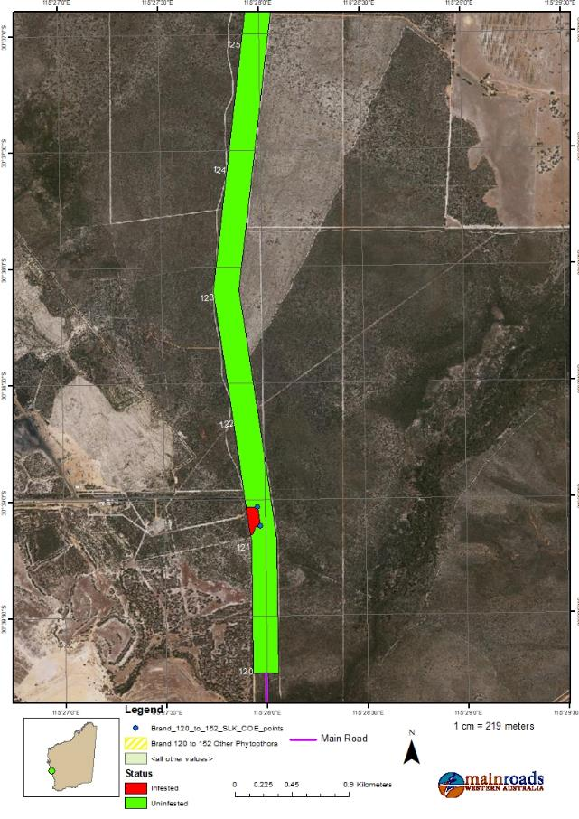
Figure 9: Clean on Entry points-Widening 120-125 SLK
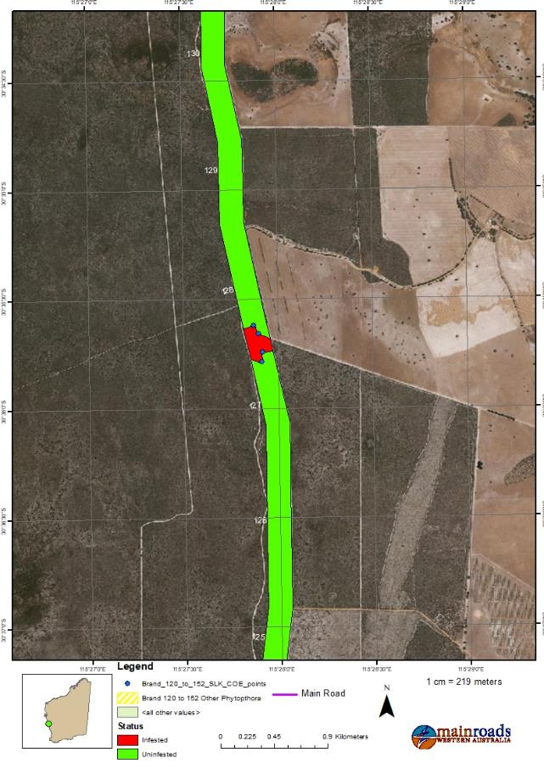
Figure 10: Clean on Entry points- Widening 125-130 SLK
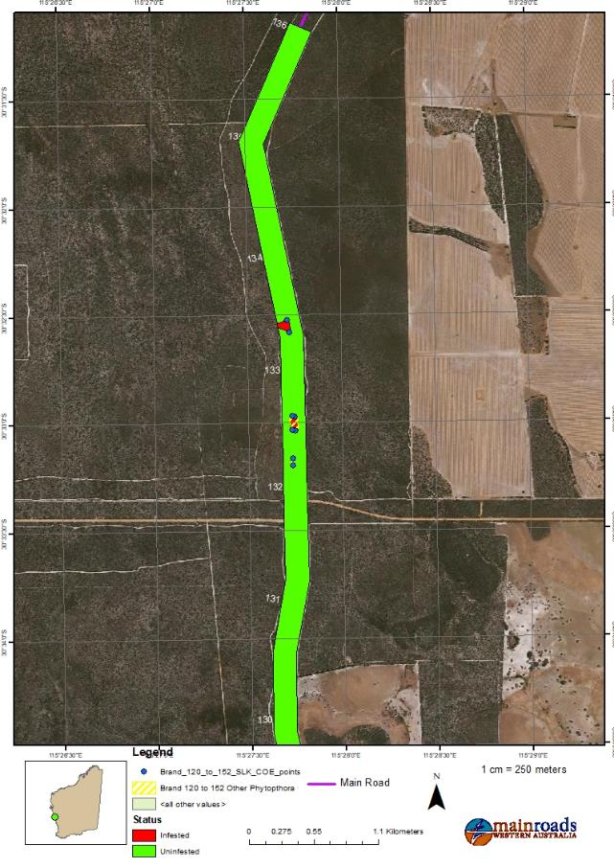
Figure 11: Clean on Entry points- Widening 130-136 SLK

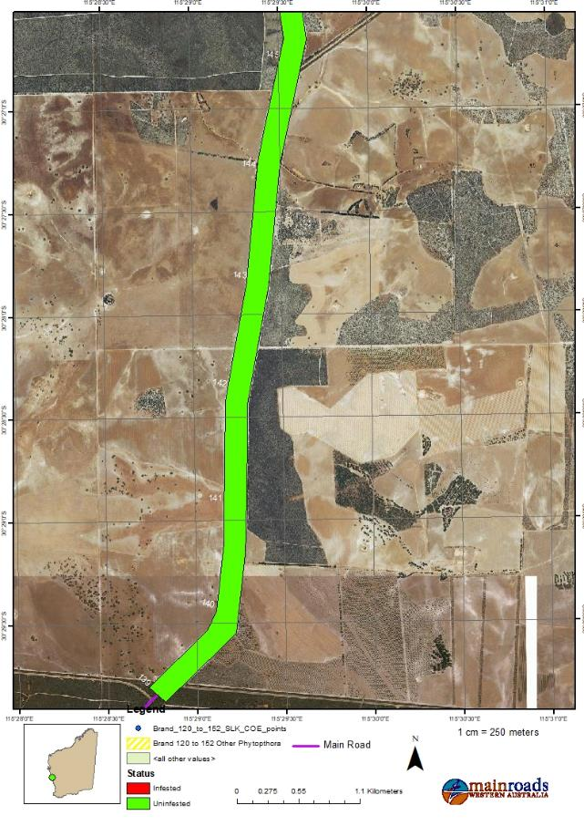
Figure 12: Clean on Entry points- Widening 139-145 SLK
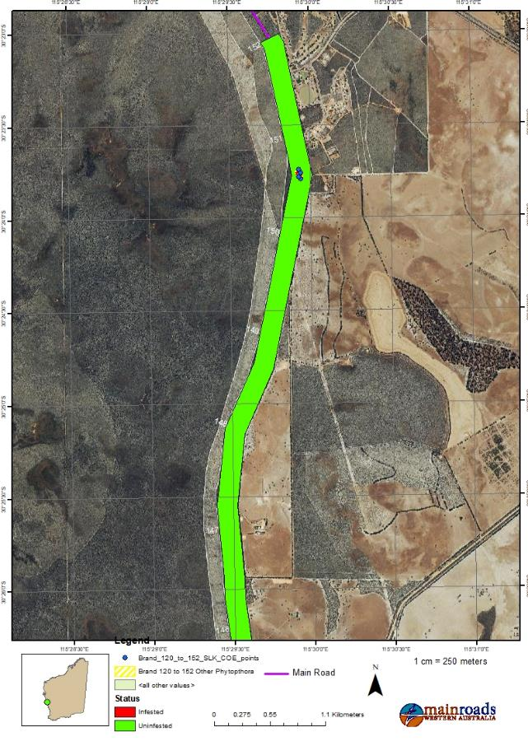
Figure 13: Clean on Entry points- Widening 145-152 SLK

Appendix C: Dieback Classification Table

Three categories are shown on a P. cinnamomi Occurrence Map; Infested (dieback occurs), Uninfested (dieback-free) or Uninterpretable (dieback unknown).

Table 5 Classification of P. cinnamomi Occurrence (CALM, 2003).
Unmappable
Areas that are sufficiently disturbed so that P. cinnamomi occurrence mapping is not possible at the time of inspection.
Mappable  Natural undisturbed vegetation. P. cinnamomi occurrence mapping is possible. Three categories may result. | Infested (dieback occurs) | Areas that have been determined to have plant disease symptoms consistent with the presence of the pathogen P. cinnamomi by a qualified disease interpreter.
 | Uninfested (dieback-free, also known as protectable areas) | Areas that have been determined to be free of the pathogen P. cinnamomi by a qualified Disease Interpreter (all susceptible indicator plant species are healthy; no plant disease symptoms normally attributed to P. cinnamomi are evident).
 | Uninterpretable (dieback unknown) | Areas situated in locations which receive > 600mm per annum rainfall or are water gaining sites (eg. granite outcrops, impeded drainage or engineering works which aggregate rainfall) where indicator plants are absent or too few to determine the presence or absence of disease caused by P. cinnamomi.
*Source: Adapted from (CALM, 2003) Phytophthora cinnamomi and Disease Caused By It, Volume I – Management Guidelines.

Appendix D: Dieback Contingency Actions

DIEBACK CONTINGENCY ACTIONS
Project Component | Trigger | Action | Responsible Person
Vegetation Clearing / Revegetation Activities | Susceptible native vegetation that was previously healthy shows signs of dieback including uniform foliage chlorosis and, progressive death of susceptible native species. | - Engage a registered Phytophthora Dieback Interpreter to confirm the presence, determine the extent and identify the likely cause of Dieback spread.  - Implement dieback control measures to contain new areas of dieback infestation in accordance with the DMP.  - Engage a dieback specialist to monitor the levels of dieback infestation annually for three years.  - Implement fencing and access around dieback uninfested areas. | Project Manager
Hygiene | Dieback has been introduced into an additional area(s) that were previously uninfested. | - Investigate the cause of the incursion of dieback into previously uninfested areas and review construction procedures.  - Engage a registered Phytophthora Dieback Interpreter to undertake sampling to determine whether dieback infestation has occurred.  - Implement control measures to contain new areas of infestation in accordance with the DMP.  - Engage a dieback specialist to monitor levels of dieback infestation on an annual basis for a period of 3 years. | Project Manager
 | Project records indicate unauthorised vehicle or machinery access into excluded areas or breach of vehicle hygiene procedure. | - Investigate the cause of the incursion of dieback into previously uninfested areas and review construction procedures.  - Engage a registered Phytophthora Dieback Interpreter to undertake sampling to determine whether dieback infestation has occurred.  - Implement control measures to contain additional areas of dieback infestation. | Project Manager
Surface Water | Evidence of surface water leaving the project area and entering adjacent dieback uninfested areas. | - Clean up area of actual or potential dieback infestation, if necessary.  - Investigate and determine the cause or source of surface water movement.  - Review practicality and relevance of dieback management procedures.  - Review and improve drainage controls to further prevent surface water run-off occurring from the project area.  - Engage a registered Phytophthora Dieback Interpreter to undertake sampling to determine whether dieback infestation has occurred, if necessary. | Project Manager
Water Use | Evidence of untreated water used within the project area. | - Immediately discontinue the use of untreated water.  - Clean-up area of actual or potential dieback infestation, if necessary.  - Review dieback management procedures to ensure water is treated prior to entry onto project area.  - Improve procedures for treatment of project water use and provide awareness  for project employees. | Project Manager

Appendix E: Dieback Report
