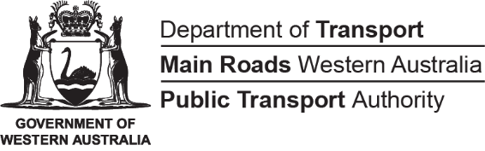

Disability Access and Inclusion Plan

2022-2027

This Plan is available in alternative formats upon request.

People with disability want to travel with ease and we recognise the important role that the Transport Portfolio has in people’s lives. The Transport Portfolio is committed to providing transport services (including employment) and infrastructure to Western Australia’s diverse community in a fair and inclusive way that provides access for people with disability, their families and carers.

Our Disability Access and Inclusion Plan (DAIP) (the Plan) outlines the Portfolio’s commitment to people with disability over the next five years. The Plan captures actions from the State Disability Strategy 2020-2030 and builds on the previous individual DAIPs of the Portfolio agencies and has strategies that provide for the development and implementation of a range of improvements in our services, systems, facilities and workplaces.
This Plan is supported by agency specific detailed DAIP implementation plans that propose actions to support achievement of the strategies. These plans are complementary to agency workforce inclusion and diversity plans that set a framework for workforce and diversity planning including actions to increase the employment and retention of people with disability.

Acknowledgement of Country
The Transport Portfolio acknowledges the Traditional Custodians of the land and their connection to land, waters and community. We pay our respect to all members of Aboriginal communities and their cultures; and to Elders past, present and emerging.

Director General’s Foreword
I am pleased to present the Transport Portfolio’s Disability Access and Inclusion Plan 2022-27.
This is our first Portfolio DAIP and I would like to thank everyone who collaborated and contributed to the development of the Plan. This includes the Transport Portfolio, people with disability, carers, advocates, disability service providers and associations, our customers, stakeholders and, in particular, the Department of Communities for their ongoing guidance and support.
Over the next five years through this DAIP, the Transport Portfolio will continue to work to improve access, inclusion and opportunities for people with disability and together we can make a difference to the Western Australian community.

Peter Woronzow
Director General Transport

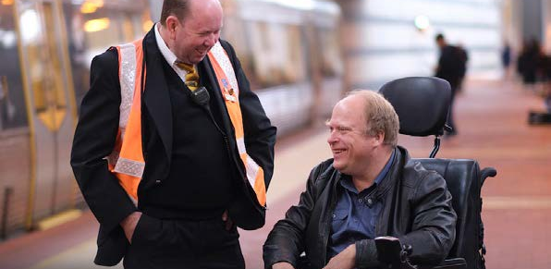
Image: Transperth Customer Service Officer providing direct assistance for a passenger with disability.

About the Transport Portfolio
The Transport Portfolio includes the three State transport agencies - the Department of Transport (DoT), Main Roads Western Australia (Main Roads) and the Public Transport Authority (PTA).
Together, we strive to provide world-class outcomes for our customers, all Western Australians, and visitors to our State. The Transport Portfolio exists to deliver an intelligent, interconnected transport network that responds to Western Australia’s way of life and ensure well designed transport infrastructure that supports vibrant, healthy and sustainable communities.
We provide a range of transport systems and services. DoT services include integrated transport planning for people and freight, strategic policy for maritime, aviation and land transport and licensing for people, vehicles and vessels. DoT also regulates the on-demand transport industry, develops and manages coastal infrastructure and administers a range of grants and subsidies.
Main Roads is responsible for the state’s highways and main roads including the construction and maintenance of freeways, major roads, bridges, roadside rest areas and principal shared paths. Main Roads are also responsible for traffic signals, road signs, school zones, road markings, speed zoning and traffic data.
PTA provides a wide range of public transport services to metropolitan and regional Western Australia including bus, road coach, train and ferry services. This includes support services such as InfoLine which can provide information on accessible public transport services, SmartRider assistance, brochures and timetables.
By working together as a Transport Portfolio we can approach transport planning and delivery in an integrated, strategic and innovative way to achieve improved outcomes.

Commitment to people with disability
The Transport Portfolio is committed to providing services to Western Australia’s diverse community in a fair and non-discriminatory manner, a commitment that is reflected in our Portfolio’s Access and Inclusion Policy.
The Policy outlines the principles we apply to ensure our workplaces, information and services (including employment) will be inclusive and accessible to all Western Australians.
Through implementing this Plan we will also support the State Disability Strategy vision for a community where everyone belongs. We spoke with and listened to people with disability and relevant support networks in the development of this Plan, which seeks to maximise opportunities and improve outcomes for people with disability.
Under each outcome area within this Plan strategies have been identified where there is potential for improved access and inclusion. The strategies provide flexibility to respond to emerging access and inclusion needs. These strategies have been used to guide the identification of actions within each agency’s DAIP implementation plans.

Achievements
We are working collaboratively to continuously improve services and systems to provide opportunities and improved outcomes for people with disability.
Some achievements over the past five years include:

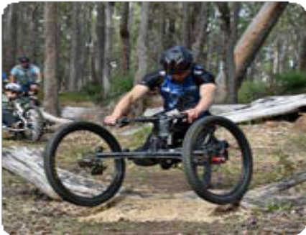
Bike Week is an annual celebration of riding a bicycle for transport, fun and/or a healthier lifestyle which receives administered grant funding by DoT. A clause was included in the grant guidelines asking prospective event planners to “demonstrate how their event takes into account and provides for the needs of people with disability”. An event that successfully gained funding was Beyond the Wheelchair, a free community Adaptive Mountain Biking Come-n-Try workshop in Albany, where people with or without disability could trial varying adaptive cycles on a nearby bush trail.

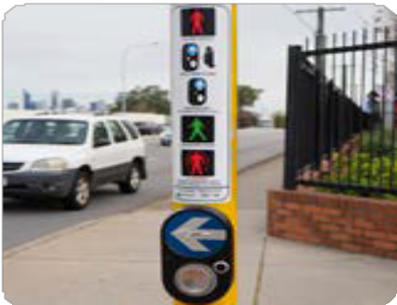
New technology for contactless sensors is being rolled out at selected signalised pedestrian crossings with high volumes of pedestrian demand in the Perth metropolitan area. As an alternative to the existing push button, signalised pedestrian crossings will have new sensors fitted that allow pedestrians to hover their hand over a sensor to activate the crossing. The trial locations will continue to have physical push buttons, audible crossing tone, and a vibrotactile arrow panel to assist hearing and visually impaired users. The additional contactless sensor flashes green when activated, not needing the pedestrian to push a button.

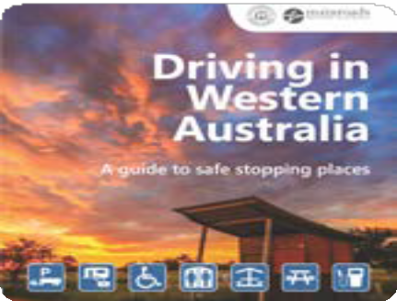
The ‘Driving in Western Australia, a guide to safe stopping places’ has been developed. The booklet features maps and information about some key WA travel routes, identifying the location of accessible toilets, accessible tables and other access information including nearest Changing Places. The new guide was developed based on feedback from stakeholders and comments provided in previous customer perception and travel information surveys. A copy of the guide can be sourced by contacting any Main Roads office or it can be downloaded from the Main Roads’ website.

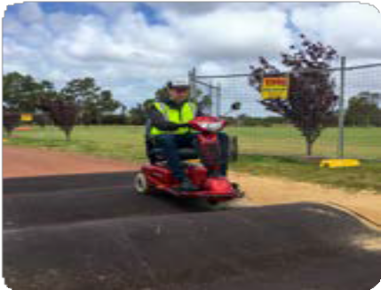
The impact of speed bumps was assessed in an offline section of Perth’s shared path network to ensure their suitability for the use of wheelchairs and mobility scooters as well as vision impaired pedestrians. This activity preceded the launch of a trial of speed bumps in high- traffic areas.

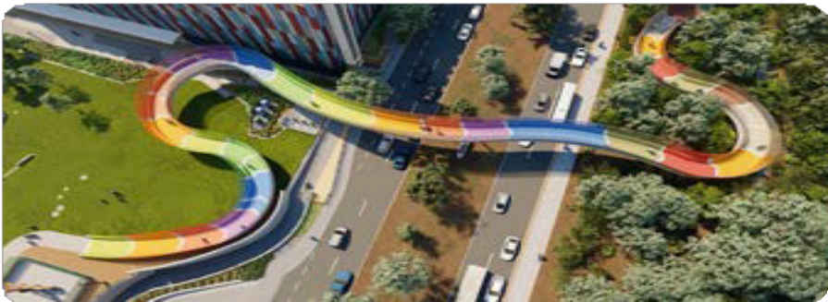
Prior to the construction of the ‘Kid’s Bridge’, Main Roads consulted and sought feedback from the Department of Communities and the Child and Adolescent Health Service Disability Advisory Committee on the design.
The Kids’ Bridge (dual name Koolangka Bridge meaning ‘children’ in Noongar) provides safe passage from Queen Elizabeth II Medical Centre campus to Kings Park, Nedlands. Feedback was gathered on specific design aspects, like signage and surface coverings, from the Main Roads Disability Advisory Group.
The outcomes of this consultation formed part of the final design and made access and inclusion an integral part of the bridge design.
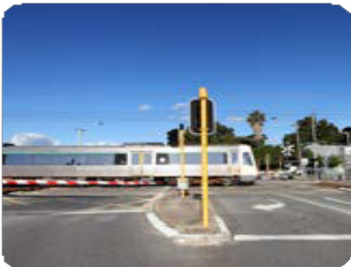
Long term solutions for managing level crossings continue, including removal and grade separation, in particular the Caledonian Avenue Level Crossing Removal project completed in 2021/2022.
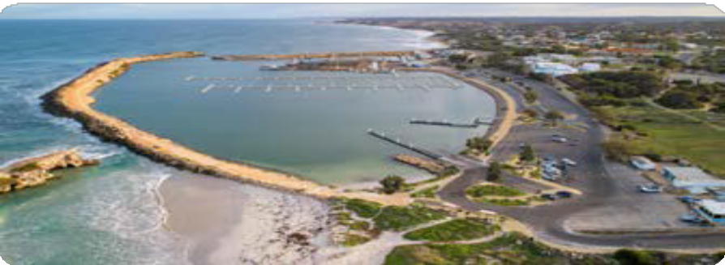
Access to a range of harbours and foreshore areas from Albany to Exmouth was upgraded. At Two Rocks Marina, the Southern Foreshore recreation hub now includes an accessible jetty, shaded seating, additional rest points and barbeques with ACROD bays and accessible toilets nearby. In Bunbury, waterfront improvements were reviewed by a specialist access consultant. Key features include new accessible toilets, a wide footpath, upgraded lighting and ramps with tactile paving and at-grade road crossings.
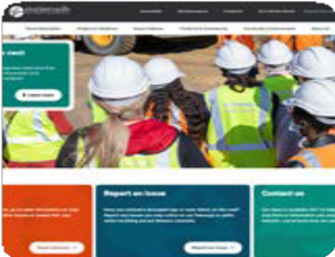

Providing our information to all users, including those with disability, is important. To assist in doing this, a new Main Roads website was launched, designed to meet the Government of Western Australia’s web accessibility standards and includes several specific features. A dedicated ‘Accessibility’ page, available from the header of the homepage, outlines accessible options for users. Focussed on meeting WCAG 2.1 AA compliance, a new content checking tool has also been employed, allowing Main Roads the opportunity to assess the accessibility of website content in real time. This facilitates in- depth accessibility reporting and the ability to make improvements quickly to content to ensure accessibility for all users.

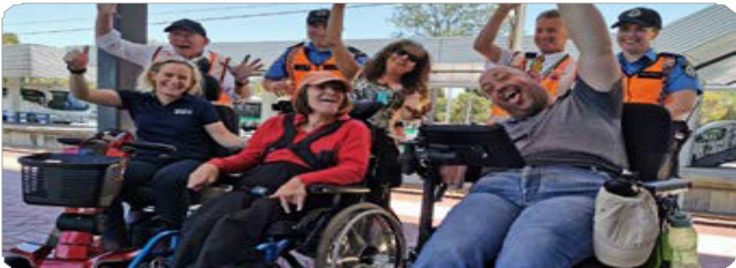
The Transport Portfolio Access and Inclusion Group recognised International Day of People with Disability by hosting an Open Access Day for people with mobility disability and staff.
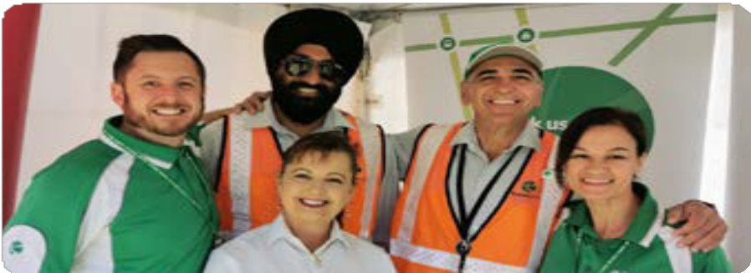
The Get On Board education program continued to support people with disability to develop their skills and confidence to safely travel on Transperth services.
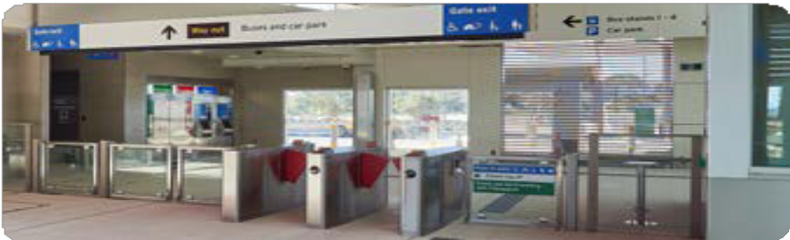
The METRONET Access and Inclusion Reference Group provided advice on the universal design features of new infrastructure, station precincts, railcars, and impacts during construction.

Review and Consultation
This Plan has been informed by people with disability, carers, advocates, disability service providers, disability associations and peak bodies, and staff, who were given the opportunity to provide comments on the development of the Portfolio DAIP. Responses were received from nearly every region across the State.
A range of consultation opportunities were provided where people could provide feedback on the previous agency DAIPs and offer advice and ideas to help shape this Plan. Opportunities to provide feedback were promoted in several ways including:
- Social media accounts
- Visual displays at points of contact with the public
- Established networks including people with disability working on access and inclusion reference groups
- Invitation to more than 30 disability service providers and advocacy organisations
- Agency Intranets
- Information about the consultation process and how to get involved was provided on the My Say Transport website and three Portfolio partner websites
- An advert was placed in the West Australian newspaper on 14 March 2022.

People were provided the opportunity to participate via:
- Two community workshops
- One stakeholder workshop
- Community and stakeholder survey
- Staff survey
- Communicating directly by phone, text or email

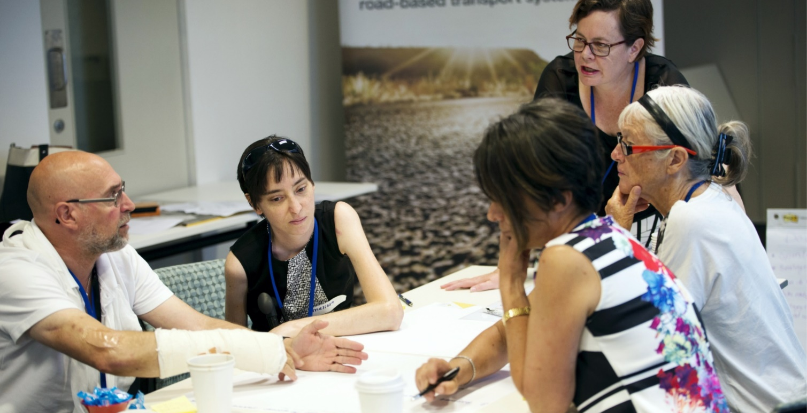

What people told us
The consultation process found that the aims of the previous DAIPs had been achieved. People with disability need transport services, systems and information that are easy to use and inclusive. Feedback received has been considered, and actions developed and included in agency DAIP implementation plans.
Key themes included:
- Accessibility of stations
- Low volume on traffic signals and pedestrian safety at intersections
- Disability awareness training
- Accessibility of Transport buildings and offices
- Employment opportunities for people with disability

We also received positive feedback in several areas including customer service, Transperth Assist app, talk back radio, access and inclusion reference groups, consultation for Main Roads projects and programs delivered by the Transperth education team.
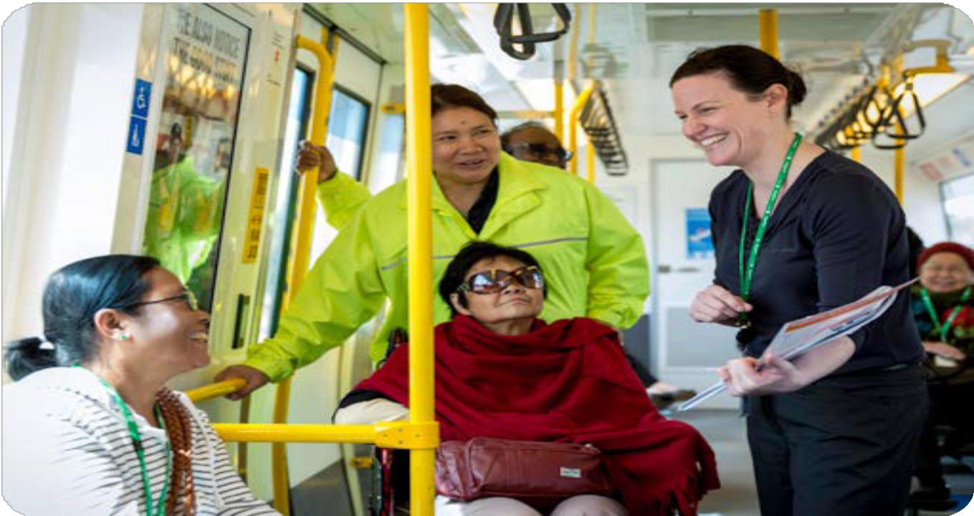

Image: Transperth Education team providing a network tour on a Transperth Train.

The Next 5 Years
This DAIP is effective for five years from October 2022 to September 2027 and contains the following high level strategies that the Portfolio has identified to improve access, inclusion and opportunities for people with disability, their families and carers. Each Portfolio agency has detailed DAIP implementation plans with progress monitored by agencies and achievements highlighted in their respective Annual Reports.

DAIP Outcome 1: Services and events
People with disability have the same opportunities as other people to access the services of, and any event organised by, the Transport Portfolio.
- Transport systems, services and processes are developed or updated so they are inclusive and accessible to people with disability.
- Maximise opportunities and improve outcomes for people with disability when using public transport.
- Organise all events/forums so they are inclusive and accessible to people with disability.
- Ensure all agents and contractors who interact with the public on behalf of the Portfolio comply with this DAIP as appropriate.
A Western Australia for Everyone: State Disability Strategy 2020-2030
Pillar 2: Inclusive communities – places and attitudes are welcoming

DAIP Outcome 2: Buildings and facilities
People with disability have the same opportunities as other people to access the buildings and other facilities of the Transport Portfolio.
- Transport services, infrastructure and premises are universally designed to ensure accessibility for people with disability.
- All new public facilities are accessible and support people with disability to use transport services and systems.
- New buildings and refurbishments will consider access to amenities and staff areas for employees with disability.
- Existing public services, infrastructure and premises are progressively upgraded to improve accessibility for people with disability.
A Western Australia for Everyone: State Disability Strategy 2020-2030
Pillar 2: Inclusive communities – places and attitudes are welcoming

DAIP Outcome 3: Information and communication
People with disability receive information from the Transport Portfolio in a format that will enable them to access the information as readily as other people are able to access it.
- Information is provided in ways that are meaningful and useful to people with disability, recognising that not everyone can access written, audible or online information. Disruptions and changes to processes, systems, services and facilities are communicated effectively.
- Websites and publications meet accessibility standards and information is available in alternative formats upon request for people with disability, and where necessary, their carers.
- Accessible information requirements are considered when designing and delivering external communication campaigns to ensure people with disability are included.
- Ensure there is access to translating and interpreting services for people with disability.

A Western Australia for Everyone: State Disability Strategy 2020-2030
Pillar 4: Rights and equity – everyone is treated Fairly

DAIP Outcome 4: Quality of service
People with disability receive the same level and quality of service from Transport Portfolio staff as other people receive.
- People with disability are supported to use transport systems and services.
- Employees and contractors are adequately trained in relation to service provision for people with disability.
- Stories and achievements of people with disability are highlighted in internal and external communications, including annual and other reports, to showcase the diverse skills and achievements of people with disability.

A Western Australia for Everyone: State Disability Strategy 2020-2030
Pillar 3: Living well – people are happy and healthy, with the support they need

DAIP Outcome 5: Complaints
People with disability have the same opportunities as other people to make complaints to the Transport Portfolio.
- We will listen to people with disability and their experience and welcome feedback to continuously improve our services.
- Complaint systems are easy to find, easy to access and easy to use.
- Complaints and feedback on access and inclusion are regularly reviewed to identify and address any systemic issues or opportunities for improvement.

A Western Australia for Everyone: State Disability Strategy 2020-2030
Pillar 4: Rights and equity – everyone is treated Fairly

DAIP Outcome 6: Consultation
People with disability have the same opportunities as other people to participate in any public consultation by the Transport Portfolio.
- Continue to ensure a consultative process through access and inclusion reference groups for key projects where required.
- Seek specialist advice on disability access issues, during planning, design and construction phases for key transport projects where required.
- Continue to review public consultation process and identify any improvements for future consultations.

A Western Australia for Everyone: State Disability Strategy 2020-2030
Pillar 1: Participate and contribute – everyone is involved

DAIP Outcome 7: Employment

People with disability have the same opportunities as other people regarding employment practices (recruitment and retention) by the Transport Portfolio.
- Partner with jobs and skills centres, disability employment service providers and networks to engage with and attract people with disability who are seeking jobs.
- Implement the Public Sector Commission’s People with Disability: Action Plan to Improve WA Public Sector Employment Outcomes 2020- 2025. Increase the representation of people with disability employed in the public sector to 5 percent by the end of 2025.
- Become accredited Disability Confident Recruiters.
- Employees and contractors who work alongside people with disability are trained to engage appropriately, respond effectively and provide necessary supports.
- Continue to raise awareness of social procurement initiatives and engagement of Australian Disability Enterprises.

A Western Australia for Everyone: State Disability Strategy 2020-2030
Pillar 1: Participate and contribute – everyone is involved

Promoting the Plan
The Plan is available to all employees, contractors and the community, including people with disability and their families and carers, via each agency’s intranet and website. The Plan will be released through promotion on agency websites and social media channels.

Monitoring implementation
Each agency is responsible for delivering actions within their DAIP implementation plans and the Portfolio will review the implementation of strategies identified in the Plan.
The Portfolio will report to the Department of Communities annually on the progress of achieving the seven outcomes of the Plan, and key achievements will be highlighted in agency Annual Reports.
In accordance with the Disability Services Act 1993, the Transport Portfolio will review the DAIP every five years.

Acknowledgements
We would like to thank all the people with disability, their support networks and the community who shared their transport experiences to inform this plan. We want to also thank the organisations who talked with us about their experiences in supporting people with disability and our staff for their feedback on how we can improve.

Feedback
To share your thoughts or if you would like this Plan provided in an alternative format,
please contact us:

Department of Transport
Disability Access and Inclusion Plan
Office of the Director General Department of Transport
GPO Box C102
Perth, WA 6839

Phone: 13 11 56
National Relay Service on
13 36 77
Email: AccessandInclusion@transport.wa.gov.au
Website:
www.transport.wa.gov.au

Main Roads
Disability Access and Inclusion Plan
Don Aitken Centre Waterloo Crescent East Perth WA 6004 PO Box 6202
East Perth WA 6892
Phone: 13 81 38
National Relay Service on
13 36 77
Email:
enquiries@mainroads.wa.gov.au

Website:
www.mainroads.wa.gov.au

Public Transport Authority
Disability Access and Inclusion Plan
Public Transport Authority
PO Box 8125
Perth Business Centre WA 6849

Phone: 13 62 13
National Relay Service on
13 36 77
Email:
daip@pta.wa.gov.au

Website:
www.pta.wa.gov.au

