The below highlights a selection of key initiatives Main Roads has been progressing from each of the seven Outcome Areas as outlined in the DAIP:

General Services and Events
Planning and Design of Pedestrian Crossings
At Main Roads we strive to address the needs of people with disability as an integral part of our drive to provide a transport network centred on what our customers need and value. Over the last few years, we have been working alongside industry partners including Department of Transport (DoT), WALGA, RAC and the Institute of Public Works Engineering Australasia (IPWEA) to refine our Guidelines for the ‘Planning and Design of Pedestrian Crossings’.

There have been subtle but life-changing differences at traffic signal intersections with signalised crossings. Some of the improvements made, to help benefit people with disability include:

- Audio and tactile push buttons with distinguished audible features for "WALK" and "DON'T WALK" cycles to assist vision impaired pedestrians to safely cross our roadways.
- Lowering of push buttons so that they can be easily activated from a wheelchair.
- Relocation of traffic signal poles and push button to the back of pedestrian ramps so that wheelchair users can access the button before entering the slope of ramp.
- Installation of AGD detectors in median islands at long crossings – these detectors sense when pedestrians are caught in the median island and activate the pedestrian crossing phase.
- Flashing yellow ‘caution lights’ to remind motorists to give-way to pedestrians when the green and flashing red time is active.
- For signalised crossings only, traffic signal poles are fitted with red and white retro-reflective bands for visibility of crossing location and to approaching motorists.

In addition, some pedestrian crossings have:
- Tactile ground surface indicators on the pedestrian ramp to help identify the start of the crossing, along with directional ground surface indicators to direct pedestrians to the location of the pedestrian ramp.
- Grab rails in median islands and pedestrian ramps to guide pedestrians at crossings.
- A 1.5 metre square platform at the back of the pedestrian ramp, for wheelchair access and turning.

While not all crossings can be fitted with all of the specifications available, the aim is always to provide as close to the requirements as possible.
Pedestrian crossings across the network are being regularly updated when other works are planned in the vicinity. Below is a recent example of upgrading pedestrian crossing facilities for vulnerable road users to the busy intersection of Charles Street and Walcott Street:
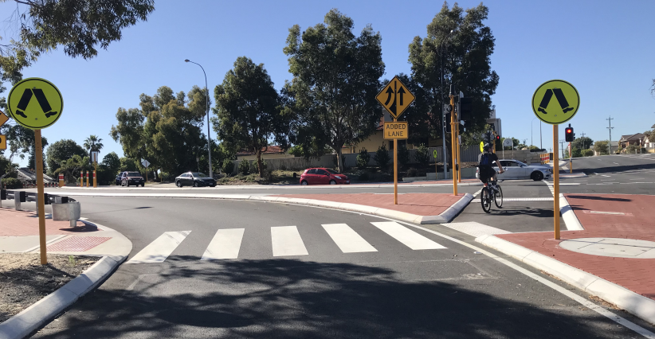

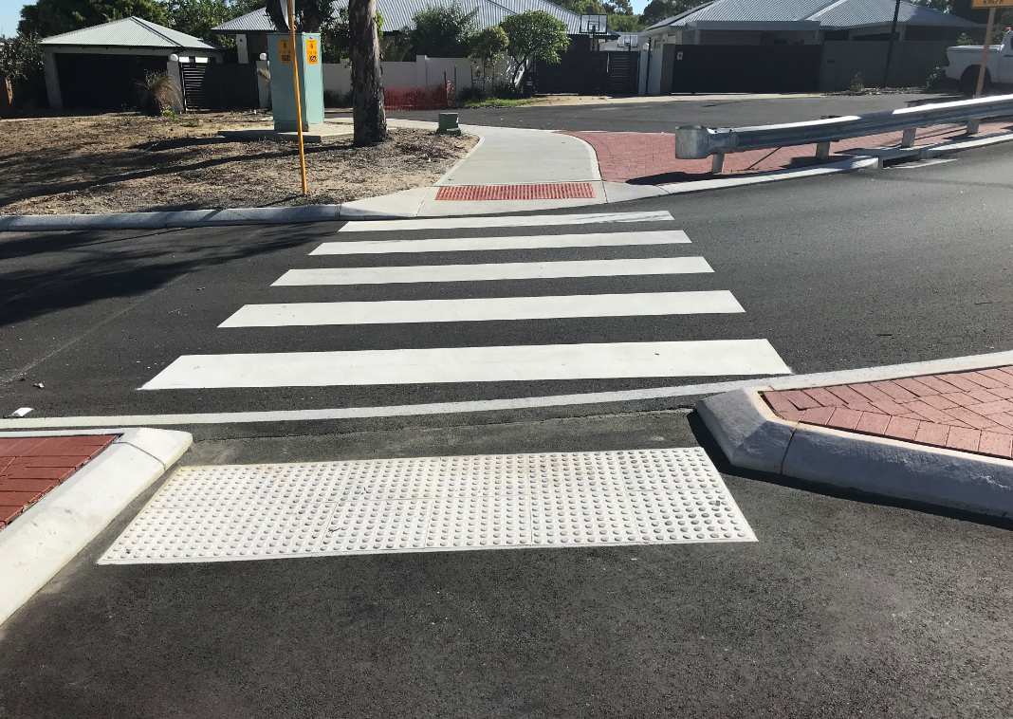
(Intersection of Charles Street and Walcott Street)

Installing New Pedestrian Crossings - Making a Difference in our Community
A package of safety improvement works, which include upgrades to the pedestrian facilities at the existing traffic signal intersection of Great Eastern Highway, Stoneville Road and Mundaring Weir Road have been completed. The works included:
- Upgrading the pedestrian facilities to provide fully controlled crossings with pedestrian countdown timers on all four approaches to the intersection
- Changes to the pedestrian ramps on the western and southern crossings to improve access
- Relocation of traffic signal poles to improve accessibility
- Installation of tactile ground surface indicators to improve guidance for vision impaired pedestrians; and
- Modification to the lane configuration on Stoneville Road to minimise delays for southbound traffic.
Pedestrian countdown timers are designed to help improve intersection safety. They display the number of seconds left for pedestrians to complete their crossing and therefore provide additional assurance and reduce potential pedestrian confusion. This means pedestrians are less likely to cross when there is not enough time to finish crossing safely, improving the intersection efficiency for both pedestrians and motorists.
A new staged mid-block, signalised pedestrian crossing with countdown timers has also been installed between Mann and Nichol Streets as part of the package of works, to provide an additional safe crossing point across Great Eastern Highway for pedestrians. More than 20 000 vehicles pass the busy intersection each day. These improvements will increase the safety of pedestrians crossing the roads at this location.
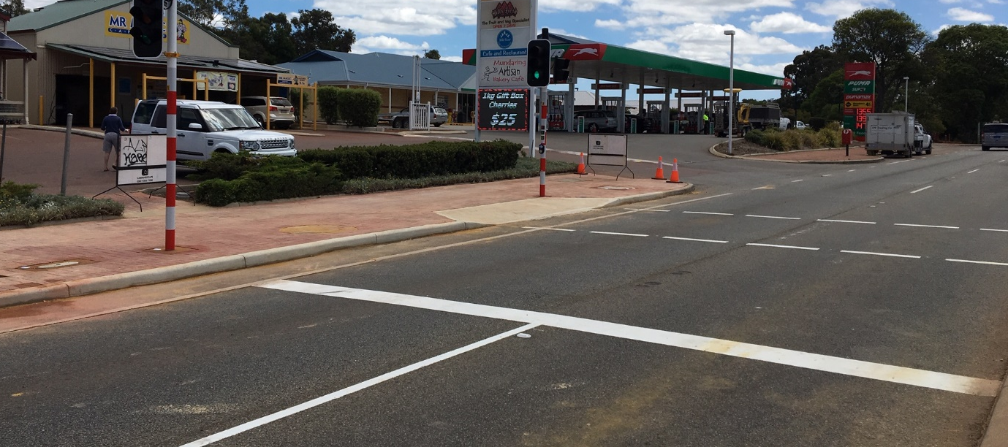
Another significant location where Main Roads has installed a pedestrian crossing is at Gilmore Avenue in the Kwinana city centre. The new crossing sits just across from the Kwinana Adventure Park and Edge Skatepark with the Kwinana Zone Youth Space opposite – a high traffic area for both cars and pedestrians. The crossing gives pedestrians 16 seconds to cross each section of road, which includes a visual countdown from 10 seconds. The pedestrian signals are coordinated with the traffic control lights at Gilmore Avenue and Harlow Road for the management of traffic flow. These improved pedestrian crossings are making a significant differences in people’s lives when accessing local amenities.

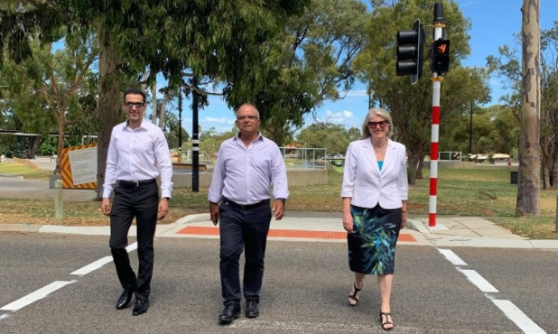
(Picture courtesy of City of Kwinana. City of Kwinana Mayor Carol Adams with (L-R) Shobair Hosseini, Coordinator Engineering design and Reza Najafzadeh, Manager- Engineering Services crossing at Gilmore Ave at the newly installed pedestrian crossing)

Hay St Pedestrian Priority Zone
Part of the City’s East End Revitalisation Program saw the activation of the Hay Street Pedestrian Priority Zone between Pier Street and Irwin Street this year. This is a unique and innovative project between the City of Perth and Main Roads providing more space and amenity for people of all abilities without compromising the functionality of the street.

The key aims of a Pedestrian Priority Zone or a Shared Space include increasing amenity and safety for pedestrians, people with disability and people riding bikes within the on-road environment. The shared pedestrian zone, which is the first of its kind in the CBD, aims to change the road hierarchy. The Pedestrian Priority Zone key features include reducing speed limits for vehicles to 20km/hr, wide footpaths, upgraded lighting and a greater focus on pedestrians.
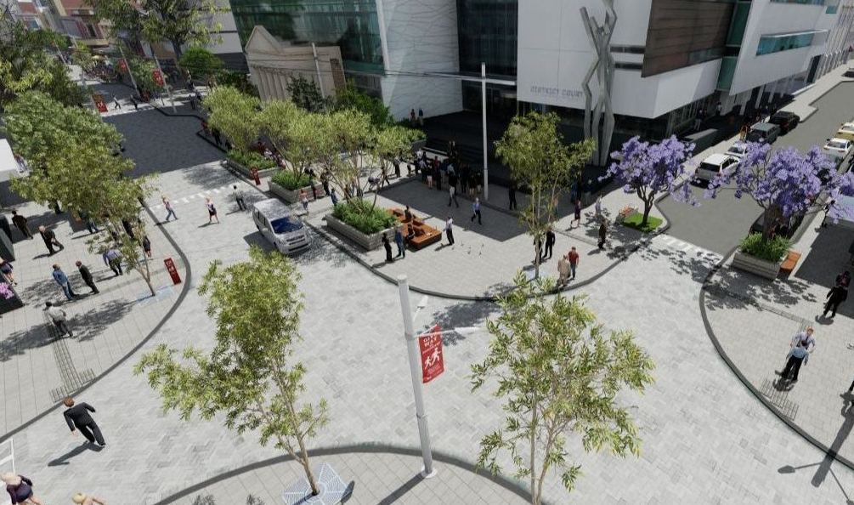
(Graphic visuals from the Hay Street East End Revitalisation video)

Safe Active Streets
Various "Safe Active Street" projects have also been implemented this year. The aim of the Safe Active Streets is to increase the safety for vulnerable road users (including people with disability), reduce vehicle speeds and volumes and utilise local roads to fill gaps in the network where separated infrastructure is not possible. The focus on the design is based around safety, residential amenity and users of the streets to provide a safer road environment for everyone. An example of this is the recently completed Safe Active Street in Nedlands, at Elizabeth Street and Talbot Street. Ongoing work includes Morland Street, Deanmore Street and Manning Street in Stirling, as well as Golding Street, Strathcona Street and Florence Street in West Perth.
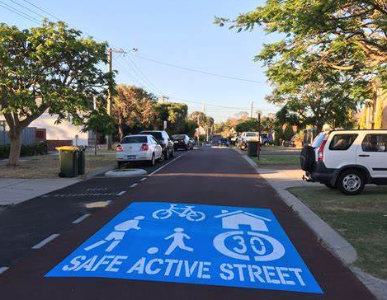
(Safe Active Street – entry signage)

- Buildings and Facilities

Universal Access Audit and Improvements
A ‘Universal Access Inspection’ audit was conducted on Main Roads offices by Building Management and Works (BMW). The purpose of the audit was to provide an inspection report to ascertain the level of compliance of the buildings (and surrounds) in relation to disability access and inclusion and make recommendations for improvements. The audit specifically required the auditors to identify issues related to access for people with disability to and from the subject building including associated amenities. As part of the contract, Main Roads requested that the auditors review our responsibility under the Main Roads Disability Access and Inclusion Plan (DAIP) to ensure the needs of people with disability are able to adequately access the buildings and services offered.

From the audit findings, this year we have completed the following projects:
- Replacement of external stair handrails at our Head Office in East Perth
- Modifications to external paved areas at our Head Office in East Perth
- Provision of universal access toilet and ambulant toilet at our Carnarvon office
- Our Traffic Operations Centre (TOC) in Newcastle Street in Perth is undertaking a comprehensive upgrade to increase accessibility, such as upgrading external ramps and stairs, and considering options for a compliant tearoom
- The provision of a universal access toilet on the 8th floor at our Head Office in East Perth.

Information and Communication

Compliance of Main Roads website and other digital platforms
During the 2020/2021 financial year a new Main Roads website was launched. The website has been designed to meet the Government of Western Australia’s web accessibility standards and includes a number of specific features.
A dedicated ‘Accessibility’ page, available from the header of the homepage, outlines accessible options for users. These include:
- Tab-based navigation and skip-to-content links: The website allows full tab-based navigation, with options at the top of each page to skip to the main content, to assist users of screen readers and users that are viewing the website zoomed in.
- Text resizing: The text on the website can by resized via tools in the browsers menu. These can also be accessed using the mouse wheel and keyboard controls.
- Hyperlinks: Wherever possible, hyperlinks contain descriptions of information found in the link’s destination. All links open in the same window to improve usability for people with vision impairment, with the exception of links to documents, which open in a new window.
- Images: Images that are used to display a meaning will have alternative text descriptions provided. Some browsers may also display a tooltip of this alternative text when the cursor hovers or focuses on the image.
- Documents attachments: Where applicable, PDF documents have also been provided in Microsoft Word format. In some cases, a Microsoft Word version can’t be provided however a request can be made to obtain a copy of a document in an alternative format.
The below image of the Main Roads website homepage highlights the ‘Accessibility’ tab available for users to explore:
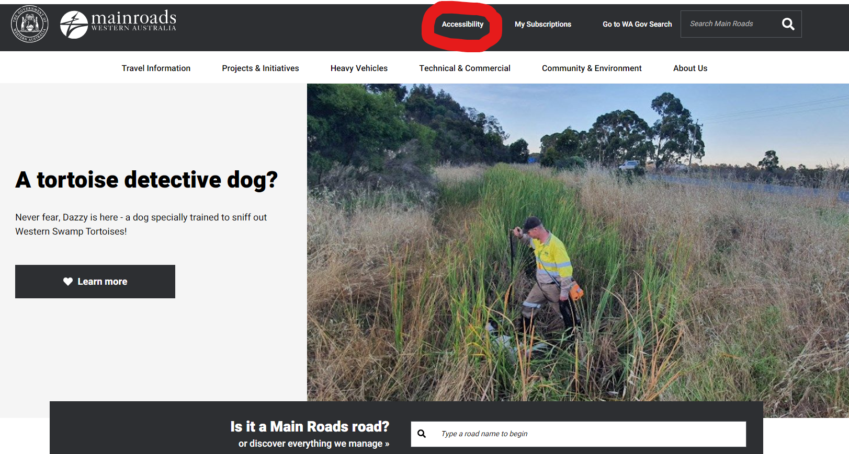

Quality of Service
New Driving in WA Guide released
Main Roads' new ‘Driving in Western Australia – A guide to safe stopping places’ booklet was released early this year.
Working with Disability Services and Changing Places, within the booklet there are a number of maps of some of the key Western Australian travel routes pinpointing facilities along the way so people can plan their trips.
The guide identifies the locations of accessible toilets, accessible tables and facilities for people with disability. In addition, it assists our customers in finding the nearest ‘Changing places’ location and information on accessing a MLAK.
The new guide was developed taking into account feedback from stakeholders and comments provided in last year's Customer Perception and Travel Information Surveys.
Designed to be a handy addition to any glovebox, the guide also provides information for road users on stopping places, basic road rules, safe overtaking, cyclones, floods and fires, fatigue, towing, animals and more.
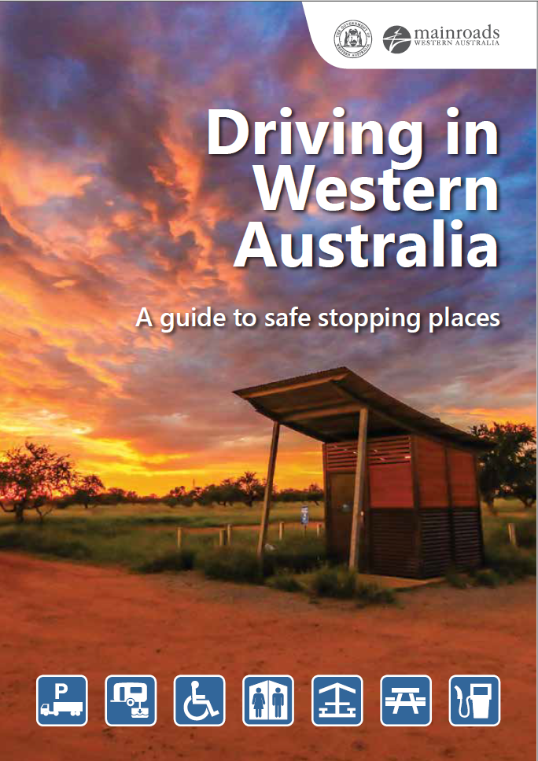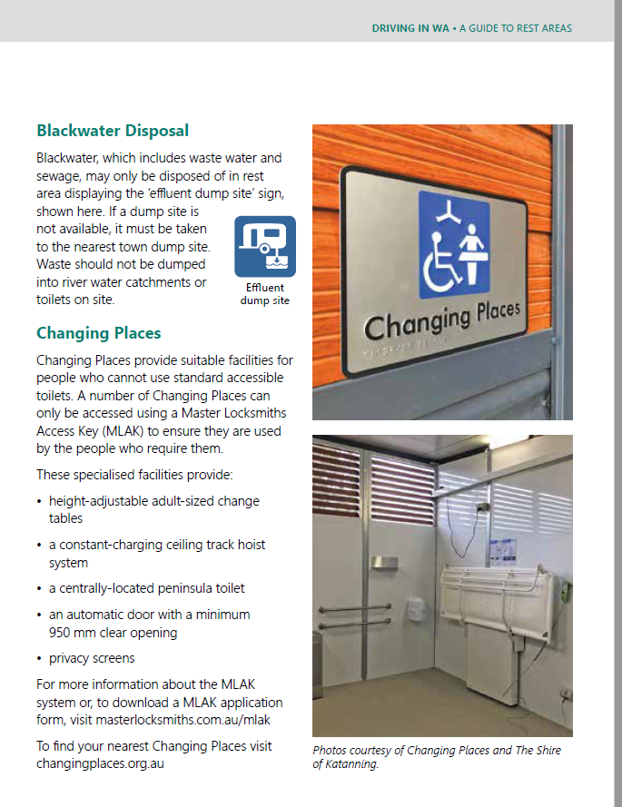

The guide also ties into Tourism WA's Wander Out Yonder campaign by providing road users with an overview of what to see and do in the regions before launching into a series of maps which highlight some of the major stopping places along key driving routes.

Highlighted below in yellow are the key icons to allow people with disability access to facilities along their journey. Below is an extract of the introduction to using the maps:
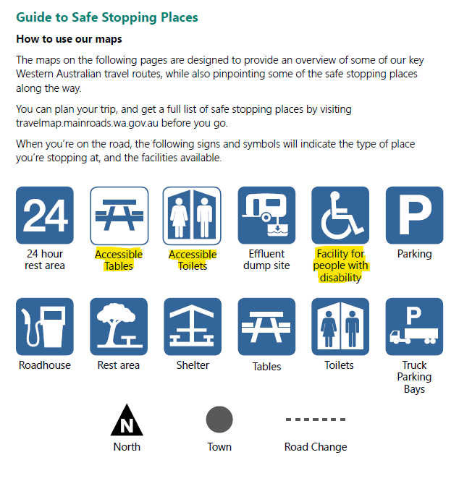

Below is an example of one of the maps, highlighting accessible facilities:

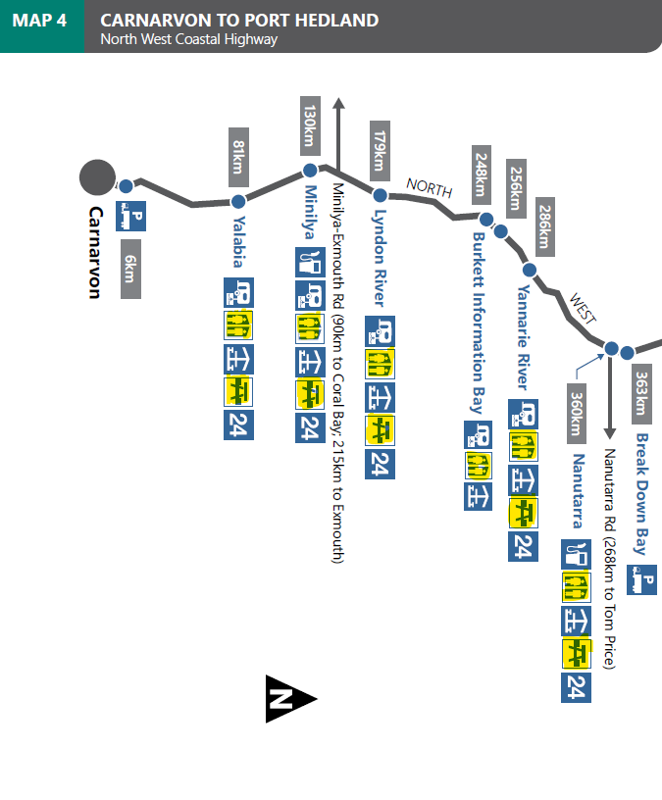

The Guide was developed through the support of our Customer Service and Regional Managers and stakeholders including the Department of Transport, Tourism WA, Road Safety Commission, Keep Australia Beautiful Council, WAPOL, Disability Services and Changing Places.
In promoting the guide, a copy was also sent to Disability Services to electronically circulate to key stakeholders.

Complaints and Safeguarding

Customer Information Centre
Main Roads is committed to ensuring relevant staff are able to provide and are equipped with the right tools/resources to provide quality customer service. The Customer Information Centre (CIC) is the frontline for people contacting Main Roads for help, this includes help with a journey, help with faults and help with emergency response. Whilst servicing customers is a key role for the CIC, the team are also the main conduit for public information during emergencies such as road closures, bushfires, flooding and cyclones. They work closely with the regions and the Real Time Traffic Operations to provide public information and to support our people on the ground who manage these incidents.
As the CIC team deal with a number of issues, it’s important they are made aware of the Main Roads Disability Access and Inclusion Plan and their obligations to ensure the team receives adequate training to effectively communicate with customers with disability. This training is ongoing, commencing at initial induction, with CIC staff required to undertake a refresher every six months.

Consultation and Engagement

Community Perception Survey
The Main Roads annual Community Perception Survey gives people an opportunity to tell us what they really think. By asking the hard questions, we can plan and deliver projects and services based on what the community wants, needs and expects. The survey is completed online, and there is the option for alternative formats or engagement methods, such as telephone interviews if the respondent requires. This allows people with disability the same opportunity to participate in the consultation.

This year, 1 357 participated in the survey, 702 residents from rural areas (100+ respondents from each region) and 655 residents from the Perth metropolitan area. The survey measures a suite of indicators, with one indicator being how satisfied the community is with Main Roads’ overall performance in the management and operation of the State road network. The rating increased in 2021, with 92% of survey participants rating Main Roads’ performance as okay or better.

Another indicator measures how satisfied the community is with Main Roads’ performance in the construction, maintenance and management of cycleways and pedestrian facilities. 89% of survey participants rated our performance as okay or better this year, coming just under our target and matching our 2018’s result. The Metropolitan region continues to achieve the highest result for this indicator.

We also capture how satisfied the community is with our overall performance in the area of road safety. Main Roads exceeded the target for the third year in a row, with 93% of participants giving an okay or better rating. After improving significantly in 2020, Great Southern dropped this year to 78%, which aligns more with previous year’s results. Goldfields-Esperance has improved by seven percent this year, while the other regions remain steady.

Key to providing a transport network centred on what our customers need and value, is recognising that all members of the community have the same rights to access our products and services. By undertaking this annual survey with a vast range of community members we can assess valuable information that allows us to track our performance in delivering vital services.

Building Relationships across the Transport Portfolio and Government
To ensure good consultation and engagement strategies are implemented, Main Roads participates in regular Transport Access and Inclusion Group meetings. The intent of these meetings are for our Portfolio partners to share resources and success stories to keep up to date on contemporary access and inclusion best practice.
The Transport Portfolio DAIP Access and Inclusion Working Group Meeting was held at Public Transport Authority (PTA) on the 2 Sept 2020, and again on the 26 February 2021 at the Department of Transport (DoT). It included representatives from PTA, DoT and Main Roads to discuss disability access and inclusion on a broader cross-portfolio level. The next Portfolio meeting is to be hosted by Main Roads in August 2021.
Main Roads also participated in a workshop facilitated by the Dept of Communities to build a 10-year State Disability Plan, with the key area of focus being ‘Transport’. In the Transport Portfolio Access and Inclusion Working Group meeting, attendees reviewed the State Disability Strategy and Action Plan that was released in late 2020, with Main Roads, Dept of Transport and Public Transport Authority agreeing to work together on a number of actions moving forward.

Employment, people and culture

Main Roads engaging WA Disability Enterprises (WADEs)

As part of the procurement planning process, our Procurement Plans and ‘Request Approval to Call Tenders Goods and Services’ documents includes a recommendation that buyers consider purchasing from an approved WA Disability Enterprise (WADE). Main Roads’ contract with Intelife for car cleaning at both our Head Office (in East Perth) and Heavy Vehicle Operations office was established in 2003 and continues to this day. Activ Foundation has also recently been awarded a contract for gardening and grounds maintenance services for our South West office and depot.

People and Culture at Main Roads

As at the 30 June 2020, Main Roads employed 1140 employees, of which 3% identified (through self-declaration) as having a disability. To create a culture of inclusion, equal employment opportunity training is compulsory for new starters. Main Roads employees also have access to a cultural competency online training package, called Diverse WA, which covers people who are deaf or hard of hearing. This training is now available on the Main Roads Learning Hub and has been promoted through an iRoads news article. Key staff in roles that communicate with the public have also been briefed on the training and policy.

For the first time this year, Main Roads also promoted the LeadAbility Program on our intranet and directly to the Main Roads DAIP Working Group. This program is being coordinated by Leadership WA and looks at developing the potential of people with disability and those in the sector who have the potential to lead and generate change.

As part of our recruitment process, we have also included a statement on our commitment to a diverse and inclusive workplace. Recently in addition to this statement, for each job advert we have outlined that if the applicant needs any support or has any access needs that may require adjustments to allow them to fully participate in this selection process to please let us know.

We are committed to fostering diversity and inclusion at all levels because we recognise that a diverse workforce is integral to the success of our business. We have a suite of resources to assist employees on our intranet page, with these resources providing information on unconscious bias and inclusion in the workplace.

