


Planning and Technical Services Directorate
Surveying and Geospatial Services Branch

Document No. D12#434822 Issue Date 23/04/2013

DIGITAL RECTIFIED IMAGES

This document is owned and controlled by the Surveying and Geospatial Services Manager.

The Senior Mapping Surveyor is the delegated custodian.

All comments for revision should be submitted to the Senior Mapping Surveyor.

Authorisation

As Executive Director of the Technology and Environment Directorate of Main Roads, I authorise the issue and use of this standard.

..............………………........................................................
EXECUTIVE DIRECTOR PLANNING AND TECHNICAL SERVICES

Date: ___/ ___/ ___

No controlled copies are issued for this standard.

The latest copy of this standard is located on the Main Roads website.

REVISION STATUS RECORD

Page  No | Latest  Revision  No | Latest  Revision Date | Revision  Description/Reference
1 |  |  | MRWA Logo changed
2
3
4 |  |  | Definition alteration - DOLA removed and replaced with “DLI – Department of Land Information”.
5
6
7
8
9 |  |  | MRWA Logo changed
10
11
12
13
14
15
16
17 |  |  | Appendix diagram changed
18 |  |  | Appendix diagram changed
19 |  |  | Standard revised – all pages

Authorised by : ________________________________ Date ____/____/____
Surveying and Geospatial Services Manager

CONTENTS

1. PURPOSE 5
2. SCOPE 5
3. REFERENCES 5
4. DEFINITIONs 5
5. DIGITAL RECTIFIED IMAGES 6
5.1 Coordinate Datum 6
5.2 Spatial Quality 6
5.3 Pixel Enlargement Limitations 7
5.4 Output Image Format 7
5.5 Image Compression Limits 7
5.6 Null image areas 8
6. DATA OVERLAYS 8
6.1 Standard Overlay Colours 8
6.2 Text 8
6.3 Grid Ticks and Displayed Coordinates 9
6.4 Title Block 9
6.4.1 Main Roads Logo and Disclaimer 9
6.4.2 Scale 9
6.4.3 North Point 10
6.4.4 Metadata Box 10
6.4.5 Company Logos 10
7. PRESENTATION LAYOUT 11
7.1 Single Image Layout Requirements 11
7.1.1 Image window requirements 11
7.1.2 Title Block Requirements 11
7.2 Booklet Requests 11
7.2.1 Front Cover 11
7.2.2 Index Page 11
7.2.3 Image Pages 12
8. DATA SUPPLY 13
8.1 Verification Plots 13
8.2 Final Plot Quality 13
8.3 Plot Size Limitations 13
8.4 Image Report 13
8.5 Lamination 13
8.6 Digital Images 13
8.7 Created Digital Overlays. 14
8.8 Mediums for Digital Data Supply 14
9. Copyright 14
APPENDIX A - IMAGE REPORT 15
APPENDIX B - SINGLE IMAGE LAYOUT REQUIREMENTS 16
appendix c – booklet layout requirement – cover page 17
appendix c – booklet layout requirement – index page 18
appendix c – booklet layout requirement – image page 19

PURPOSE

The purpose of this standard is to establish the requirements for digital images and the resulting hardcopies for Main Roads.

SCOPE

This standard shall apply to all digital rectified images and mosaics undertaken for Main Roads.

Advice and further information can be obtained by contacting the Senior Mapping Surveyor.

REFERENCES

The following documents relate to this procedure

67-08-33 Data License/Copyright.

DEFINITIONs

The following terms used in this procedure have the specific meanings indicated

MRWA – Main Roads.
Mosaic - A combination of two or more photographic images into one composite image.
Seamless Mosaic - A mosaic with no discernable joins or seams
Rectified Image - An image that has been altered from its original state to achieve a desired spatial outcome. Including mosaics.
Ortho photograph – An ortho photograph is a photograph that has been corrected for sensor, platform-induced, geometric and topographic distortions. It possesses the geometric characteristics of a map.
MRS – Metropolitan Region Scheme.
UV – Ultra Violet.
dpi – dots per inch.
RHS – Right Hand Side.
LHS – Left Hand Side.
ECW – ERMapper Compressed Wave file.
GSM – Grams per Square Meter.

DIGITAL RECTIFIED IMAGES

Main Roads produces and uses digital rectified images for a number of applications to assist in project development. The following standards have been developed to ensure constant product outputs and presentations.

Examples of product uses are;

- Presentations - for internal and public presentations.
- Planning - to aid in route analysis.
- Projects - creation of maps for concept road design.

5.1 Coordinate Datum

All georeferenced images shall be referenced to the local GDA94 grid unless otherwise specified.

5.2 Spatial Quality

All rectified images shall meet the following spatial quality criteria:

Scale
SQ = -----------
Rk

Where;

SQ = Spatial Quality output in metres
Scale = the output scale of the resultant rectified image i.e. 5000 for 1:5000
Rk = Rectification Class Constant

Image Standard | Rectification Class Constant
Class A | 5000
Class B | 1500
Class C | 250

The SQ value is the positional accuracy of any clearly defined feature on the resultant image.

5.3 Pixel Enlargement Limitations

The final image must have an output resolution of 300dpi. A pixel, from the source image, can only be enlarged to a maximum of 2.50 times. For example:

A 1:20000 photograph scanned at 1200dpi will have a pixel enlargement factor of 2.5 times to produce a 1:2000 scale product at 300 dpi. This is the maximum allowable enlargement for this scan.

Working steps for the example:

- 1:20000 photograph scanned at 1200 dpi allows a straight enlargement to a 1:5000 image at 300 dpi. (1200 dpi / 300 dpi = 4. Therefore 1:20000 can be enlarged 4 times to 1:5000. The 1:5000 image is now at the maximum output resolution of 300 dpi.)
- Each individual pixel from the 1:5000 300dpi combination therefore can only be enlarged another 2.5 times. Therefore the maximum allowable enlargement from the 1:5000 image is 1:2000. (5000 / 2000 = 2.5)

An 1800 dpi scan of the same 1:20000 aerial photography would have an enlargement factor of 1.66 at 1:2000.

5.4 Output Image Format

All digital data shall be supplied as native ERMapper files or in a TIF file format. All georeferenced files are additionally to be supplied. Tiled TIF images will not be accepted.

5.5 Image Compression Limits

ECW images shall not be compressed more than the following:

Photography type | ECW file
Colour | 25 X
Black and White | 15 X

Null image areas

Null image areas are areas of a final image that fall off the captured aerial photography but are part of the final image rectangle. Null image areas are to be white in colour. In the example below the white areas around the aerial photography are null image areas.
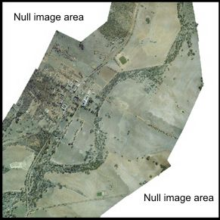

DATA OVERLAYS

All overlayed vector data shall be the latest information available at the time of the image creation. Consultants should check the availability of data from Main Roads before purchasing it from external agencies otherwise data is at the consultant’s own expense.

All data included in the title block and overlayed over the raster image shall be at 300 dpi or greater.

6.1 Standard Overlay Colours

Overlayed data is to conform to the following colours:

- Cadastral boundaries– Green;
- MRS boundaries – Red;
- Contours including labels and spot heights –Yellow;
- Grid ticks – Black;
- Text – Preferably black with a white halo otherwise black or white; and
- Design – As directed by the project manager.

6.2 Text

Text is to appear on all existing roads of interest (i.e. along the new road alignment), roads intersecting the road of interest and areas of importance. (i.e. Lakes, Rivers etc) All natural water features are to labelled using italic font.

Ideally text colour shall be black with a white halo otherwise a black or white font is to be used.

All text is to be page orientated (not North orientated) and to face toward the top of the page. All text labelling features that are straight up and down are to be read from the RHS of the page. (i.e. Text to have their tops pointing toward the LHS.)

6.3 Grid Ticks and Displayed Coordinates

Grid ticks are to only appear on orthophotos. Grid ticks are to be black in colour and are not to be overbearing in appearance (i.e. of the thinnest line weight). Grid intervals must be approximately 10 cm apart at final image scale. Grid ticks are to be accompanied with coordinates which are to be located around the edges of the image window.

6.4 Title Block

A title block is to be located at the base of all images. All items in the title block are to be laid out as per Appendix B. The title block will contain the following items.

6.4.1 Main Roads Logo and Disclaimer

The Main Roads logo must appear on all products and must be accompanied with the following disclaimer below it:

“Copyright and Intellectual property over the information displayed on this plan shall remain the property of Main Roads. The copying, exchange, sale or release of the information cannot be undertaken without prior notification and written agreement of Main Roads.”

Please note: Text disclaimer and logo are not to scale with each other. The Government of Western Australia logo must not be less than 1.5cm wide, and the Main Roads logo must not be less than 6cm wide.

6.4.2 Scale

A clearly labelled scale and scale bar must appear with each image.

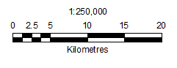

6.4.3 North Point

A standard Main Roads North point is to be located with each image. North points are never to face downwards.


6.4.4 Metadata Box

A metadata box is to appear on all image products. All data sources must be acknowledged within the metadata box. An example of a metadata box for an Orth photo is below.

DATA | SOURCE | DATE | SCALE | ACCURACY
Aerial Photography | Landgate | 01/01/2013 | 1:20000 | -
Design | MRWA | 07/12/2012 | - | -
Cadastre | Landgate | 07/02/2013 | - | 2.0m
Contours | MRWA | 12/11/2012 | 1:2000 | 0.5m
Contour Interval: 2.0m |  |  | Datum: PCG94
Plan Number: 12345-6 |  |  | Date: 14/04/2013
This plan complies with MRWA Standard – Digital Rectified Images – Class A

6.4.5 Company Logos

Company logos and acknowledgements may be discretely placed on the ortho within the title bar or on the title pages of a booklet. The placement of the logos is as per Appendix B. A company’s logo, address, phone numbers etcetera (combined) must not be larger than the Main Roads logo.

PRESENTATION LAYOUT

The following layouts are required on the following presentation formats.

7.1 Single Image Layout Requirements

Single image layout will be presented as per Appendix B. The layout of the rectified image is broken into two areas:

- image window; and
- title block.

7.1.1 Image window requirements

The only items to be displayed in the image window are the raster image, vector overlay data, road/place text labels and grid ticks (if applicable).

7.1.2 Title Block Requirements

All additional information is to be placed within the title block located at the base of the image. This includes logo, legend, disclaimers, north point, scale bar, title, metadata, location diagram or any other additional information. All vector overlays are to appear in the legend. The Main Roads project manager will supply the project title.

7.2 Booklet Requests

Booklet images are to be presented as per Appendix C and additionally contain a blank final page. All booklets are to be bound with the title page and blank final page being encapsulated in UV resistant laminate.

7.2.1 Front Cover

A front page must contain the Main Roads logo, the Government of Western Australia logo, booklet description (orthophoto/mosaic), a title, a description, the Main Roads Region and a location diagram. The contract manager will provide the title.

7.2.2 Index Page

The index page shall contain a reference map or image that covers the complete project area. Individual image pages contained in the booklet are to be outlined on the index with a corresponding page number. For easier referencing, suburbs, town names, places of significance, rivers, intersecting road names and SLK’s (if provided), must be placed to assist with locating the project area. Additionally a title block is to appear at the base of the index page and must conform to “7.1.2 Title block requirements”.

7.2.3 Image Pages

All image pages are to be set out as per “7.1 Single Image Layout”. These pages are to be prepared as if each image page can be used and viewed as a single entity. They are to contain all relevant data overlays in addition to a title. Centred under the title a page number is to be displayed (eg Page 1 of X).

DATA SUPPLY

All data supplied to Main Roads is to comply with Main Roads software and hardware systems as described below, with all data supplied with the final plots. The following products are to be received as a minimum for each product.

8.1 Verification Plots

A plain paper colour test plot is to be supplied to Main Roads for verification and possible minor changes before the final plot is produced. This should be at final scale unless otherwise approved.

8.2 Final Plot Quality

Single layout presentations are to be plotted on a digital photographic printer or an equivalent approved by the Senior Mapping Surveyor. Booklet presentations are to be printed on paper with a minimum weight of 90 GSM.

8.3 Plot Size Limitations

Hardcopy plots are to be no longer than two thousand millimetres (2m) in length and no wider than 900 millimetres (0.9m) unless approved by the project manager.

8.4 Image Report

All images and image booklets must be accompanied with an image report (digitally in word format and an A4 hardcopy print) and is to conform to the format of Appendix A. Each image is to be accompanied with its own report. (i.e. multiple images must be accompanied with multiple reports).

8.5 Lamination

The final print of a single image must be encapsulated in UV resistant laminate unless otherwise requested. For booklets, only the title page and a blank final page are to be encapsulated in plastic.

8.6 Digital Images

Two digital copies of the image must be supplied, either as a compressed ERMapper file (ecw) or tiff image. One copy shall be of the single image layout or booklet page. The second image shall be the complete background image (no overlays or title information). All georeferenced files are to be supplied.

Created Digital Overlays.

The consultant to Main Roads must supply any overlays created and used in conjunction with images. Overlay data must be supplied in ERMapper, MX, AutoCAD or Microstation formats.

All Microstation files are to contain a Global Origin of 300000, 5000000 and working units of m (metres) and subunits cm (centimetre) with a resolution of 100 cm per m and 10 Pos Units Per cm.

8.8 Mediums for Digital Data Supply

Digital Data shall be presented on either of the following mediums:

DVDs:
- DVD–R or DVD–RW
- 4.7 GB
- Main Roads Windows compatible (Windows 7)

Hard Drive:
      - Main Roads Windows compatible (Windows 7)

Copyright

Under the Government procurement act (refers 67-08-33 Data License/Copyright), any information created for Main Roads is Main Roads property. No consultant can on sell or keep any Main Roads data.

APPENDIX A - IMAGE REPORT

IMAGE REPORT

Metadata Category | Core Metadata Element | Description
Dataset | Image file name | Road2A.ecw (or Road2A.tif)
 | Type of image | Ortho photo/Mosaic/Single Image/Oblique Image
 | Title | Great Eastern Highway SLK 1-100
 | Custodian | Surveying and Geospatial Services Branch
 | Main Roads Contract number | 9999/99 if applicable
 | Description | 1 km wide Image centred around Great Eastern Hwy.
Consultant Contact Address | Organisation | John Smith Aerial Mapping
 | Contact Position | John Smith
 | Mail Address | 99 Smithdale Court  East Perth WA 6005
 | Telephone | 9666 6666
 | Facsimile | 9666 6665
 | Electronic Mail | John.smith@inett.com
 | Reference number | Smith 0999
Image Description | Final Product Scale | 1:10000
 | Width | 567.1 mm and 6698 pixels
 | Length | 938.5 mm and 11085 pixels
 | Format | Tif / ecw
 | Date of Construction. | 15/3/12 (Not date of photography.)
 | Coordinate System | Perth Coastal Grid
 | Accuracy Class | Class A/Class B/Class C
Source data | Source data | Aerial photography: Great Eastern Highway SLK 1-100
 | Film number | WA 3566 (c)
 | Scale | 1:40000
 | DLI job number | 019998
 | Date Flown | 1st Jan, 2012
 | Original scan resolution | 1200 dpi
Overlay Information | Source data | Verified Cadastral Data
 | Source | Landgate
 | Accuracy | 0.2m
 | Date of acquisition | 15/1/2013
 | File Format | DGN / DXF / DWG
 | Source data | Topo – DLI 1:25000 digital mapping
 | Source | Landgate
 | Scale | 1:25000
 | Accuracy | 1.5m
 | Date of acquisition | 25/5/12
 | File Format | DGN / DXF / DWG
 | Source data | Design
 | Source | Main Roads
 | Accuracy | 0.1m
 | Date of acquisition | 10/1/2013
 | File Format | DGN / DXF / DWG
Further Information | Further Information

APPENDIX B - SINGLE IMAGE LAYOUT REQUIREMENTS

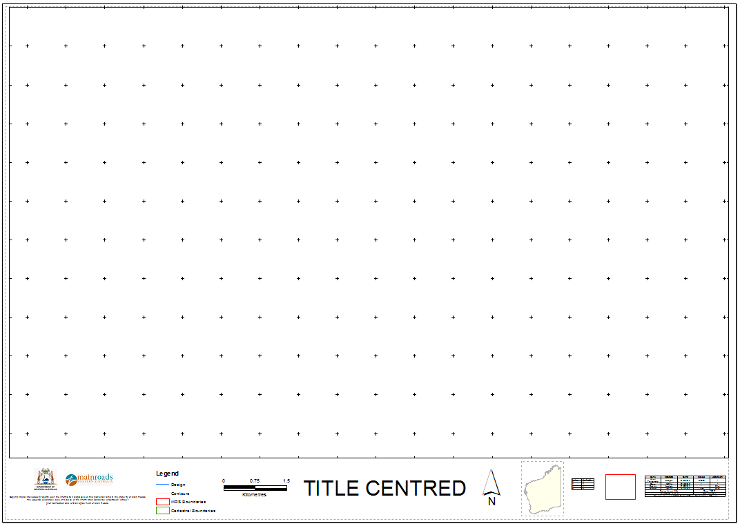

appendix c – booklet layout requirement – cover page

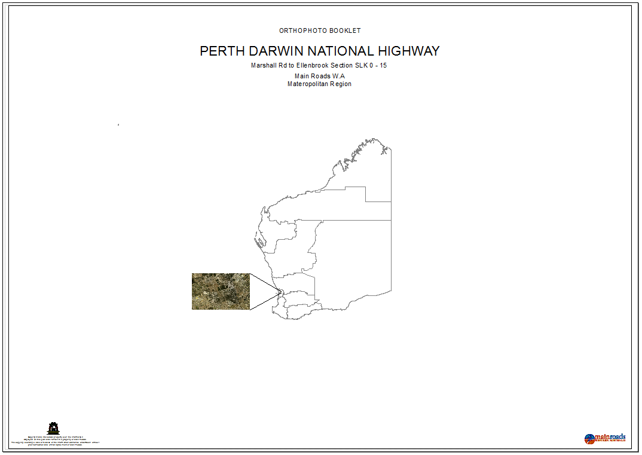

appendix c – booklet layout requirement – index page
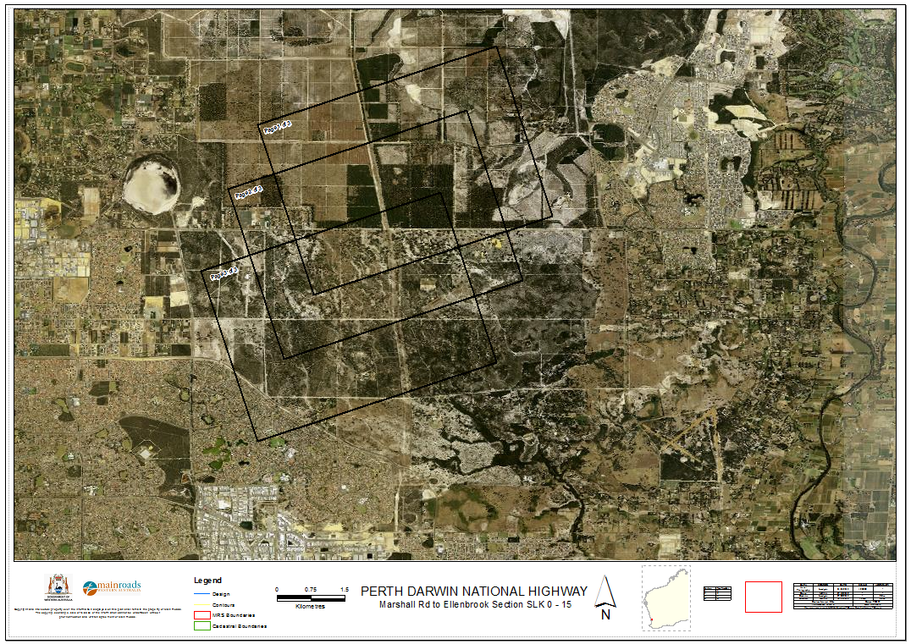

appendix c – booklet layout requirement – image page

