**INTRODUCTION TO No-Overtaking Zone Barrier Line Spreadsheet**

The no-overtaking zone barrier line spreadsheet will allow users to produce the locations of left and right barrier lines as a function of chainage by using imported visibility reports created from **Bentley MXROAD software.** *(Refer Visibility.inp)*

**NOTES FOR USE OF SPREADSHEET:**

* Currently limited to outputting results for ~15000 entries
* If reverse direction data is left as part of the visibility report, the spreadsheet will output data for it **but it should not be used**. Calculation of left and right barrier locations only require the forward direction visibility report data to operate. Calculations are based off of assumed relationships between forward and reverse direction barriers.
* Sheet names should not be modified as it will result in reference errors.
* Caution should be used if Visibility report contains adjoining rows of cells in the visibility distance column that vary constantly between less than and greater than minimum sight distance.

**INSTRUCTIONS FOR USING THE SPREADSHEET:**

1. Start with sheet ‘**Start page’** open and **enter the design speed used for the section and the chainage interval applied to the visibility report** in the boxes provided. This will fetch all the relevant criteria retained in ‘Design Criteria data’ and apply them to the spreadsheet.
2. Next, open up sheet ‘**Barrier line calculations’** and import the visibility report into the spreadsheet. To do this, while sheet ‘**Barrier line calculations’** is open, click on ‘DATA’ in the top toolbar, then select ‘From Text’ in the ‘Get external Data’ submenu.
3. Browse to the location of the visibility report in the window that pops up and click open.
4. In the text import wizard, click ‘next’ to skip to step 2.
5. In step 2, scroll down to find the where the data begins and create the break lines for the columns as shown below:

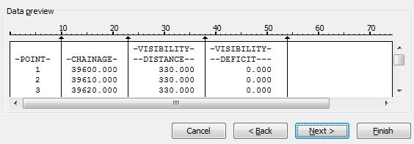

Then click ‘next’, then ‘Finish’.

1. A window will pop up asking “where do you want to put the data?”, ensure that existing worksheet is selected with the cell ‘=$A$1’ chosen as shown below.

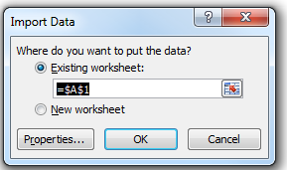

1. With the file now imported, the cells within the sheet should be automatically populated and will display the locations of both left and right barrier lines where they are required. The sheet ‘**Barrier line calculations’** contains most of the mechanics used in calculating the barrier line locations; With the end column on the right Labelled ‘**TOTAL BARRIER**’ indicates the relative position of the barriers with regard to chainage.

Highlighted for ease of use**, Green indicates where a left barrier line should be placed, Yellow indicates where a right barrier should be placed and Red indicates locations of overlap or where there is a double two way barrier.**

For interest, the process of how the spreadsheet calculates the Barrier line locations is expanded in **‘Barrier line spreadsheet Work Flow’** below.

1. A simplified view is available in the sheet **‘Final Barrier layout’,** with only the final left and right Barrier line layouts shown with a scrollable graphical supplement.
2. Barriers lines should be placed according to the tables by beginning the barriers at the chainage correlating to the first highlighted point and ending at the last highlighted point

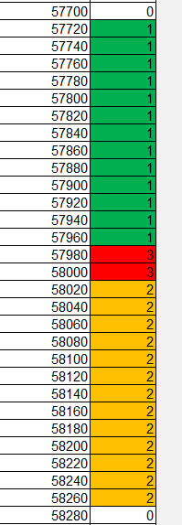

E.g. Left barrier lines should be placed between CH57720-CH58000 and right barrier lines between CH57980-CH58260.

Therefore there will be a left one way barrier extending out from CH57720-CH57980, double two way barriers between CH57980-CH58000 and right one way barrier extending out from CH58000-CH58260.

**BARRIER LINE SPREADSHEET WORK FLOW**

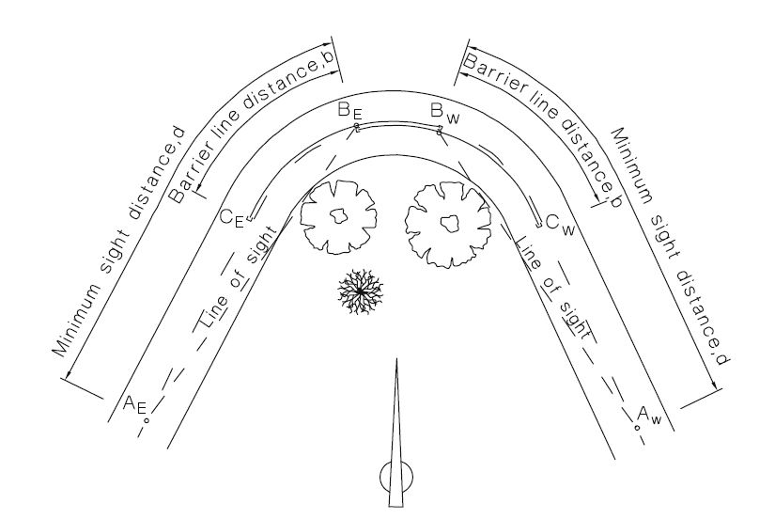

After opening the spreadsheet and importing the visibility report txt file into the sheet ‘**Barrier line calculations’** (arranging margin breaks as specified), the spreadsheet will auto-populate.

**Imported Txt files can have differing design speeds and chainage interval than that set as default but it must be entered into the correct box in ‘start page’ (110 KPH and 10m intervals are the default values set)**

* If the visibility report has been imported correctly, the reports range of data should cover Columns **A-E**
* Columns **F-K** calculates the points **AE, BE, CE, BW, CW AND AW** on the barrier lines represented in the diagram above. The columns **L (Barrier line left 1)** and **M (Barrier line right 1)** represent the Barrier line layout of the left and right barrier lines respectively without **having yet consideration of constraints other than minimum sight distance.**

Points **CW** and **AW** were calculated using assumed ideal relationships between the curves such as: **BE** in the forward direction should correspond with the chainage for full sight distance restored in the Reverse direction and **BW** in the reverse direction should correspond with chainage for full sight distance restored in the forward direction.

* Columns **P-T and W-Y** represent the work flow that checks whether the left and right barrier lines calculated in column L and M meets the minimum length of barrier line criteria for the design speed as set out in column 4 of the table in the sheet ‘Design Criteria data’

1. Column P looks for the ends of barrier lines in column L using a number of conditions, at each row that correlates to the end of a barrier, the cell in column P outputs the count of the number of cells with a value greater than or equal to 0 in the range of [row()-x : row()]. Where x is (minimum sight distance/ chainage interval)
2. This allows column Q to decide whether the length of **‘Barrier line left’** is sufficient. It does this by multiplying the value in column P minus 1 by the interval and comparing it against the minimum length of barrier line. If **‘Barrier line (1)’** is greater than or equal to the minimum length the output is 0, otherwise it will output 1.
3. If output of column Q is 1, column R = roundup (minimum length of barrier line/interval) i.e. the value of the cell will represent the number of cells above it that a barrier needs to be placed in order to meet the minimum length of barrier criteria, otherwise it will equal 0.
4. If there is a value in column R greater than 0, the adjacent cell in column S will equal the value in column R, otherwise it will subtract 1 from the value of the cell below it. This allows the spreadsheet to display the minimum length of barrier line extending back from point BW (column I), which is represented by a value greater than or equal to 0. This is simplified in column T by simply assigning any cell adjacent to where column P>=0 to 1.
5. **‘Barrier line left 2’** in Column U is the summation of columns L and T and Column **V** just outputs any value in column U >0 to equal to 1. This is done to allow conditional formatting to separate left, right and double barrier locations. Column V (**Barrier line left =**1) now represents the barrier line layout **with consideration of minimum barrier lengths and minimum sight distance.**
6. Columns **W-Y** ultimately does the same thing as columns **P-T** but affect the right side barrier line. Column Z then sums up the values in column Y and M. Column **AA** then converts any cells with a value >0 in column Z to equal to 2. Once again this is done to allow conditional formatting to highlight the different parts of the barrier line.

So now the column AA (**barrier line right =2)** represents the barrier line layout **with consideration of minimum barrier lengths and minimum sight distance.**

* Columns **AC-AE** represents the work flow that checks the length of road where minimum sight distance is lost is greater than the ‘minimum length of road with overtaking sight distance below minimum’ as set out in column 6 of the table in sheet ‘design criteria data’.

1. Column AC looks for values in column C that are less than the minimum sight distance and marks them as 1 if they are.
2. At chainages where BW occurs, Column AD counts the number of row above that are equal to 1 in column AC within a certain range. The range is affected by minimum length of road with overtaking sight distance and thus varies with design speed.
3. Column AE then checks to see if the counted value in column AD is greater or less than (‘minimum length of road with sight distance below minimum’/interval). If it is less, then the value is equal to 1.
4. Constraints set in column **L** and column **M**, check that the value column V is not equal to 1. If it is equal to 1, due to the length of road being too short then the value of the cell in column J and M becomes 0. Effectively eliminating the need for a barrier at that location.

* Columns **AG-AJ** represents the calculations used to connect disjointed lengths of barrier lines that are separated by a distance less than that set out by ‘minimum distance between barrier lines’ in column 6 of the table in sheet ‘design criteria data’.

1. Column AG is set to count the cells in a range defined by

{ [current row()-(minimum distance between barriers)/interval]:[current row()]}

for column V when the value in the cell is >=1. If there are cells in column V with a value greater than 0 within the range, then column AG will be equal to the count of those cells.

1. Column AH is set to =1 under 2 different scenarios. First when the top of a barrier line displayed in column V (**Barrier line LEFT (2)**)correlates with the value in AG being >0, or when the value of the row below in column AH=1 and the adjacent row in column V (**Barrier line (2))** =0.

This will cause any gaps between sets of barrier line where the minimum distance criteria is not met to be =1.   
Conditional formatting then highlights any gaps where the distance between adjacent barrier lines is less than the minimum distance between barriers.

* Column **AN** is the summation of columns **AL** and **AM** and represents the final layout of the barrier lines after consideration of all relevant criteria. Values equal to **1** represent left one way barrier locations, **2** represent right one way barrier locations and **3** represent points of overlap/ double two way barriers.
* Column AO is essentially the same as column AN other than it will make sure that the tails of the barriers are no longer than Barrier line Distance for that speed. If the length of a tail exceeds that distance that it will convert the over-run into a double barrier.

**Visibility Report Distance considerations**

Currently the spreadsheet is limited to outputting ~15000 rows; this is about 300km for a chainage interval of 20m which should be enough for most situations. However if a longer distance is required, it is a simple matter of extending the columns F – AN in sheet “Barrier line Calculations” to the required row by copying the cells in row 15000 and pasting it as needed.

If the sheet “Barrier line Calculations” is extended to more than 15000 rows, sheet “Final Barrier layout will also need to be extended to reflect any changes made in the previous sheet. As before, simply copy columns B-E at row 15000 and paste as required. Various hidden ranges will also need to be altered correctly in order for the charts to display properly as well.

Note however that although the visibility report may not cover 15000 chainage intervals, the spreadsheet will always populate rows where a function exists in the cell. This should be considered before unnecessarily extending the spreadsheet as it could have the effect of drastically slowing down the processing time of the spreadsheet. In sheet “Final Barrier Layout”, at the end of useful forward direction data, the rows following will contain #N/A, this is just the nature of how the spreadsheet operates as having it output anything other than #N/A will cause all the unneeded rows to display on the charts.