This Environmental Work Instruction (EWI) is to be provided to all contractors and consultants undertaking engineering surveying activities on behalf of Main Roads. The requirements outlined in this EWI are intended to minimise impacts to native vegetation, flora, fauna, heritage values and other environmental receptors, and assist Main Roads in meeting its environmental and heritage obligations under values relevant legislation, approvals and corporate requirements.
Potential Environmental Risks
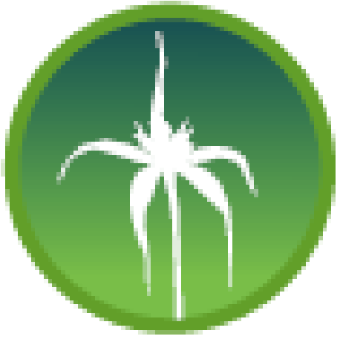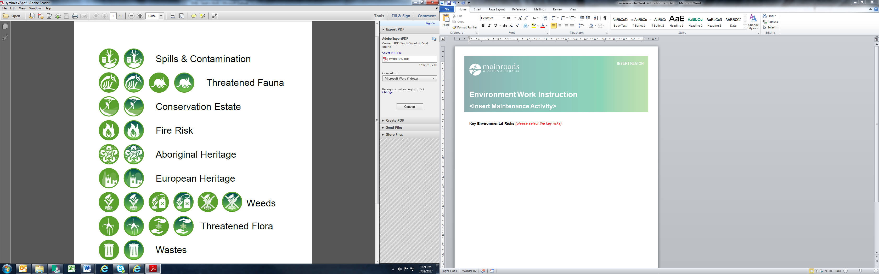
Native Conservation Threatened Threatened Aboriginal Dieback Weeds Spills Waste
Vegetation Estate Flora Fauna Heritage
TABLE 1: STANDARD ENVIRONMENTAL MANAGEMENT REQUIREMENTS
Pre-Works
- Identify where vehicles and plant are going to be located during the works to avoid impacts to vegetation.
- Vegetation clearing is not permitted. If clearing is required, a Low Impact Screening Checklist (LISC) and Heritage Risk Assessment (HRA) must be submitted to the Regional Environment Officer for obtaining the required approvals and providing the required environmental and heritage management document prior to works proceeding.
- Entry into areas between yellow Threatened Flora must be avoided where practicable. Where access is required within a marked area, the Regional Environment Officer must be consulted prior to works commencing to ensure any relevant environmental requirements are met.
- Designated access routes and work areas must be identified and communicated to all personnel prior to works, where applicable, to minimise disturbance to vegetation.
- All staff must have completed a site induction and be suitably qualified to undertake the works.
During Works
- All vehicles and plant must be clean on entry to site and between sites where applicable, and free of soil and vegetation to prevent the spread of dieback, pests and weeds. Record this using the Hygiene Checklist attached below (Appendix 1).
- Vegetation clearing must not occur unless approved by the Regional Environment Officer and Project Manager.
- Ensure works, movements and vehicle/plant locations do not disturb or impact vegetation and are limited to designated access routes and work areas where these have been identified.
- All heritage requirements must be complied with, including limits to movements, clearing and ground disturbance.
- No servicing, refuelling or storage of fuel, oils and other hazardous materials must occur on-site or within 50 m of a watercourse or wetland.
- Waste must be effectively contained.
- Ensure no pets, traps, or firearms are in the work area, and do not feed, harm or kill fauna.
- For sick, injured, or orphaned wildlife, contact Wildcare Helpline (08 9474 9055).
- Any spills will be contained immediately, cleaned up and contaminated material removed within 24 hours to minimise potential contamination of soil, surface water and groundwater, and must be reported as an incident within 24 hours using EQ.
- Works must cease immediately if unexpected environmental or heritage impacts occur, and the Project Manager and Regional Environment Officer must be notified.
Post-Works
- All material, equipment and plant must be removed from site.
- All waste must be removed from site and disposed of at an authorised waste disposal site.
- Any area outside the work site that is damaged is to be rehabilitated and stabilised to the satisfaction of the Project Manager.
General Conditions
- A fully stocked spill kit must be maintained on-site and be used to contain and clear up any spills as soon as possible.
- Any communication to external parties must be through the Director Environment and Heritage.
- Avoid works in wet conditions where dieback spread or soil disturbance risk is increased.
- Report any environmental incidents using EQ.
Key Contacts
- Main Roads Project Manager – <insert contact details>
- Main Roads Environment Officer – Shane Collins, (08) 9323 4424, 0419 047 724
- Main Roads Heritage Officer – Monique Pasqua, (08) 9323 6557, 0428 985 125
- Pollution Watch Hotline (24 hrs): 1300 784 782
All personnel undertaking the works must sign Table 2 below to demonstrate they have read and understood the requirements in this EWI and will comply fully with them.
TABLE 2: EWI SIGN-ON SHEET
Name | Organisation/Position | Signature
Please ensure this EWI sign-on sheet is returned to the relevant Main Roads Project Manager, who is responsible for saving a copy of the sign-on sheet into the relevant TRIM folder.

APPENDIX 1: HYGIENE CHECKLIST
Use the Main Roads Hygiene Checklist available on the Main Roads website under:
Environmental & Heritage Management | Main Roads Western Australia
(Technical & Commercial > Contracting to Main Roads > Environmental & Heritage Management)

