Printed copies are uncontrolled unless marked otherwise. Refer to iRoads for current version.

D17#972348

December 2017

**Guideline**

Barrier Line Marking Assessment

Contents

1 PURPOSE 4

2 application 4

2.1 Definitions 4

2.2 Background 4

2.3 Application 4

2.3.1 Types of Barrier Lines 4

2.3.2 Requirements for the Provision of No-overtaking Zones 5

2.3.3 No-overtaking Zones at Intersections 6

2.3.4 No-Overtaking Zones between Intersections – Roads ≥ 70 km/h 6

2.3.5 No-Overtaking Zones between Intersections – Roads ≤ 60 km/h 6

3 technical guidelines 6

3.1 Introduction 6

3.2 Location and Setting Out Methodology 6

3.3 Modification of Barrier Line Requirements 8

3.4 Main Roads WA Pattern Change Marks 11

3.5 Checking Marked Barrier Lines 12

3.6 Procedure for Checking Existing Marked Barrier Lines 12

3.6.1 General 12

3.6.2 Method 12

3.7 Special Considerations 13

4 References 13

5 Appendices 13

Appendix 1: Applicable Main Roads Drawings 14

Document Control

|  |  |
| --- | --- |
| **Owner** | Dave Landmark |
| **Custodian** | Ron Koorengevel |
| **Document Number** | D17#972348 |
| **Issue Date** | 21/12/2017 |
| **Review Frequency** | 5 Years |

Revision Register

|  |  |  |  |
| --- | --- | --- | --- |
| Revision Number | Revision Date | Description of Key Changes | Section / Page No. |
| 0 | 21/12/2017 | Guideline Issued | All |
| 1 | 9/08/2021 | Document template updated.  Figures 1, 2 and 3 updated.  Driver eye height amended to 1.10 m and 300 m barrier line requirement for road train routes added to Table 1. | 3.2  Table 1  3.6.1  3.6.2 |
|  |  |  |  |
|  |  |  |  |
|  |  |  |  |
|  |  |  |  |
|  |  |  |  |

# PURPOSE

This guideline describes principles, requirements and procedures for assessing horizontal and vertical curves to install longitudinal barrier markings to prohibit overtaking.

# application

## Definitions

The definitions provided below are for terms not contained in or have a different meaning for the Guideline to the definitions given in Main Roads [Glossary of Terms](https://www.mainroads.wa.gov.au/technical-commercial/technical-library/road-traffic-engineering/glossary-of-technical-terms/).

| **Term** | **Definition** |
| --- | --- |
| **Main Roads** | Main Roads Western Australia |
|  |  |
|  |  |

## Background

Barrier lines are a subset of longitudinal lines as they separate opposing directions of traffic. They are provided where it is necessary to prohibit drivers from travelling to the right of a longitudinal line in order to overtake other vehicles. They may be installed on two lane two way roads where the sealed pavement widths meet the requirements of AS 1742.2 Section 4.2 Pavement Markings and Delineation and where traffic volumes meet the requirements of AS 1742.2 Section 5.3 Longitudinal lines, but where barrier lines are necessary because of sight distance limitations.

## Application

### Types of Barrier Lines

A barrier line is a dividing line that replaces the single broken separation line to prohibit crossing movements from one or both directions, as described below: This guideline deals with the methodology for establishing unbroken separation/single barrier line, double one way and double two way barrier line markings and their setting out.

1. Unbroken Separation / Single Barrier Line

An unbroken separation line is a continuous line that is only used in urban/built up areas where the speed limit is ≤ 60 km/h. Movements across the line for the purpose of overtaking are prohibited. The line may only be crossed for the purpose of entering or leaving the carriageway from either side (e.g. at a driveway access). The line width varies relative to the road standard where it is being installed (refer standard drawing [9931-0198](https://www.mainroads.wa.gov.au/technical-commercial/technical-library/?q=&take=25&filter=&type=&page=4&sectionFilter=731&node=Standard%20Contract%20Drawings,Pavement%20Marking)).

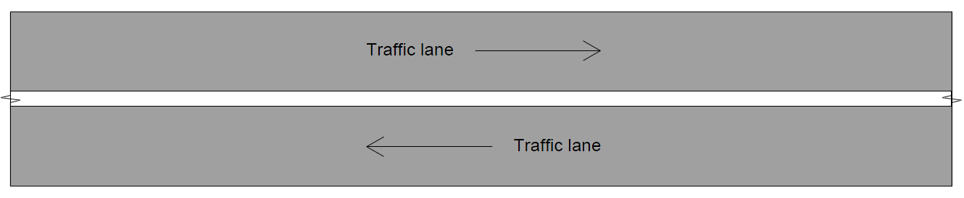

**Figure 1: Unbroken Separation / Single Barrier Line**

1. Double one way barrier line

A double one way barrier line is a continuous line beside a broken line. Overtaking movements across the lines are permitted from the broken line side but not from the continuous line side. The line may be crossed for the purpose of entering or leaving the carriageway from either side (e.g. at a driveway access)

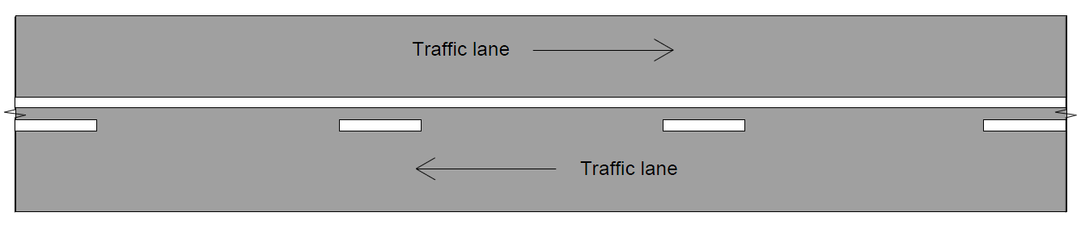

**Figure 2: Double One Way Barrie Line**

1. Double two way barrier line

A double two way barrier line comprises two continuous lines side by side. Movements across the lines, or to the right of the lines, for the purpose of overtaking are prohibited in either direction. Although the current Road Traffic Code 2000 permits the lines to be crossed for the purpose of entering or leaving the carriageway, the intention is to prohibit these manoeuvres in the future, effectively bringing Western Australia legislation in line with other Eastern States. Accordingly, gaps should be left in these lines at driveways and side roads as per Main Roads WA standard drawing [200631-0038](https://www.mainroads.wa.gov.au/technical-commercial/technical-library/?q=&take=25&filter=&type=&page=1&sectionFilter=731&node=Standard%20Contract%20Drawings,Pavement%20Marking) to cater for future conditions.

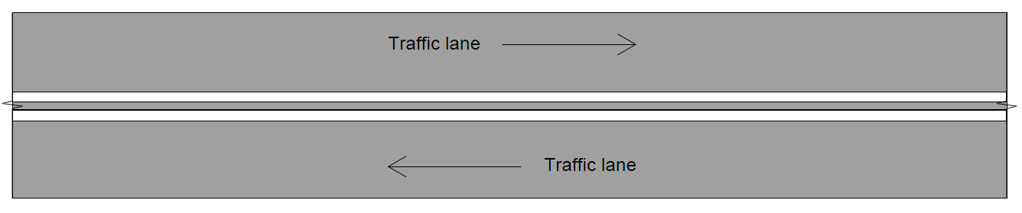

**Figure 3: Double Two Way Barrie Line**

### Requirements for the Provision of No-overtaking Zones

Requirements for the provision of no-overtaking zones are as follows:

1. Roads 5.5 m or more wide

Vertical and horizontal curves on which the overtaking sight distance falls below that shown in Column 2 of Table 1 shall be marked as no-overtaking zones.

1. Roads less than 5.5 m wide

Main Roads WA does not install line marking on roads sealed less than 5.5 m. Roads sealed less than 5.5 m should preferably be widened at substandard crests and curves to at least 5.5 m to allow for barrier line marking.

If it is not practicable to mark the no-overtaking zone at vertical curves, the CREST warning sign (W5-11B) should be used.

1. Two-lane bridges

Barrier lines shall not normally be marked on two-lane bridges, unless the warrant in Item (a) indicates that a no-overtaking zone is required and the width is 5.5 m or greater between kerbs.

Gaps in double two way barrier lines in rural areas may be provided for turning traffic where there is adequate sight distance to oncoming traffic as follows:

1. At intersections—generally 10 to 20 m gap.
2. At private driveways—generally 3 to 5 m gap.

### No-overtaking Zones at Intersections

Main Roads WA standard drawing [200331-0182](https://www.mainroads.wa.gov.au/technical-commercial/technical-library/?q=&take=25&filter=&type=&page=1&sectionFilter=731&node=Standard%20Contract%20Drawings,Pavement%20Marking) and [200331-0183](https://www.mainroads.wa.gov.au/technical-commercial/technical-library/?q=&take=25&filter=&type=&page=1&sectionFilter=731&node=Standard%20Contract%20Drawings,Pavement%20Marking) provide the details and warrants for pavement markings and RRPM’s at Type “BA”, “AU” and “CH” intersections.

It is normal design practice to design these no-overtaking zones first before applying the design process to road sections between intersections.

### No-Overtaking Zones between Intersections – Roads ≥ 70 km/h

Double one way or double two way barrier lines shall be used to create no-overtaking zones on roads speed zoned at 70 km/h or higher where there is restricted overtaking sight distance due to horizontal or vertical curves, or both, or where a hazardous condition exists, e.g. at approaches to major intersections or intersections and mid-block central roadway obstructions.

### No-Overtaking Zones between Intersections – Roads ≤ 60 km/h

Details of the gaps and unbroken separation line (single barrier line) have been provided on Main Roads WA standard drawing [200631-0038](https://www.mainroads.wa.gov.au/technical-commercial/technical-library/?q=&take=25&filter=&type=&page=1&sectionFilter=731&node=Standard%20Contract%20Drawings,Pavement%20Marking).

An unbroken separation line (single continuous dividing line) shall be used instead of a double two way barrier line only in urban areas (where speeds are 60 km/h or less) and where it is necessary to permit crossing of the line by traffic entering or leaving the roadway.

NOTE: General use of unbroken separation lines (single continuous barrier lines) to form no-overtaking zones is discouraged on safety grounds as they do not have the impact and better understood meaning of the double one way and double two way barrier lines. Furthermore, they are not able to indicate places where crossing the line is permitted in one direction of travel but not the other.

# technical guidelines

## Introduction

The location and setting out of barrier lines should generally follow the following process:

Step 1: Locate and set out all barrier lines required at intersections in accordance with Main Roads WA standard drawings [200331-0182](https://www.mainroads.wa.gov.au/technical-commercial/technical-library/?q=&take=25&filter=&type=&page=1&sectionFilter=731&node=Standard%20Contract%20Drawings,Pavement%20Marking) and [200331-0183](https://www.mainroads.wa.gov.au/technical-commercial/technical-library/?q=&take=25&filter=&type=&page=1&sectionFilter=731&node=Standard%20Contract%20Drawings,Pavement%20Marking).

Step 2: Locate and set out all barrier lines required at overtaking lanes as per Main Roads WA standard drawing [200631-0039](https://www.mainroads.wa.gov.au/technical-commercial/technical-library/?q=&take=25&filter=&type=&page=1&sectionFilter=731&node=Standard%20Contract%20Drawings,Pavement%20Marking), i.e. assessing that no overtaking is permitted in the single lane direction and standard drawing [201431-0021](https://www.mainroads.wa.gov.au/technical-commercial/technical-library/?q=&take=25&filter=&type=&page=3&sectionFilter=731&node=Standard%20Contract%20Drawings,Pavement%20Marking) if the warrants for overtaking in the single lane direction are met.

Step 3: Locate and set out barrier lines as per AS 1742.2 methodology, as detailed in section 3.3.

Step 4: Apply modifications to barrier line requirements as per section 3.4.

## Location and Setting Out Methodology

Main Roads WA uses the same method for locating and setting out barrier lines as AS 1742.2 Clause 5.3.3.3 with the exception that the minimum barrier line distance required for Main Roads WA is amended as shown in Table 1.

The method for locating and setting out barrier lines is shown in Figure 4 and the steps to be used are as set out (AS 1742.2 Clause 5.3.3) as follows:

1. As the point AE approaches the curve, overtaking sight distance progressively decreases.
2. Where the overtaking sight distance AE to BE (Column 2 of Table 1) reaches the minimum for the 85th percentile speed selected (Column 1 of Table 1), a barrier line should commence at CE, the barrier line distance (Column 3 of Table 1) from BE. This may be triggered by a sight distance failure in the horizontal and vertical geometry or both.
3. After further eastward travel from CE, the minimum overtaking sight distance is regained at BW and the barrier line is terminated.

The above procedure is equally applicable for vertical crest curves or a combination of the horizontal and vertical geometry that limit overtaking sight distance.

|  |  |  |
| --- | --- | --- |
| **1** | **2** | **3** |
| **V85** | **MINIMUM OVERTAKING SIGHT DISTANCE\***  **(1.10 m TO 1.10 m)** | **MRWA DESIRABLE BARRIER LINE DISTANCE\*\*** |
| **km/h** | **m** | **m** |
| **0 to 40** | **120** | **84 (7)** |
| **41 to 50** | **150** | **108 (9)** |
| **51 to 60** | **180** | **132 (11)** |
| **61 to 70** | **210** | **156 (13)** |
| **71 to 80** | **240** | **180 (15)** |
| **81 to 90** | **270** | **204 (17)** |
| **91 to 100** | **300** | **228 (19)** |
| **101 to 110** | **330** | **252 (21)\*\*\*\*** |

**\* OVERTAKING AT CRESTS OR CURVES IS PERMITTED IF THE OVERTAKING SIGHT DISTANCE BETWEEN TWO POINTS 1.10 m (DRIVER EYE HEIGHT) ABOVE THE CENTRELINE DOES NOT FALL BELOW THE MINIMUM OVERTAKING SIGHT DISTANCE. THIS IS BASED ON WHAT IS ASSUMED TO BE A TYPICAL OVERTAKING MANOEUVRE, I.E. A VEHICLE TRAVELLING AT THE 85TH PERCENTILE SPEED OVERTAKES A SLOWER VEHICLE AND IS OPPOSED BY AN ONCOMING VEHICLE ALSO TRAVELLING AT THE 85TH PERCENTILE SPEED.**

**\*\* THE NUMBER OF 12 m MODULES CORRESPONDING TO THIS DISTANCE IS SHOWN IN BRACKETS. FOR EXAMPLE, THE BARRIER LINE DISTANCE FOR 80 km/h APPROXIMATES 15x12 m (THE LINE MARKING MODULE)**

**\*\*\* MRWA BARRIER LINE DISTANCES HAVE BEEN ADOPTED TO ALIGN WITH A 12 m GAP/LINE SPACING (9 m GAP /3 m STRIPE) AND ENSURE A CONSERVATIVE APPROACH TO THE PLACEMENT AND MEASUREMENT OF THE DOUBLE ONE-WAY BARRIER DISTANCES**

**\*\*\*\* FOR ROAD TRAIN ROUTES USE A MINIMUM 300 m (25). Road train defined as any combination in length > 30 m.**

**Table 1: Requirements for the Establishment of No-Overtaking Zones**

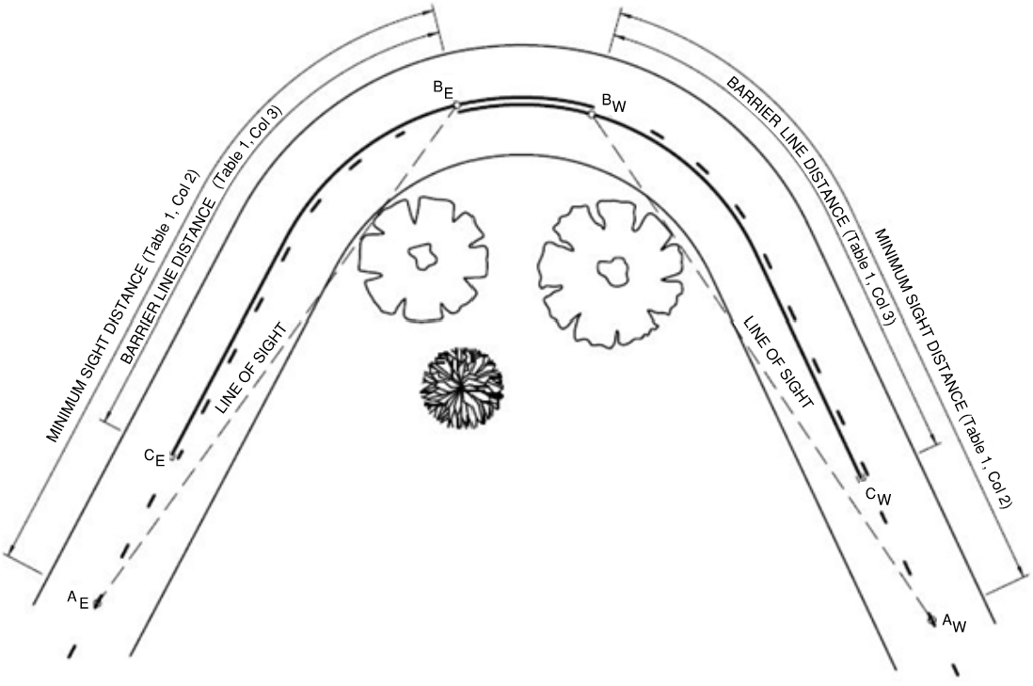

**Figure 4: Method for Locating a No-Overtaking Zone on an Isolated Curve**

For the purpose of a desktop assessment, Main Roads WA has developed an excel spreadsheet that undertakes these checks from a visibility text report obtained from MX Road design software. This can be referenced under [Barrier Line Marking Visibility Report](https://www.mainroads.wa.gov.au/technical-commercial/technical-library/road-traffic-engineering/typical-project-processes/barrier-line-marking/?q=&take=25&filter=&type=&page=1&sectionFilter=731&node=Road+and+Traffic+Engineering%2cTypical+Project+Processes%2cBarrier+Line+Marking).

Requirements for checking the visibility are as follows:

1. The envelope for the visibility should be constrained by the bottom of the table drain in cut situations. Under certain circumstances it may be considered from the bottom of the embankment interface in fill situations. Sightlines outside this envelope may be restricted by shrubs and trees in the future which may not necessarily be cleared as part of routine maintenance activities.
2. The visibility only needs to be checked centre line to centre line in the forwards direction (one direction only) and should be checked between two points (driver eye height) of 1.10 m above the centre line.
3. To aid the setting out of the markings the incremental distance of 12 m should be used in the visibility check as this will align with the length of a separation line marking module.

It is important to note that the desktop assessment is indicative only and shall be verified on site in accordance with AS 1742.2. A note to this effect shall be included on the line marking drawings.

## Modification of Barrier Line Requirements

The application of the method specified above will, in some instances, result in too short a length of barrier line or too short a distance between barrier lines for passing to be accomplished. If this occurs, the barrier line should be either eliminated or lengthened, depending on the circumstances.

An example of the minimum distance between barrier lines is shown in Figure 5 below. Column 4 in Table 2 shows the minimum distance between barrier lines for various speed limits.

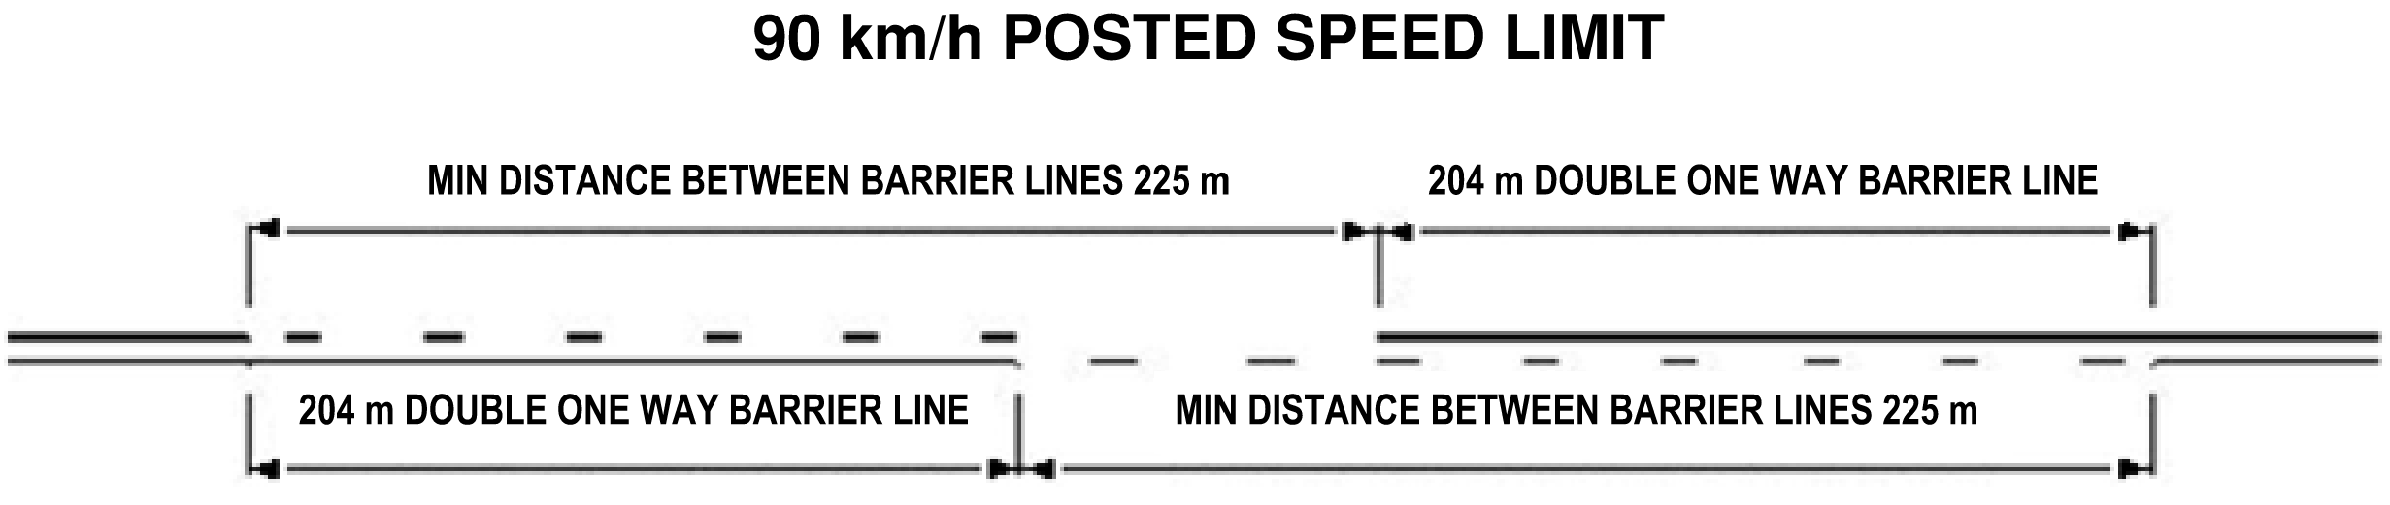

**Figure 5: Example of Minimum Distance between Barrier Lines (Column 4 Table 2)**

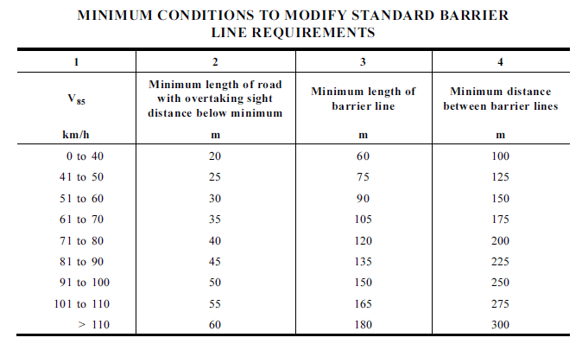

**Table 2: Minimum Conditions to Modify Standard Barrier Line Requirements (source AS 1742.2)**

Suggested modifications to the barrier line lengths, as located and set out in accordance with the above are covered below as per AS 1742.2 Clause 5.3.3.4. Some typical instances and suggested modifications are as follows:

1. Where only a short length of road (see Column 2 of Table 2) has substandard overtaking sight distance, barrier lines should not be marked, e.g. within a short sag (floodway, causeway) in an otherwise level road.
2. Where a barrier line marked in accordance with section 3.2 is very short, it will not have sufficient visual impact and will not give the impression of continuity. The distance CE to BW in Figure 4, in some circumstances will be less than the minimum length of barrier line (Column 3 of Table 2) i.e. the overtaking sight distance is established again, point BW, prior to the point BE. In these cases the minimum length of barrier line should be marked back from the point BW and in many cases will extend beyond the point CE. This occurrence is shown in Figure 6 and highlights the resulting line marking arrangement.

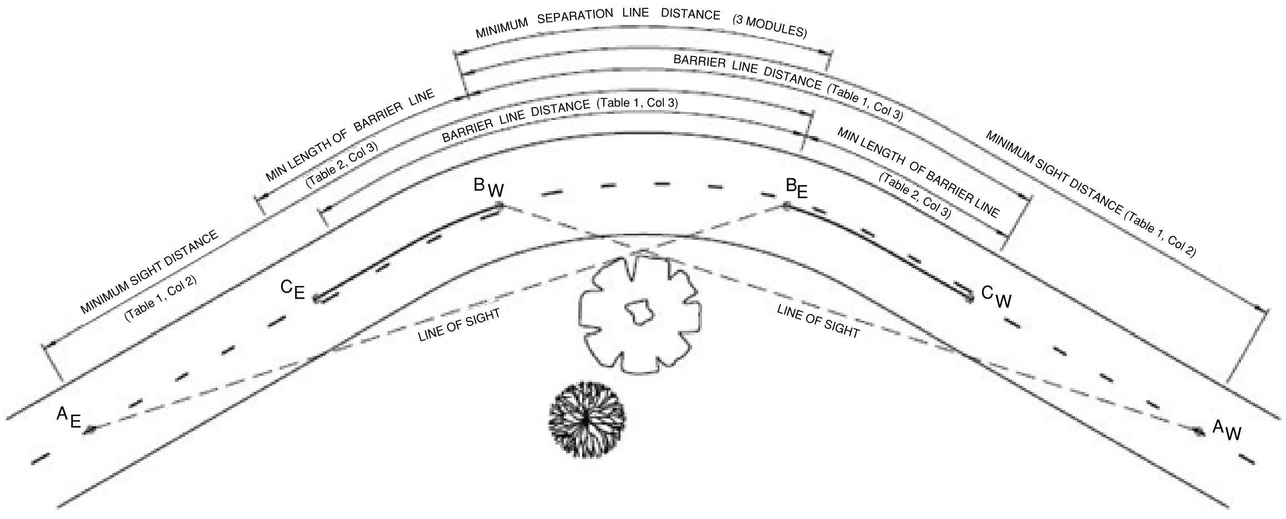

**Figure 6: BW Established Before BE**

1. In rare situations BW may occur before CE as shown in Figure 7. In these cases the minimum length of barrier line (Column 3 of Table 2) should be marked to terminate at the point BW at which minimum overtaking sight distance (Column 2 of Table 1) is regained.

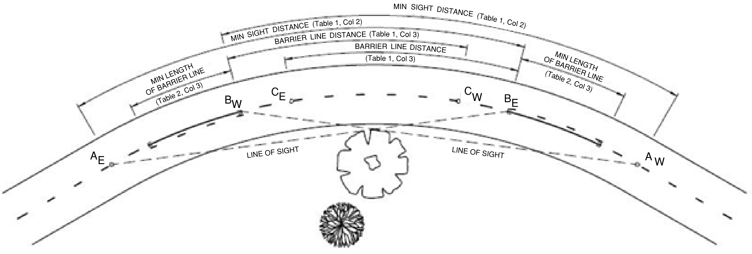

**Figure 7: CE Established After BW**

1. Where the distance between the end of one barrier line and the start of the succeeding barrier line restricting overtaking in the same direction is equal to or below the minimum distance between barrier lines (see Column 4 of Table 2), the barrier line should be joined to form one continuous two way double barrier line as shown in Figure 8. For example, this may occur on a short straight between two curves.

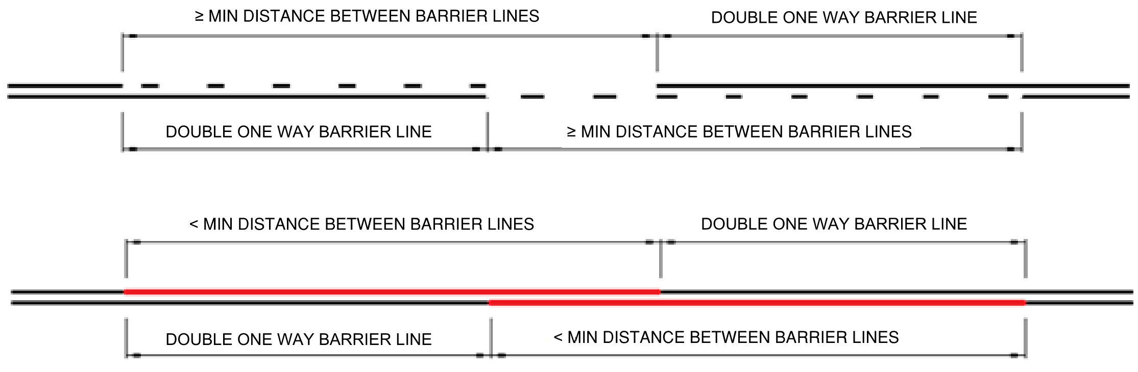

**Figure 8: Joining Short Sections of Barrier Line**

1. The default for barrier lines at overtaking lanes is not to permit overtaking in the non-passing lane direction, i.e. to provide a double barrier line between an overtaking lane and the opposing direction as per Main Roads WA standard drawing [200631-0039](https://www.mainroads.wa.gov.au/technical-commercial/technical-library/?q=&take=25&filter=&type=&page=1&sectionFilter=731&node=Standard%20Contract%20Drawings,Pavement%20Marking). However, this may lead to a situation where the construction of an overtaking lane in one direction leads to the elimination of a perfectly good overtaking opportunity in the opposite direction. For this reason, Main Roads has decided to permit overtaking in the opposing direction, provided the following conditions are met:
2. Double barrier lines are installed at the start (diverge) and end (merge) of the overtaking lane.
3. For the section between the start and end of the overtaking lane, the overtaking sight distance is assessed in the single lane direction as per section 3.2, but with the following provisos:
   * Overtaking in the single lane direction is not permitted around a left-hand curve. This is because the view of the road ahead will always be blocked by the vehicle in front.
   * For right hand curves, the visibility envelope is taken to be tangential to the lane markings as indicated on figure 9. This is because a vehicle in the left-hand lane (two-lane direction) may block the visibility to another vehicle behind, potentially about to pass.
4. Notwithstanding the above, MR-WM-50 signs (No overtaking unless oncoming lanes are clear) shall be installed on the single lane direction approach prior to the start of the one-way double barrier line, as indicated in Main Roads WA standard drawing [201431-0021](https://www.mainroads.wa.gov.au/technical-commercial/technical-library/?q=&take=25&filter=&type=&page=3&sectionFilter=731&node=Standard%20Contract%20Drawings,Pavement%20Marking).

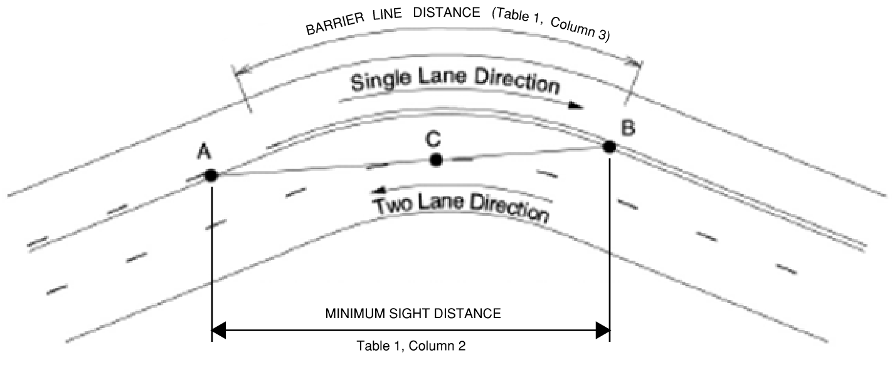

**\* BARRIER LINE FOR SINGLE LANE DIRECTION TRAFFIC IS CHECKED AND MARKED ACCORDING TO THESE GUIDELINES. EXCEPT: POINT B (FOR MEASUREMENT OF BARRIER LINE DISTANCE) IS DETERMINED WHEN C FIRST FALLS WITHIN LEFT HAND LANE ON TWO-LANE DIRECTION.**

**Figure 9: Barrier Lines for Overtaking Lanes where overtaking may be permitted in the**

**Single Lane Direction**

## Main Roads WA Pattern Change Marks

Main Roads WA drawing [201331-0026](https://www.mainroads.wa.gov.au/technical-commercial/technical-library/?q=&take=25&filter=&type=&page=3&sectionFilter=731&node=Standard%20Contract%20Drawings,Pavement%20Marking) gives details of pattern change marks for barrier lines on curves and crests. This drawing is to be read in conjunction with these guidelines and MRWA guidelines for longitudinal line marking.

## Checking Marked Barrier Lines

Barrier lines set out strictly in accordance with 3.2 and 3.3 will occasionally produce no-overtaking zones which err on the safe side and may be too restrictive.

To check this, the road should be traversed at the posted speed when setting out is complete, but before marking has commenced. At this speed all barrier lines should appear reasonable and not unduly restrictive. Particular attention should be given to sections of steep or winding alignment where little opportunity remains for overtaking. If the markings are considered too restrictive, the barrier lines should be reviewed as follows:

1. Check that the appropriate 85th percentile approach speed was used at each sight distance restriction. For example, while the 85th percentile approach speed to a section of winding alignment may be 100 km/h, the first curve may so reduce vehicle speeds that the approach speed to subsequent curves may be as low as 40 km/h.
2. See if short gaps can be left in the barrier line to allow cars to overtake slow-moving trucks. These gaps should, desirably, be not less than 100 m long. If necessary, the barrier line distance should be reduced to permit overtaking opportunities at the safest places consistent with shoulder width, roadside obstacles and other potential hazards, as well as sight distance.

## Procedure for Checking Existing Marked Barrier Lines

### General

MRWA double one way barrier lines lengths have been adopted to align with a 12 m length (9 m gap and 3 m stripe) to ensure a conservative approach to the placement and measurement of these barrier lines. This is a two-person procedure to ensure Traffic Management is undertaken in accordance with Main Roads WA Short Term Stops Procedure/Working between traffic. A spotter must be present at all times for the person on the road.

Below is the minimum equipment required to undertake the task of barrier assessments.

* Rangefinder to measure one way barrier lines. The rangefinder should have a specified accuracy of ±0.3 m over 1000 m and a 7X magnification optics to ensure target is being hit. A monopod can be fitted to the rangefinder to ensure measurements are taken at a constant height of 1.10 m (eye height).
* One 1.10 m high visibility cylinder cone with reflective strip at the top to assist in confirming eye height (1.10 m) and assist in measuring distances.
* Two two-way radios to ensure communications between the team.

### Method

* Identify the curve or crest for assessment by confirming the sight distance is less than the minimum overtaking sight distance for the posted speed as per Table 1 and Main Roads WA drawing [201331-0026](https://www.mainroads.wa.gov.au/technical-commercial/technical-library/?q=&take=25&filter=&type=&page=3&sectionFilter=731&node=Standard%20Contract%20Drawings,Pavement%20Marking) (e.g. 330 m for 110 km/h). Sight distance is to be measured using the rangefinder from a height of 1.10 m to a target (cylinder cone) at 1.10 m high, which is of critical importance when a vertical curve is involved.

If vegetation impacts on the sight distance available, the assessor is to determine if maintenance pruning is required or existing barrier line markings are modified/adjusted. Ideally, vegetation is maintained outside the bottom of the table drain in cut situations.

* Drive through the horizontal curve or vertical crest and identify the point that the minimum overtaking sight distance is regained (i.e. 330 m for 110 km/h). Mark this location on the centre line as per drawing [201331-0026](https://www.mainroads.wa.gov.au/technical-commercial/technical-library/?q=&take=25&filter=&type=&page=3&sectionFilter=731&node=Standard%20Contract%20Drawings,Pavement%20Marking). This point becomes the end of the double two way barrier/start double one way barrier.
* From this position moving forward measure the double one way barrier line distance for the posted speed as per [201331-0026](https://www.mainroads.wa.gov.au/technical-commercial/technical-library/?q=&take=25&filter=&type=&page=3&sectionFilter=731&node=Standard%20Contract%20Drawings,Pavement%20Marking) (i.e. 252 m for 110 km/h). Mark this location on the centre line as per [201331-0026](https://www.mainroads.wa.gov.au/technical-commercial/technical-library/?q=&take=25&filter=&type=&page=3&sectionFilter=731&node=Standard%20Contract%20Drawings,Pavement%20Marking). This point becomes the start separation line point.
* Drive back through the curve/crest and identify the point that the minimum overtaking sight distance is regained in the opposite direction. This point becomes the end of the double two way barrier/start double one way barrier. Mark this location on the centre line as per [201331-0026](https://www.mainroads.wa.gov.au/technical-commercial/technical-library/?q=&take=25&filter=&type=&page=3&sectionFilter=731&node=Standard%20Contract%20Drawings,Pavement%20Marking). This point becomes the end of the double two way barrier/start double one way barrier in the opposite direction.
* From this position move forward and measure the double one way barrier line distance for the posted speed as per [201331-0026](https://www.mainroads.wa.gov.au/technical-commercial/technical-library/?q=&take=25&filter=&type=&page=3&sectionFilter=731&node=Standard%20Contract%20Drawings,Pavement%20Marking) (i.e. 252 m for 110 km/h). Mark this location on the centreline as per [201331-0026](https://www.mainroads.wa.gov.au/technical-commercial/technical-library/?q=&take=25&filter=&type=&page=3&sectionFilter=731&node=Standard%20Contract%20Drawings,Pavement%20Marking). This point becomes the start separation line point.
* The horizontal and vertical geometry requirements for barrier lines have now been marked as per [201331-0026](https://www.mainroads.wa.gov.au/technical-commercial/technical-library/?q=&take=25&filter=&type=&page=3&sectionFilter=731&node=Standard%20Contract%20Drawings,Pavement%20Marking).

## Special Considerations

The following special considerations should be given when reviewing overtaking line marking and barrier line systems:

* Where mid to large radii (R = 1000 m to 3000 m) on high speed roads are determined to provide adequate sight distances these should be reviewed in the field, specifically for the left-hand curve direction. For a car following another vehicle around a left-hand curve, the sight distance of the following car is likely to be obstructed by the car in front. Restrictions for curves in the right-hand direction may also result in longer lengths of double one-way barrier line than the lengths noted in Table 1, Column. 3.
* Marking of two-way double barrier lines where a minimal opportunity for overtaking exists (i.e. the minimum distance between barrier lines is used) if there are more appropriate/safer opportunities just before or after the borderline/questionable opportunity. The clear opportunities shall be within 2 minutes of travel time either side of the section in question.
* Consideration needs to be given if a road is identified as a road train route. A minimum barrier line distance is indicated on the relevant standard drawing is to be applied.

# References

AS1742.2: Manual of Uniform Traffic Control Devices Part 2: Traffic Control Devices for General Use.

# Appendices

|  |  |
| --- | --- |
| **Appendix** | **Title** |
| **Appendix 1** | Applicable Main Roads Drawings |

Appendix 1: Applicable Main Roads Drawings

The following Main Roads drawings are applicable to this guideline:

|  |  |
| --- | --- |
| **Drawing Number** | **Title** |
| [9931-0198](https://www.mainroads.wa.gov.au/technical-commercial/technical-library/?q=&take=25&filter=&type=&page=4&sectionFilter=731&node=Standard%20Contract%20Drawings,Pavement%20Marking) | Standard Drawing  Pavement Marking Line Types |
| [200331-0182](https://www.mainroads.wa.gov.au/technical-commercial/technical-library/?q=&take=25&filter=&type=&page=1&sectionFilter=731&node=Standard%20Contract%20Drawings,Pavement%20Marking) | Standard Drawing  Pavement Markings and RRPM’s at Type “BA” and Type “AU” Intersections |
| [200331-0183](https://www.mainroads.wa.gov.au/technical-commercial/technical-library/?q=&take=25&filter=&type=&page=1&sectionFilter=731&node=Standard%20Contract%20Drawings,Pavement%20Marking) | Standard Drawing  Pavement Markings and RRPM’s at Type “CH” Intersections |
| [200331-0184](https://www.mainroads.wa.gov.au/technical-commercial/technical-library/?q=&take=25&filter=&type=&page=1&sectionFilter=731&node=Standard%20Contract%20Drawings,Pavement%20Marking) | Standard Drawing  Splitter Island – Line Marking and RRPM’s for islands ≤ 3.0 m Wide and Posted Speed Limit ≤ 60 km/h |
| [200331-0191](https://www.mainroads.wa.gov.au/technical-commercial/technical-library/?q=&take=25&filter=&type=&page=1&sectionFilter=731&node=Standard%20Contract%20Drawings,Pavement%20Marking) | Standard Drawing  Pavement Markings and RRPM’s at Raised Medians ≥3.0 m Wide |
| [200631-0038](https://www.mainroads.wa.gov.au/technical-commercial/technical-library/?q=&take=25&filter=&type=&page=1&sectionFilter=731&node=Standard%20Contract%20Drawings,Pavement%20Marking) | Standard Drawing  Longitudinal Dividing Lines to Prohibit Overtaking in Both Directions on Two Lane, Two Way Roads |
| [200631-0039](https://www.mainroads.wa.gov.au/technical-commercial/technical-library/?q=&take=25&filter=&type=&page=1&sectionFilter=731&node=Standard%20Contract%20Drawings,Pavement%20Marking) | Standard Drawing  Signs and Line Marking for Overtaking Lanes  No Overtaking Permitted in Single Lane Direction |
| [201031-0004](https://www.mainroads.wa.gov.au/technical-commercial/technical-library/?q=&take=25&filter=&type=&page=2&sectionFilter=731&node=Standard%20Contract%20Drawings,Pavement%20Marking) | Standard Drawing  Splitter Island on Terminating Road  Line Marking and RRPM’s for islands ≤ 3.0 m Wide and Posted Speed Limit ≥ 70 km/h |
| [201031-0026](https://www.mainroads.wa.gov.au/technical-commercial/technical-library/?q=&take=25&filter=&type=&page=2&sectionFilter=731&node=Standard%20Contract%20Drawings,Pavement%20Marking) | Standard Drawing  Raised Pavement Markers  General Applications  Freeways, Controlled Access Highways, Highways, Main Roads and Arterial Roads in Urban Areas |
| [201031-0027](https://www.mainroads.wa.gov.au/technical-commercial/technical-library/?q=&take=25&filter=&type=&page=2&sectionFilter=731&node=Standard%20Contract%20Drawings,Pavement%20Marking) | Standard Drawing  Raised Pavement Markers  General Applications  Freeways, Highways, Main Roads and Arterial Roads in Rural and Outer Metropolitan Areas |
| [201331-0026](https://www.mainroads.wa.gov.au/technical-commercial/technical-library/?q=&take=25&filter=&type=&page=3&sectionFilter=731&node=Standard%20Contract%20Drawings,Pavement%20Marking) | Standard Drawing  MRWA Pattern Change Marks  For Barrier Lines on Curves or Crests |
| [201431-0021](https://www.mainroads.wa.gov.au/technical-commercial/technical-library/?q=&take=25&filter=&type=&page=3&sectionFilter=731&node=Standard%20Contract%20Drawings,Pavement%20Marking) | Standard Drawing  Signs and Line Marking for Overtaking Lanes  Overtaking Permitted in Single Lane Direction |