WA Performance Based Standards (PBS) Scheme
Vehicle Specifications (Part B)

Contents
Instructions for the Assessor 3
Instructions For the Certifier 3
1 Application Details 4
2 Document Control 5
3 Towing Vehicle Inspection Details 6
4 Trailing Units InspectIon Details 9
5 Combination Dimensions and Compliance 13
6 Vehicle Design Schematic Drawing 14
7 As Built Measurements (for Certifier to Complete) 15

Instructions for the Assessor
- Sections 1.1, 1.2 and 1.3 must be completed.
- For amendments or variations, the assessor must also complete section 2 and highlight all amendments or variations in yellow.
- In sections 3-5 the assessor must complete the relevant details in the Required Specification Column for each PBS vehicle.
- If the PBS heavy vehicle is a combination, the relevant parts must be completed for each unit in the combination (e.g., Lead trailer, semi-trailer, dolly or dog trailer)
- In section 4, the assessor may list interchangeable units together in the same table (e.g., if units 2 and 4 are interchangeable, units 2 and 4 may be listed together)
- To be considered interchangeable, units must have identical Required Specifications & Dimensions.
- The Vehicle Design Schematic must be inserted in section 6.
- When the vehicle is completely described, the Assessor must complete the Assessor Declaration in section 7 of the WA PBS Assessment Results (Part A) and submit both parts to hvsnetworkaccess@mainroads.wa.gov.au

Instructions For the Certifier
- Section 1.4 must be completed.
- Sections 3-5 the certifier must complete the relevant evidence in the Certifier to Complete Columns for each vehicle e.g. Manufacturer rating letters or verified onsite.
- If the PBS heavy vehicle is a combination, the relevant parts must be completed for each unit in the combination (e.g., Lead trailer, semi-trailer, dolly or dog trailer)
- Section 7 must be completed for measurements.
- All certification records must be maintained for a minimum of 7 years and produced to Main Roads Heavy Vehicle Services personnel upon request.

Application Details

Applicant and Vehicle Design Details
Applicant
Name of company |  | Contact person
Postal address
Email
Phone |  | Mobile
Vehicle Design Details
Vehicle Design Number

Design Owner Details (if different from applicant details)
Design Owner
Name of company |  | Contact person
Postal address
Email
Phone |  | Mobile

Assessor Details
Assessor
Name of company |  | Contact person
Postal address
Email
Phone |  | Mobile
Assessor job number

Inspection Details (Certifier to Complete)
Inspection Details
Main Roads Reference Number (if applicable) | MRWA
Inspection Location
Inspection Date
Name of person who completed Inspection
Certification Reference Number

Document Control

Initial Document Details
Document Number | For Main Roads Office Use Only
Initial Issue Date

Application Amendments and Variations
Amendment Description | Date | TRIM Reference (office use only)
 | Click or tap to enter a date.
 | Click or tap to enter a date.
 | Click or tap to enter a date.
 | Click or tap to enter a date.

Note: All amendments/variations/corrections from the previous version should be marked on the form with yellow highlight for clarity.

Towing Vehicle Inspection Details
Assessor to Complete |  |  |  | Certifier to Complete
Unit Type |  |  | Choose an item. | VIN
 |  |  | Choose an item. | Inspection Type | Choose an item.
 | Category or Component | Parameter | Required Specification | As Built Specification |  | List evidence provided to support as built specification
 | Vehicle | Make
 | Vehicle | Model
 | Vehicle | Description  (e.g., Prime Mover/Rigid Truck - 8x4, 8x6, 10x6)
 | Engine and Driveline | Make and model
 | Engine and Driveline | Engine Power: (The output at a specified engine RPM, e.g., 448kW@1800rpm)
 | Engine and Driveline | Engine Torque: (The output at a specified engine RPM, e.g., 2778Nm@1200rpm)
 | Engine and Driveline | Engine Emission Rating:  (e.g., Euro 5, or ADR 80/02 compliant)
 | Engine and Driveline | Clutch engagement torque in Nm. (For manual transmission only).
 | Engine and Driveline | Torque converter characteristics (For automatic transmission only).
 | Gearbox | Make and model
 | Gearbox | Gearbox ratio:  Include all gear ratios
 | Differential | Make and model
 | Differential | Final drive ratio  (e.g., 4.55:1)
 | Differential | Tractive effort distribution/torque distribution. (e.g., 50:25:25 or 33:33:33)
 | Suspension | Steer Axle Make and Model | Single steer (if applicable)
 | Suspension | Steer Axle Make and Model | Twin steer (if applicable) – non-load sharing
 | Suspension | Steer Axle Make and Model | Twin steer (if applicable) – load sharing
 | Suspension | Steer Axle group rating
 | Suspension | Drive Axle Type, Make & Model: (Leaf spring or airbag. If leaf spring, specify number, e.g., 3 leaf or 9 leaf)
 | Suspension | Drive Axle group rating
 | Wheels and axles | Track width and dual tyre spacing | Steer Track:
 | Wheels and axles | Track width and dual tyre spacing | Drive Track:
 | Wheels and axles | Track width and dual tyre spacing | Dual tyre spacing:
 | Tyres | Tyre requirements | Steer:
  Size | Load Index (min) | Generic Tyre Dataset used in Assessment
 | Tyres | Tyre requirements | Drive:
  Size | Load Index (min) | Generic Tyre Dataset used in Assessment
 | Couplings | Make and Model
 | Couplings | Type (e.g. fifth wheel /ballrace/ Ringfeder)
 | Couplings | D-rating (Lowest rating for the assembly, e.g. lowest rating of fifth wheel or ballrace)
 | Brakes | Brake Type:  (Axles fitted with disc brakes or drum brakes)
 | Brakes | Brake Controls:  (e.g. ABS or EBS)
 | Brakes | Trailer Brake Power Supply:  (The power output supplied to the trailer EBS system)
 | Tare | Minimum tare mass (kg) (Including any accessories fitted)
 | Mass | Gross Vehicle Mass (GVM) rating (kg)
 | Mass | Gross Combination Mass (GCM) rating (Kg)
 | Other | Additional or special requirements

Trailing Units InspectIon Details
Assessor to Complete |  |  |  | Certifier to Complete
Unit Type |  |  | Choose an item. | VIN
Position of unit in the combination |  |  |  | Inspection Type | Choose an item.
 | Category or Component | Parameter | Required Specification | As Built Specification |  | List evidence provided to support as built specification
 | Vehicle | Make
 | Vehicle | Model
 | Vehicle | Description (e.g. tandem dolly, tri axle semi-trailer or six axle dog trailer)
 | Vehicle | Body type (e.g., side tipper, fuel tanker or skel trailer)
 | Suspension | Dolly Axle Group Suspension Type, Make & Model (If applicable):  (Leaf spring or airbag. If leaf spring, specify number, e.g., 3 leaf or 9 leaf)
 | Suspension | Rear Axle Group Suspension Type, Make & Model (If applicable):  (Leaf spring or airbag. If leaf spring, specify number, e.g., 3 leaf or 9 leaf)
 | Suspension | Steerable axle suspension make and model  (If applicable)
 | Suspension | Steerable Axle Degree of Articulation  (If applicable):
 | Wheels and axles | Track width and dual tyre spacing | Track width:
 | Wheels and axles | Track width and dual tyre spacing | Dual Tyre:
 | Wheels and axles | Lift axle/s
 | Tyres | Tyre requirements
  Size | Load Index (min) | Generic Tyre Dataset used in Assessment
 | Couplings | Dolly Drawbar Coupling Type, Make & Model  (If applicable):  (e.g., Tow Eye or Gooseneck Kingpin)
 | Couplings | Dolly Drawbar Coupling D-Rating:
 | Couplings | Dolly to Semi-trailer Coupling Type, Make & Model (If applicable):  (e.g., fifth wheel or ballrace)
 | Couplings | Dolly to Semi-trailer Coupling D-Rating:  (Specify lowest rating for the assembly, e.g. lowest rating of fifth wheel and/or ballrace)
 | Couplings | Semi-trailer Kingpin Make & Model  (If applicable):
 | Couplings | Semi-trailer Kingpin D-Rating:
 | Couplings | Rear Coupling Type, Make & Model  (If applicable):  (e.g., fifth wheel / ballrace / Ringfeder fitted to rear of semi-trailer or dog trailer)
 | Couplings | Rear Coupling D-Rating:
 | Brakes | Dolly Brake Type:  (If applicable)  (Axles fitted with disc brakes or drum brakes)
 | Brakes | Dolly Brake Controls:  (e.g., TEBS or LPV)
 | Brakes | Dolly TEBS CAN Bus Connection:  (Linking the TEBS and RSS on all semi-trailers)
 | Brakes | Semi-trailer or Dog Trailer Axle Group Brake Type  (If applicable):  (Axles fitted with disc brakes or drum brakes)
 | Brakes | Semi-trailer or Dog Trailer Axle Group Brake Controls:  (e.g., TEBS with RSS)
 | Brakes | Semi-trailer or Dog Trailer TEBS CAN Bus Connection:  (Linking the TEBS and RSS on all semi-trailers)
 | Tare | Minimum tare mass (kg) (Including any accessories fitted)
 | Mass | Aggregate Trailer Mass (ATM) rating (kg)
 | Other | Additional or special requirements

Combination Dimensions and Compliance
Assessor to Complete |  |  |  | Certifier to Complete
 | Category or Component | Parameter | Required Specification | As Built Specification | List evidence provided to support as built specification
 | Dimensions | Compliance with the dimensions in the drawing/s (specify drawing number/s)

Vehicle Design Schematic Drawing

As Built Measurements (for Certifier to Complete)

Prime Mover:

 | Front Overhang | Wheelbase | Fifth Wheel Offset | Fifth Wheel Height | Height
Required
Actual

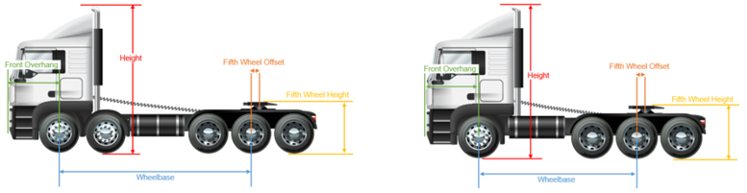

 | Axle 1-2 | Axle 2-3 | Axle 3-4 | Axle 4-5
Required
Actual

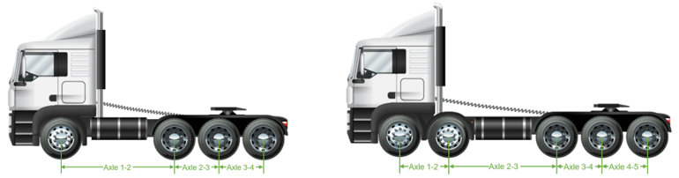

 | Steer Track Width | Track Width | Dual Tyre Spacing
Required
Actual
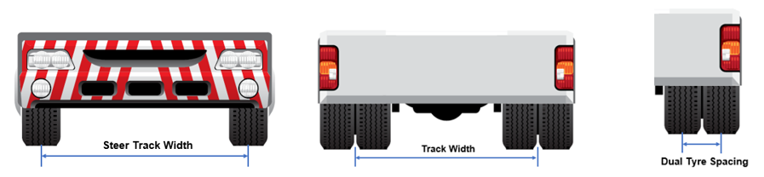

Semi-trailer

 | Front Overhang | S-Dimension | Rear Overhang | Coupling Overhang | Coupling Underrun | Coupling Height | Deck Height | Height
Required
Actual

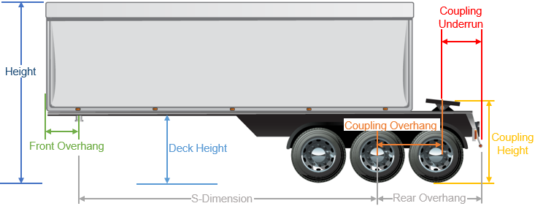

 | Axle 1-2 | Axle 2-3 | Axle 3-4
Required
Actual

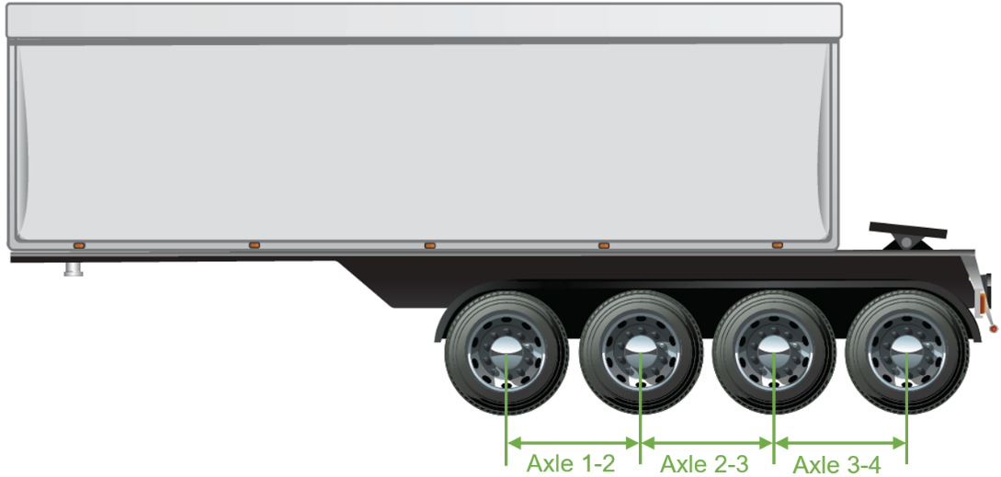

 | Track Width | Dual Tyre Spacing
Required
Actual

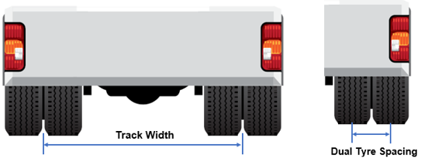

Converter Dolly

 | Drawbar Length | Fifth Wheel Offset | Fifth Wheel Height
Required
Actual

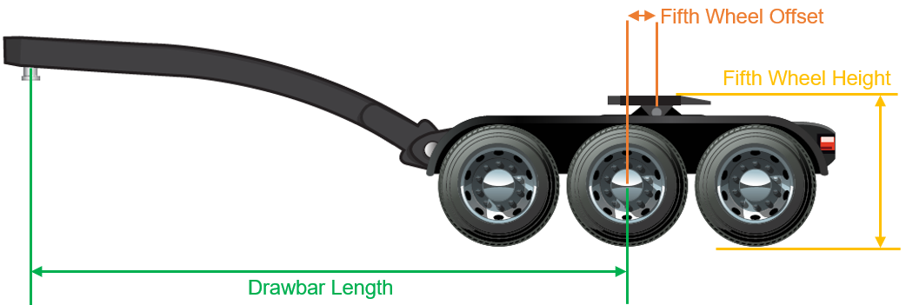

 | Axle 1-2 | Axle 2-3 | Axle 3-4
Required
Actual

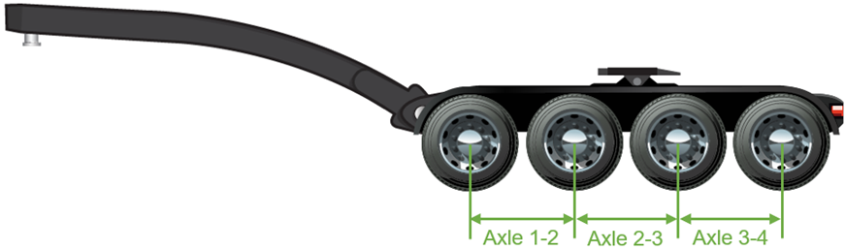

 | Track Width | Dual Tyre Spacing
Required
Actual

Dog Trailer

 | Drawbar Length | Fifth Wheel Offset | Fifth Wheel Height
Required
Actual

 | Axle 1-2 | Axle 2-3 | Axle 3-4
Required
Actual

 | Track Width | Dual Tyre Spacing
Required
Actual

 | Front Overhang | S-Dimension | Rear Overhang | Coupling Overhang | Coupling Underrun | Coupling Height | Deck Height | Height
Required
Actual

 | Axle 1-2 | Axle 2-3 | Axle 3-4
Required
Actual

 | Track Width | Dual Tyre Spacing
Required
Actual

Combination:

 | Cab to Kin Pin | Inner 1-2 | Inner 2-3 | Inner 3-4 | Inner 4-5 | Inner 5-6 | Inner 6-7 | Inner 7-8 | Overall Length
Required
Actual
 |  | Outer 1-2 | Outer 2-3 | Outer 3-4 | Outer 4-5 | Outer 5-6 | Outer 6-7 | Outer 7-8
Required
Actual

