WA Performance Based Standards (PBS) Scheme
Vehicle Specifications (Part B)

Contents
Instructions for the Assessor 3
1 Application Details 4
2 Document Control 5
3 Towing Vehicle Inspection Details 6
4 Trailing Units InspectIon details 9
5 Combination Dimensions and compliance 13
6 Vehicle design Schematic Drawing 13
7 Inspection Notes (For Main Roads office use only) 13
8 as built measurements (for Main roads office use only) 15

Instructions for the Assessor
- Sections 1.1, 1.2 and 1.3 must be completed.
- For amendments or variations, the assessor must also complete section 2 and highlight all amendments or variations in yellow.
- In sections 3-5 the assessor must complete the relevant details in the Required Specification Column for each PBS vehicle.
- If the PBS heavy vehicle is a combination, the relevant parts must be completed for each unit in the combination (e.g., Lead trailer, semi-trailer, dolly or dog trailer)
- In section 4, the assessor may list interchangeable units together in the same table (e.g., if units 2 and 4 are interchangeable, units 2 and 4 may be listed together)
- To be considered interchangeable, units must have identical Required Specifications & Dimensions.
- The Vehicle Design Schematic must be inserted in section 6.
- When the vehicle is completely described, the Assessor must complete the Assessor Declaration in section 7 of the WA PBS Assessment Results (Part A) and submit both parts to hvsnetworkaccess@mainroads.wa.gov.au

Application Details

Applicant and Vehicle Design Details
Applicant
Name of company |  | Contact person
Postal address
Email
Phone |  | Mobile
Vehicle Design Details
Vehicle Design Number

Design Owner Details (if different from applicant details)
Design Owner
Name of company |  | Contact person
Postal address
Email
Phone |  | Mobile

Assessor Details
Assessor
Name of company |  | Contact person
Postal address
Email
Phone |  | Mobile
Assessor job number

Inspection Details (For Main Roads office use only)
Inspection Details
Main Roads Reference Number | MRWA
Inspection Location
Inspection Date
Name of person who completed Inspection
Certification Reference Number

Document Control

Initial Document Details
Document Number | For Main Roads Office Use Only
Initial Issue Date

Application Amendments and Variations
Amendment Description | Date | TRIM Reference (office use only)
 | Click or tap to enter a date.
 | Click or tap to enter a date.
 | Click or tap to enter a date.
 | Click or tap to enter a date.

Note: All amendments/variations/corrections from the previous version should be marked on the form with yellow highlight for clarity.

Towing Vehicle Inspection Details
Assessor to Complete |  |  |  | Main Roads to Complete
Unit Type |  |  | Choose an item. | VIN
 |  |  |  | Inspection Type | Choose an item.
 | Category or Component | Parameter | Required Specification | As Built Specification |  | List evidence provided to support as built specification
 | Vehicle | Make
 |  | Model
Description
(e.g., Prime Mover/Rigid Truck - 8x4, 8x6, 10x6)
 | Engine and Driveline | Make and model
 |  | Engine Power: (The output at a specified engine RPM, e.g., 448kW@1800rpm)
 |  | Engine Torque: (The output at a specified engine RPM, e.g., 2778Nm@1200rpm)
Engine Emission Rating:
(e.g., Euro 5, or ADR 80/02 compliant)
 |  | Clutch engagement torque in Nm. (For manual transmission only).
 |  | Torque converter characteristics (For automatic transmission only).
 | Gearbox | Make and model
Gearbox ratio:
Include all gear ratios
 | Differential | Make and model
Final drive ratio
(e.g., 4.55:1)
 |  | Tractive effort distribution/torque distribution. (e.g., 50:25:25 or 33:33:33)
 | Suspension | Steer Axle Make and Model | Single steer (if applicable)
 |  |  | Twin steer (if applicable) – non-load sharing
 |  |  | Twin steer (if applicable) - load sharing
 |  | Steer Axle group rating
 |  | Drive Axle Type, Make & Model: (Leaf spring or airbag. If leaf spring, specify number, e.g., 3 leaf or 9 leaf)
 |  | Drive Axle group rating
 | Wheels and axles | Track width and dual tyre spacing | Steer Track:
 |  |  | Drive Track:
 |  |  | Dual tyre spacing:
 | Tyres | Tyre size & Load Index | Steer:
 |  |  | Drive:
 |  | New tyre make, model (if applicable) | Steer:
 |  |  | Drive:
 |  | Re-tread tyre make, model (if applicable) | Drive ONLY:
 | Couplings | Make and Model
 |  | Type (e.g. fifth wheel /ballrace/ Ringfeder)
 |  | D-rating (Lowest rating for the assembly, e.g. lowest rating of fifth wheel or ballrace)
 | Brakes | Brake Type:  (Axles fitted with disc brakes or drum brakes)
Brake Controls:
(e.g. ABS or EBS)
Trailer Brake Power Supply:
(The power output supplied to the trailer EBS system)
 | Tare | Minimum tare mass (kg) (Including any accessories fitted)
 | Mass | Gross Vehicle Mass (GVM) rating (kg)
 |  | Gross Combination Mass (GCM) rating (Kg)
 | Other | Additional or special requirements

Trailing Units InspectIon details
Assessor to Complete |  |  |  | Main Roads to Complete
Unit Type |  |  | Choose an item. | VIN
Position of unit in the combination |  |  |  | Inspection Type | Choose an item.
 | Category or Component | Parameter | Required Specification | As Built Specification |  | List evidence provided to support as built specification
 | Vehicle | Make
 |  | Model
 |  | Description (e.g. tandem dolly, tri axle semi-trailer or six axle dog trailer)
 |  | Body type (e.g., side tipper, fuel tanker or skel trailer)
 | Suspension | Dolly Axle Group Suspension Type, Make & Model (If applicable):  (Leaf spring or airbag. If leaf spring, specify number, e.g., 3 leaf or 9 leaf)
Rear Axle Group Suspension Type, Make & Model (If applicable):
(Leaf spring or airbag. If leaf spring, specify number, e.g., 3 leaf or 9 leaf)
Steerable axle suspension make and model
(If applicable)
Steerable Axle Degree of Articulation
(If applicable):
 | Wheels and axles | Track width and dual tyre spacing | Track width:
 |  |  | Dual Tyre:
 |  | Lift axle/s
 | Tyres | Tyre size & Load Index
 |  | New tyre make, model (if applicable)
 |  | Re-tread tyre make, model (if applicable)
 | Couplings | Dolly Drawbar Coupling Type, Make & Model  (If applicable):  (e.g., Tow Eye or Gooseneck Kingpin)
 |  | Dolly Drawbar Coupling D-Rating:
Dolly to Semi-trailer Coupling Type, Make & Model (If applicable):
(e.g., fifth wheel or ballrace)
Dolly to Semi-trailer Coupling D-Rating:
(Specify lowest rating for the assembly, e.g. lowest rating of fifth wheel and/or ballrace)
Semi-trailer Kingpin Make & Model
(If applicable):
 |  | Semi-trailer Kingpin D-Rating:
Rear Coupling Type, Make & Model
(If applicable):
(e.g., fifth wheel / ballrace / Ringfeder fitted to rear of semi-trailer or dog trailer)
 |  | Rear Coupling D-Rating:
 | Brakes | Dolly Brake Type:  (If applicable)  (Axles fitted with disc brakes or drum brakes)
Dolly Brake Controls:
(e.g., TEBS or LPV)
Dolly TEBS CAN Bus Connection:
(Linking the TEBS and RSS on all semi-trailers)
Semi-trailer or Dog Trailer Axle Group Brake Type
(If applicable):
(Axles fitted with disc brakes or drum brakes)
Semi-trailer or Dog Trailer Axle Group Brake Controls:
(e.g., TEBS with RSS)
Semi-trailer or Dog Trailer TEBS CAN Bus Connection:
(Linking the TEBS and RSS on all semi-trailers)
 | Tare | Minimum tare mass (kg) (Including any accessories fitted)
 | Mass | Aggregate Trailer Mass (ATM) rating (kg)
 | Other | Additional or special requirements

Combination Dimensions and compliance
Assessor to Complete |  |  |  | Main Roads to Complete
 | Category or Component | Parameter | Required Specification | As Built Specification | List evidence provided to support as built specification
 | Dimensions | Compliance with the dimensions in the drawing/s (specify drawing number/s)

Vehicle design Schematic Drawing

Inspection Notes (For Main Roads office use only)
Associated Documents | Trim Reference
Inspected Part B
Towing Vehicle Manufacturer Declaration(s)
Trailer Manufacturer Declaration(s)
Inspection Photos
Towing Vehicle Ratings Letter(s)
End of Line Brake Report(s)
Other (specify)

as built measurements (for Main roads office use only)

Prime Mover:

 | Front Overhang | Wheelbase | Fifth Wheel Offset | Fifth Wheel Height | Height
Required
Actual

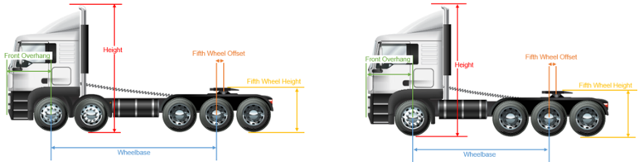

 | Axle 1-2 | Axle 2-3 | Axle 3-4 | Axle 4-5
Required
Actual

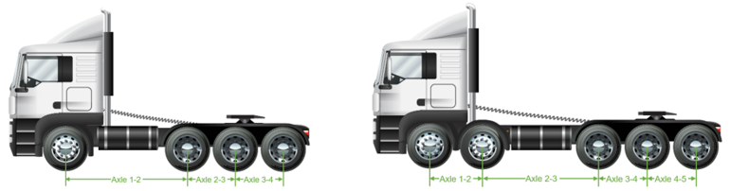

 | Steer Track Width | Dual Tyre Spacing | Track Width
Required
Actual

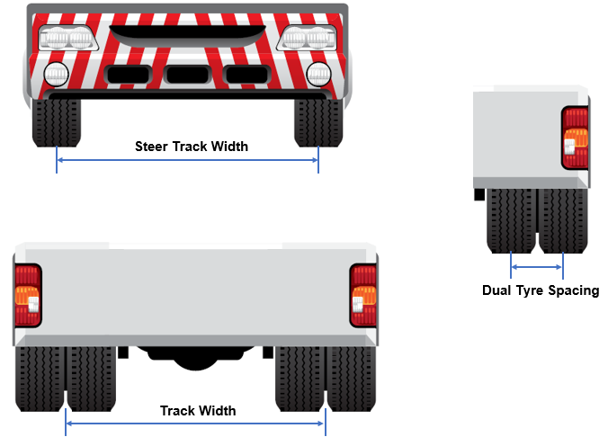

Semi-trailer

 | Front Overhang | S-Dimension | Rear Overhang | Coupling Overhang | Coupling Underrun | Coupling Height | Deck Height | Height
Required
Actual

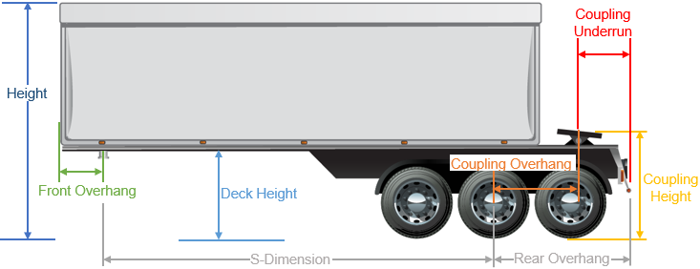

 | Axle 1-2 | Axle 2-3 | Axle 3-4
Required
Actual
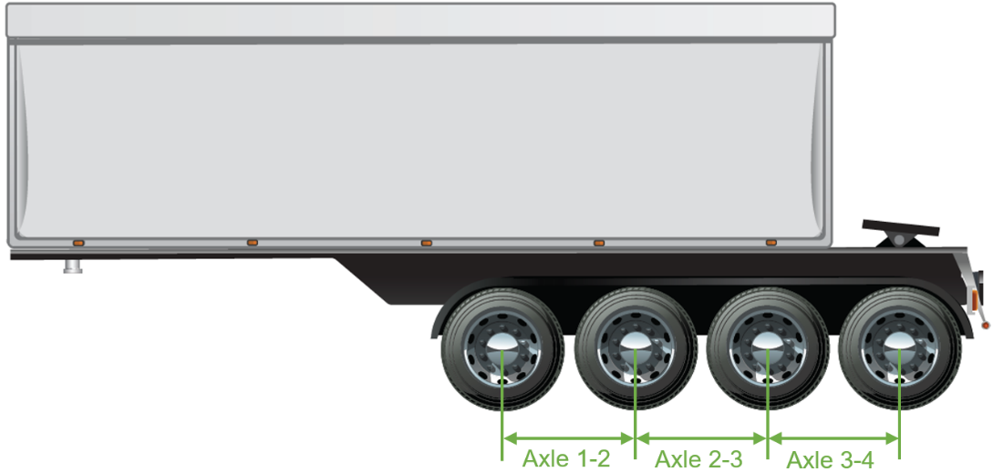

 | Dual Tyre Spacing | Track Width
Required
Actual

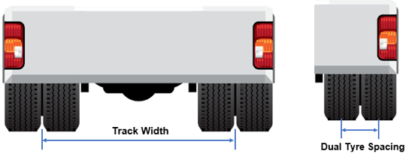

Converter Dolly

 | Drawbar Length | Fifth Wheel Offset | Fifth Wheel Height
Required
Actual

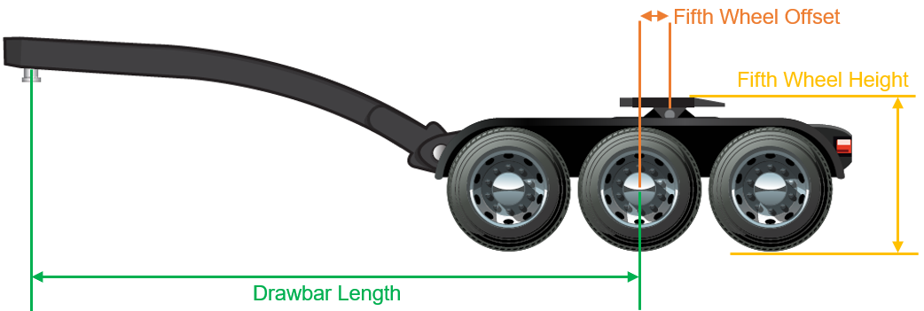

 | Axle 1-2 | Axle 2-3 | Axle 3-4
Required
Actual

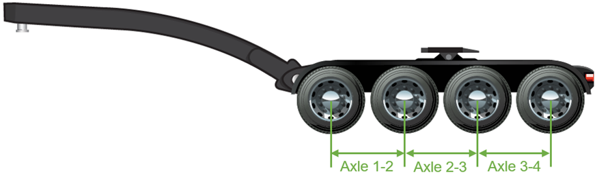

 | Dual Tyre Spacing | Track Width
Required
Actual

Dog Trailer

 | Drawbar Length | Fifth Wheel Offset | Fifth Wheel Height
Required
Actual

 | Axle 1-2 | Axle 2-3 | Axle 3-4
Required
Actual

 | Dual Tyre Spacing | Track Width
Required
Actual

 | Front Overhang | S-Dimension | Rear Overhang | Coupling Overhang | Coupling Underrun | Coupling Height | Deck Height | Height
Required
Actual

 | Axle 1-2 | Axle 2-3 | Axle 3-4
Required
Actual

 | Dual Tyre Spacing | Track Width
Required
Actual

Combination:

 | Cab to Kin Pin | Inner 1-2 | Inner 2-3 | Inner 3-4 | Inner 4-5 | Inner 5-6 | Inner 6-7 | Inner 7-8 | Overall Length
Required
Actual
 |  | Outer 1-2 | Outer 2-3 | Outer 3-4 | Outer 4-5 | Outer 5-6 | Outer 6-7 | Outer 7-8
Required
Actual

