Oversize Vehicle Route Survey

From {enter location} to {enter location}

{enter load description}

Contents
1 Vehicle & Load 3
2 Route details 3
3 Road Width and Roadside impediments 4
4 Swept paths 5
5 Height Clearances 5
6 Power LInes 6
7 Road Information Tables 6
8 Periodic review 7
9 Appendices 7
APPENDIX 1: Traffic Guidance Scheme for Peter Hwy Contraflow Movement 8
APPENDIX 2: Western Power Approval 9
APPENDIX 3: Horizon Power Approval 10

Document Control
Owner
Custodian
Document Number
Issue Date
Review Frequency | Quarterly

Amendments
Revision Number | Revision Date | Description of Key Changes | Section / Page No.

- Vehicle & Load
This route survey has been conducted for the following vehicle and load:

 | Vehicle & Load Details
Load Description | {enter description of load}
Vehicle Configuration | {enter vehicle configuration, e.g. Tri drive prime mover, tandem axle low loader dolly, quad axle low loader}
Overall Width | {enter overall width of the vehicle combination and load}
Overall Length | {enter the overall length of the vehicle combination and load}
Overall Height | {enter the overall height of the vehicle combination and load}
Ground Contact Width | {enter the ground contact width of the trailer, i.e. the widest ground contact}
Load Ground Clearance | {enter the clearance between the ground and the lowest part of the load}
Rear Overhang | {enter rear overhang, i.e. from the centre of the rear axle group to the rear of the load. This does not apply to platform trailers}
Rear Projection | {enter rear projection, i.e. from the rear of the vehicle to the rear of the load}

- Route details
This route survey has been conducted for the vehicle and load specified in Section 1, along the following route:

Journey Start Location | Journey End Location
{enter journey start location} |  | {enter journey end location}

Road Name | From | To
{enter first road on journey} | {enter start location} | {enter next intersection}
{enter next road on journey} | {enter intersection} | {enter next intersection}
{enter next road on journey} | {enter intersection} | {enter next intersection}
{enter last road on journey} | {enter intersection} | {enter end location}

- Road Width and Roadside impediments
There is sufficient road width along the route specified in Section 2 to accommodate the vehicle and load specified in Section 1, except for the following pinch points:

Pinch Point | Procedure
Smith Street  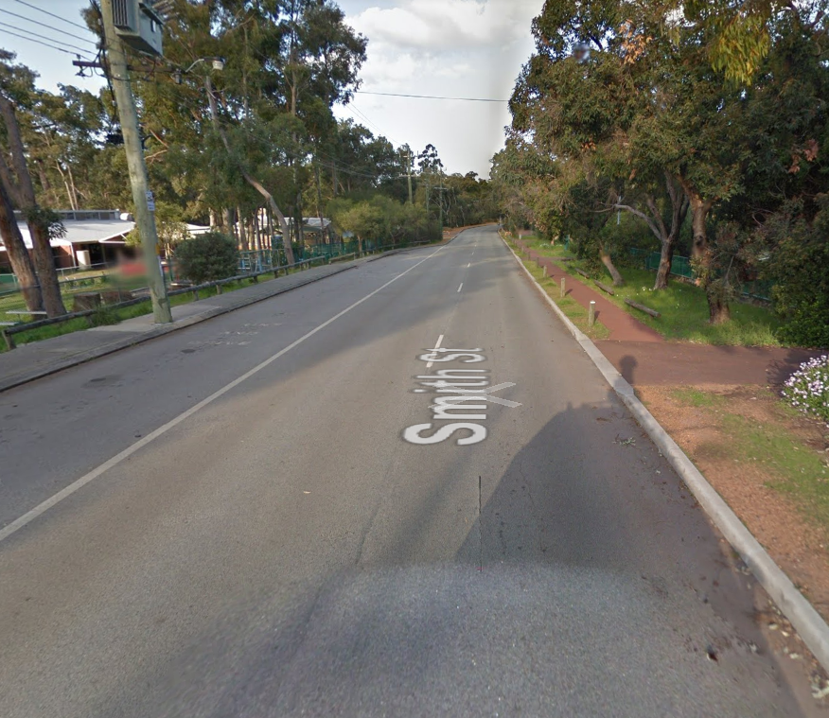 | Example only:  Roadside parking at school inhibits available road width.  Do not travel on this road during school pick up hours.  Oversize vehicle to wait at truck bay on Jones St while the Pilot ensures no vehicles are parked in this area.
Graham Street  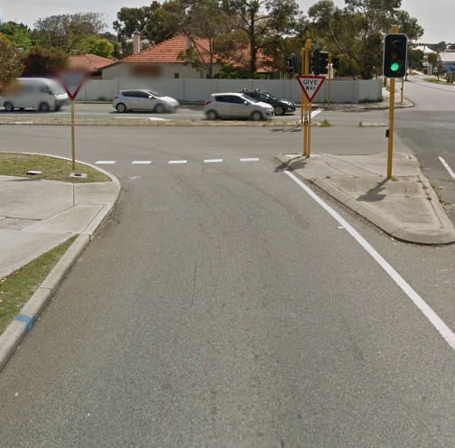 | Example only:  Width between “give way” signs is only 6 metres, which is not sufficient to accommodate the 6.1 metre load.  Pilot must remove left hand sign prior oversize load traveling through the intersection.  Driver to take extreme care while Pilots guide the load through the intersection to avoid damage to roadside furniture.  Driver to take extreme care and ensure footpath is clear prior to commencing left turn.
Paul St  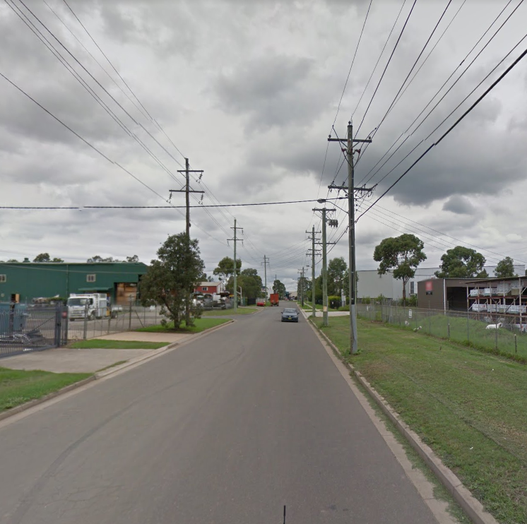 | Example only:  Height of power lines only 6.6 metre and width between power lines is only 6.6 metres.  Load must be centred between the power lines. Driver to take extreme care while two Pilots guide the load between the power lines.  Additional two Pilots required to adequately manage traffic ahead of the load, i.e. effectively closing the road to oncoming traffic.
Alex St  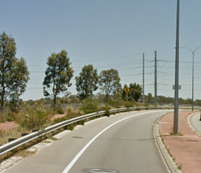 | Example only:  Width between light pole and guardrail only 5.9 metres.  Load must have a minimum ground clearance of 1.2 metres to enable the oversize vehicle to travel to the left of the carriageway, with the load overhanging the guardrail.  Driver to take extreme care while Pilots guide the load past the light pole to avoid damage to roadside furniture.

- Swept paths
Example only:

AutoTrack Swept Paths conducted for each intersection along the route specified in Section 2.

AutoTrack files saved in ‘C’ Drive, under file “Route Survey 541”.

- Height Clearances
There is a minimum 300mm safety buffer between the highest part of the load and all overhead structures, without requiring the load to be lowered, on the route specified in Section 2, except for the following pinch points:

Pinch Point | Procedure
John Street  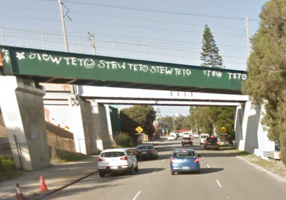 | Example only:  John St Bridge only 6.2 metres high. Trailer must be lowered 200mm prior to traversing under the bridge to ensure a 300mm safety buffer is maintained.  Trailer to be lowered in the left lane ahead of the bridge, with Pilots providing traffic management.  Trailer to be raised again after traversing the bridge, in the left hand lane, with Pilots providing traffic management.
Elliot St  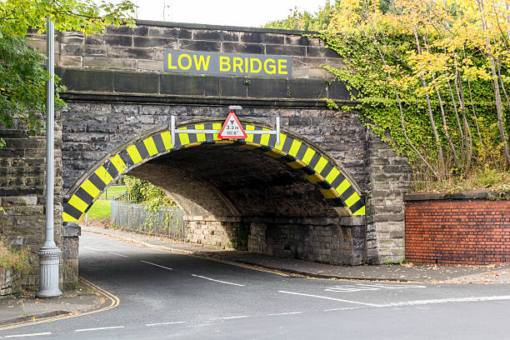 | Example only:  Due to low bridge on Elliot St, oversize vehicle must use the Peter Hwy to bypass the bridge.  Elliot St onto Peter Hwy is left turn only. As such, contraflow movement is required in accordance with the Traffic Guidance Scheme in Appendix 1.

- Power LInes
Overhead power lines identified along the route specified in Section 2. Western Power and Horizon Power approval obtained, as per Appendix 2 and 3. Two Western Power line lifts required as follows:

Pinch Point | Procedure
James Street  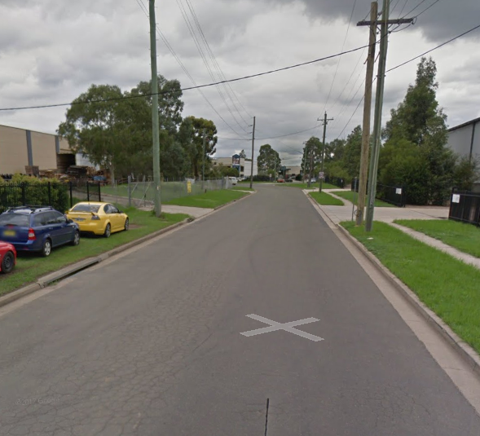 | Example only:  Power line height not sufficient to accommodate the 6.1 metre high load.  Western Power Escort to be contacted on 0412 345 678 the day prior to departure to arrange a time for the line lift.  Oversize vehicle must only traverse under the power line under direction from the Western Power Escort.
Paul St | Example only:  Power line height not sufficient to accommodate the 6.1 metre high load.  Western Power Escort to be contacted on 0412 345 678 the day prior to departure to arrange a time for the line lift.  Oversize vehicle must only traverse under the power line under direction from the Western Power Escort.

- Road Information Tables
Road Information tables have been checked as part of the route survey and will be checked on the day of the movement, prior to commencement. The following areas affect the movement and the specified conditions must be complied with:

Road | Condition
{enter road name} | {enter conditions specified in Road Information table}
{enter road name} | {enter conditions specified in Road Information table}
- Periodic review

Review Date | Description of Any Changes to the Route | Reviewed by | Position Title

- Appendices
Appendix | Title
Appendix 1 | Traffic Guidance Scheme for Peter Hwy Contraflow Movement
Appendix 2 | Western Power Approval
Appendix 3 | Horizon Power Approval

APPENDIX 1: Traffic Guidance Scheme for Peter Hwy Contraflow Movement

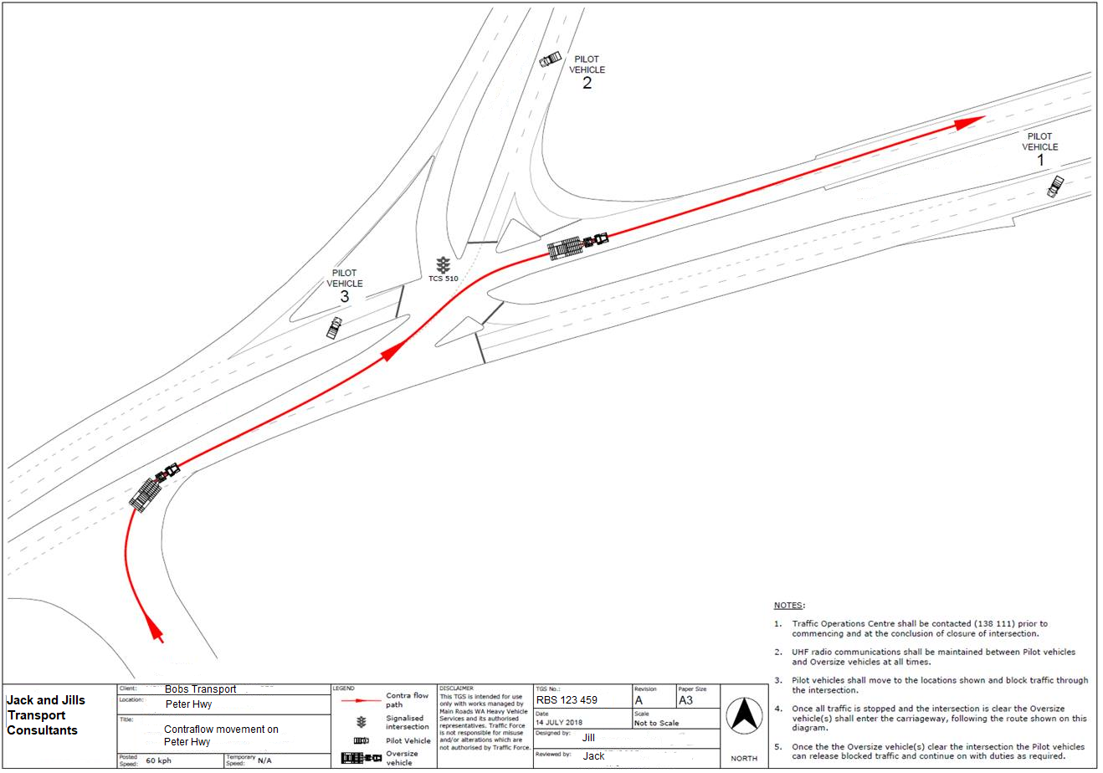

APPENDIX 2: Western Power Approval

{Insert Western Power Approval letter}

APPENDIX 3: Horizon Power Approval

{Insert Horizon Power Approval letter}

