Main Roads Multicultural Plan  
2021-2024

Inclusive | Acceptance | Respect

Contents

A Current Snapshot of Main Roads Cultural Diversity... 4

Our Profile - 38% of our workforce identify as being culturally diverse 4

Countries 4

Top 10 countries of origin for employees 4

Languages 4

Managing Director’s Message 5

Our Business 6

How this Plan was developed 7

How will we monitor and report on this Plan? 7

How will we achieve our Outcomes? 7

Policy Priority 1 Harmonious and inclusive communities 8

What our employees are currently telling us 11

What our CaLD community members are telling us 11

Case study Multilingual Advisory Signs 12

Policy Priority 2 Culturally responsive policies, programs and services 13

What our employees are telling us 18

What our CaLD community members are telling us 18

Case study Bernie Dimanlig 19

Policy Priority 3 20

What our employees are telling us 22

What our CaLD community members are telling us 22

Case study Internal Communications 23

# A Current Snapshot of Main Roads Cultural Diversity...

## Our Profile - 38% of our workforce identify as being culturally diverse

Our workforce profile helps to illustrate who we are. As at 30 June 2020, we had 1140 employees, with 38% of our workforce identifying as being culturally diverse.

|  |  |  |  |
| --- | --- | --- | --- |
| **Demographics** | **2018 (%)** | **2019 (%)** | **2020 (%)** |
| Employees of culturally diverse background* | 22 | 25 | 38 |

*Information collected through self-declaration

**Countries**

We currently have employees from at least 57 countries around the world.

## Top 10 countries of origin for employees

1. United Kingdom   
   (England, Scotland, Wales &   
   Northern Ireland)

6. Bangladesh

7. China

8. Philippines

9. South Africa

10. Singapore

1. Malaysia
2. Sri Lanka
3. India
4. New Zealand

## Languages

From our November 2020 internal survey, 101 responses were from culturally and linguistically diverse (CaLD) employees, with 64 of these employees speaking another language at home other than English. Languages included, Sinhala, Bengali, Spanish, Chinese, Italian, Russian, Finnish, Nepali, Thai, Vietnamese, Arabic, Filipino, German, Punjabi, Hindi, and Malay to name a few!

## 

## % Ratings

CaLD employees agree Main Roads has developed a workplace culture that is welcoming and inclusive of all Western Australians.

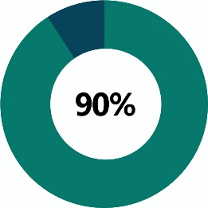

## % Total Average, Good and Very Good Ratings from all employees

Agree Main Roads is inclusive for people from all cultures, backgrounds & customs.

# Managing Director’s Message

At Main Roads, we are very proud of our culturally diverse workplace. By living our values, I believe that we are inclusive and welcoming and we recognise the benefits professionally and personally, of having people from Culturally and Linguistically Diverse (CaLD) backgrounds.

We want to have a workforce that is rich, diverse and based on equality ensuring that we can all work in an environment that is free from harassment and discrimination. We want all of our employees to have access to training, progression and promotion.

I firmly believe that a diverse and multicultural workforce brings a greater range of skills, knowledge, experiences, backgrounds and capabilities into our organisation. This environment will lead to higher performing teams and better outcomes for our customers. The public sector has an obligation to engage people from diverse backgrounds, reflecting the broader community, however at Main Roads, we want to see and deliver more than just an obligation.

On 17 March 2020, the Western Australian Government launched the inaugural Western Australian Multicultural Policy Framework (WAMPF) for the WA public sector. The Framework was developed in response to the state’s growing diversity, where over 32 per cent of people are born overseas. Public sector agencies are required to develop a Multicultural Plan to develop actions that meet the policy priorities of the Framework.

As part of the Western Australian public sector, we are committed to support the capacity and contribution of people from CaLD backgrounds in Western Australia’s civic, social and economic environments. I look forward to keeping you updated on our progress over the life of the plan and sharing our achievements as we progress the actions.

# Our Business

Since 2010, we have been working together with our portfolio partners, the Department of Transport and Public Transport Authority, to enhance the coordination of our operations. The Transport portfolio isn't just about roads boats, planes or trains. It's about people. We recognise that transport is an integral part of the everyday lives of all Western Australians.

As portfolio partners we each have different responsibilities, with Main Roads being responsible for the state's highways and main roads. This includes planning, building, maintaining and operating freeways, major roads, bridges, roadside rest areas and principal shared paths. We are also responsible for traffic signals, road signs, school zones, road markings, speed zoning and network data and are the heavy vehicle regulator for Western Australia.

We are one of the largest geographically spread road agencies in the world. Vast distances and sparse populations present complex challenges. We are responsible for more than 18,600 kilometres of road spread over 2.5 million square kilometres, with a matching diversity in climate and road user needs of our customers. Everyone who relies on, or uses the road network is by definition a customer of Main Roads.

Our **Values** form the foundation upon which Main Roads is built. Our values are about us, they represent our culture, guide our behaviour, influence our decision-making processes and influence our relationships with each other, our customers and our partners. Our values are:

**Roads Matter**  
Taking pride in managing the road network for the benefit of the community.

**Embracing Challenge**  
Anticipating and taking up challenges.

**Excellence in Customer Service**  
Going to extraordinary lengths to understand and provide what is important to our customers.

**Working together**  
Striving to enhance relationships and achieve excellence.

**Professionalism**  
Providing high levels of expertise and experience in delivery services.

**Family**  
Respecting and supporting our customers, the community and each other.

A set of guiding principles assist us to incorporate our values in everything we do. They underpin the way we operate as we set our future direction. They include:

* Striving to improve sustainability and community amenity
* Being an agile and responsive organisation that can prosper in a rapidly changing environment.
* Putting the customer and their experience at the centre of everything we do.
* Developing and investing in leaders that will challenge the status-quo in a real and authentic way.
* Continuing to build and maintain strong relationships with the Transport Portfolio to achieve better outcomes.
* Recognising and cultivating innovation to take up challenges and stay ahead.

# How this Plan was developed

The actions and strategies that are included in this Plan were determined through an extensive consultation process undertaken in October and November 2020. These actions will assist us to not only work towards achieving the vision and outcomes of the Framework but also ensure participation and contribution to a harmonious work environment that celebrates and recognises our employees’ diversity.

Internally our staff were encouraged to contribute to this Plan and complete a confidential survey to identify their views on programs and policies we have in place, and their thoughts on future opportunities we could embrace. In total, we received 220 responses, of which 101 (46%) identified as being of a CaLD background.

For external community members, we developed a survey with our colleagues from the Department of Transport and the Public Transport Authority. We promoted it on all of our social media platforms encouraging the community to take part in the survey and share their views. The Office of Multicultural Interests also promoted the survey link in their weekly bulletin and we forwarded it to a further 550 community members using our own customer database.

By promoting the survey through these various channels, we received 220 responses, of which 148 (67%) identified as being from CaLD backgrounds.

## How will we monitor and report on this Plan?

We will use our annual Business Planning process to deploy, monitor and report on the actions from this Plan. In addition, we will review the Plan every three years and report key achievements within our Annual Report.

## How will we achieve our Outcomes?

Three Policy Priorities underpin the Western Australia Multicultural Policy Framework. These areas and their outcomes will guide us in delivering our Multicultural Plan commitments over the life of the Plan.

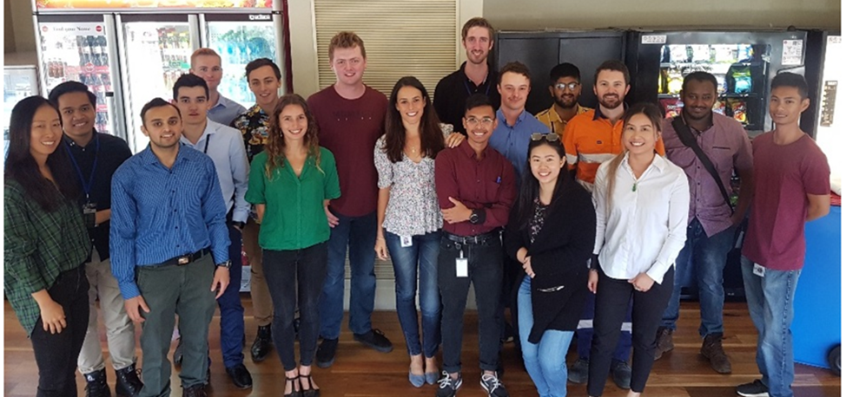Main Roads recent development employees

## Policy Priority 1 Harmonious and inclusive communities

|  |  |  |  |  |
| --- | --- | --- | --- | --- |
| Outcome | Every Western Australian values cultural, linguistic and religious diversity and feels that they belong. | | | |
| Strategies | * Promote the benefits of cultural and linguistic diversity and celebrate the achievements of people from culturally diverse backgrounds. * Address racism and discrimination at both an individual and institutional/systemic level, including implementing the Policy Framework for Substantive Equality. * Develop workplace cultures that are welcoming and inclusive of all Western Australians. * Initiate and support events and projects that build mutual understanding and respect between cultures. | | | |
| Action | | Responsibility | Timeframe | KPIs |
| Recognition and Promotion – Celebrating diversity and recognising achievements | | | | |
| * 1. Promote and celebrate Harmony Week throughout Main Roads | | S&C to promote, all Directorates to support events | Mar 2021 (ongoing during Harmony week) | * 2 iRoads articles posted to promote key events * No. of events held through metropolitan and regional offices |
| * 1. Based on employee feedback, select a number of multicultural events to celebrate during the year | | S&C | Based on survey suggestions, in 2021 Main Roads will recognise:   * Lunar New Year (February) * Eid al-Fitr "Festival of Breaking the Fast” (May) * Diwali (November) | * iRoads articles to celebrate and raise recognition of events. * Increased number of employees showcasing their stories and cultures |
| * 1. Incorporate key multicultural events in the Corporate Calendar | | S&C | Jan 2021 | * Updated calendar on Main Roads intranet |

|  |  |  |  |
| --- | --- | --- | --- |
| * 1. Celebrate achievements of CaLD employees through internal communication channels, such as iRoads news articles | S&C to promote, all Directorates to contribute | Ongoing | Annually post 2 articles on CaLD employees achievements that is linked to annual reporting |
| * 1. Showcase diversity at appropriate Main Roads events. For example, showcasing dance, food and different cultures at Family Day | All Directorates | Oct 2021 | Positive survey responses on diversity activities from participants to Main Roads events, such as Family Day |
| * 1. Review internal and external promotional material to ensure it aligns with our commitment to a diverse workforce, including photos on the Main Roads external website and intranet | S&C | Jun 2022 | Increase our Photo library content to include people from diverse cultures |
| * 1. Review and promote the Portfolio Access and Inclusion Policy to support diversity | S&C | Nov 2022 | Review completed of Portfolio policy and agency procedures to ensure clear guidance on diversity |
| * 1. Raise awareness of Office of Multicultural Interests (OMI) and Equal Opportunity Commission (EOC) events and news | S&C | Ongoing | Promote OMI and EOC events and news via iRoads |
| * 1. Participation in relevant CaLD community events within a region or metropolitan location | All Directorates | Ongoing | Number of events attended and engagements |

|  |  |  |  |
| --- | --- | --- | --- |
| Workforce - Recruitment, training and talent management (ie mentoring, career progression) | | | |
| * 1. Encourage employees to continue to list other languages on their profiles to enable assistance should someone require help translating | HR | Nov 2021 | * An increase in the number of employees updating their profiles * Promote awareness of the availability of language skills |
| Engagement and Participation - Engagement, representation and consultation with members from CaLD backgrounds | | | |
| * 1. Continue to support our CaLD employees by offering designated spaces to be used for diverse cultural needs, eg, the multi-faith prayer room. | F&CS – Property Management | Ongoing | Utilization of the facilities through the booking system |
| * 1. Where appropriate, continue to use the expertise of people with CaLD backgrounds on delivering our projects and services within the community, ie, multilingual road signs. | All Directorates | Ongoing | Increased utilisation of CaLD reference groups on projects |
| Desired Impact:   * An inclusive and welcoming workplace established for all staff, stakeholders and clients * Staff and stakeholders have broader awareness about issues impacting CaLD communities * Broadens awareness of staff of culturally significant days and events that may impact people from CaLD backgrounds | | | |

# What our employees are currently telling us:

## % of Main Roads staff surveyed

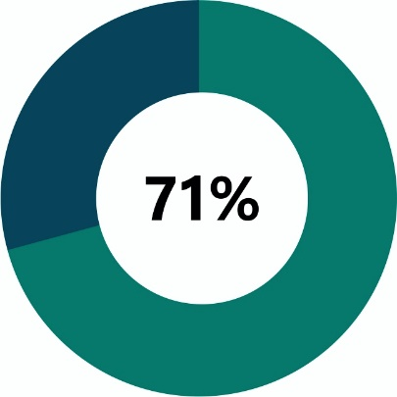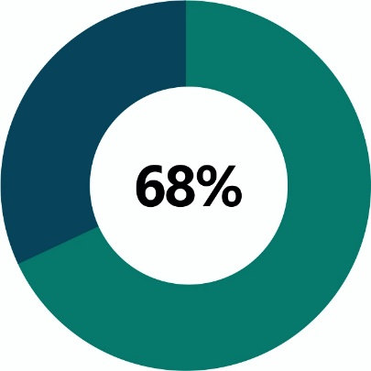

Agree Main Roads promotes the benefits Agree Main Roads addresses racism and  
of cultural and linguistic diversity and discrimination at both an individual and  
celebrate the achievements of people from institutional/systemic level  
culturally diverse backgrounds

# What our CaLD community members are telling us:

## % of CaLD community members surveyed

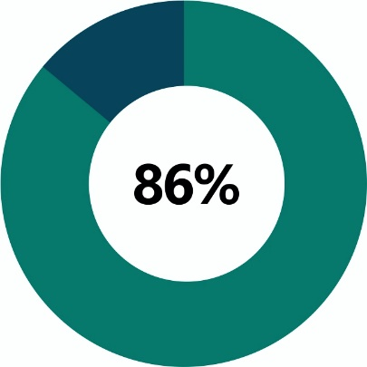

Found the Transport Portfolio as being inclusive for people from all cultures, backgrounds and customs.

# Case study Multilingual Advisory Signs

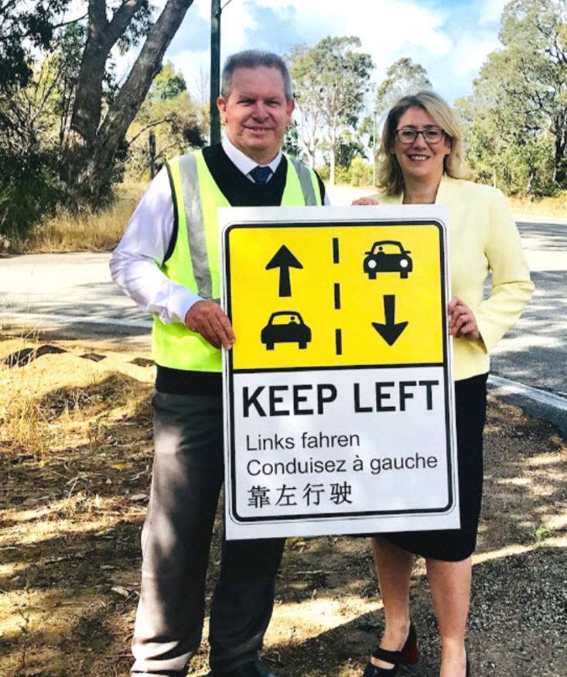At the end of 2019, multilingual advisory signs were rolled out on some Western Australian roads as part of a trial to help international drivers safely navigate the State's most popular tourism routes.

The trial involved the installation of signs with symbolic 'keep left' arrows, and 'keep left' spelt in German, French and Simplified Mandarin. Directional arrows were also painted intermittently on the road surface to remind drivers to keep left when driving in Australia.

During the research phase of the multilingual signs, some of our staff from Chinese native speaking backgrounds were consulted to help with the design and ensure correct translation. Although this demonstrated a good use of our organisations CaLD resources, it also helped us identify an opportunity to refine our existing processes to allow better utilisation of these skills.

**Pic above**: Bernie Miller, Regional Manager of Midwest-Gascoyne Region shows off one of the multilingual signs with Transport Minister Rita Saffioti.

Indian Ocean Drive - which connects WA's coastal tourism hotspots of Lancelin, Cervantes, Jurien Bay and Dongara - was the first road to receive the signage.

The trial coincided with the widening works to a 10 kilometre section of Indian Ocean Drive to accommodate wide centre line treatments between Wilbinga Grove and Moore River.

## Policy Priority 2 Culturally responsive policies, programs and services

|  |  |  |  |  |
| --- | --- | --- | --- | --- |
| Outcome | * All Western Australians are informed of and have equitable access to government services. * Programs and services are culturally appropriate and responsive to the needs of all Western Australians. * Customised CaLD – specific services are provided for those that need them. * A workforce that is culturally competent and representative of its community and business and client needs. | | | |
| Strategies | * Integrate multicultural policy goals into strategic and corporate planning, procurement and review processes. * Identify inequities in service access and outcomes for Western Australians from CaLD backgrounds and develop strategies to address them. * Provide language services to ensure language is not a barrier to equitable access to information and services, including complaints processes. * Collect and analyse cultural and linguistic data to contribute to the identification of client needs, the development of policies and programs, and evaluation of outcomes * Enable culturally diverse communities to have meaningful input into policies, programs and systems through co-design and planning, co-delivery and implementation, and evaluation processes * Implement recruitment and selection processes that facilitate workforce diversity, and provide opportunities for the development of cultural competencies across the workforce | | | |
| Action | | Responsibility | Timeframe | KPIs |
| Recognition and Promotion - Celebrating diversity and recognising achievements | | | | |
| * 1. Incorporate key actions and opportunities from Multicultural Plan as part of Business Planning and incorporate key actions into Corporate, Directorate and Branch business plans. | | S&C in consultation with Directorates | Commence Aug 2021 | Key actions incorporated into Business Plans |
| 2.2 Review complaints database (CONNECT) to ensure issues around CaLD are identified and reviewed | | S&C | June 2021 | Issues identified from corporate database on a quarterly basis showcasing their stories and cultures |
| 2.3 Review complaints and feedback on CaLD issues to identify and address systemic issues, through a process of continuous improvement | | S&C | Dec 2021 | Issues identified and addressed |
| 2.4 Promote seminars, workshops, forums and information sessions provided by EEO, PSC and other external working groups as practicable to inform planning, design, delivery and implementation of CaLD policy and services. | | HR | Apr 2021 | Promotion of relevant seminars to meet business needs or address identified knowledge gaps. |
| 2.5 Collaborate with Transport Portfolio partners to share and develop multicultural strategies. | | S&C | Biannually | Bi-annual meetings with Portfolio partners to discuss strategies, latest developments and opportunities. |
| 2.6 Review the current job advert statement encouraging culturally and linguistically diverse applicants to apply. | | HR | May 2021 | 100% of job advertisement include the statement. |
| 2.7 Create a promotional case study for the job vacancy section on the external website to encourage CaLD applicants to apply. | | HR | Aug 2021 | Increase number of applicants from CaLD employees |
| Workforce - Recruitment, training and talent management (ie mentoring, career progression) | | | | |
| 2.8 Continue to collect and analyse CaLD data in the workplace to identify the current number of employees from CaLD backgrounds at all levels. | | HR | Jan 2022 (annually) | Data and data capture methods at onboarding and on our payroll system correctly capture our CALD workforce. |

|  |  |  |  |
| --- | --- | --- | --- |
| 2.9 Continue to provide guidance for Panel Members to ensure recruitment and selection decisions are free from discrimination and bias. | HR | Jun 2021 | * 100% of recruitment panel members have a HR representative. * No successful breach of standards due to discrimination. |
| 2.10 Conduct a regular training needs survey of all staff to identify and address staff training needs around diversity awareness, access and inclusion. | HR | Dec 2021 | Training needs identified |
| 2.11 As part of the suite of Learning and Development programs, promote the online ‘Diverse WA Cultural Competence Training Program’ developed by OMI. | HR | Dec 2021 | Training program promoted across Main Roads |
| 2.12 Review, update and communicate Code of Conduct, EEO policies, recruitment, and grievance policies to remove barriers to CaLD participation in the workplace. | HR | Dec 2021 | Code of Conduct updated as required and changes communicated to all employees |
| 2.13 Facilitate completion of mandatory eLearning training on EEO & anti-discrimination for all new starters and for all staff every three years to promote a culturally safe work environment. | HR | Dec 2021 | * Mandatory training included at induction for all new staff. * 100% of staff to undertake refresher every three years. |
| 2.14 Educate senior leaders on the effects of racism by providing ongoing training to promote inclusive, respectful culturally aware work places | HR | Dec 2023 | Senior leaders have undertaken training |

|  |  |  |  |
| --- | --- | --- | --- |
| 2.15 Establish a regular presence at employment and career expos and highlight Main Roads as an employer of choice | HR | Annually | Increase number of CaLD applicants applying for positions |
| Engagement and Participation - Engagement, representation and consultation with members from CaLD backgrounds | | | |
| 2.16 Participate in the WA Multicultural Policy Framework Interagency Network (WAMPF) to identify and share information and policies on key issues affecting CaLD communities. | S&C and HR | Ongoing | * Main Roads have representatives attend the WAMPF meetings * Participate in the delivery of relevant actions |
| 2.17 Utilise our ideas management system, Bright Ideas, to seek input from our staff on new policies and strategies relating to people from culturally linguistic backgrounds. | S&C | May 2023 | Invite ideas through a Bright Idea challenge |
| 2.18 Continue to work with OMI on cross-government projects/initiatives to improve outcomes for CaLD communities. | S&C | Ongoing (review May annually) | Regular collaboration with OMI |
| Access and Communications – Strategies for accessible information | | | |
| 2.19 Promote Main Roads ‘How To’ for staff to be aware of interpreter services available and how to access them. | S&C | Dec 2021 | * iRoads article on services available * Customer Information Centre staff training |

|  |  |  |  |
| --- | --- | --- | --- |
| 2.20 Ensuring front-line staff are able to provide and are equipped with the right tools/resources to provide quality customer service responding to correspondence, considering communication needs of all. | All | Mar 2021 | * All Customer Information Centre employees aware of resources. * 100% of correspondence is successfully responded to |
| 2.21 Review our community engagement methods and networks to ensure engagement of people from CaLD backgrounds. | S&C | Jun 2021 | Where appropriate, CaLD community members participate in community consultation |
| 2.22 Implement the Language Services Policy 2020 to ensure language is not a barrier when accessing information and services from Main Roads. | All | May 2021 | Language Services Policy 2020 promoted on iRoads and to key employee groups. |
| **Desired Impact:**   * Information and complaints processes reviewed to ensure better access for people with English language barriers * CaLD actions embedded into the Corporate Business Planning process * Cultural awareness training completed by staff to ensure an educated an informed workforce that works with CaLD employees and communities | | | |

# What our employees are telling us:

## % of Main Roads staff surveyed

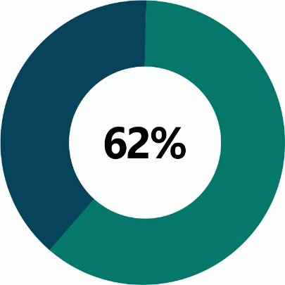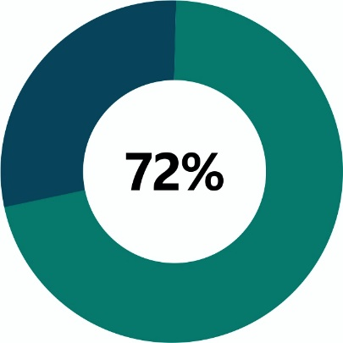

Agreed that Main Roads implements Agreed that Main Roads integrates   
recruitment and selection processes that multicultural goals into strategic and corporate   
facilitates workforce diversity, and provide planning, procurement and review process.  
opportunities for the development of cultural   
competencies across the organisation.

# What our CaLD community members are telling us:

## % Total Neutral to Outstanding of CaLD community members surveyed

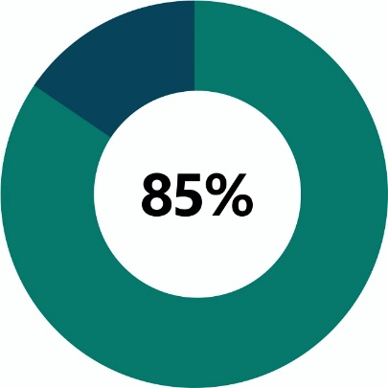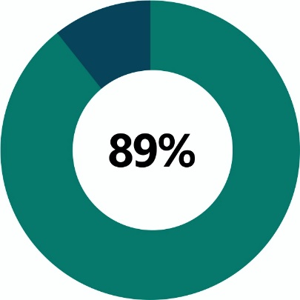

Accessibility of Main Roads’ online information Accessibility of Main Roads major roads,  
and website to culturally and linguistically highways or freeways to culturally  
diverse people and linguistically diverse people

# Case study Bernie Dimanlig

People would have heard her many times over the years on their commute, in the office or at home bringing us up to date traffic reports or speaking to presenters. However, many listeners do not realise Real-Time Media Co-ordinator Bernie Dimanlig is of Asian heritage.

Bernie’s parents, her Dad from the Philippines and her Mum from Hong Kong, brought their family to Australia when she was only four years old. Nonetheless, she says although she was encouraged to immerse herself in the Australian way of life, she was never deprived of her own vibrant Asian culture.

Chinese culture was always an important part of the home environment with their first language being Catonese when she was little. Bernie’s grandma, who she called ‘pawpaw’ also emigrated to help raise the family while her parents worked. Bernie continues this tradition of multigenerational living by having her own parents reside with her.

**Pic above**: Pic above: Bernie Dimanlig

Although she has experienced some forms of racial discrimination, she says it definitely has changed and improved over the years. She has hope for her boys’ generation as they have a lot more tools at hand than she did and avenues to ask questions and voice their opinions.

‘I am Australian through and through, I just have different cultures and understanding of things. I believe the message and education is out there. It’s about coming together and asking questions.’

# Policy Priority 3

## Economic, social, cultural, civic & political participation

|  |  |  |  |  |
| --- | --- | --- | --- | --- |
| Outcome | * Western Australians from culturally and linguistically diverse backgrounds are equitably represented in employment and on boards, committees and other decision making bodies. * Western Australia’s CaLD community is harnessed to grow economic, social, cultural, civic and political development. | | | |
| Strategies | * Implement recruitment and career development processes that support employment and progression of staff from CaLD backgrounds. * Achieve equitable representation of people from CaLD backgrounds at all levels and in decision-making roles. * Identify, develop and implement initiatives that encourage social, cultural, civic and political participation by members of Western Australia’s CaLD community. | | | |
| **Action** | | **Responsibility** | **Timeframe** | **KPIs** |
| Recognition and Promotion – Celebrating diversity and recognising achievements | | | | |
| * 1. Through liaising with CaLD community groups, use the lighting on Matagarup Bridge to acknowledge key cultural events | | S&C | Jun 2021 | Link in with 2 culturally significant events per year. |
| * 1. Engage CaLD community groups to facilitate a ‘Lunch and Learn’ session to explain cultural differences | | HR | Ongoing | Lunch and learn session held |
| Workforce - Recruitment, training and talent management (ie mentoring, career progression) | | | | |
| * 1. Review Manager guides and documents relating to individual Career Conversations, to provide adequate guidance on training and skill development that may be required by CaLD employees | | HR | Jan 2023 | Career Conversations updated |
| * 1. Build the skills and capability of our CaLD managers and employees by offering equitable access to development opportunities, including leadership/management skills training | | HR | Jan 2022 | Track the diversity within leadership and management training opportunities. |
| Engagement and Participation - Engagement, representation and consultation with members from CaLD backgrounds | | | | |
| * 1. Managers to support CaLD employees to take appropriate leave to celebrate culturally significant events | | All | Ongoing | Increase in the number of CaLD employees celebrating culturally significant events |
| **Desired Impact:**   * Build the skills of CaLD employees to be competitive for employment prospects * Increase the participation of people from CaLD background to strength innovation and decision making across Main Roads | | | | |

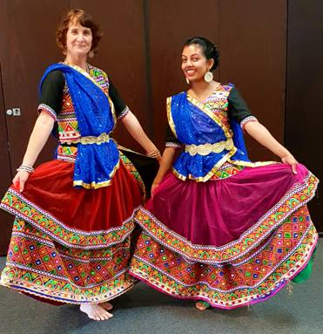

**Pic above**: Bollywood dancers from Family Day 2018

# What our employees are telling us:

## % of Main Roads staff surveyed



Agree Main Roads implements recruitment and career development processes that support employment and progression of staff from CaLD backgrounds

# What our CaLD community members are telling us:

## % of CaLD community members surveyed

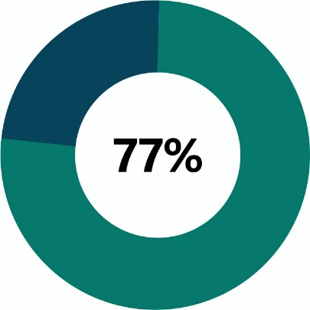

Agreed that they have not experienced issues or barriers in using or accessing Transport Portfolio Services

# Case study Internal Communications

The Internal Communications team manage corporate messaging on our intranet to ensure staff are engaged and informed on the agency’s activities and wider transport issues.​ Some of the ways we utilise this facility to raise awareness and promote the benefits of a culturally diverse workforce include:

* We include articles that have a focus on a particular group, significant cultural practice or availability of facilities. For example, promoting our multi-faith prayer room, as a way of building more understanding and education, or an interview that was undertaken with Muslim employees on ‘What is Ramadan?”
* Encourage employees to list other languages on our Intranet profiles to enable assistance should someone require help translating.
* We have a Diversity Calendar that lists dates and events of significance to our minority groups. These dates are highlighted and awareness raised through internal news stories, information sessions by guest speakers and participation in community events and projects supporting these diverse groups.
* Equal employment opportunity training is compulsory for new starters. Employees also have access to the Diverse WA, a cultural competency online training package. In addition, information on unconscious bias and inclusion in the workplace is readily available on our intranet page.
* During Harmony Week, to celebrate those from culturally and linguistically diverse (CaLD) backgrounds, we produced a video that featured of our people delivering a greeting in some of the many different languages spoken across our organisation.

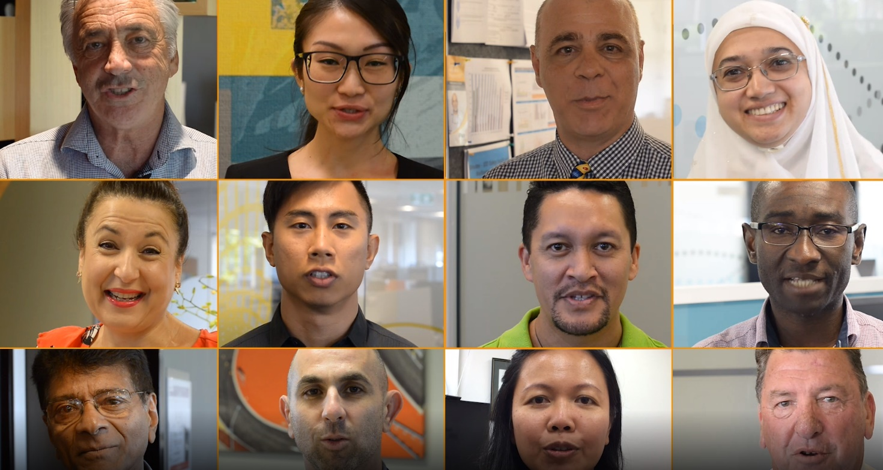

**Pic above**: Screenshot of Main Roads Harmony week video – Celebrating Diversity in our Workplace